Changed weights function

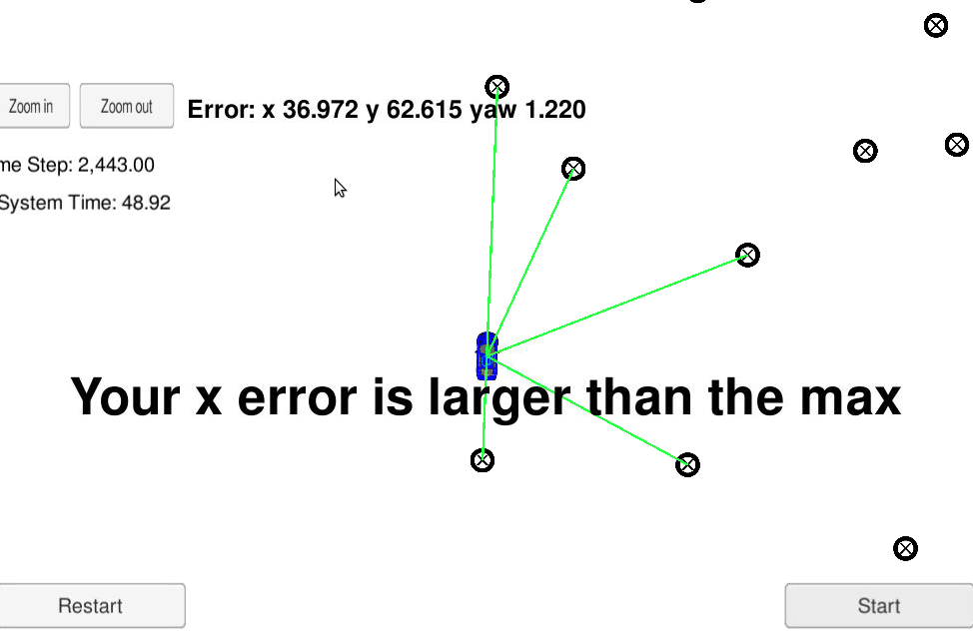

Initialized x values as doubles instead of floats. Had been missing info because of casting. Error improved now.

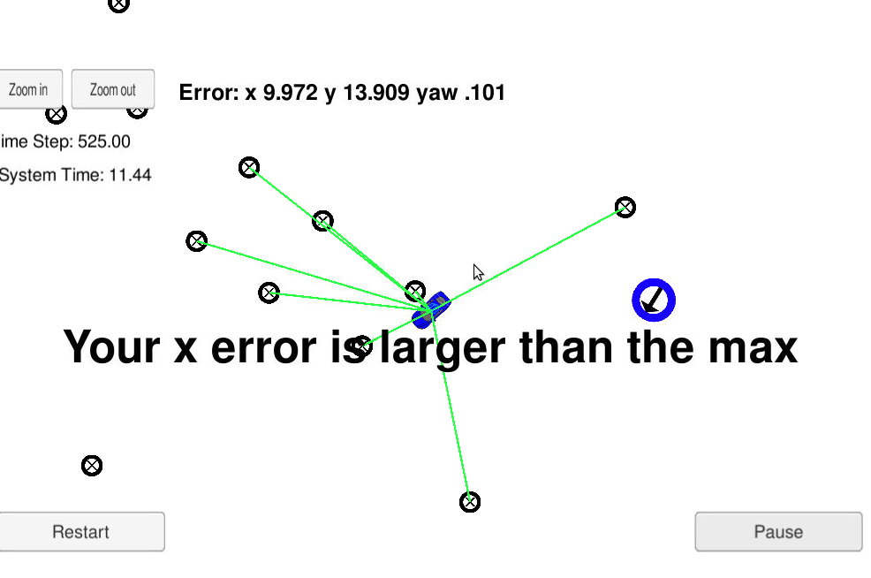

Weights catch zero multiplication. Reduced error

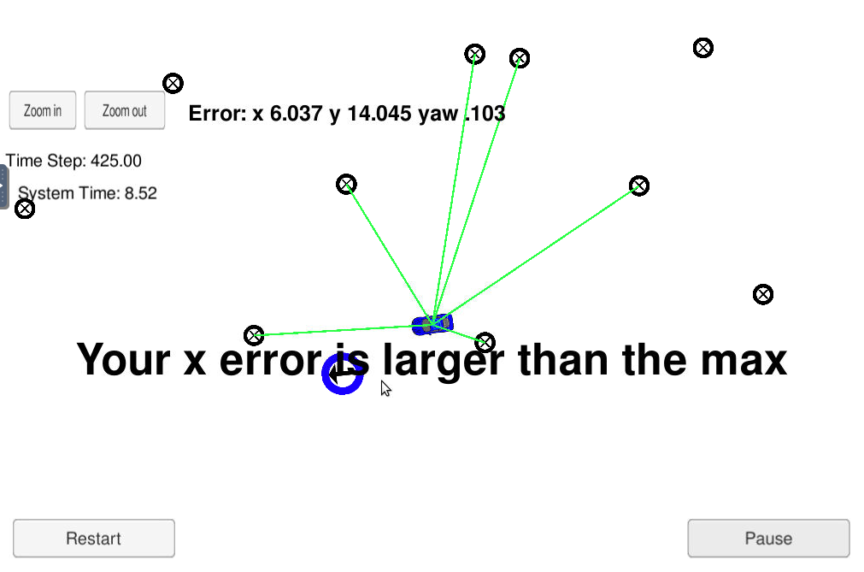

Increase particles to 100. Reduced error but slow

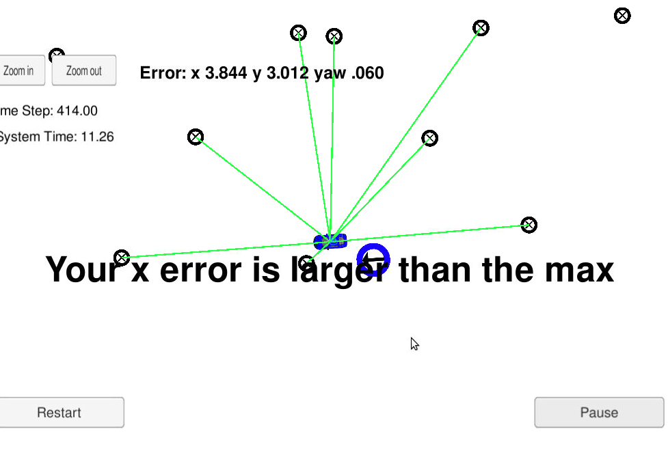

Reset weight calculation and reset predictions

