Week 2: Advanced Data Visualization and Storytelling with Python
The Rhythm and Risk of India’s Rainfall, 1901–2017
Dataset: Sub-Divisional Monthly Rainfall in India (India Meteorological Department)
Tools: Python 3, Pandas, NumPy, Matplotlib, Seaborn

1. Introduction
Rainfall is the single most important environmental variable in India. It decides whether farms are productive, whether reservoirs fill, and whether towns flood. Yet for most people, rainfall data is a spreadsheet of thousands of numbers. This report turns one such dataset into a visual story that a non-technical reader can follow.
In Week 1 the dataset was acquired, cleaned and explored. It covers 36 meteorological subdivisions over 117 years (4,188 subdivision-year records), with monthly rainfall in millimetres. Week 2 builds on that cleaned data to answer one question:
Where, when and how unpredictably does India’s rain fall, and what does that mean for people who must plan around it?

1.1 Intended audience
The intended reader is a non-technical decision-maker, such as a planner, a farm-sector manager or a disaster-management officer. Every chart therefore uses plain titles that state the finding, direct annotations, and colour used to carry meaning, not decoration.

1.2 The story in six chapters
- Where: each region has its own rainfall “fingerprint” (Figure 1).
- How dependent: regions differ widely in how much they rely on the monsoon (Figure 2).
- When, over time: national rainfall swings between wet and dry spells (Figure 3).
- How reliable: dry regions are the hardest to predict (Figure 4).
- How extreme: in some regions a single month can deliver a whole year’s rain (Figure 5).
- How different: long-term trends differ from one region to another (Figure 6).

2. Methods

2.1 Data and preparation
The analysis uses the cleaned file produced in Week 1 (rainfall_clean.csv, 4,188 rows). Missing monthly values were filled with each subdivision’s own median for that month, and the ANNUAL total was recomputed from the monthly columns. No rows were dropped. A small number of gaps remain only in the four seasonal summary columns (JF, MAM, JJAS, OND), which are not used here. Seasonal totals needed for this report are recomputed directly from the monthly columns.

2.2 Derived measures
Measure | How it is computed | Used in
Mean monthly rainfall | Average of each month per subdivision, 1901–2017 | Figure 1
Monsoon share (%) | Sum of June–September rain ÷ total annual rain, per subdivision | Figure 2
National mean and SD | Mean of subdivision rainfall each year; then mean and standard deviation across years | Figure 3
Rolling mean | 11-year centred moving average | Figures 3, 6
Coefficient of variation (CV) | Standard deviation ÷ mean of annual rainfall, per subdivision (%) | Figure 4
Peak-month ratio | Wettest single month on record ÷ average annual rainfall (%) | Figure 5
Linear trend | Least-squares slope of annual rainfall vs. year, in mm per century | Figure 6

2.3 Visual design principles
- Choose the chart type that fits the question: heatmap for a two-way pattern, bars for ranking, scatter for relationships, lines for time.
- Put the finding in the title or an annotation so readers do not have to decode the chart.
- Use colour to carry meaning (for example, red is dry or risky, blue is wet) and keep it consistent throughout.
- Use sorted categories and few visual elements so the eye goes straight to the pattern.

3. Visual Analyses

3.1 Figure 1: Every region has a rainfall fingerprint
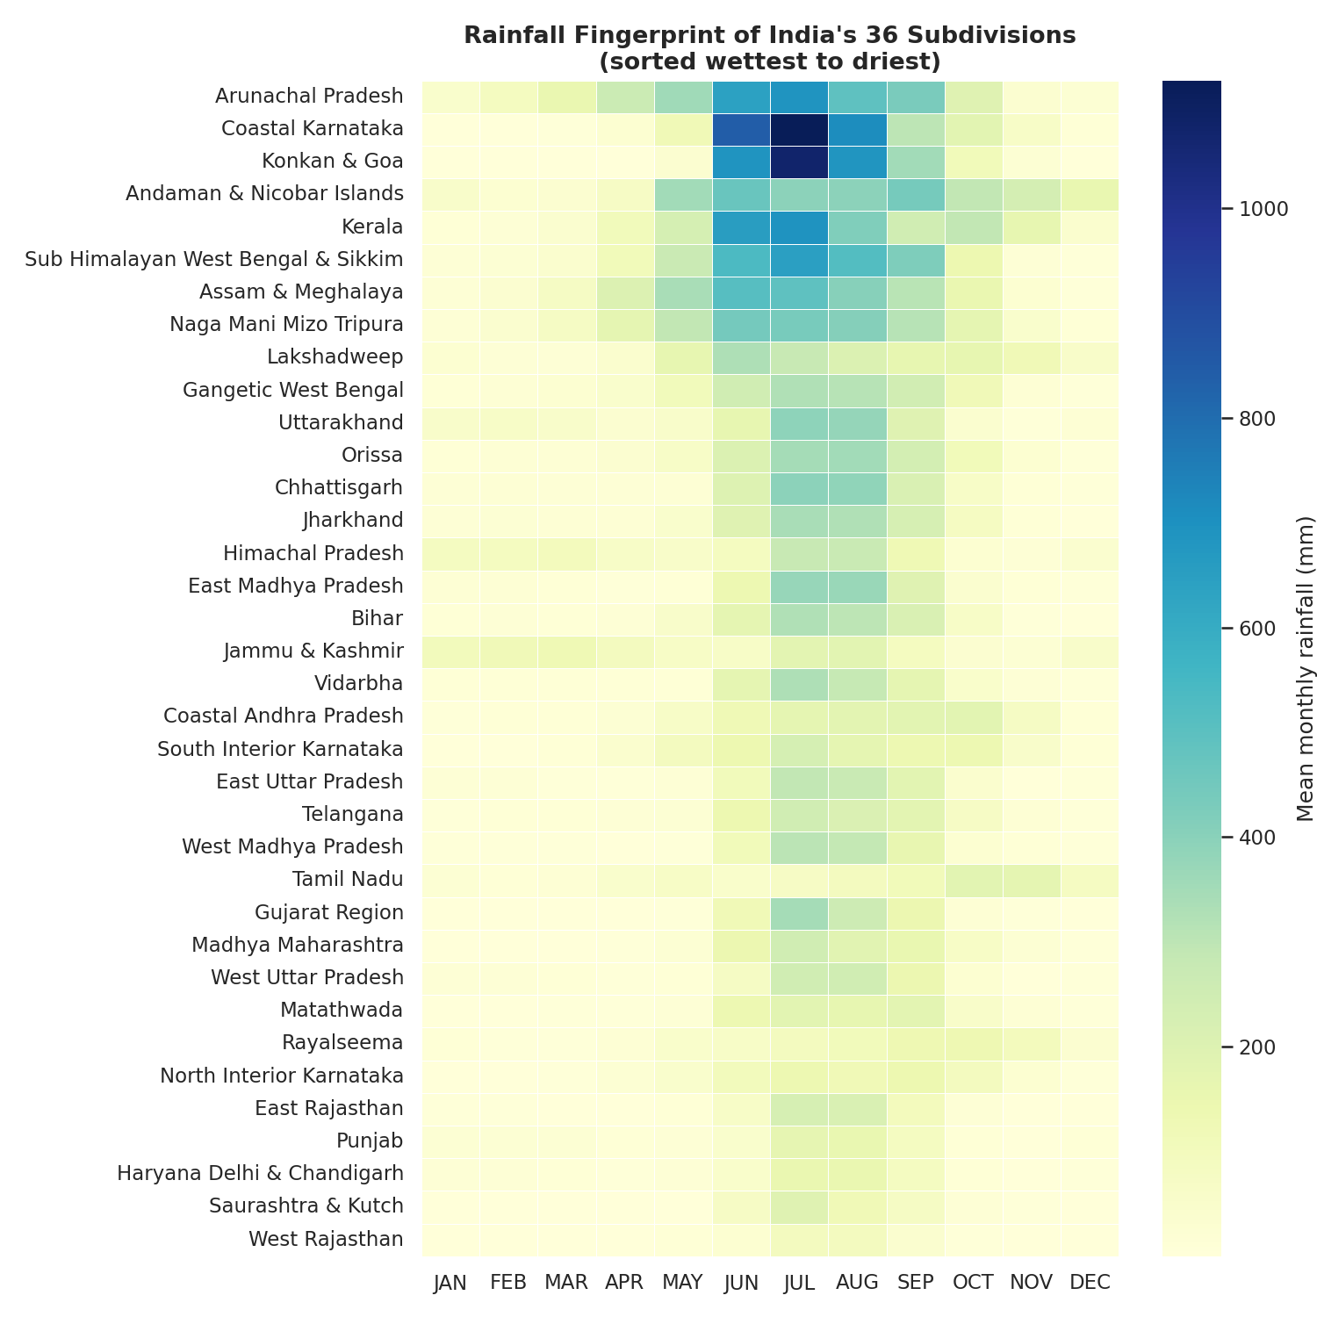
Figure 1. Mean monthly rainfall for each subdivision, sorted from wettest to driest.
What it shows. Each row is a region and each column a month; darker blue means more rain. Heavy, dark bands in June–September dominate the upper rows (Konkan & Goa, Coastal Karnataka, Kerala, Arunachal Pradesh). Rows near the bottom (West Rajasthan, Haryana, Punjab) are pale throughout. A few rows break the pattern: Andaman & Nicobar has rain nearly all year, and Tamil Nadu shows a second wet period in October–December.
Why this visual. A heatmap is the only chart that can show 36 regions × 12 months (432 values) in one view without clutter. It opens the story by showing that “India’s rainfall” is really many different rainfall patterns.
Role in the narrative. It sets up the central idea of the report: any plan or model that treats India as a single average will miss most of what matters.

3.2 Figure 2: How much does each region depend on the monsoon?
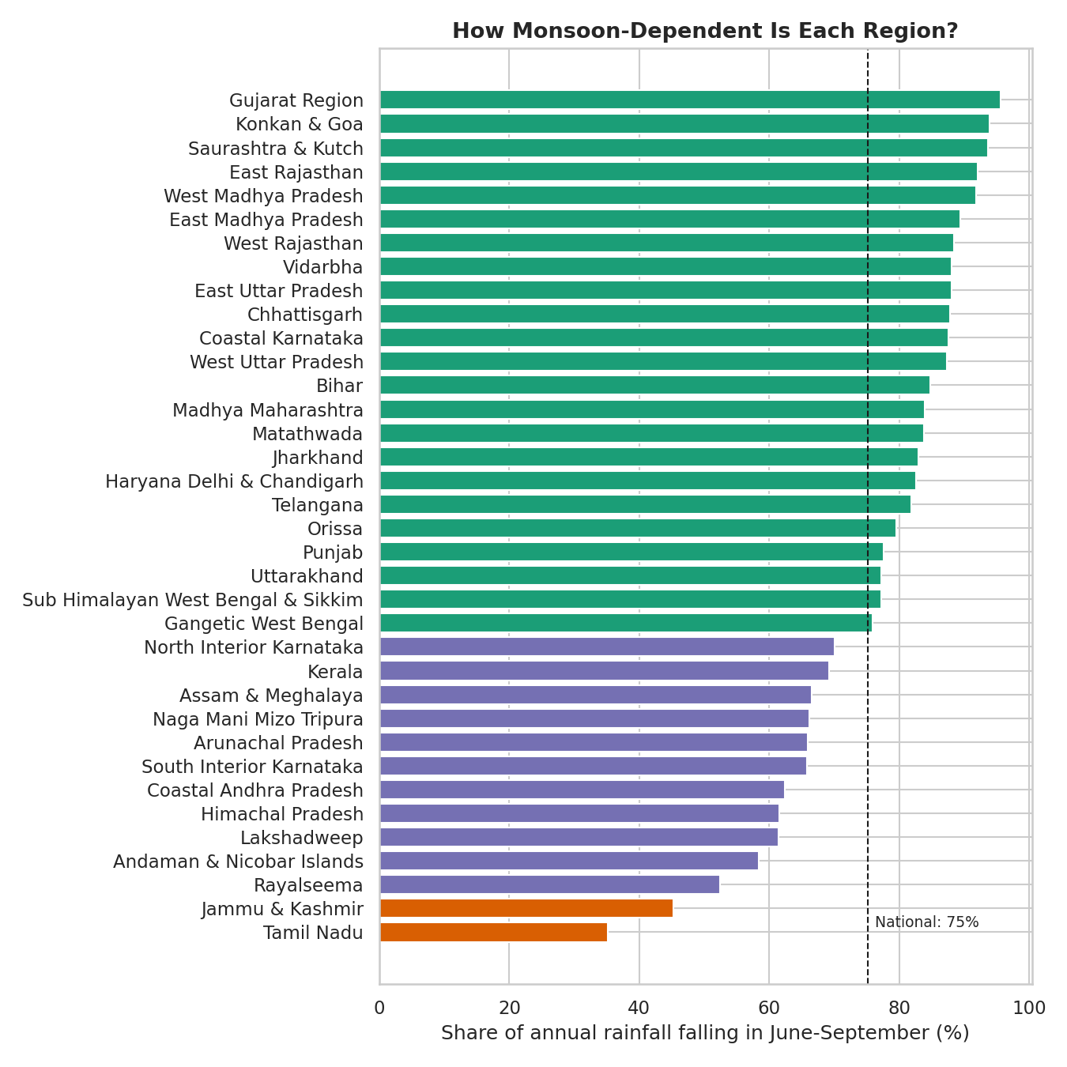
Figure 2. Share of annual rainfall that falls in June–September. Green: 75% or more; purple: 50–75%; orange: under 50%. Dashed line: national share.
What it shows. Nationally, 75% of annual rain arrives in the four monsoon months. But the range is wide: 96% in the Gujarat Region against only 35% in Tamil Nadu. Tamil Nadu and Jammu & Kashmir are the only two subdivisions below 50%, because they depend on the north-east monsoon and on winter western disturbances respectively.
Why this visual. A sorted horizontal bar chart makes ranking effortless and leaves room for long region names. The colour bands turn a continuous measure into three easy groups, and the dashed national line gives a reference point.
Role in the narrative. Figure 1 showed that regions differ; Figure 2 quantifies one key difference. Regions in green face a single high-stakes season, while regions in orange must watch other times of year.

3.3 Figure 3: Wet and dry years across 117 years
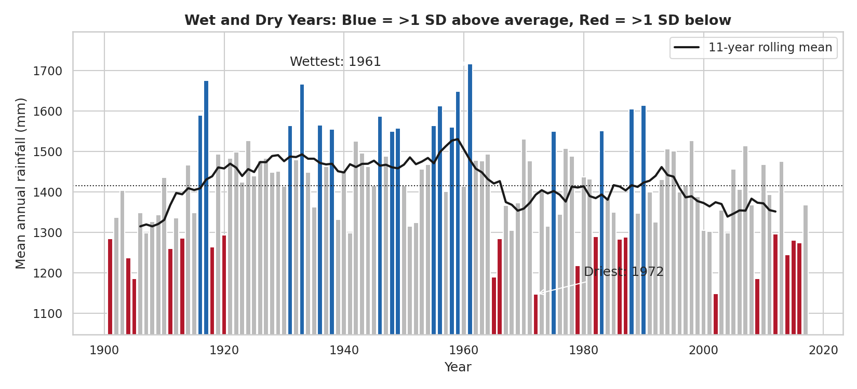
Figure 3. National mean annual rainfall by year. Blue: more than one standard deviation above average; red: more than one below; black line: 11-year rolling mean.
What it shows. The long-term national average is 1,415 mm with a standard deviation of 118 mm. The wettest year was 1961 (1,717 mm) and the driest was 1972 (1,146 mm). The 11-year line shows slow multi-decade swings: it rose to a peak of about 1,485 mm in the 1930s, stayed high through the 1950s, then drifted lower, and the 2000s (1,334 mm) and 2010s (1,350 mm) are the lowest decades since the 1900s. Extreme years are common: 18 years were unusually wet and 20 unusually dry.
Why this visual. Bars colour-coded by anomaly make individual extreme years visible, while the overlaid rolling mean separates the slow signal from the year-to-year noise. A plain line (as in Week 1) hides which years are truly exceptional.
Role in the narrative. It adds the dimension of time: national rainfall has no steady upward or downward line, but it moves in long wet and dry spells that planners should expect.

3.4 Figure 4: Dry regions are also the least predictable
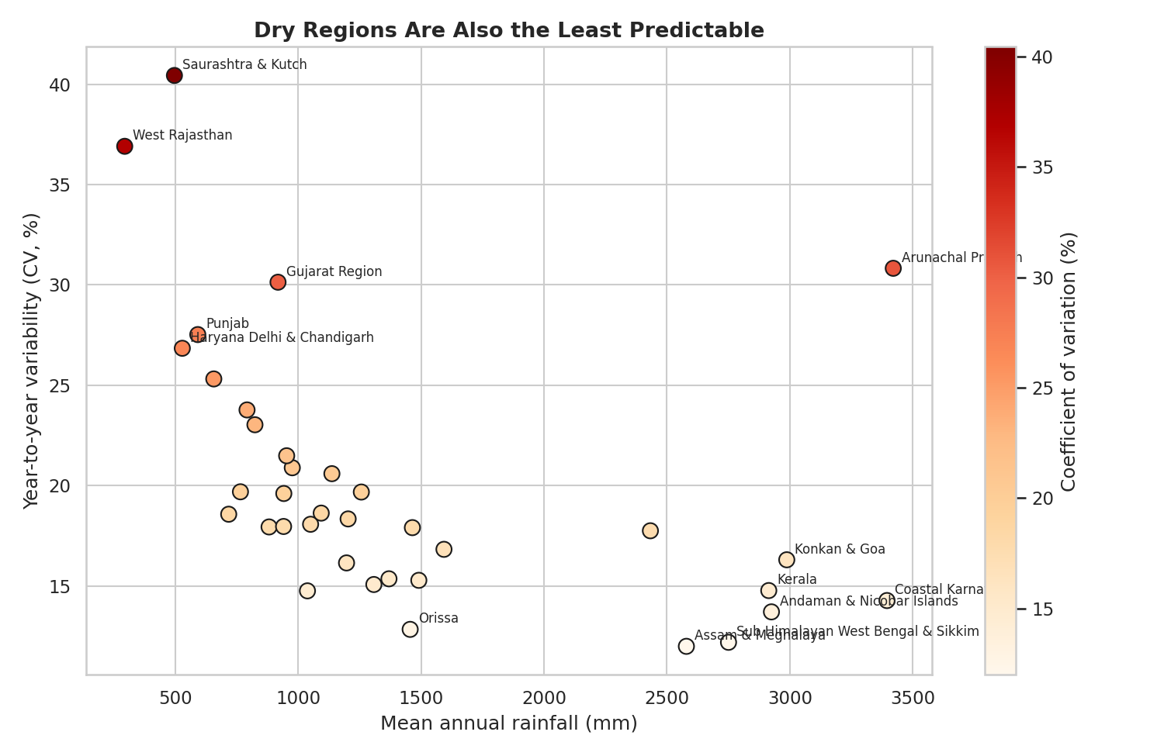
Figure 4. Each dot is a subdivision. Horizontal axis: average annual rainfall. Vertical axis and colour: year-to-year variability (coefficient of variation).
What it shows. Variability falls as average rainfall rises (correlation about −0.45). The most erratic regions are Saurashtra & Kutch (CV 40%) and West Rajasthan (37%), both dry. The most stable are Assam & Meghalaya (12%) and Sub-Himalayan West Bengal & Sikkim (12%), both very wet. Arunachal Pradesh is the notable exception: it is very wet and also quite variable (31%).
Why this visual. A scatter plot is the standard way to show a relationship between two measures. Adding colour for the vertical value and labelling only the outliers keeps it readable.
Role in the narrative. It moves from “how much” to “how reliable”. For a farmer or planner, a region with 500 mm that varies by 40% is a harder problem than a region with 3,000 mm that varies by 12%.

3.5 Figure 5: When one month delivers a year of rain
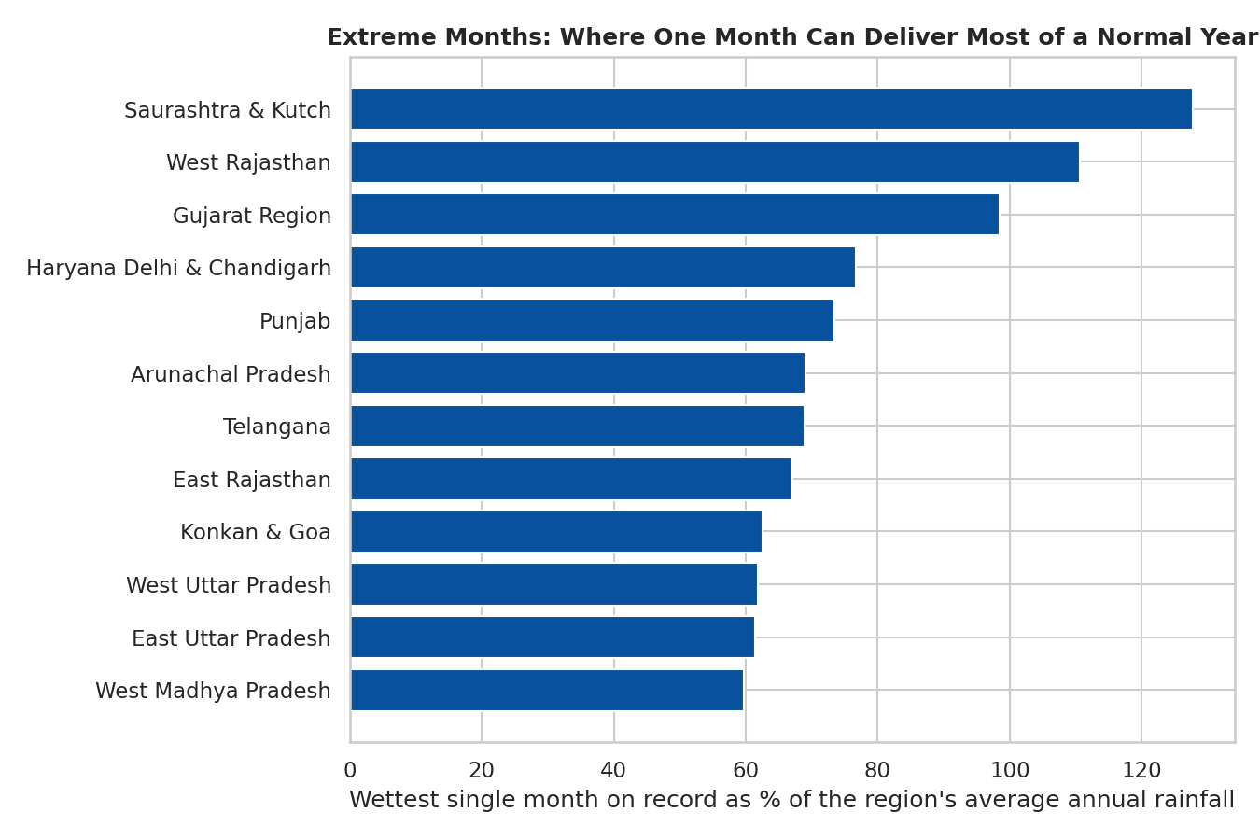
Figure 5. Twelve subdivisions where the single wettest month on record is largest relative to the region’s normal annual rainfall.
What it shows. In Saurashtra & Kutch, the wettest month ever recorded (128% of an average year) delivered more than a whole normal year of rain. West Rajasthan (111%) is similar, and Gujarat Region comes close (98%). In Haryana-Delhi-Chandigarh and Punjab one month reached 73–77%.
Why this visual. Expressing the extreme as a percentage of a normal year gives an intuitive measure (“one month equals a whole year”) and allows fair comparison between wet and dry places, which raw millimetres would not.
Role in the narrative. This is the flood-risk chapter. It links the variability in Figure 4 to a concrete hazard: in the north-west, drainage and warning systems built for average rainfall can be overwhelmed by a single month.

3.6 Figure 6: Four climates, four different stories
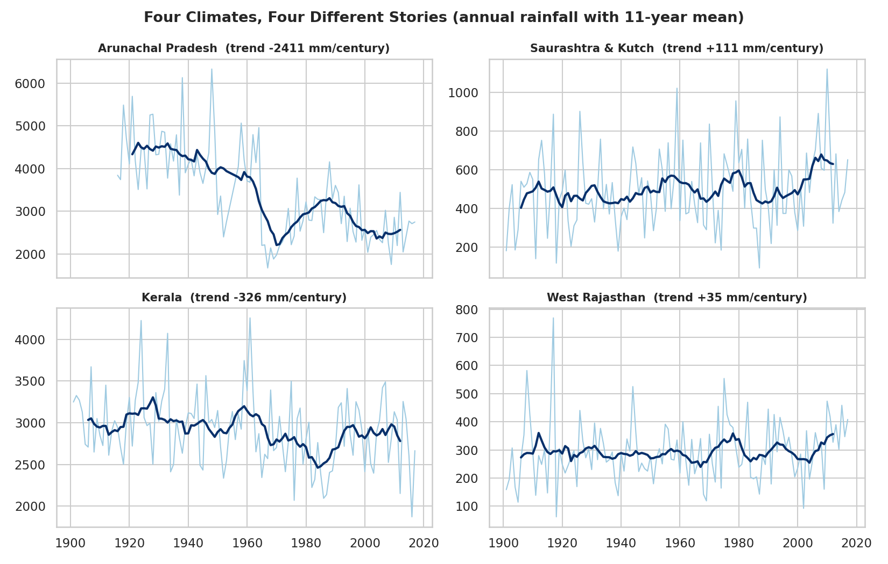
Figure 6. Annual rainfall (light line) with 11-year rolling mean (dark line) for four contrasting regions. The slope shown in each title is the linear trend in mm per century.
What it shows. Regions do not move together. Kerala shows a modest decline (about −330 mm per century). Saurashtra & Kutch shows a slight rise (about +110 mm). West Rajasthan is essentially flat. Arunachal Pradesh shows a very large decline, with its average falling from about 4,400 mm in the 1920s–1940s to roughly 2,400–2900 mm in recent decades.
A caution. Such a sharp drop in a single region may partly reflect changes in how and where rainfall is measured in a remote mountain area, not only climate. It should be treated as a finding to verify with additional data, not as a settled fact.
Why this visual. Small multiples let the reader compare four series with the same encoding. Each panel has its own scale because the regions differ so much in rainfall levels, so the shape of change, not its size, is what is being compared.
Role in the narrative. This closes the loop: the national picture in Figure 3 hides regional differences, so any climate-related decisions have to be taken region by region.

4. Key Findings
Question | Finding | Figure
Where does rain fall? | Heavily concentrated in the west coast, north-east and islands; north-west is driest | 1
How monsoon-dependent? | 75% nationally; from 96% (Gujarat Region) to 35% (Tamil Nadu) | 2
Is there a trend over time? | No steady trend, but multi-decade wet and dry spells; 2000s–2010s are among the lowest | 3
Where is rain unreliable? | Dry regions: Saurashtra & Kutch (CV 40%), West Rajasthan (37%) | 4
Where are single-month extremes largest? | Saurashtra & Kutch (128%), West Rajasthan (111%), Gujarat (98%) | 5
Do regions change in the same way? | No; trends differ in size and direction | 6

5. Business and Scientific Implications

5.1 Flood early warning and disaster management
- Alert thresholds must be set per region, not nationally. A rainfall amount that is normal in Konkan would be a catastrophe in West Rajasthan.
- North-western and western regions (Gujarat, Rajasthan, Punjab, Haryana) deserve priority for flash-flood warning systems because a single month can exceed a normal year.
- Monthly data alone cannot support short-lead warnings. The next stage should combine these regional baselines with daily or hourly rainfall, river-basin and terrain data.

5.2 Agriculture and food security
- Highly monsoon-dependent regions (above 85%) carry concentrated risk: a weak monsoon has no second season to compensate. Crop insurance and contingency seed plans are most valuable there.
- High-variability dry regions need drought-tolerant crops and water storage, as average rainfall is a poor guide to any given year.

5.3 Water resources and infrastructure
- Multi-decade wet and dry spells mean reservoir and drainage design should not assume that the recent past is typical. A planner using only the 1930s–1950s would overestimate supply today.
- Tamil Nadu and Jammu & Kashmir need planning calendars distinct from the rest of India because their wet seasons fall outside June–September.

5.4 Scientific directions
- Investigate the large decline in Arunachal Pradesh and the decline in Kerala using station-level data to separate climate signal from measurement change.
- Test whether the late-twentieth-century fall in the monsoon-season share and total is linked to known drivers such as El Niño and aerosol changes.
- Use the regional variability measures as input features for a forecasting model.

6. Conclusions
India’s rainfall is best understood as a set of regional stories. The monsoon is the main driver nationally, supplying three-quarters of the year’s rain, but regions differ greatly in how much they depend on it, how reliable it is, how extreme its peaks can be, and how it has changed over a century. The six visuals move from the broad pattern (where and when) to the practical consequence (risk and variability), so that a non-technical reader reaches the same conclusion the numbers support: plans and warnings must be local.

6.1 Limitations
- Rainfall is averaged over large subdivisions, which hides local variation within them.
- The data is monthly, so it cannot capture short, intense bursts that cause flash floods.
- Missing values were imputed with medians (about 3% of monthly cells), which slightly smooths extremes.
- Linear trends are simple summaries and are sensitive to the start and end years and to changes in station networks.

6.2 Time and effort
Estimated effort within the 30–35 hour guideline: data review and design of the story (~6 h), developing and refining the six visualizations (~16 h), interpretation and implications (~5 h), and writing and formatting this document (~6 h).

Appendix: Reproducibility
All figures were generated in Python from rainfall_clean.csv using Pandas for aggregation and Matplotlib/Seaborn for plotting. The final charts were exported at 150 dpi as PNG images and placed in this document.

