Week 3: Statistical Analysis and Hypothesis Testing
Has India's Monsoon Rainfall Changed Over Time? | Dataset: IMD Sub-Divisional Rainfall, India, 1901-2017

1. Introduction and Hypothesis
This analysis continues the flash-flood early-warning project by asking a question with direct real-world relevance: has the monsoon (June-September, 'JJAS') rainfall that drives most of India's flood risk meaningfully changed between the first half of the 117-year record and the second half? A statistically grounded answer matters because it determines whether a flood-prediction model should assume a shifting baseline or a stable one.

Primary Hypothesis (Two-Sample t-Test)
- H0 (null): Mean monsoon (JJAS) rainfall is equal between the Early period (1901-1960) and the Recent period (1961-2017).
- H1 (alternative): Mean monsoon rainfall differs between the two periods.

Supporting Hypothesis 1 (Chi-Square Test)
- H0: Whether a subdivision-year has 'extreme' monsoon rainfall (top 10% nationally) is independent of which period (Early/Recent) it falls in.
- H1: Period and extreme-monsoon occurrence are associated.

Supporting Hypothesis 2 (One-Way ANOVA)
- H0: Mean monsoon rainfall is equal across five climate-representative subdivisions (West Rajasthan, Tamil Nadu, East Madhya Pradesh, Arunachal Pradesh, Konkan & Goa).
- H1: At least one subdivision's mean monsoon rainfall differs from the others.

2. Methodology
Monsoon rainfall (JJAS) was computed per subdivision-year by summing the JUN, JUL, AUG, and SEP columns of the Week 1 cleaned dataset (4,188 rows, zero missing values). The 117-year span was split at 1960/1961 to create two roughly equal-sized groups (n=2,136 early, n=2,052 recent).
- Two-sample comparison: Welch's t-test was used instead of Student's t-test because Levene's test indicated unequal variances (p = 0.031) between the two periods.
- Normality was checked with the Shapiro-Wilk test and Q-Q plots. Both periods show significant deviation from normality (expected with n>2000, as rainfall is right-skewed) — however, the Central Limit Theorem makes the t-test's sampling-distribution assumption robust at this sample size, so the test proceeds with this caveat noted.
- Independence: A chi-square test of independence was run on a 2x2 contingency table of Period x Extreme-monsoon flag (extreme = JJAS total above the 90th percentile across the full dataset).
- Group comparison: A one-way ANOVA compared JJAS rainfall across five subdivisions chosen to represent India's climate diversity (arid, semi-arid, moderate, high-rainfall, and extreme-rainfall zones), followed by Tukey's HSD post-hoc test to identify which specific pairs differ.
Core analysis code:
from scipy import stats

df['JJAS'] = df[['JUN','JUL','AUG','SEP']].sum(axis=1)
df['PERIOD'] = np.where(df['YEAR']<=1960,'Early','Recent')

# Welch's t-test (unequal variances)
t_stat, p_val = stats.ttest_ind(early, recent, equal_var=False)

# Chi-square test of independence
chi2, p_val, dof, expected = stats.chi2_contingency(contingency)

# One-way ANOVA + Tukey HSD
f_stat, p_val = stats.f_oneway(*groups)
from statsmodels.stats.multicomp import pairwise_tukeyhsd
tukey = pairwise_tukeyhsd(anova_df['JJAS'], anova_df['SUBDIVISION'])

3. Results

3.1 Primary Test: Welch's t-Test (Early vs Recent Monsoon Rainfall)
Metric | Early (1901-1960) | Recent (1961-2017)
n | 2,136 | 2,052
Mean JJAS rainfall | 1,080.5 mm | 1,047.9 mm
Std deviation | see Fig. 1 | see Fig. 1

Welch's t = 1.493, p = 0.136 (two-tailed). 95% confidence interval of the mean difference: [-75.3, +10.2] mm. Effect size (Cohen's d) = -0.046 (negligible).
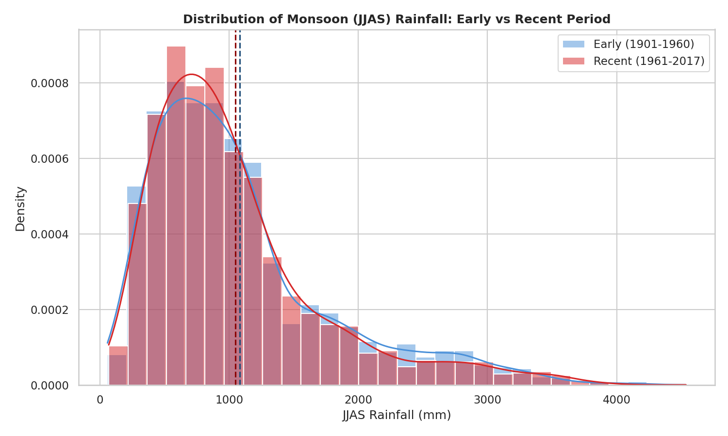
Figure 1. Distribution of monsoon (JJAS) rainfall, Early vs Recent period, with means marked.
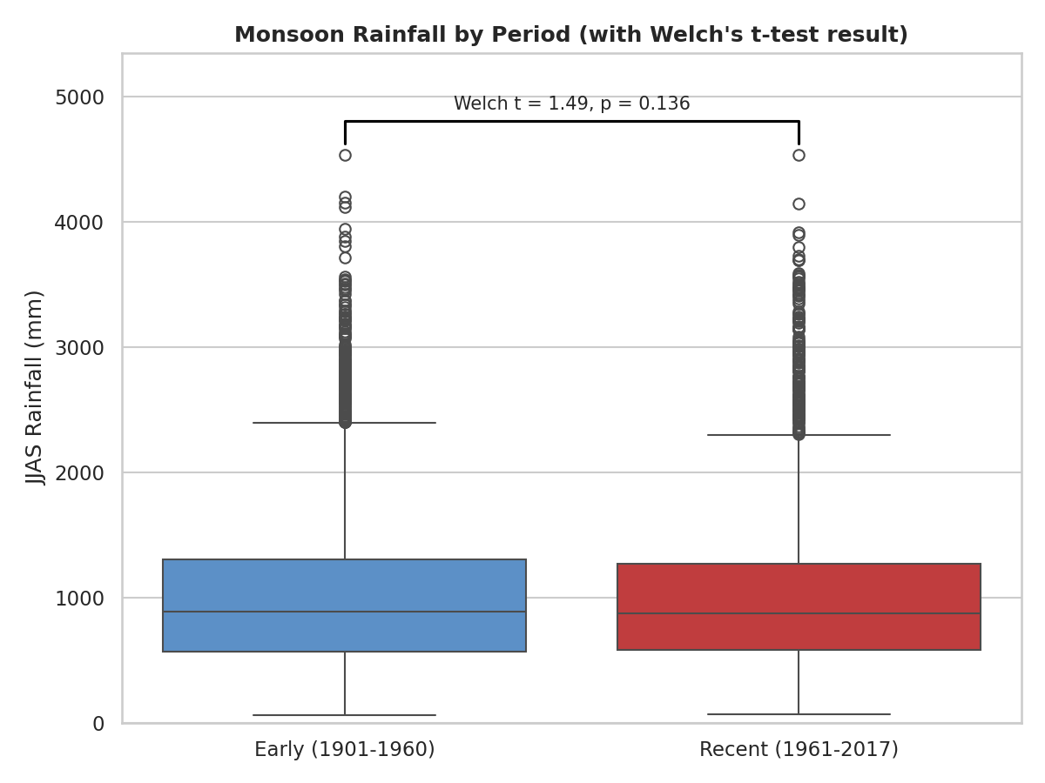
Figure 2. Boxplot comparison of monsoon rainfall by period, annotated with the t-test result.
Interpretation: With p = 0.136 (> 0.05), we fail to reject the null hypothesis. There is no statistically significant difference in mean monsoon rainfall between the early and recent halves of the 117-year record, and the confidence interval includes zero. The negligible effect size (d = -0.046) confirms that even if a true difference exists, it is too small to be practically meaningful. This suggests a flood-prediction model should not assume monsoon totals are trending up or down over the long run.

3.2 Supporting Test: Chi-Square Test of Independence
Period | Not Extreme | Extreme (>90th pct)
Early (1901-1960) | 1,901 | 235
Recent (1961-2017) | 1,868 | 184

Chi-square = 4.590, df = 1, p = 0.032. Cramer's V = 0.033 (very weak association).
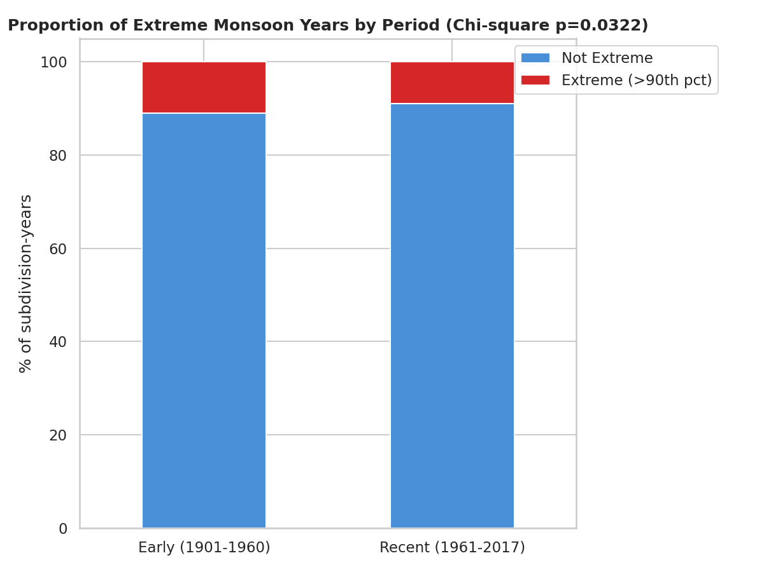
Figure 3. Proportion of extreme vs non-extreme monsoon years, by period.
Interpretation: At the conventional alpha = 0.05 threshold, p = 0.032 is statistically significant, so we reject the null and conclude period and extreme-monsoon occurrence are not fully independent — the Early period shows a slightly higher rate of extreme monsoon years (11.0%) than Recent (9.0%). However, Cramer's V = 0.033 indicates the association is extremely weak in practical terms, so this result should be read as 'statistically detectable due to large sample size' rather than 'a meaningful shift in flood risk.' It does not support a narrative of worsening extremes in recent decades.

3.3 Supporting Test: One-Way ANOVA Across Subdivisions
Subdivision | n | Mean JJAS (mm) | Std Dev (mm)
West Rajasthan | 117 | 260.1 | 101.3
Tamil Nadu | 117 | 330.9 | 70.0
East Madhya Pradesh | 117 | 1,075.1 | 196.4
Arunachal Pradesh | 99 | 2,254.3 | 823.4
Konkan & Goa | 117 | 2,804.2 | 459.3

F(4, 562) = 863.55, p < 0.001. Effect size (eta squared) = 0.860 — subdivision identity explains about 86% of the variance in monsoon rainfall across this sample.
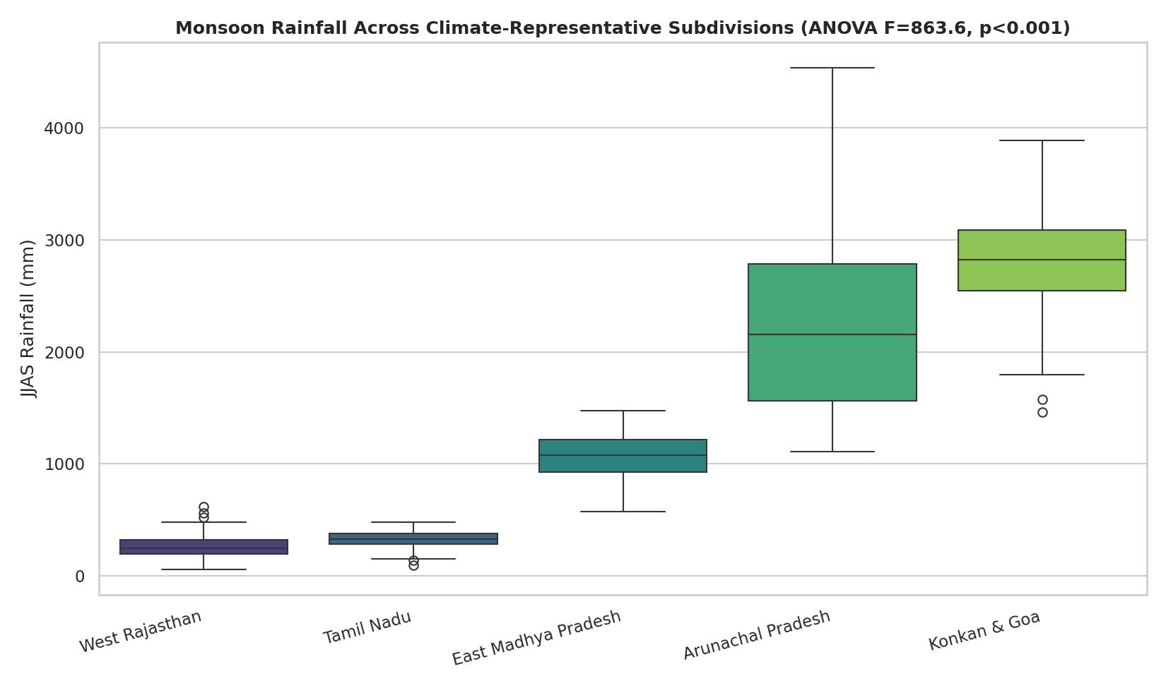
Figure 4. Monsoon rainfall distributions across five climate-representative subdivisions, ordered by mean.
Tukey HSD post-hoc results: all pairwise comparisons were statistically significant (adjusted p < 0.001) except Tamil Nadu vs. West Rajasthan (adjusted p = 0.690), which are not significantly different from each other despite being in different regions of India.
Interpretation: The extremely small p-value and large effect size confirm what geography already suggests: monsoon rainfall varies enormously and significantly by region. This is not a surprising finding on its own, but it statistically validates the Week 2 regional risk-mapping work — region is a far stronger driver of rainfall totals than time period is, reinforcing that a flood-prediction model should be built per-subdivision rather than as one national model.

3.4 Assumption Checks
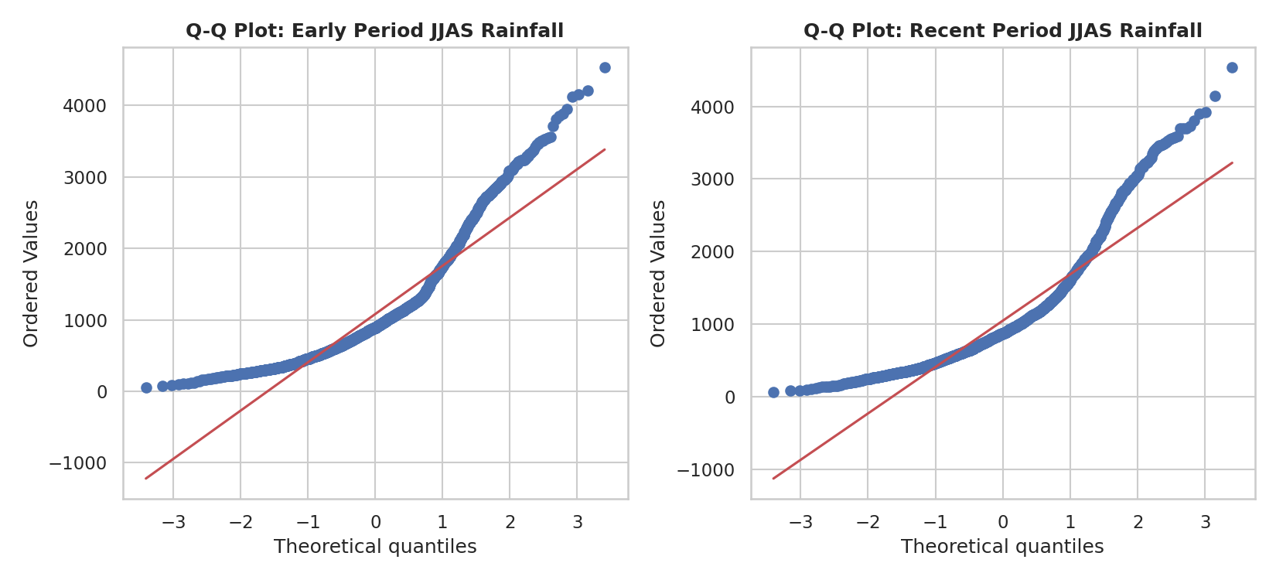
Figure 5. Q-Q plots assessing normality of JJAS rainfall for each period.
Both Q-Q plots curve away from the reference line at the upper tail, confirming the right-skew typical of rainfall data (a small number of very wet years). Levene's test (p = 0.031) indicated the two periods' variances are not equal, which is why Welch's t-test (robust to unequal variances) was used instead of the standard Student's t-test.

4. Conclusions and Implications
- Primary finding: Monsoon rainfall totals have not changed significantly between 1901-1960 and 1961-2017 (p = 0.136). Long-term average monsoon intensity is statistically stable, which argues against building flood models around an assumed long-term intensification trend.
- Secondary finding: Extreme monsoon years show a statistically detectable but practically negligible difference between periods (p = 0.032, Cramer's V = 0.033) — not strong enough evidence to claim rising extremes nationally.
- Third finding: Region is overwhelmingly the dominant driver of monsoon rainfall (eta squared = 0.86, p < 0.001), far outweighing any time-based effect. This statistically confirms that subdivision-level (not national) modeling is the right approach for the flash-flood early-warning system.
- Practical takeaway: Instead of asking 'is the monsoon intensifying everywhere,' the flash-flood project should treat each subdivision's historical rainfall distribution as its own stable baseline and focus modeling effort on detecting real-time deviations from that regional baseline, rather than a shifting national one.

5. Tools and Effort
- Python 3, Pandas, NumPy for data preparation; SciPy (ttest_ind, chi2_contingency, f_oneway, shapiro, levene, probplot) for hypothesis testing; statsmodels (pairwise_tukeyhsd) for post-hoc analysis; Matplotlib/Seaborn for visualization
- Estimated time: hypothesis formulation and methodology design (~5h), analysis and test execution (~12h), visualization (~8h), documentation (~8h) — within the 30-35 hour guideline

