Supplementary Appendix

Details of Statistical Analysis

Covariate Selection
As mentioned in the primary manuscript, we constructed directed acyclic graphs (DAGs) to facilitate covariate selection. DAGs are graphical models used to represent causal relationships between variables. They consist of nodes (representing variables) and directed arrows (representing causal influences). DAGs can help minimize several sources of bias that are inherent in many observational studies, such as confounding bias and selection bias. When constructed with subject-matter knowledge, they can provide a framework for making causal inferences from observational data. Specifically, they can help researchers with three key benefits:
- Identify minimal adjustment sets: Determine the smallest set of variables to control for to estimate the causal effect of an exposure on an outcome.
- Avoid over-adjustment: Prevent controlling for variables that are mediators or colliders, which can bias the results.
- Clarify causal assumptions: Make the underlying causal assumptions explicit and transparent¹.
In constructing DAGs for this project, we used guidance and recommendations from previous literature^{2–4}.

Primary and Secondary Outcomes
For our primary outcome model we specified the following DAG:
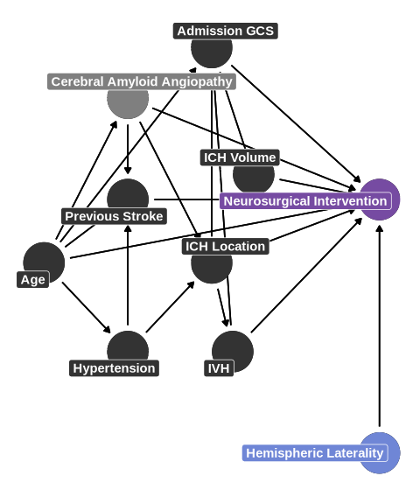
Before considering if covariate adjustment is indicated for our outcome of interest, we need to establish the difference between the total, direct, and indirect effect of hemispheric laterality on neurosurgical intervention and the effect with which we are interested.²
The total effect of hemispheric laterality (X) on neurosurgical intervention (Y) refers to the overall influence of X on Y, regardless of the mechanisms through which that influence operates. It is the effect we would observe if we simply compared outcomes between patients with left vs. right hemispheric ICH without controlling for any variables.
The direct effect of X on Y refers to the influence of X on Y that is not mediated by any other variables in the DAG. It is the effect of hemispheric laterality on neurosurgical intervention that remains after holding all mediating variables constant.
The indirect effect of X on Y refers to the influence of X on Y that is mediated by one or more intermediate variables. It is the effect of hemispheric laterality on neurosurgical intervention that operates through other variables in the DAG.
We were interested in the direct effect of hemispheric laterality on neurosurgical intervention. We hypothesized that this relationship could be mediated by other variables that are commonly used to determine if a patient will undergo neurosurgical intervention. To estimate this effect, we included to the following covariates in our statistical model for the primary outcome: age, admission GCS, ICH location, ICH volume, and presence of IVH.
Since we felt that there were not materially different causal structures at play with our secondary outcomes, we used a similar DAG for the following outcomes: receipt of external ventricular drain (EVD), receipt of tracheostomy, days of mechanical ventilation, receipt of do-not-resuscitate (DNR) order at any point in the hospitalization, withdrawal of life-sustaining therapy (WLST) at any point in the hospitalization, and early WLST (defined as < 72 from symptom onset). We included the same covariates in our statistical models for all secondary outcomes specified above.

Functional Outcomes
We specified the following DAG when examining functional outcomes (e.g., modified Rankin Scale and EuroQOL measures):
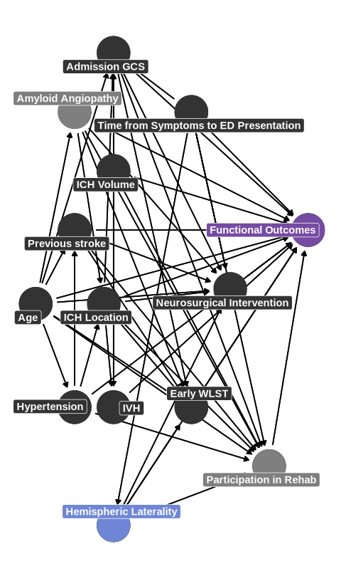
We are again interested in the direct effect of hemispheric laterality on functional outcomes, independent of the influence of neurosurgical intervention. Therefore, our statistical models for functional outcomes were adjusted for age, admission GCS, ICH location, ICH volume, presence of IVH, and neurosurgical intervention. This approach allows us to isolate the prognostic significance of the affected hemisphere on functional outcomes.

Priors

Prior Distribution Definitions
In defining prior distributions, we generally followed suggestions from previous literature.^{5–7} Specifically, we defined 4 sets of priors for each outcome:
Neutral prior: This prior assumed that hemispheric lateralization did not significantly affect the primary outcome and represents the null hypothesis. It is centered around a mean of 0 and standard deviation of 0.35, corresponding to OR of 1 and 95% of the probability mass for the OR between 0.5 to 1.99.
Left hemisphere prior: This prior assumes that the primary and secondary outcomes are more likely with left hemisphere injury, centering around a mean of -0.22 and standard deviation of 0.175 which corresponds to an OR of 0.8 and 95% of the probability mass for the OR between 0.57 to 1.13.
Right hemisphere prior: This prior assumes that the primary and secondary outcomes are more likely with right hemisphere injury, centering around a mean of 0.18 and standard deviation of 0.175 which corresponds to an OR of 1.2 and 95% of the probability mass for the OR between 0.85 to 1.69.
Flat prior: This prior most mimics a frequentist analysis in that the prior distribution is so wide that it essentially contributes no information to the posterior model. It is centered around a mean of 0 and standard deviation of standard deviation of 5 which corresponds to an OR of 1 and 95% of the probability mass for the OR between 0 to 1.8033745^{4}.

Prior Predictive Checks
Prior predictive checks were performed to understand the implications of the prior distributions before analyzing the data and ensuring the prior distributions represented plausible information regarding each outcome.

Neurosurgical Intervention
Table 1: Prior predictive check results for neurosurgery
Table 1: Prior Predictive Checks
Type of Prior | Left Hemisphere | Right Hemisphere | aOR | Lower 95% Credible Interval | Upper 95% Credible Interval | Probability of Difference (aOR >1)¹ | % of Distribution outside of ROPE
Neutral | 21.8% | 23.2% | 0.99 | 0.38 | 2.67 | 0.49 | 0.92
Left Hemisphere | 14.4% | 11.8% | 0.80 | 0.57 | 1.12 | 0.90 | 0.89
Right Hemisphere | 10.8% | 13.8% | 1.19 | 0.85 | 1.68 | 0.85 | 0.87
Flat | 50.1% | 50.2% | 1.01 | 0.00 | 16,135 | 0.50 | 0.99
¹For left hemisphere prior, the p(aOR) < 1 is shown

Ventriculostomy
Table 2: Prior predictive check results for ventriculostomy
Table 1: Prior Predictive Checks
Type of Prior | Left Hemisphere | Right Hemisphere | aOR | Lower 95% Credible Interval | Upper 95% Credible Interval | Probability of Difference (aOR >1)¹ | % of Distribution outside of ROPE
Neutral | 49.9% | 49.9% | 1.00 | 0.50 | 2.00 | 0.50 | 0.88
Left Hemisphere | 60.7% | 55.8% | 0.80 | 0.57 | 1.13 | 0.90 | 0.90
Right Hemisphere | 40.4% | 44.8% | 1.20 | 0.85 | 1.68 | 0.84 | 0.87
Flat | 50.1% | 50.2% | 1.01 | 0.00 | 16,135 | 0.50 | 0.99
¹For left hemisphere prior, the p(aOR) < 1 is shown

Tracheostomy
Table 3: Prior predictive check results for tracheostomy
Table 1: Prior Predictive Checks
Type of Prior | Left Hemisphere | Right Hemisphere | aOR | Lower 95% Credible Interval | Upper 95% Credible Interval | Probability of Difference (aOR >1)¹ | % of Distribution outside of ROPE
Neutral | 2.2% | 2.5% | 1.00 | 0.50 | 2.00 | 0.50 | 0.89
Left Hemisphere | 0.2% | 0.1% | 0.80 | 0.57 | 1.14 | 0.89 | 0.90
Right Hemisphere | 2.1% | 2.9% | 1.20 | 0.85 | 1.69 | 0.85 | 0.87
Flat | 50.1% | 50.2% | 1.01 | 0.00 | 16,135 | 0.50 | 0.99
¹For left hemisphere prior, the p(aOR) < 1 is shown

Days of Mechanical Ventilation
Table 4: Prior predictive check results for days of mechanical ventilation
Table 1: Prior Predictive Checks
Type of Prior | aOR | Lower 95% Credible Interval | Upper 95% Credible Interval | Probability of Difference (aOR >1)¹ | % of Distribution outside of ROPE
Neutral | 1.00 | 0.50 | 1.98 | 0.50 | 0.89
Left Hemisphere | 0.80 | 0.57 | 1.14 | 0.89 | 0.89
Right Hemisphere | 1.20 | 0.85 | 1.68 | 0.85 | 0.86
Flat | 0.92 | 0.00 | 16,547.34 | 0.49 | 0.99
¹For left hemisphere prior, the p(aOR) < 1 is shown

Comfort Care
Table 5: Prior predictive check results for comfort care
Table 1: Prior Predictive Checks
Type of Prior | Left Hemisphere | Right Hemisphere | aOR | Lower 95% Credible Interval | Upper 95% Credible Interval | Probability of Difference (aOR >1)¹ | % of Distribution outside of ROPE
Neutral | 2.2% | 2.5% | 1.00 | 0.50 | 2.00 | 0.50 | 0.89
Left Hemisphere | 0.2% | 0.1% | 0.80 | 0.57 | 1.14 | 0.89 | 0.90
Right Hemisphere | 2.1% | 2.9% | 1.20 | 0.85 | 1.69 | 0.85 | 0.87
Flat | 50.1% | 50.2% | 1.01 | 0.00 | 16,135 | 0.50 | 0.99
¹For left hemisphere prior, the p(aOR) < 1 is shown

Early WLST
Table 6: Prior predictive check results for early WLST
Table 1: Prior Predictive Checks
Type of Prior | Left Hemisphere | Right Hemisphere | aOR | Lower 95% Credible Interval | Upper 95% Credible Interval | Probability of Difference (aOR >1)¹ | % of Distribution outside of ROPE
Neutral | 0.3% | 0.3% | 1.00 | 0.50 | 2.01 | 0.50 | 0.89
Left Hemisphere | 0.0% | 0.0% | 0.80 | 0.57 | 1.13 | 0.90 | 0.89
Right Hemisphere | 0.9% | 1.1% | 1.19 | 0.85 | 1.70 | 0.85 | 0.87
Flat | 50.1% | 50.2% | 1.01 | 0.00 | 16,135 | 0.50 | 0.99
¹For left hemisphere prior, the p(aOR) < 1 is shown

DNR
Table 7: Prior predictive check results for DNR
Table 1: Prior Predictive Checks
Type of Prior | Left Hemisphere | Right Hemisphere | aOR | Lower 95% Credible Interval | Upper 95% Credible Interval | Probability of Difference (aOR >1)¹ | % of Distribution outside of ROPE
Neutral | 2.2% | 2.5% | 1.00 | 0.50 | 2.00 | 0.50 | 0.89
Left Hemisphere | 0.2% | 0.1% | 0.80 | 0.57 | 1.14 | 0.89 | 0.90
Right Hemisphere | 2.1% | 2.9% | 1.20 | 0.85 | 1.69 | 0.85 | 0.87
Flat | 50.1% | 50.2% | 1.01 | 0.00 | 16,135 | 0.50 | 0.99
¹For left hemisphere prior, the p(aOR) < 1 is shown

mRS 90
Table 8: Prior predictive check results for modified Rankin score at 90 days
Table 1: Prior Predictive Checks
Type of Prior | aOR | Lower 95% Credible Interval | Upper 95% Credible Interval | Probability of Difference (aOR >1)¹ | % of Distribution outside of ROPE
Neutral | 0.99 | 0.14 | 7.28 | 0.50 | 0.96
Left Hemisphere | 0.80 | 0.57 | 1.13 | 0.90 | 0.90
Right Hemisphere | 1.20 | 0.85 | 1.68 | 0.85 | 0.86
Flat | 1.00 | 0.00 | 17,557.92 | 0.50 | 0.99
¹For left hemisphere prior, the p(aOR) < 1 is shown

EuroOOL Mobility 90
Table 9: Prior predictive check results for EuroQOL - Mobility at 90 days
Table 1: Prior Predictive Checks
Type of Prior | aOR | Lower 95% Credible Interval | Upper 95% Credible Interval | Probability of Difference (aOR >1)¹ | % of Distribution outside of ROPE
Neutral | 0.99 | 0.14 | 7.12 | 0.50 | 0.96
Left Hemisphere | 0.80 | 0.57 | 1.13 | 0.90 | 0.90
Right Hemisphere | 1.19 | 0.85 | 1.68 | 0.85 | 0.87
Flat | 0.95 | 0.00 | 15,252.07 | 0.50 | 0.99
¹For left hemisphere prior, the p(aOR) < 1 is shown

EuroOOL Self-Care 90
Table 10: Prior predictive check results for EuroQOL - Self-Care at 90 days
Table 1: Prior Predictive Checks
Type of Prior | aOR | Lower 95% Credible Interval | Upper 95% Credible Interval | Probability of Difference (aOR >1)¹ | % of Distribution outside of ROPE
Neutral | 0.99 | 0.14 | 7.12 | 0.50 | 0.96
Left Hemisphere | 0.80 | 0.57 | 1.13 | 0.90 | 0.90
Right Hemisphere | 1.19 | 0.85 | 1.68 | 0.85 | 0.87
Flat | 0.95 | 0.00 | 15,252.07 | 0.50 | 0.99
¹For left hemisphere prior, the p(aOR) < 1 is shown

EuroOOL Usual Activities 90
Table 11: Prior predictive check results for EuroQOL - Usual Activities at 90 days
Table 1: Prior Predictive Checks
Type of Prior | aOR | Lower 95% Credible Interval | Upper 95% Credible Interval | Probability of Difference (aOR >1)¹ | % of Distribution outside of ROPE
Neutral | 0.99 | 0.14 | 7.12 | 0.50 | 0.96
Left Hemisphere | 0.80 | 0.57 | 1.13 | 0.90 | 0.90
Right Hemisphere | 1.19 | 0.85 | 1.68 | 0.85 | 0.87
Flat | 0.95 | 0.00 | 15,252.07 | 0.50 | 0.99
¹For left hemisphere prior, the p(aOR) < 1 is shown

EuroOOL Pain/Discomfort 90
Table 12: Prior predictive check results for EuroQOL - Pain/Discomfort at 90 days
Table 1: Prior Predictive Checks
Type of Prior | aOR | Lower 95% Credible Interval | Upper 95% Credible Interval | Probability of Difference (aOR >1)¹ | % of Distribution outside of ROPE
Neutral | 0.99 | 0.14 | 7.12 | 0.50 | 0.96
Left Hemisphere | 0.80 | 0.57 | 1.13 | 0.90 | 0.90
Right Hemisphere | 1.19 | 0.85 | 1.68 | 0.85 | 0.87
Flat | 0.95 | 0.00 | 15,252.07 | 0.50 | 0.99
¹For left hemisphere prior, the p(aOR) < 1 is shown

EuroOOL Anxiety/Depression 90
Table 13
Table 1: Prior Predictive Checks
Type of Prior | aOR | Lower 95% Credible Interval | Upper 95% Credible Interval | Probability of Difference (aOR >1)¹ | % of Distribution outside of ROPE
Neutral | 0.99 | 0.14 | 7.12 | 0.50 | 0.96
Left Hemisphere | 0.80 | 0.57 | 1.13 | 0.90 | 0.90
Right Hemisphere | 1.19 | 0.85 | 1.68 | 0.85 | 0.87
Flat | 0.95 | 0.00 | 15,252.07 | 0.50 | 0.99
¹For left hemisphere prior, the p(aOR) < 1 is shown

EuroOOL VAS 90
Table 14: Prior predictive check results for EuroQOL - VAS at 90 days
Table 1: Prior Predictive Checks
Type of Prior | aOR | Lower 95% Credible Interval | Upper 95% Credible Interval | Probability of Difference (aOR >1)¹ | % of Distribution outside of ROPE
Neutral | 0.99 | 0.14 | 7.12 | 0.50 | 0.96
Left Hemisphere | 0.80 | 0.57 | 1.13 | 0.90 | 0.90
Right Hemisphere | 1.19 | 0.85 | 1.68 | 0.85 | 0.87
Flat | 0.95 | 0.00 | 15,252.07 | 0.50 | 0.99
¹For left hemisphere prior, the p(aOR) < 1 is shown

Posterior Simulation Diagnostics
Posterior Simulation Checks To ensure the reliability and validity of our Bayesian models, we performed several posterior simulation checks.
Chain Convergence: We assessed the convergence of the Markov Chain Monte Carlo (MCMC) chains by visually inspecting trace plots for each parameter. The trace plots showed that the chains were well-mixed and stationary, indicating that they had converged to a stable posterior distribution. Additionally, we calculated the R-hat statistic for all parameters, ensuring that all values were below 1.01, which confirms the convergence of the chains.
Posterior Predictive Checks: We conducted posterior predictive checks to evaluate the model’s fit to the data. This involved simulating data from the posterior predictive distribution and comparing it to the observed data. The close correspondence between the simulated and observed data confirmed that our models provided a good fit to the underlying data structure.

MCMC Chain Convergence and Resolution

Neurosurgical Intervention
Table 15: Posterior diagnostic checks for Neurosurgical Intervention
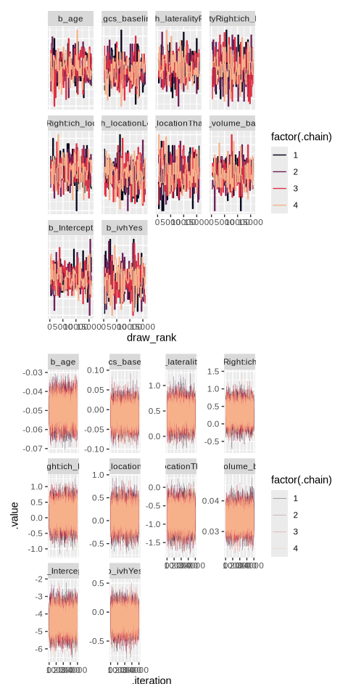

Ventriculostomy
Table 16: Posterior diagnostic checks for Ventriculostomy
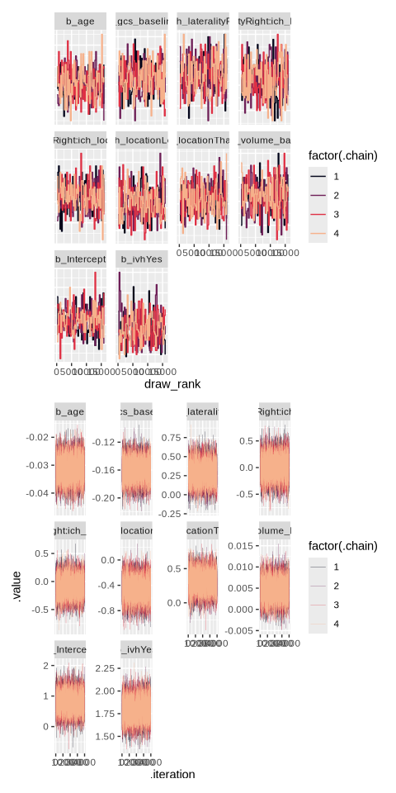

Tracheostomy
Table 17: Posterior diagnostic checks for Tracheostomy
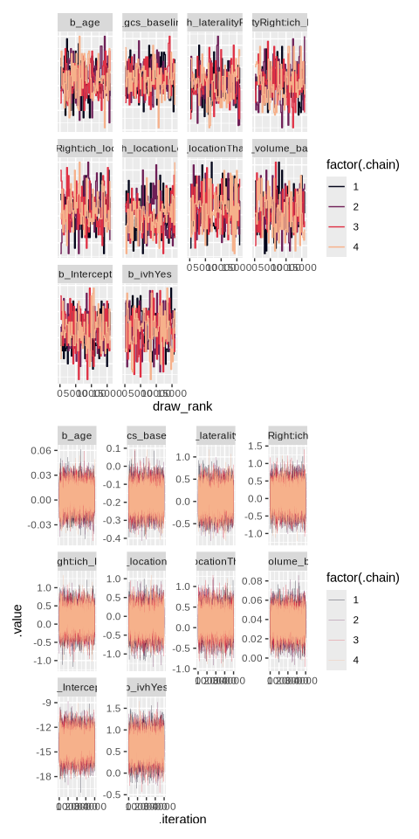

Days of Mechanical Ventilation
Table 18: Posterior diagnostic checks for Days of Mechanical ventilation
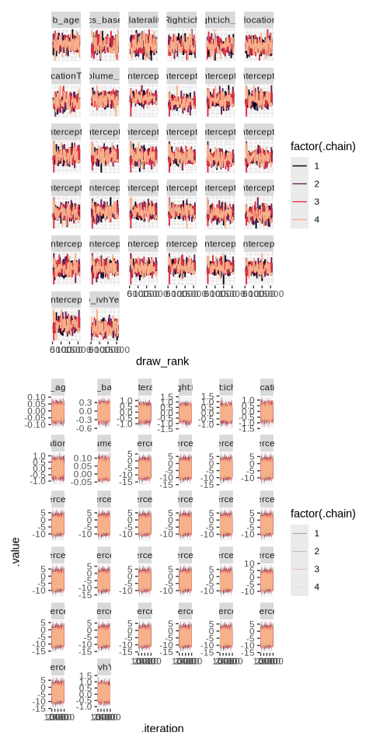

Comfort Care
Table 19: Posterior diagnostic checks for comfort care
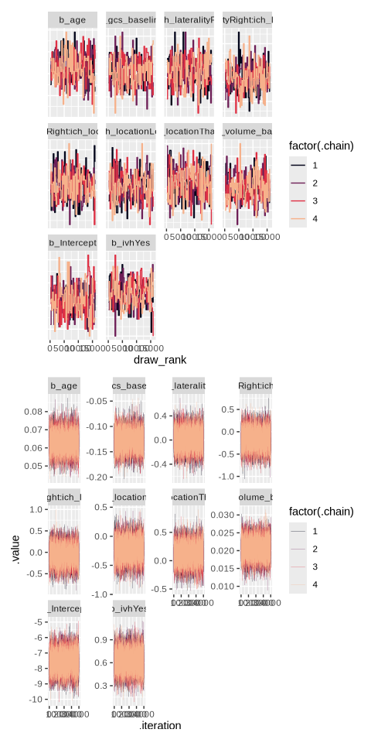

Early WLST
Table 20: Posterior diagnostic checks for early WLST
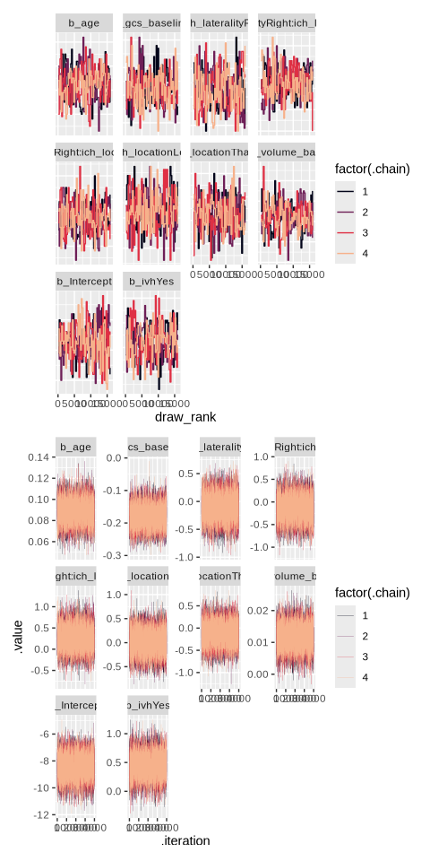

DNR
Table 21: Posterior diagnostic checks for DNR
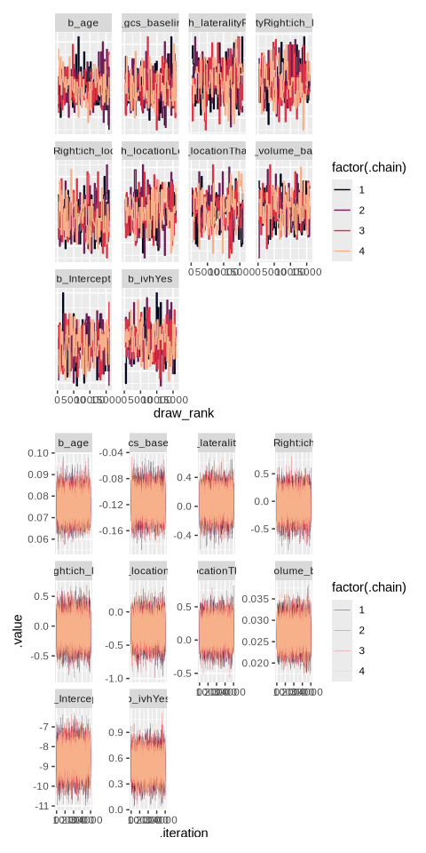

mRS 90
Table 22: Posterior diagnostic checks for modified Rankin score at 90 days
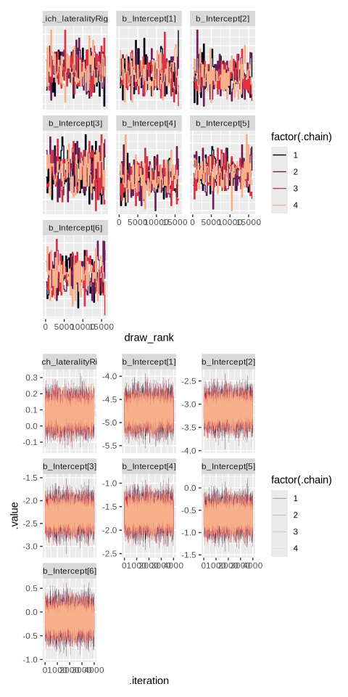

EuroQOL Mobility 90
Table 23: Posterior diagnostic checks for EuroQOL - Mobility at 90 days
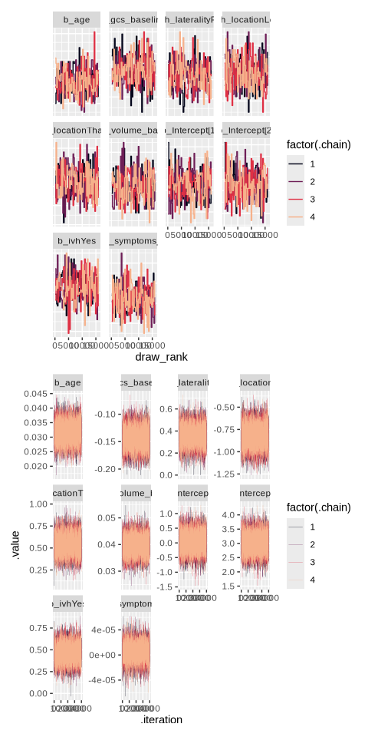

EuroQOL Self-Care 90
Table 24: Posterior diagnostic checks for EuroQOL - Self-Care at 90 days
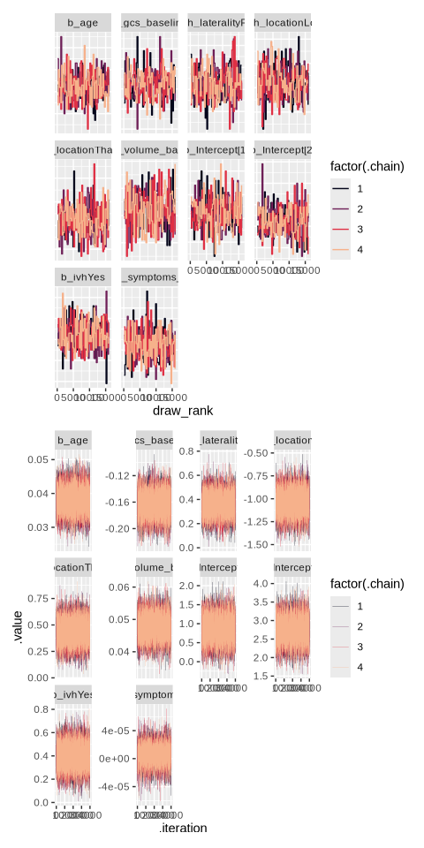

EuroQOL Usual Activities 90
Table 25
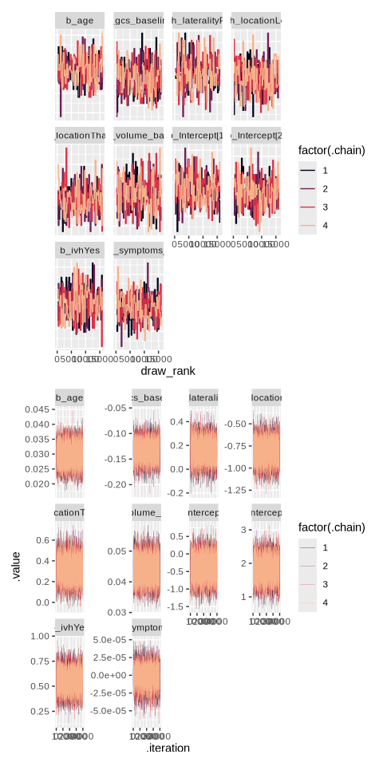

EuroQOL Pain/Discomfort 90
Table 26: Posterior diagnostic checks for EuroQOL - Pain/Discomfort at 90 days
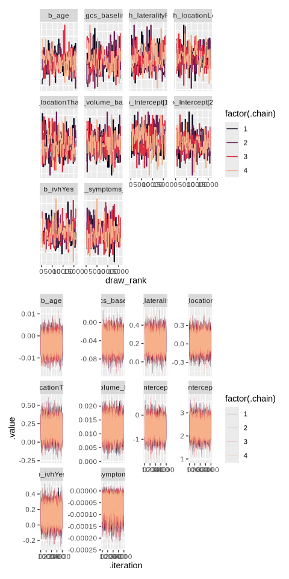

EuroQOL Anxiety/Depression 90
Table 27: Posterior diagnostic checks for EuroQOL - Anxiety/Depression at 90 days
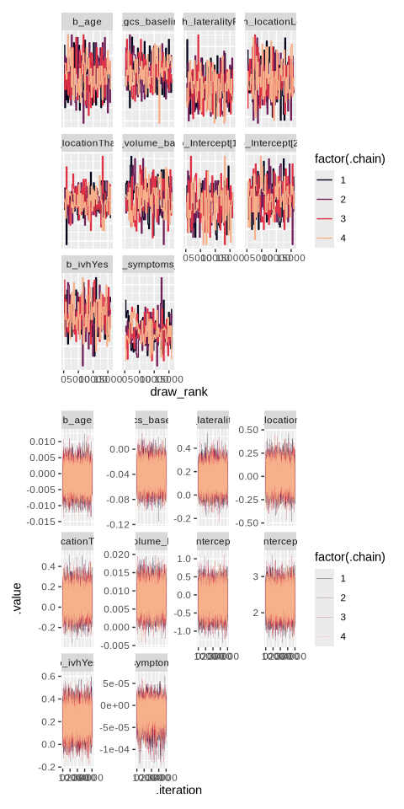

EuroQOL VAS 90
Table 28: Posterior diagnostic checks for EuroQOL - VAS at 90 days
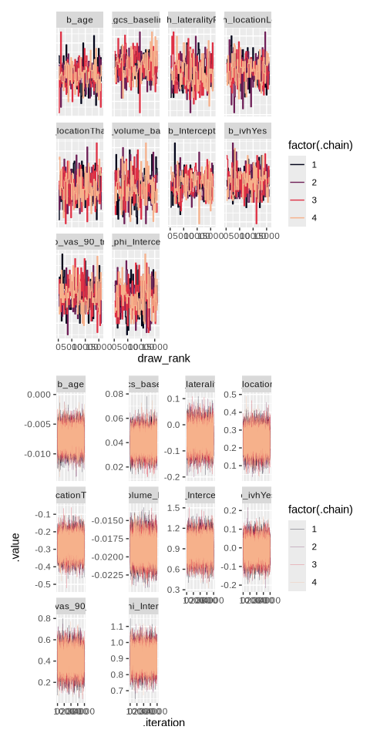

Posterior predictive checks

Neurosurgical Intervention
Table 29: Posterior predictive checks for neurosurgical intervention
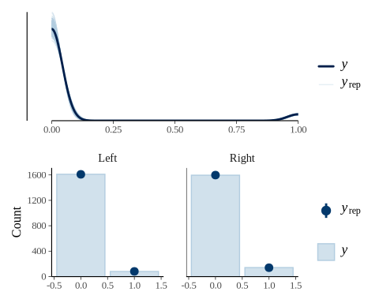

Ventriculostomy
Table 30: Posterior diagnostic checks for ventriculostomy
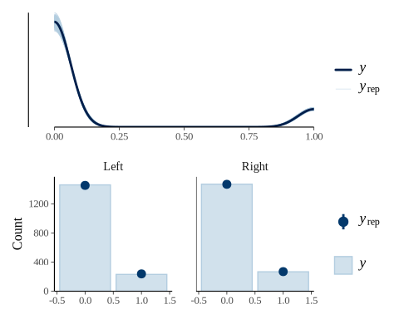

Tracheostomy
Table 31: Posterior diagnostic checks for tracheostomy
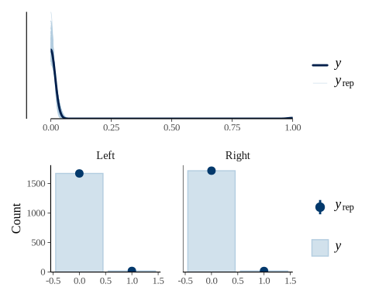

Days of Mechanical Ventilation
Table 32: Posterior diagnostic checks for days of mechanical ventilation
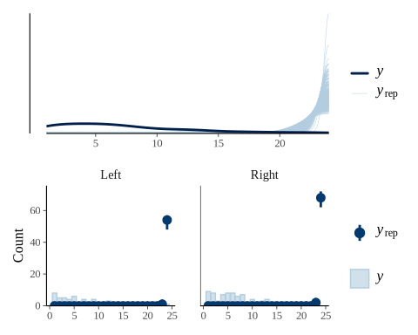

Comfort Care
Table 33: Posterior diagnostic checks for comfort care
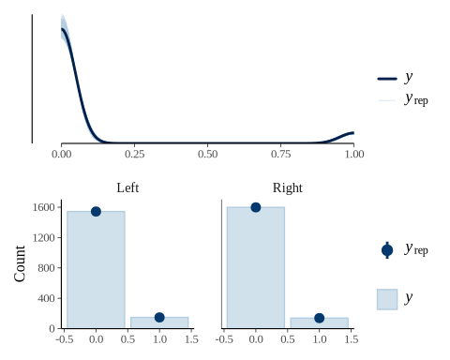

Early WLST
Table 34: Posterior diagnostic checks for early WLST
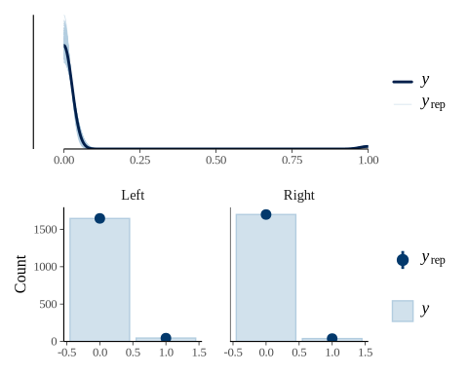

DNR
Table 35: Posterior diagnostic checks for DNR
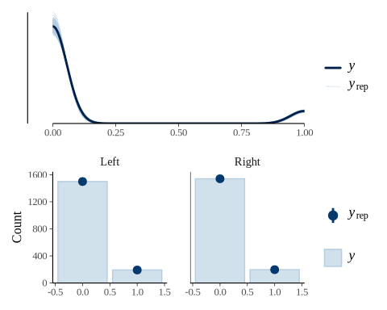

mRS 90
Table 36: Posterior diagnostic checks for modified Rankin Score 90 days
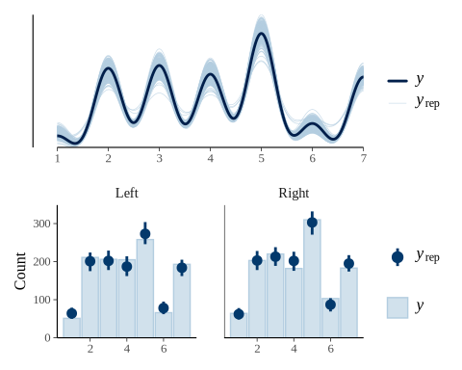

EuroQOL Moblity 90
Table 37: Posterior diagnostic checks for EuroQOL - Mobility 90 days
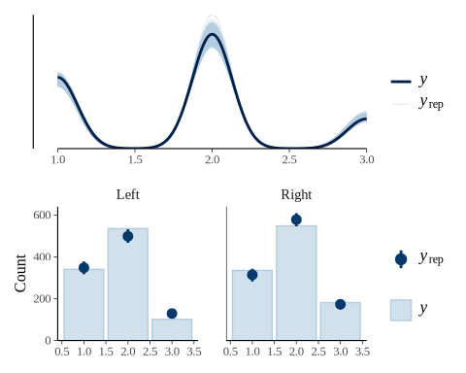

EuroQOL Self-Care 90
Table 38: Posterior diagnostic checks for EuroQOL - Self-Care 90 days
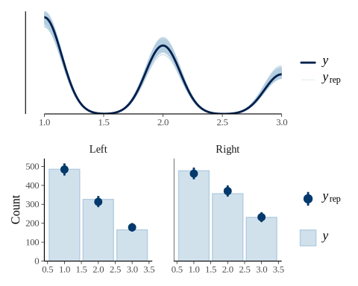

EuroQOL Usual Activities 90
Table 39: Posterior diagnostic checks for EuroQOL - Usual Activities 90 days
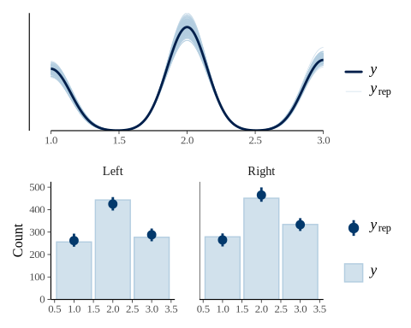

EuroQOL Pain/Discomfort 90
Table 40: Posterior diagnostic checks for EuroQOL - Pain/Discomfort 90 days
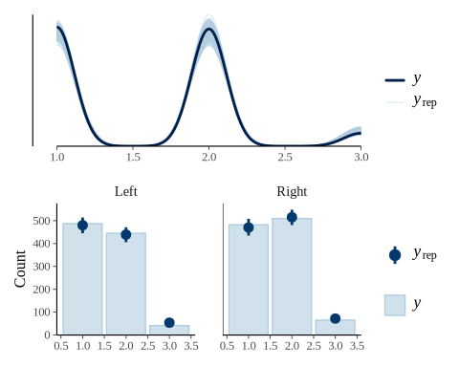

EuroQOL Anxiety/Despression 90
Table 41: Posterior diagnostic checks for EuroQOL - Anxiety/Depression 90 days
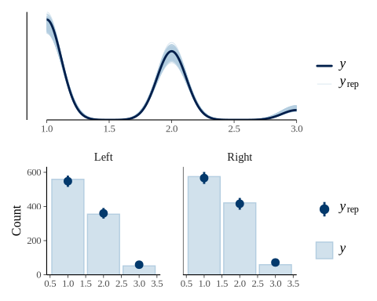

EuroQOL VAS 90
Table 42: Posterior diagnostic checks for EuroQOL - VAS 90 days
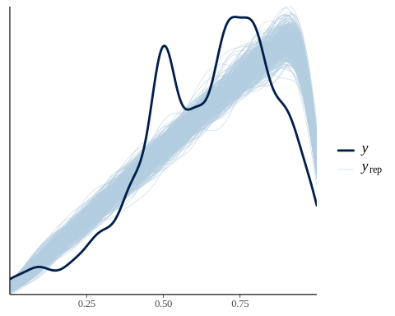

Sensitivity Analyses
To assess the robustness of our findings for the primary outcome, we conducted several sensitivity analyses. First, we repeated the primary analysis using three alternative prior distributions: a left-hemisphere prior, a right-hemisphere prior, and a flat (minimally informative) prior. This allowed us to evaluate the influence of different initial beliefs on the resulting posterior distributions. Second, we explored an alternative covariate adjustment set based on a minimal adjustment set identified from our directed acyclic graphs (DAGs) to ensure our results were not dependent on the specific model specification. Finally, we employed an alternative method for handling missing data to confirm that our findings were not unduly influenced by the imputation strategy used in the primary analysis. The results of these sensitivity analyses were consistent with our primary findings, demonstrating the robustness of our conclusions.

Table 2 with Different Priors

Left Hemisphere Prior
Table 43
Outcome | Left Hemisphere | Right Hemisphere | aOR (95% CI)¹ | Probability of any difference (aOR > 1) | Probability of a substantial difference (aOR > 1.2) | ROPE²
Neurosurgical Intervention | 86 (5.0%) | 144 (8.2%) | 1.26 (0.99 - 1.6) | 0.97 | 0.65 | 0.06
External Ventricular Drain | 236 (13.7%) | 272 (15.5%) | 1.18 (0.96 - 1.45) | 0.95 | 0.44 | 0.11
Days of Mechanical Ventilation | 6 (3 - 12)³ | 6 (3 - 9)³ | 0.81 (0.58 - 1.13) | 0.10 | 0.01 | 0.11
Tracheostomy | 19 (1.1%) | 19 (1.1%) | 0.89 (0.65 - 1.21) | 0.22 | 0.03 | 0.19
Withdrawal of Life-Sustaining Therapy | 152 (8.8%) | 143 (8.1%) | 0.95 (0.75 - 1.2) | 0.33 | 0.02 | 0.30
Early Withdrawal of Life-Sustaining Therapy | 45 (2.6%) | 39 (2.2%) | 0.87 (0.66 - 1.16) | 0.17 | 0.01 | 0.17
DNR Order | 195 (11.3%) | 202 (11.5%) | 1 (0.8 - 1.25) | 0.50 | 0.05 | 0.34
¹aOR = adjusted odds ratio, CI = 95% credible interval; adjusted for age, admission GCS, ICH location, ICH volume, IVH, and study (as random intercept); Reference Category: Left Hemisphere Laterality
²ROPE = region of practical equivalence, defined as 0.95 > aOR > 1.05
³median (IQR)

Right Hemisphere Prior
Table 44
Outcome | Left Hemisphere | Right Hemisphere | aOR (95% CI)¹ | Probability of any difference (aOR > 1) | Probability of a substantial difference (aOR > 1.2) | ROPE²
Neurosurgical Intervention | 86 (5.0%) | 144 (8.2%) | 1.4 (1.1 - 1.79) | 1.00 | 0.90 | 0.01
External Ventricular Drain | 236 (13.7%) | 272 (15.5%) | 1.24 (1.01 - 1.52) | 0.98 | 0.62 | 0.05
Days of Mechanical Ventilation | 6 (3 - 12)³ | 6 (3 - 9)³ | 1.15 (0.83 - 1.62) | 0.80 | 0.40 | 0.16
Tracheostomy | 19 (1.1%) | 19 (1.1%) | 1.16 (0.85 - 1.57) | 0.82 | 0.41 | 0.16
Withdrawal of Life-Sustaining Therapy | 152 (8.8%) | 143 (8.1%) | 1.01 (0.81 - 1.28) | 0.55 | 0.08 | 0.33
Early Withdrawal of Life-Sustaining Therapy | 45 (2.6%) | 39 (2.2%) | 1.04 (0.79 - 1.39) | 0.61 | 0.17 | 0.26
DNR Order | 195 (11.3%) | 202 (11.5%) | 1.05 (0.84 - 1.32) | 0.68 | 0.13 | 0.31
¹aOR = adjusted odds ratio, CI = 95% credible interval; adjusted for age, admission GCS, ICH location, ICH volume, IVH, and study (as random intercept); Reference Category: Left Hemisphere Laterality
²ROPE = region of practical equivalence, defined as 0.95 > aOR > 1.05
³median (IQR)

Flat Prior
Table 45
Outcome | Left Hemisphere | Right Hemisphere | aOR (95% CI)¹ | Probability of any difference (aOR > 1) | Probability of a substantial difference (aOR > 1.2) | ROPE²
Neurosurgical Intervention | 86 (5.0%) | 144 (8.2%) | 1.45 (0.91 - 2.3) | 0.94 | 0.79 | 0.05
External Ventricular Drain | 236 (13.7%) | 272 (15.5%) | 1.45 (0.99 - 2.12) | 0.97 | 0.83 | 0.04
Days of Mechanical Ventilation | 6 (3 - 12)³ | 6 (3 - 9)³ | 0.58 (0.05 - 5.47) | 0.32 | 0.27 | 0.03
Tracheostomy | 19 (1.1%) | 19 (1.1%) | 0.87 (0.27 - 2.62) | 0.40 | 0.28 | 0.07
Withdrawal of Life-Sustaining Therapy | 152 (8.8%) | 143 (8.1%) | 1.12 (0.68 - 1.89) | 0.67 | 0.39 | 0.14
Early Withdrawal of Life-Sustaining Therapy | 45 (2.6%) | 39 (2.2%) | 0.53 (0.18 - 1.38) | 0.10 | 0.05 | 0.04
DNR Order | 195 (11.3%) | 202 (11.5%) | 1.11 (0.7 - 1.78) | 0.67 | 0.38 | 0.15
¹aOR = adjusted odds ratio, CI = 95% credible interval; adjusted for age, admission GCS, ICH location, ICH volume, IVH, and study (as random intercept); Reference Category: Left Hemisphere Laterality
²ROPE = region of practical equivalence, defined as 0.95 > aOR > 1.05
³median (IQR)

Table 4 with Different Priors

Left Hemisphere Prior
Table 46
Outcome | aOR (95% CI)¹ | Probability of any difference (aOR > 1) | Probability of a substantial difference (aOR > 1.2) | ROPE²
Modified Rankin Score | 1.12 (0.98 - 1.28) | 0.95 | 0.17 | 0.16
EuroQOL - Mobility | 1.29 (1.1 - 1.51) | 1.00 | 0.82 | 0.01
EuroQOL - Self-Care | 1.29 (1.1 - 1.51) | 1.00 | 0.81 | 0.01
EuroQOL - Usual Activities | 1.09 (0.94 - 1.28) | 0.87 | 0.12 | 0.27
EuroQOL - Pain/Discomfort | 1.15 (0.98 - 1.34) | 0.96 | 0.29 | 0.13
EuroQOL - Anxiety/Depression | 1.08 (0.92 - 1.27) | 0.84 | 0.10 | 0.30
Euro VAS | 0.95 (0.88 - 1.03) | 0.87³ | 0.00⁴ | 0.52
¹aOR = adjusted odds ratio, CI = 95% credible interval; adjusted for age, admission GCS, ICH location, ICH volume, IVH, and study (as random intercept); Reference Category: Left Hemisphere Laterality
²ROPE = region of practical equivalence, defined as 0.95 > aOR > 1.05
³Probability of aOR < 1
⁴Probability of aOR < 0.8

Right Hemisphere Prior
Table 47
Outcome | aOR (95% CI)¹ | Probability of any difference (aOR > 1) | Probability of a substantial difference (aOR > 1.2) | ROPE²
Modified Rankin Score | 1.18 (1.04 - 1.35) | 0.99 | 0.42 | 0.04
EuroQOL - Mobility | 1.39 (1.18 - 1.62) | 1.00 | 0.96 | 0.00
EuroQOL - Self-Care | 1.38 (1.18 - 1.62) | 1.00 | 0.96 | 0.00
EuroQOL - Usual Activities | 1.17 (1 - 1.37) | 0.98 | 0.40 | 0.08
EuroQOL - Pain/Discomfort | 1.23 (1.05 - 1.44) | 1.00 | 0.63 | 0.02
EuroQOL - Anxiety/Depression | 1.16 (1 - 1.36) | 0.97 | 0.35 | 0.10
Euro VAS | 0.95 (0.88 - 1.03) | 0.87³ | 0.00⁴ | 0.52
¹aOR = adjusted odds ratio, CI = 95% credible interval; adjusted for age, admission GCS, ICH location, ICH volume, IVH, and study (as random intercept); Reference Category: Left Hemisphere Laterality
²ROPE = region of practical equivalence, defined as 0.95 > aOR > 1.05
³Probability of aOR < 1
⁴Probability of aOR < 0.8

Flat Prior
Table 48
Outcome | aOR (95% CI)¹ | Probability of any difference (aOR > 1) | Probability of a substantial difference (aOR > 1.2) | ROPE²
Modified Rankin Score | 1.18 (1.01 - 1.37) | 0.98 | 0.40 | 0.06
EuroQOL - Mobility | 1.44 (1.2 - 1.73) | 1.00 | 0.98 | 0.00
EuroQOL - Self-Care | 1.44 (1.2 - 1.72) | 1.00 | 0.98 | 0.00
EuroQOL - Usual Activities | 1.17 (0.98 - 1.39) | 0.96 | 0.38 | 0.11
EuroQOL - Pain/Discomfort | 1.24 (1.05 - 1.48) | 0.99 | 0.65 | 0.03
EuroQOL - Anxiety/Depression | 1.16 (0.97 - 1.39) | 0.95 | 0.36 | 0.12
Euro VAS | 0.95 (0.88 - 1.03) | 0.87³ | 0.00⁴ | 0.52
¹aOR = adjusted odds ratio, CI = 95% credible interval; adjusted for age, admission GCS, ICH location, ICH volume, IVH, and study (as random intercept); Reference Category: Left Hemisphere Laterality
²ROPE = region of practical equivalence, defined as 0.95 > aOR > 1.05
³Probability of aOR < 1
⁴Probability of aOR < 0.8

Alternative Handling of Missing Data
The primary analysis was conducted as a complete case analysis. We performed multiple imputation by chained equations and created 100 imputed datasets with the mice package⁸. Three separate Bayesian models were fitted to the 100 imputed datasets using the following outcomes: neurosurgical intervention, external ventricular drain, and modified Rankin score at 90 days. All models were fitted using Markov Chain Monte Carlo (MCMC) with 4 chains and 5,000 iterations per chain (including a warmup period of 1,000 iterations).
Outcome | aOR (95% CI)¹ | Probability of any difference (aOR > 1) | Probability of a substantial difference (aOR > 1.2) | ROPE²
Neurosurgical Intervention | 1.51 (1.04 - 2.19) | 0.99 | 0.89 | 0.02
External Ventricular Drain | 1.34 (1.02 - 1.76) | 0.98 | 0.78 | 0.04
Modified Rankin Score | 1.2 (1.05 - 1.36) | 1.00 | 0.48 | 0.02
¹aOR = adjusted odds ratio, CI = 95% credible interval; adjusted for age, admission GCS, ICH location, ICH volume, IVH, and study (as random intercept)
²ROPE = region of practical equivalence, defined as 0.95 > aOR > 1.05
1. Hernán MA, Sauer BC, Hernández-Díaz S, Platt R, Shrier I. Specifying a target trial prevents immortal time bias and other self-inflicted injuries in observational analyses. Journal of Clinical Epidemiology. 2016;79:70–75.
2. Tennant PWG, Murray EJ, Arnold KF, Berrie L, Fox MP, Gadd SC, Harrison WJ, Keeble C, Ranker LR, Textor J, Tomova GD, Gilthorpe MS, Ellison GTH. Use of directed acyclic graphs (DAGs) to identify confounders in applied health research: Review and recommendations. International Journal of Epidemiology. 2021;50(2):620–632.
3. Sauer B, VanderWeele TJ. Use of Directed Acyclic Graphs. In: Developing a Protocol for Observational Comparative Effectiveness Research: A User’s Guide. Agency for Healthcare Research and Quality (US); 2013.
4. Barrett M, McGowan LD, Gerke T. Causal Inference in R.; 2025.
5. Zampieri FG, Casey JD, Shankar-Hari M, Harrell FE, Harhay MO. Using Bayesian Methods to Augment the Interpretation of Critical Care Trials. An Overview of Theory and Example Reanalysis of the Alveolar Recruitment for Acute Respiratory Distress Syndrome Trial. American Journal of Respiratory and Critical Care Medicine. 2021;203(5):543–552.
6. Kruschke JK. Bayesian Analysis Reporting Guidelines. Nature Human Behaviour. 2021;5(10):1282–1291.
7. Gelman A, Vehtari A, Simpson D, Margossian CC, Carpenter B, Yao Y, Kennedy L, Gabry J, Bürkner P-C, Modrák M. Bayesian Workflow. 2020.
8. Buuren SV, Groothuis-Oudshoorn K. Mice : Multivariate Imputation by Chained Equations in R. Journal of Statistical Software. 2011;45(3).

