SYSTEM DESIGN — INTERNAL
AI JIRA Story Generator
A conversational pipeline that turns raw meeting notes into validated, INVEST-scored JIRA stories using Claude, then pushes them to a JIRA Cloud project on request.
Status Working draft Updated 2026-07-14 Owner Nikhil Patil Runtime FastAPI + React (Vite) + Claude (Anthropic)
01 Overview
The app is a single chat surface backed by a small FastAPI service. A user pastes unstructured text — meeting notes, a feature idea — and an orchestrator agent decides, turn by turn, whether to ask a clarifying question, run the generation pipeline, revise a draft, or push approved stories to JIRA. Session state (conversation history, drafted stories, stage) lives in a single in-memory store keyed by session_id, so the whole system is one process with no database.
Story quality is enforced by a second loop inside generation: each requirement is drafted, scored by a validator agent against INVEST criteria, and refined automatically until it passes or a retry budget runs out — before the user ever sees it.
02 Request lifecycle
Every message from the client passes through POST /api/chat (app/main.py), which reads the session's current stage and dispatches to one of three branches.
gathering → reviewing → done
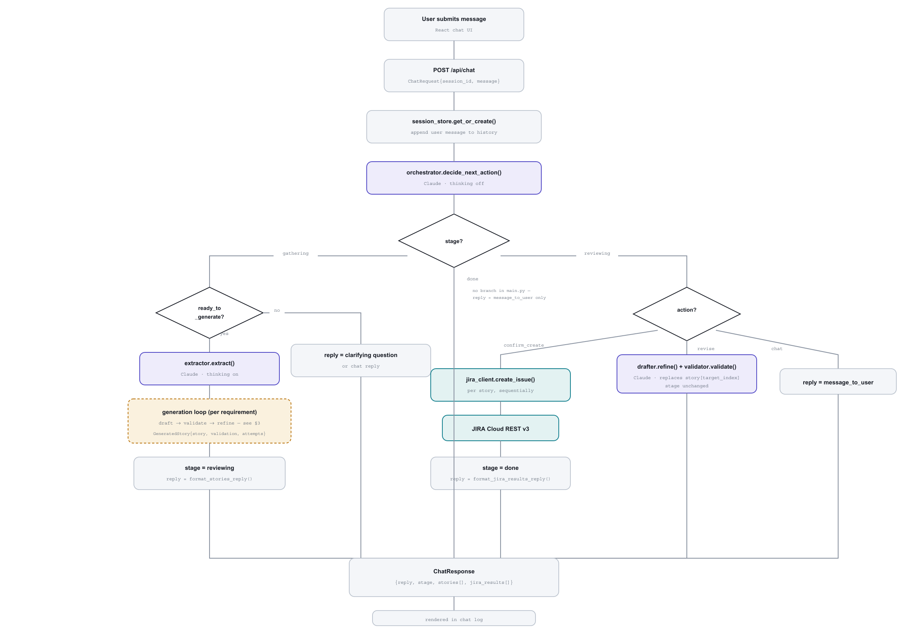
■ API / control flow ■ Claude call ■ external system (JIRA) ■ expands in §3
03 Generation sub-flow
app/pipeline.py::generate_stories() runs once per ready_to_generate decision, once per extracted requirement. This is the only automatic retry loop in the system.
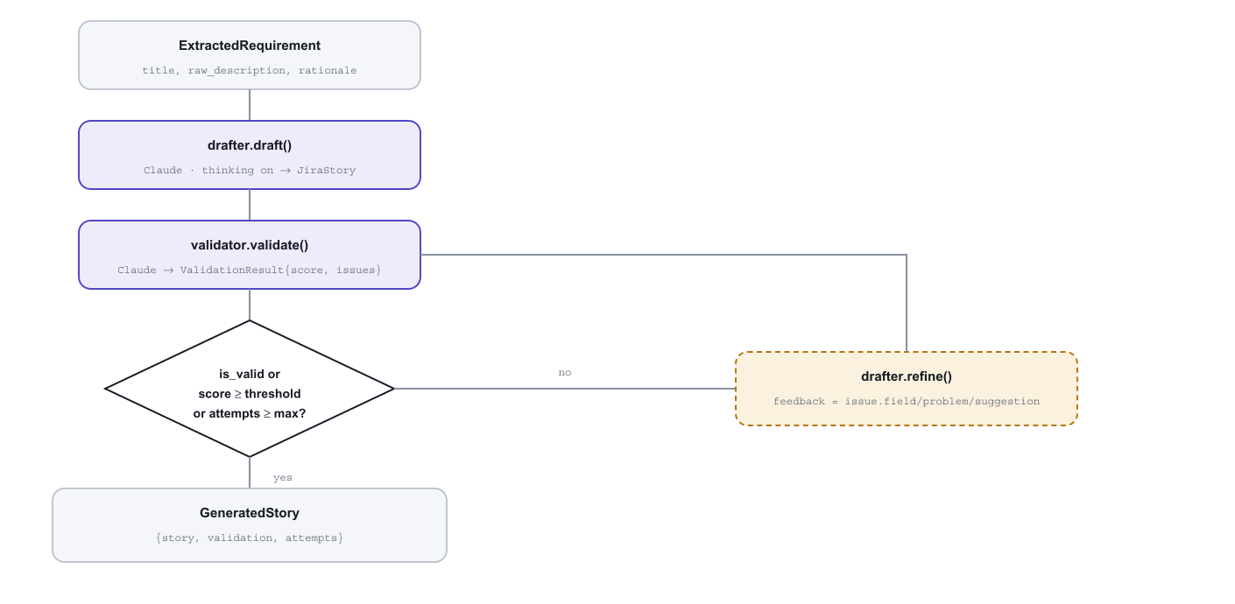
MAX_REFINEMENT_ATTEMPTS default 2 VALIDATION_PASS_SCORE default 75
A story can still exit with is_valid = false once attempts are exhausted — it is returned anyway, and format_stories_reply() flags it inline as needing a look before it's sprint-ready rather than blocking the reply.
04 Components
MODULE | RESPONSIBILITY | CALLS
app/main.py | FastAPI app; /api/chat, /api/reset, /health; stage dispatch; serves built frontend | orchestrator, pipeline, jira_client, session_store, formatting
app/agents/base.py | Shared structured_call() — wraps AsyncAnthropic().messages.parse() with a Pydantic output_format | Anthropic API
app/agents/orchestrator.py | Classifies the user's latest message into an action given the current stage | base.structured_call
app/agents/extractor.py | Splits raw text into independently deliverable requirements + open questions | base.structured_call
app/agents/drafter.py | Writes a JIRA story from a requirement (draft) or revises one from feedback (refine) | base.structured_call
app/agents/validator.py | Scores a story 0–100 against INVEST criteria, lists concrete issues | base.structured_call
app/pipeline.py | Runs extract → draft → validate → refine across all requirements | extractor, drafter, validator
app/services/jira_client.py | Builds ADF description, posts to JIRA Cloud REST v3 | JIRA Cloud REST API
app/services/session_store.py | In-memory dict[session_id, SessionState]; get-or-create / reset | —
app/formatting.py | Renders stories / JIRA results into chat-readable text | —
app/config.py | Loads .env; exposes model name, refinement/validation thresholds, JIRA credentials | —
05 Data model
Pydantic schemas in app/models/schemas.py, used directly as Claude's structured output format.
ExtractionResult  requirements: ExtractedRequirement[]  open_questions: string[] | JiraStory  summary: string ≤100c  user_story: As a / I want / so that  description: string  acceptance_criteria: string[3–6]  story_points: int | null  priority: Highest…Lowest  labels: string[]  issue_type: Story | Task | Bug
ValidationResult  is_valid: bool  score: int 0–100  issues: {field, problem, suggestion}[] | GeneratedStory  story: JiraStory  validation: ValidationResult  attempts: int
OrchestratorDecision  action: ask_clarification | ready_to_generate | confirm_create | revise | chat  message_to_user: string  target_story_index: int | null  revision_instructions: string | null | SessionState  id: uuid4  stage: gathering | reviewing | done  history: {role, content}[]  raw_text_parts: string[]  stories: GeneratedStory[]  jira_results: dict[]
06 Known constraints
- Single-process state. session_store is a module-level dict — sessions are lost on restart and not shared across multiple workers or instances.
- No auth on the API. /api/chat and /api/reset take a bare session_id with no ownership check.
- No explicit “done” handling. Once JIRA creation completes, later messages still reach the orchestrator but nothing in main.py acts on them — a new batch requires /api/reset.
- One JIRA project, one issue mapping. No epic linking; story points only get set if JIRA_STORY_POINTS_FIELD is configured for the target instance's custom field id.
- Secrets via .env. ANTHROPIC_API_KEY and JIRA_API_TOKEN load through dotenv — keep real values out of any checked-in example file.
Generated from the current state of the repository — regenerate after material changes to app/main.py, app/pipeline.py, or app/models/schemas.py.

