TestCo
Carbon Audit & ESG Sustainability Report

Executive Summary
This section covers Executive Summary for TestCo operating in the Steel sector. Based on the reported data, total Scope 1 emissions are 431.9 tCO2e, Scope 2 emissions are 3540.0 tCO2e, and Scope 3 (value chain) emissions are 6.0 tCO2e, yielding a combined footprint of 3977.9 tCO2e. Carbon intensity relative to annual revenue (USD 1,000,000.0) is 0.004 tCO2e per USD. Waste recycling rate stands at 60.0%. Female workforce representation is 40.0% and board diversity is 37.5%. The organisation is advised to implement a structured emission reduction roadmap aligned with GHG Protocol standards and ISO 14064 requirements to demonstrate continued commitment to environmental stewardship and regulatory compliance.

Company Overview
This section covers Company Overview for TestCo operating in the Steel sector. Based on the reported data, total Scope 1 emissions are 431.9 tCO2e, Scope 2 emissions are 3540.0 tCO2e, and Scope 3 (value chain) emissions are 6.0 tCO2e, yielding a combined footprint of 3977.9 tCO2e. Carbon intensity relative to annual revenue (USD 1,000,000.0) is 0.004 tCO2e per USD. Waste recycling rate stands at 60.0%. Female workforce representation is 40.0% and board diversity is 37.5%. The organisation is advised to implement a structured emission reduction roadmap aligned with GHG Protocol standards and ISO 14064 requirements to demonstrate continued commitment to environmental stewardship and regulatory compliance.

Environmental Impact
This section covers Environmental Impact for TestCo operating in the Steel sector. Based on the reported data, total Scope 1 emissions are 431.9 tCO2e, Scope 2 emissions are 3540.0 tCO2e, and Scope 3 (value chain) emissions are 6.0 tCO2e, yielding a combined footprint of 3977.9 tCO2e. Carbon intensity relative to annual revenue (USD 1,000,000.0) is 0.004 tCO2e per USD. Waste recycling rate stands at 60.0%. Female workforce representation is 40.0% and board diversity is 37.5%. The organisation is advised to implement a structured emission reduction roadmap aligned with GHG Protocol standards and ISO 14064 requirements to demonstrate continued commitment to environmental stewardship and regulatory compliance.

Carbon Reduction Strategy
This section covers Carbon Reduction Strategy for TestCo operating in the Steel sector. Based on the reported data, total Scope 1 emissions are 431.9 tCO2e, Scope 2 emissions are 3540.0 tCO2e, and Scope 3 (value chain) emissions are 6.0 tCO2e, yielding a combined footprint of 3977.9 tCO2e. Carbon intensity relative to annual revenue (USD 1,000,000.0) is 0.004 tCO2e per USD. Waste recycling rate stands at 60.0%. Female workforce representation is 40.0% and board diversity is 37.5%. The organisation is advised to implement a structured emission reduction roadmap aligned with GHG Protocol standards and ISO 14064 requirements to demonstrate continued commitment to environmental stewardship and regulatory compliance.

Emission Analysis
This section covers Emission Analysis for TestCo operating in the Steel sector. Based on the reported data, total Scope 1 emissions are 431.9 tCO2e, Scope 2 emissions are 3540.0 tCO2e, and Scope 3 (value chain) emissions are 6.0 tCO2e, yielding a combined footprint of 3977.9 tCO2e. Carbon intensity relative to annual revenue (USD 1,000,000.0) is 0.004 tCO2e per USD. Waste recycling rate stands at 60.0%. Female workforce representation is 40.0% and board diversity is 37.5%. The organisation is advised to implement a structured emission reduction roadmap aligned with GHG Protocol standards and ISO 14064 requirements to demonstrate continued commitment to environmental stewardship and regulatory compliance.
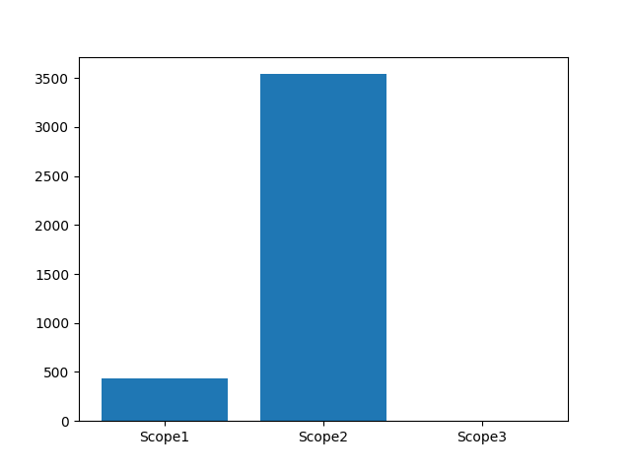
Fig 1 – Emission Distribution

Future Sustainability Roadmap
This section covers Future Sustainability Roadmap for TestCo operating in the Steel sector. Based on the reported data, total Scope 1 emissions are 431.9 tCO2e, Scope 2 emissions are 3540.0 tCO2e, and Scope 3 (value chain) emissions are 6.0 tCO2e, yielding a combined footprint of 3977.9 tCO2e. Carbon intensity relative to annual revenue (USD 1,000,000.0) is 0.004 tCO2e per USD. Waste recycling rate stands at 60.0%. Female workforce representation is 40.0% and board diversity is 37.5%. The organisation is advised to implement a structured emission reduction roadmap aligned with GHG Protocol standards and ISO 14064 requirements to demonstrate continued commitment to environmental stewardship and regulatory compliance.

Environmental Metrics
Metric | Value
Total Emissions | 3977.9
Carbon Intensity | 0.0
Recycle Rate | 0.6
Female Workforce % | 40.0

