ADAPTIVE MULTI-JUNCTION
TRAFFIC GRID CONTROLLER
Technical Report | Tasks 1–6
SystemVerilog RTL · EDA Playground · Icarus Verilog
Prepared for project documentation and final review
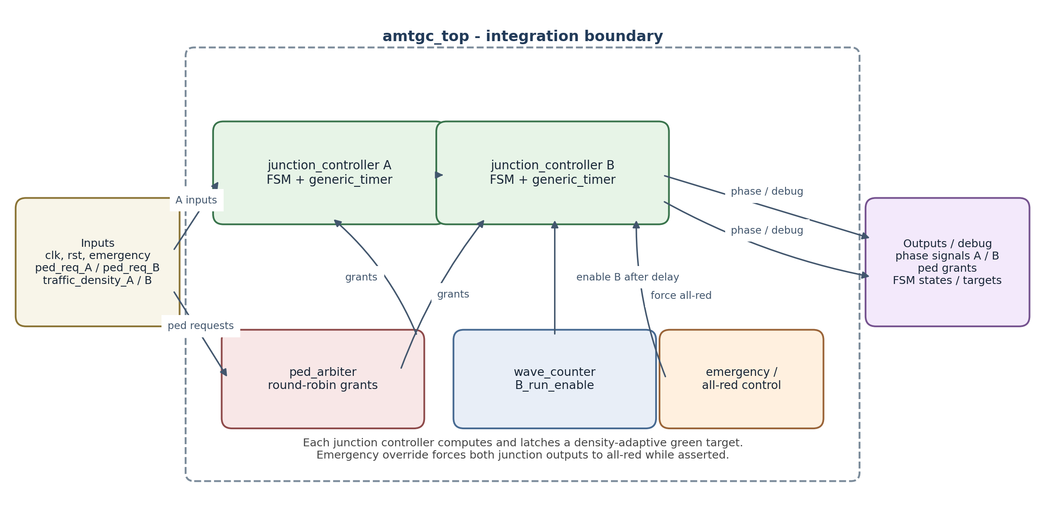
Current source revision reviewed: combined design.sv and testbench.sv
REVIEW STATUS: The submitted EDA Playground console reports 2,124/2,124 checks passed. This report also records coverage gaps and source-level review items that must be addressed before declaring the one-time submission release-ready.

1. Project Overview
The Adaptive Multi-Junction Traffic Grid Controller (AMTGC) is a SystemVerilog design for coordinating two four-way traffic junctions, Junction A and Junction B. The project combines timed traffic phases, pedestrian request arbitration, emergency all-red behavior, a follower-start delay, and traffic-density-dependent green timing.
The design is written as a synchronous RTL system. A shared clock drives state and counter updates. Reset is synchronous and active-high. Emergency override is a separate runtime input: when asserted, both junction outputs are driven to all-red and the controller state is directed to an all-red state on a clock edge.

Primary project objectives
- Provide a reusable generic timer whose target and width are configurable.
- Use one junction-controller RTL module for both junctions with different parameter settings.
- Share pedestrian arbitration between Junction A and Junction B and avoid simultaneous grants.
- Keep conflicting vehicle movements separated by all-red phases.
- Increase green time with traffic density while respecting minimum and maximum limits.
- Verify system behavior with an automated check task and retain simulation evidence.

Current verification evidence
The EDA Playground console screenshot supplied for the recovered combined design reports 2,124 total checks, 2,124 passed, and 0 failed. It also reports 110 pedestrian request events, 55 grant counts for each junction, six emergency tests, and five density tests. This report treats those figures as the output of that recorded EDA Playground run, not as proof that every required coverage scenario was implemented.

2. Architecture
The submitted combined design uses four modules in one design source file. The top-level amtgc_top instantiates two junction_controller instances and a shared ped_arbiter. Each junction_controller instantiates generic_timer. Green-wave startup behavior is implemented as a counter inside amtgc_top rather than as a separate coordinator module.
Figure 1. Block-level view of the recovered combined design.

Module responsibilities
Module | Responsibility | Important interface elements
amtgc_top | Integrates the two junctions, shared pedestrian arbiter, startup wave counter, and debug outputs. | clk, rst, emergency; ped_req_A/B; traffic_density_A/B; phase outputs, grants, state and target debug.
junction_controller | Implements phase FSM, pedestrian pending latch, adaptive green target, all-red override, and timer instance. | run_enable, force_all_red, ped_request, traffic_density; phase outputs, state_dbg, green_target_dbg.
generic_timer | Counts clock cycles to count_target; handles target zero and reset. | start, count_target; done, count_dbg.
ped_arbiter | Maintains one active pedestrian grant and alternates tie resolution. | ped_req_A/B; ped_grant_A/B.

Coordination and safety intent
- Junction A is enabled after reset. Junction B is held in all-red while B_run_enable is low, then enabled when the wave counter reaches WAVE_DELAY.
- Emergency override is separate from reset and is passed to both junction controllers as force_all_red.
- The arbiter receives request signals and returns grant signals; it is not intended to inspect internal junction state.

3. RTL Design

3.1 Generic timer
generic_timer is parameterized by COUNTER_WIDTH. On synchronous active-high reset it clears count_dbg and done. When start is low, it clears the count and deasserts done. If start is high and count_target is zero, done is asserted. For a non-zero target, the count advances until the target boundary is reached, then count_dbg is cleared and done is asserted for the completion cycle.

3.2 Junction controller and adaptive target
The junction_controller contains the traffic-phase state, pedestrian pending flag, density_latched register, timer target selection, and output decoding. Its green target is computed from the latched 3-bit density and clamped by MIN_GREEN_TIME and MAX_GREEN_TIME. In the recovered source, the expression is effectively MIN_GREEN_TIME + density_latched × GREEN_EXTENSION, followed by minimum/maximum clamping.
Source-review item: GREEN_TIME is declared and passed as a parameter in the recovered combined RTL, but the current adaptive_green_time equation uses MIN_GREEN_TIME + density_latched × GREEN_EXTENSION and does not use GREEN_TIME. Confirm whether this is intentional before final release.

3.3 Pedestrian arbiter
The arbiter holds a selected active_grant until the corresponding external request is deasserted. If both requests are high while no grant is active, last_grant determines which client wins the tie. This is intended to alternate simultaneous requests and avoid fixed-priority behavior.

3.4 Top-level emergency and wave behavior
The top-level wave_counter increments while below WAVE_DELAY and pauses during emergency. B_run_enable becomes true when the counter reaches the configured delay. Junction B outputs remain forced all-red while disabled. This is a startup-enable delay; the current top-level implementation does not create an explicit recurring A-to-B start event interface.

4. FSM Design
The recovered junction_controller defines seven states using a 3-bit state encoding. State names and encodings are taken from the uploaded design source.
State | Encoding | Role / normal successor
ST_NS_GREEN | 0 | North-south green; advances to ST_NS_YELLOW when timer_done.
ST_NS_YELLOW | 1 | North-south yellow; advances to ST_ALL_RED_1.
ST_ALL_RED_1 | 2 | First all-red safety phase; goes to pedestrian phase if pending/requested, otherwise east-west green.
ST_PED | 3 | Pedestrian walk interval; current RTL advances to ST_EW_GREEN when timer_done.
ST_EW_GREEN | 4 | East-west green; advances to ST_EW_YELLOW.
ST_EW_YELLOW | 5 | East-west yellow; advances to ST_ALL_RED_2.
ST_ALL_RED_2 | 6 | Second all-red safety phase; goes to pedestrian phase if pending/requested, otherwise north-south green.

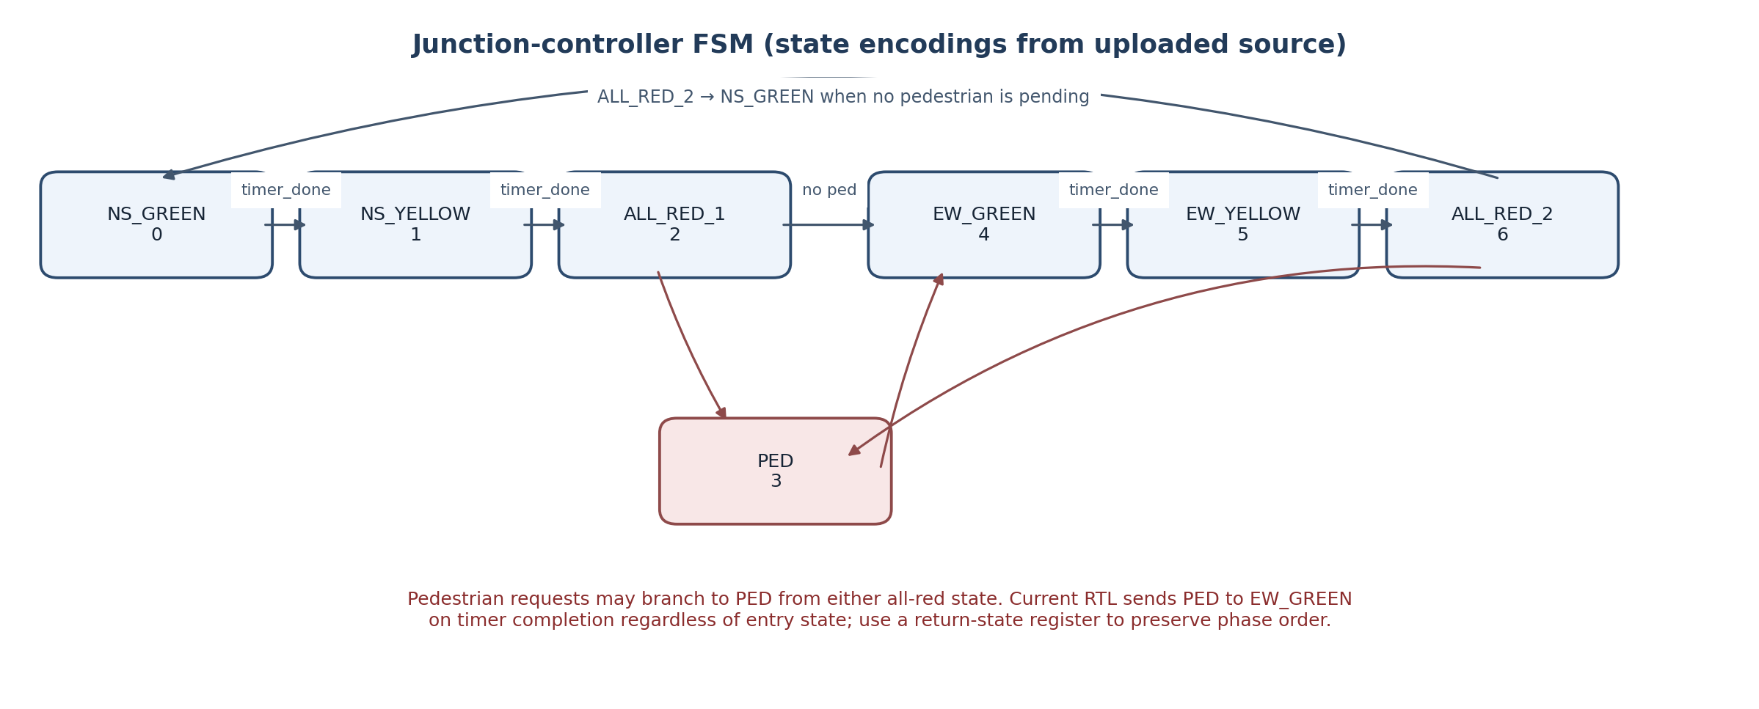
Figure 2. State flow based on the recovered FSM implementation.
FSM review item: ST_PED currently transitions to ST_EW_GREEN unconditionally. If a pedestrian phase is entered from ST_ALL_RED_2, the next phase is therefore east-west green rather than north-south green. Add a return-state register or equivalent explicit logic and verify that repeated pedestrian service cannot starve north-south traffic before final submission.

Emergency priority
When force_all_red is asserted, the state register assigns ST_ALL_RED_1 at the next rising edge. The output decoder also forces all_red high whenever force_all_red is asserted, so the output override does not wait for the state transition. When run_enable is low, all_red is likewise forced high.

5. Verification Methodology
The recovered testbench is a unified, self-checking SystemVerilog testbench. A task named check_condition increments total_checks and either passed_checks or failed_checks, and prints a [PASS] or [FAIL] message. A clocked process checks vehicle green mutual exclusion, pedestrian grant mutual exclusion, green-target bounds, and emergency all-red outputs while reset is inactive. The testbench writes a VCD file using $dumpfile("dump.vcd") and $dumpvars.

Tests represented in the uploaded testbench
Test area | Stimulus / check in current testbench | Coverage judgement
Reset and normal operation | Initial reset, nominal operation, and valid-output checks. | Present.
Adaptive density | Five selected density combinations and a density change during operation. | Present, but not an exhaustive measured phase-duration sweep of every density 0–7.
Pedestrian requests | 110 simultaneous request pulses; arbiter grants counted; both clients checked for non-zero service. | Present; console reports 55 grants each.
Emergency | Emergency asserted during normal operation, then repeated five times; all-red checked. | Present, but current testbench does not explicitly target every traffic phase and the pedestrian phase.
Active reset | Reset reasserted during operation and A state checked. | Present.
Green-wave | One check that B_run_enable_dbg becomes high after waiting. | Partial; does not measure the actual NS-green offset over five different density combinations.
Randomized regression | No random/constrained-random phase is present in the recovered combined testbench. | Missing from this revision.

6. Simulation Results
The supplied EDA Playground / Icarus Verilog console screenshot for this recovered design shows the following summary:
Reported metric | Observed result
Total checks | 2,124
Passed checks | 2,124
Failed checks | 0
Pedestrian events | 110
A pedestrian grant count | 55
B pedestrian grant count | 55
Emergency tests | 6
Density tests | 5
Final message | TASK 5 VERIFICATION PASS

These figures support the claim that the specific recorded run completed its checks without a reported failure. The summary also displays “Reset tests = 1” and “Green-wave tests = 5”, but those two values are printed as fixed text in the uploaded testbench summary. They are not derived from dedicated counters in this version; the actual source only explicitly checks the reset during operation and B-run-enable startup once. They must not be presented as five measured green-wave offset runs.
The visible VCD filename from the run is dump.vcd. The screenshots shown in this project were captured through EPWave after an EDA Playground run using Icarus Verilog. They should not be labelled as ModelSim screenshots. If ModelSim/Questa output is mandated, it must be generated in that simulator and saved with its real transcript.

7. Challenges Faced
- Source recovery: the original combined design and testbench had to be recovered from saved text backups after editor contents were lost.
- Revision consistency: a previously bundled modular revision used different ports/parameters from the combined design that produced the 2,124-check console. The combined files are the reference for this report.
- Waveform navigation: early EPWave windows did not include the emergency assertion intervals. The simulation output and a later waveform made the repeated emergency events visible.
- Evidence classification: an EPWave trace demonstrates the EDA Playground simulation; it is not a substitute for ModelSim/Questa evidence if the assignment explicitly requires that simulator.
- Coverage gaps found during source review: emergency-by-phase coverage, measured green-wave offsets over multiple density combinations, randomized testing, and pedestrian return-state behavior should be strengthened before final submission.

8. Conclusions
The recovered design demonstrates a modular two-junction traffic controller with a generic timer, a shared pedestrian arbiter, density-dependent green targets, emergency all-red handling, and a delay-based follower startup. The EDA Playground console provided by the student reports a successful self-checking run with 2,124 checks and zero failures.
However, a passing count alone does not demonstrate every mandatory assignment scenario. The current testbench has a startup-enable check rather than a measured green-wave phase-offset test across five density combinations, does not include a randomized phase, and does not explicitly assert emergency in every state. Source inspection also found that the pedestrian state always returns to east-west green. These are release actions, not claims that the passing console is invalid.
The project should be submitted only after these gaps are addressed in the final source, the full regression is rerun, the final repository source is confirmed to match the tested source, and all required documentation, screenshots, simulator logs, demo video, and public links are present.

Appendix A. Final release checklist
☐ Confirm prescribed assignment folder names; do not rename required directories. | ☐ Resolve and retest pedestrian phase return-state behavior.
☐ Add a randomized/constrained-random test; record cycle count and seed. | ☐ Assert emergency in every required traffic phase, including pedestrian phase.
☐ Measure green-wave NS-start offset across at least five density combinations. | ☐ Use real summary counters; identify any unmeasured coverage explicitly.
☐ Run the final submitted RTL/testbench; archive transcript and VCD. | ☐ If required, produce genuine ModelSim/Questa evidence in that simulator.
☐ Confirm mandatory screenshot filenames and record the demo video. | ☐ Publish the public repository and test its URL while logged out.
☐ Complete self-attestation only after personally checking every item.

Appendix B. Evidence file map
These are working filenames from the project workflow. Before submission, compare them with the exact screenshot names required by the original assignment document; rename only evidence files if the brief permits it, and never rename prescribed folders.
Evidence item | Working filename | Current status | Destination
Final Task 5 console | task5_final_console.png | Captured from EDA Playground / Icarus Verilog | sim/screenshots/
Repeated emergency waveform | task5_emergency_repeated_events.png | Captured in EPWave | sim/screenshots/
Density + pedestrian waveform | task5_density_pedestrian_waveform.png | Captured in EPWave | sim/screenshots/
Normal traffic waveform | Confirm exact required filename | Verify/capture and check rubric | sim/screenshots/ or prescribed folder
Measured green-wave offset | Confirm exact required filename | Still needs measured offset over >=5 density pairs | sim/screenshots/ or prescribed folder
ModelSim/Questa transcript | Use assignment-required filename | Pending if simulator-specific evidence is mandatory | sim/logs/

Appendix C. Reproducibility and publication record
Item | Record
Design language | SystemVerilog
Observed simulator environment | EDA Playground using Icarus Verilog 12.0, as selected during the project workflow
Waveform file | dump.vcd
Recorded console result | 2,124 checks; 2,124 passed; 0 failed, as shown in the supplied console screenshot
Public GitHub URL | Not yet supplied - insert the real public URL after publishing and testing access
Demo-video URL | Not yet supplied - insert the actual video URL after recording and publishing

Release status and open gates
Gate | Current status | Action required before submission
Recorded EDA Playground check set | Console shows 2,124 / 2,124 passed and 0 failed. | Keep console image and dump.vcd; rerun after any RTL/testbench change.
Pedestrian phase return behavior | Open source-review item. | Remember the entry all-red state and return to the expected next vehicle phase; verify no starvation.
Emergency phase coverage | Not demonstrated for every FSM phase in the current testbench. | Add directed tests for every traffic phase, including pedestrian phase.
Green-wave density coverage | Only follower enable startup is checked in this revision. | Measure A-to-B NS-green offset for at least five density pairs.
Randomized regression | Not present in recovered combined testbench. | Add documented randomized/constrained-random cycles and seed.
Public GitHub / demo video | URLs not supplied yet. | Publish and test both public URLs before the one-time submission.

Release recommendation: keep this report as the current technical record, but do not submit the one-time final package until all mandatory open gates are closed or explicitly resolved with the internship evaluator.

