Critical and Creative Thinking | Formative Assessment 1 | Artificial Intelligence
SustainStyle: Eco-App in Action

1. Research Report
Why fashion is a problem. The fashion industry is responsible for roughly 10% of global greenhouse gas emissions (UNFCCC, 2019). It uses about 79 billion cubic metres of fresh water a year, and dyeing and treating textiles causes around 20% of freshwater pollution (Global Fashion Agenda and BCG, 2017). About 92 million tonnes of textile waste are produced every year, a number expected to reach 148 million tonnes by 2030, and less than 1% of the material in clothes is recycled into new clothes (Ellen MacArthur Foundation, 2017). Washing synthetic clothes also sends around 500,000 tonnes of plastic microfibres into the ocean each year. The human cost is just as serious: the 2013 Rana Plaza collapse in Bangladesh killed more than 1,100 garment workers and led to the Fashion Revolution campaign for transparency in supply chains.
How people shop. People say they care, but their habits lag behind. In Zalando's 2025 report, 71% of consumers said they want to buy more sustainably, yet price is the biggest barrier (41%), followed by trouble identifying sustainable items (27%) and not knowing where to find them (24%). A Sheffield Hallam University survey of 60 students (2022) found that nine in ten had bought fast fashion, only one in six could name a sustainable brand, and just 43% thought about how their clothes were made before buying. That sample is small, so we treat it as a hint and not as proof.
Gaps in existing apps. Apps like Good On You combine public data and certifications into a score out of five covering people, planet and animals (Dazed, 2019). This is useful, but we noticed three gaps. First, the score is for a brand, not for the garment in your hand. Second, brands that publish less information are likely to score lower, and the weighting is hard for a normal user to see. Third, the app tells you what is bad but does not offer a cheaper alternative or reward you for choosing better, so the price problem stays. (The second and third points are our own analysis, not claims made in the sources.)
What we took from the research:
 | Insight | What the app should do
I1 | Price is the number one barrier (41%) | Show greener options that are also cheaper, like second-hand and repair
I2 | 27% cannot tell which items are sustainable | Scan the actual item, and let people try it without signing up
I3 | Good intentions do not turn into action | Give an instant result and a reward for better choices
I4 | Trust in sustainability claims is shaky | Show how the score is made and how reliable the data is
App goal: to create a user-friendly mobile app that anyone can use and adjust to their own budget, style and language, which gives an instant item-level eco-score and a cheaper, greener alternative at the moment of buying, and rewards better choices with GreenPoints.



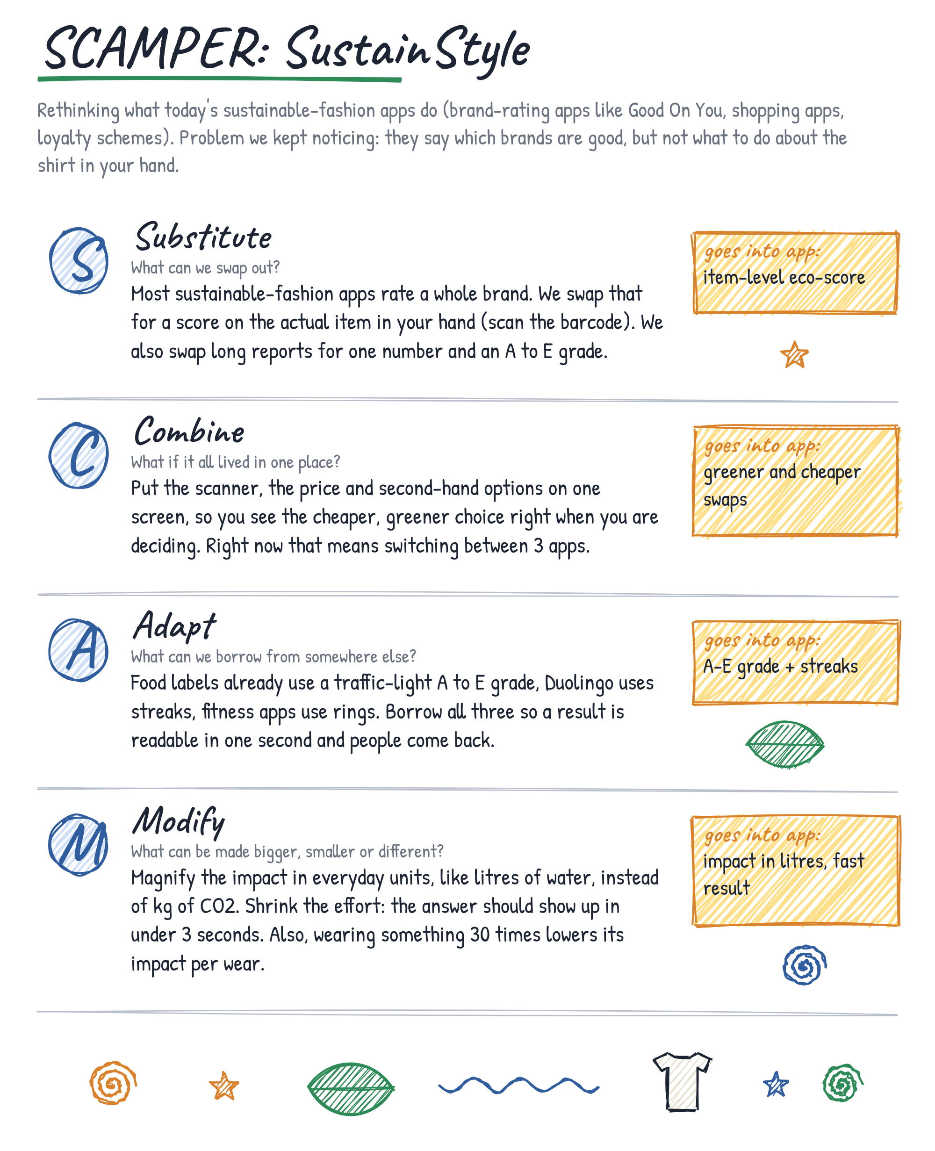

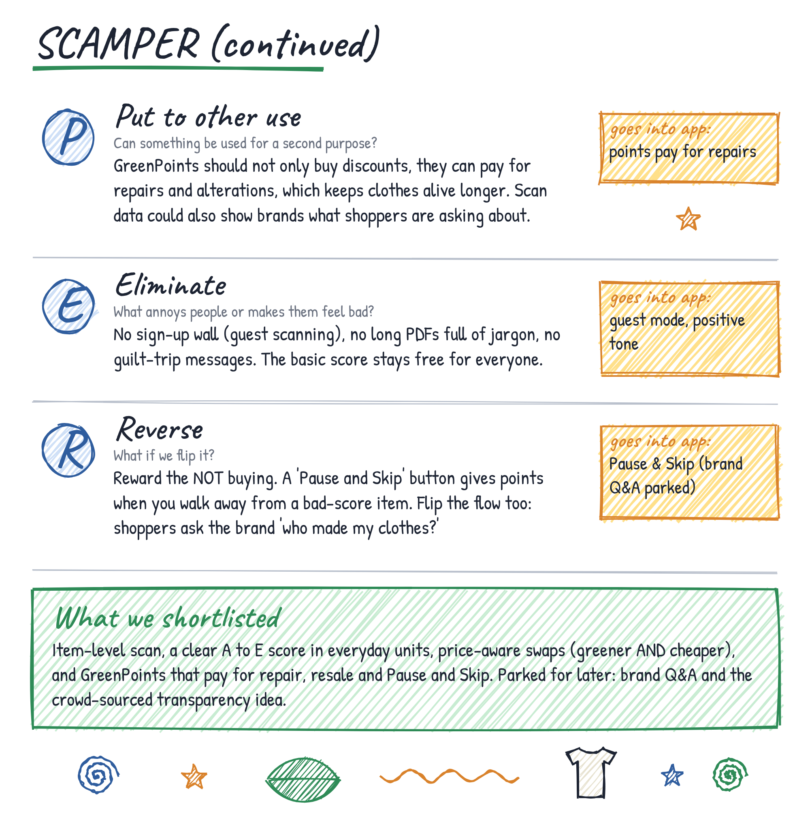

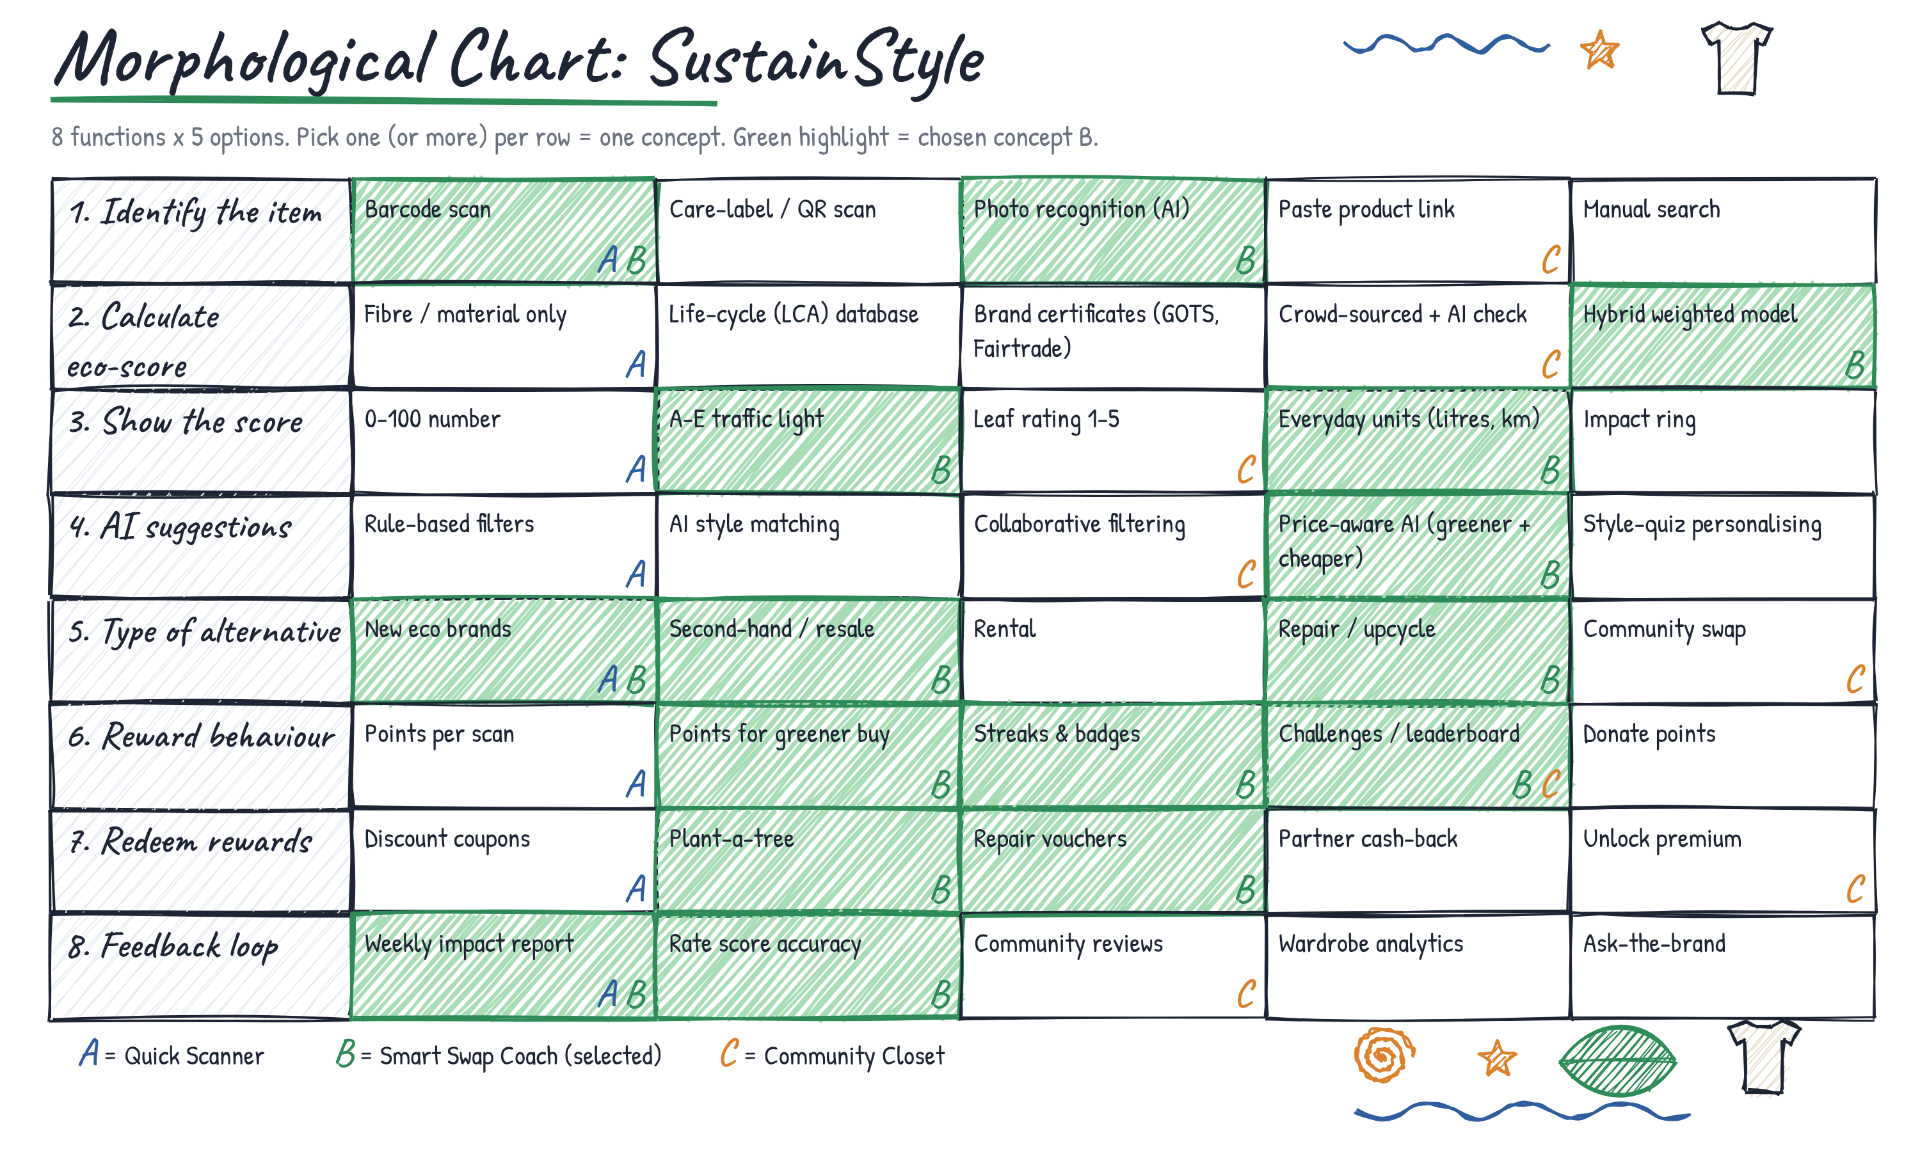

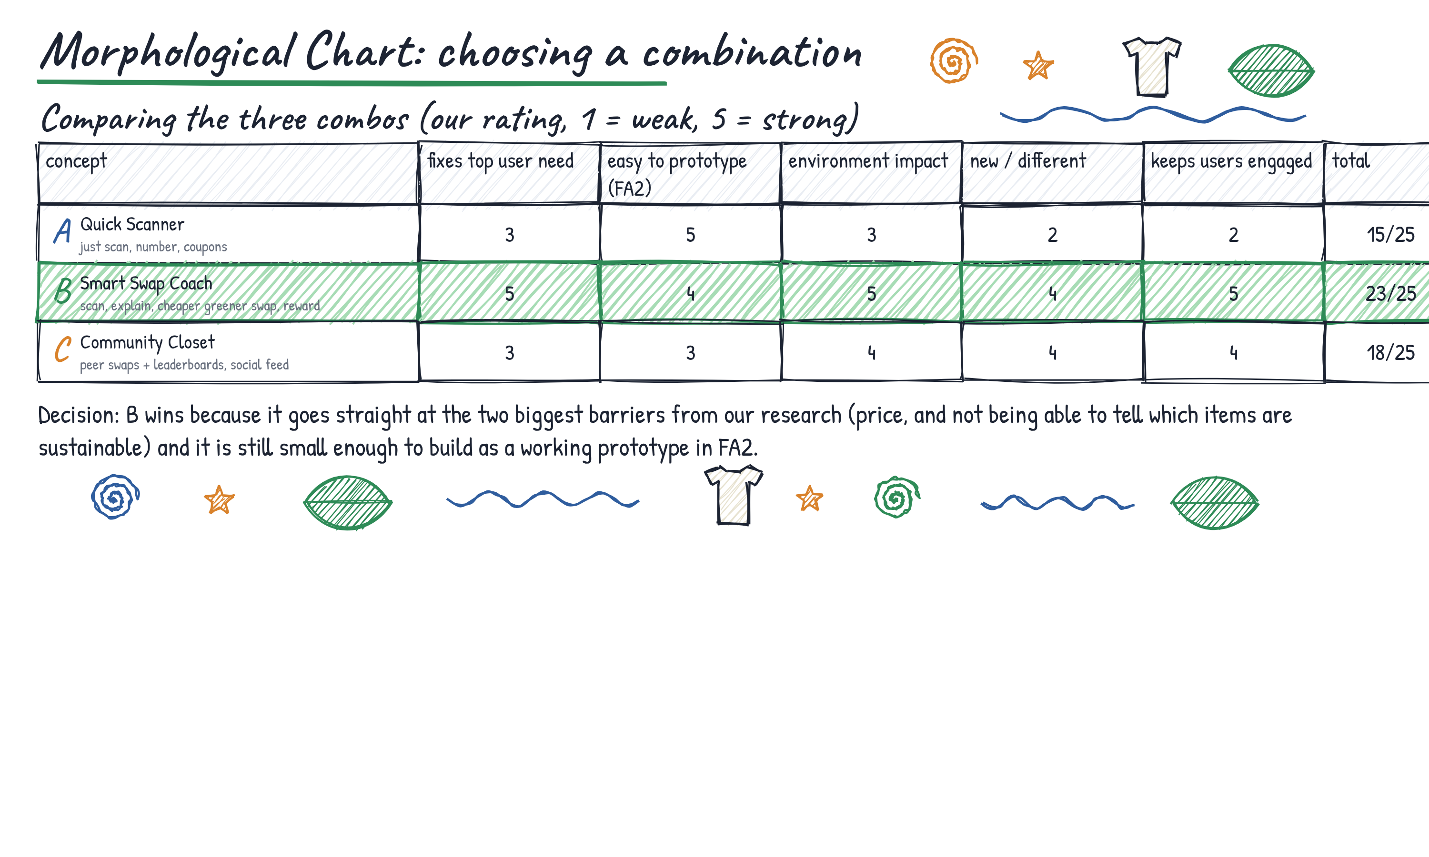

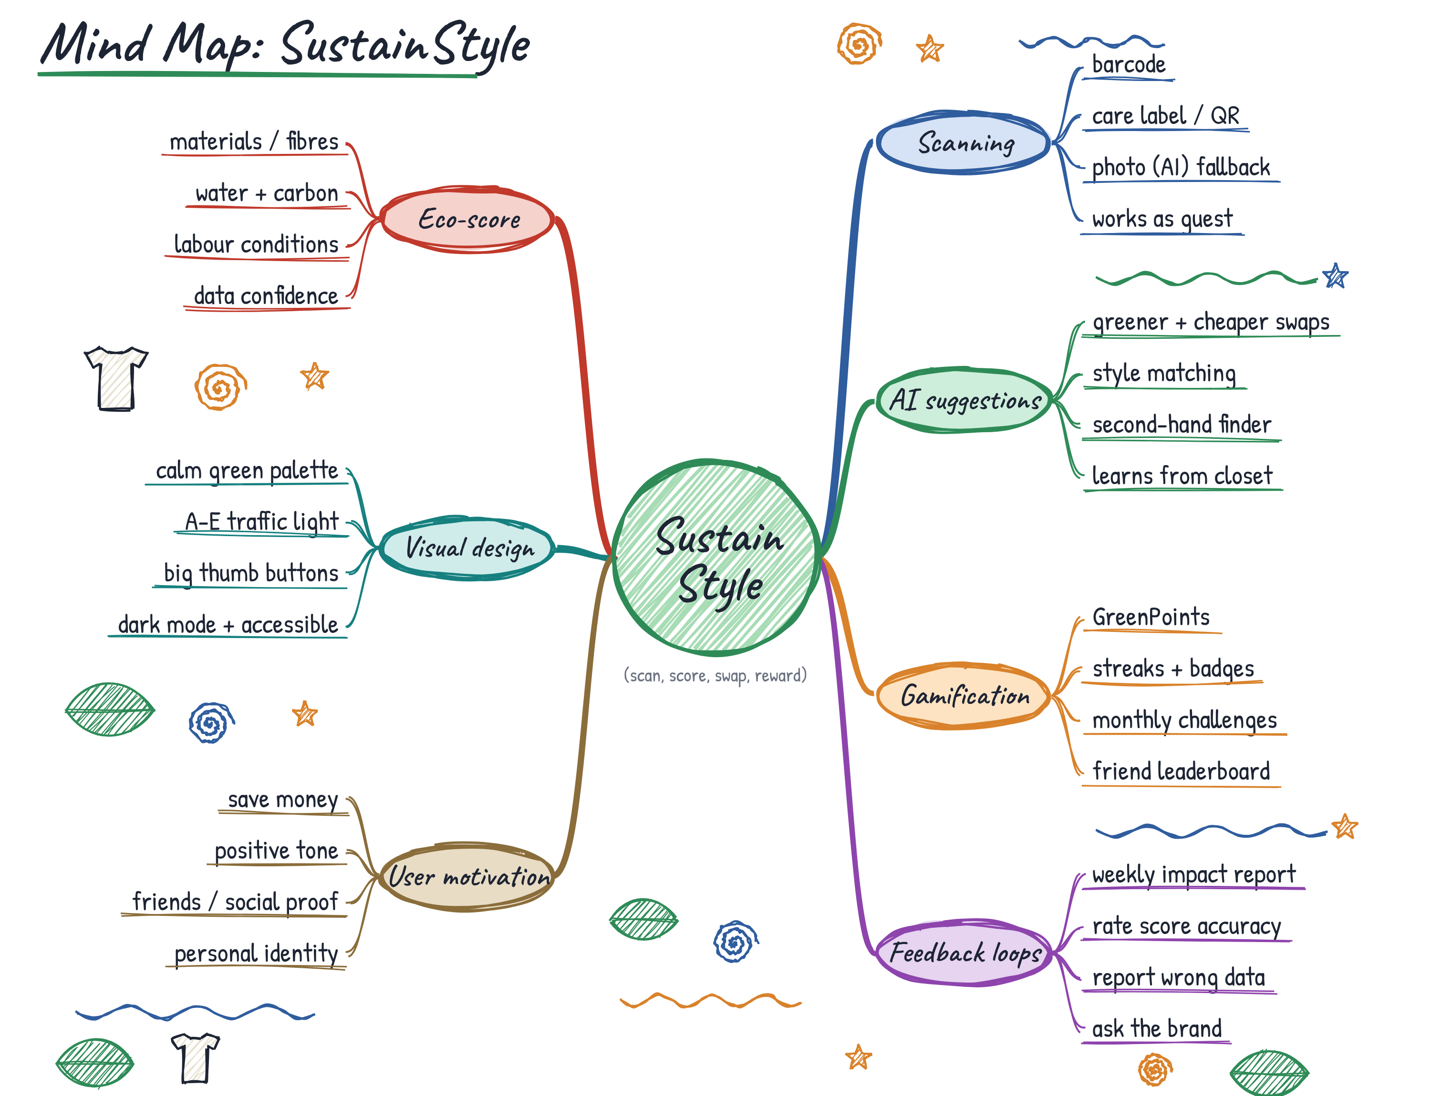

5. Core Features and Why We Chose Them
From the chosen combination (concept B) we picked four core features. Each one answers a finding from the research and comes out of a SCAMPER idea.
Feature | What it does | Why it is in the app
1. Barcode and label scanner (photo and manual entry as backup, guest mode) | Identifies the exact item in a few seconds, in a shop or online, with no sign-up. | Existing apps rate brands, so a shopper still cannot tell about the shirt in front of them (I2). Guest mode removes the first reason to quit. Comes from Substitute and Eliminate.
2. Transparent eco-score | Gives a 0 to 100 score and an A to E grade from materials, water, carbon and labour, with impact in everyday units and a note on how reliable the data is. | A quick, clear result helps people act (I3), and showing how it is calculated deals with doubts about greenwashing (I4). Comes from Adapt and Modify.
3. Price-aware AI recommendations | Suggests second-hand, organic or repair options that cost less and score better, matched to size, style and budget. | Price is the biggest barrier at 41% (I1). A cheaper, greener option right then removes the main excuse. Comes from Combine.
4. GreenPoints | Points, streaks and challenges for scans, swaps and Pause and Skip, which can be used for repair vouchers, coupons or planting trees. | Rewards help close the gap between wanting to be sustainable and actually doing it (I3). Paying for repairs keeps clothes in use longer. Comes from Put to other use and Reverse.

How the three stages connect
Research | Ideation choice | Storyboard screen
I2 Identifying items | Item-level scan, guest mode (Substitute, Eliminate) | 1 Home, 2 Scan
I4 Trust | Transparent score and data confidence (Adapt, Modify) | 3 Eco-Score
I1 Price | Price-aware swaps, second-hand and repair (Combine) | 4 Swaps
I3 Intention vs action | GreenPoints, streaks, Pause and Skip (Put to other use, Reverse) | 5 Reward, 6 My Impact

6. Storyboard (6 screens)
The six screens on the next pages follow one shopper from opening the app to seeing their progress. Each screen has a short note on its purpose and interaction, the research finding it answers (I1 to I4) and the SCAMPER idea it comes from. The app lets every user customise language, budget, style and accessibility, so it is not limited to one type of person. Product names and numbers are made up for the wireframes.

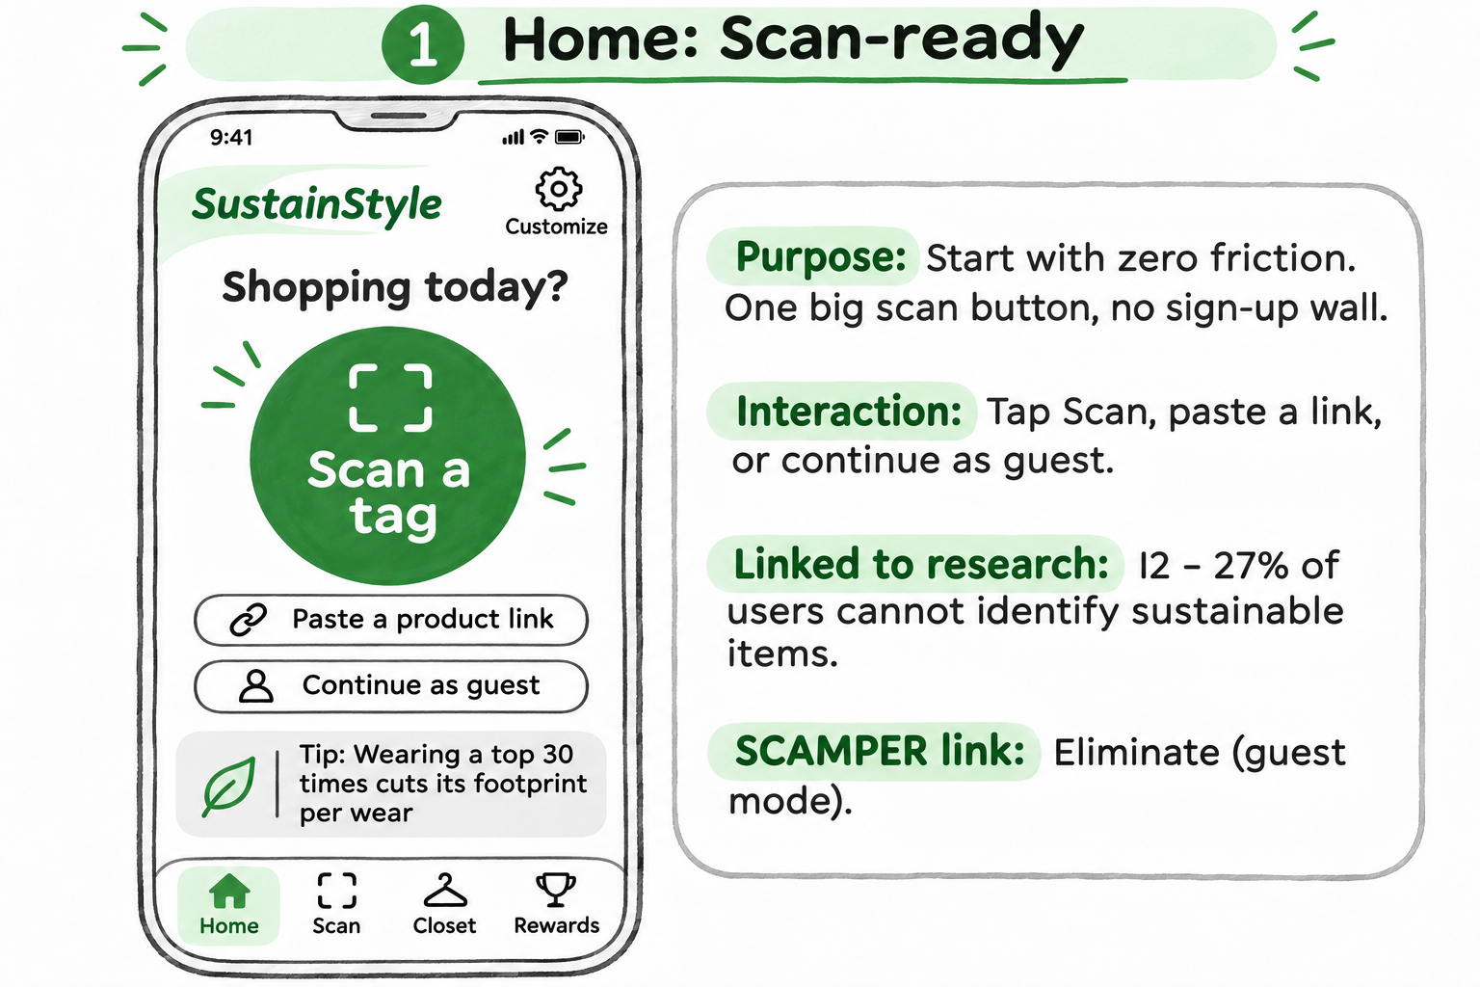

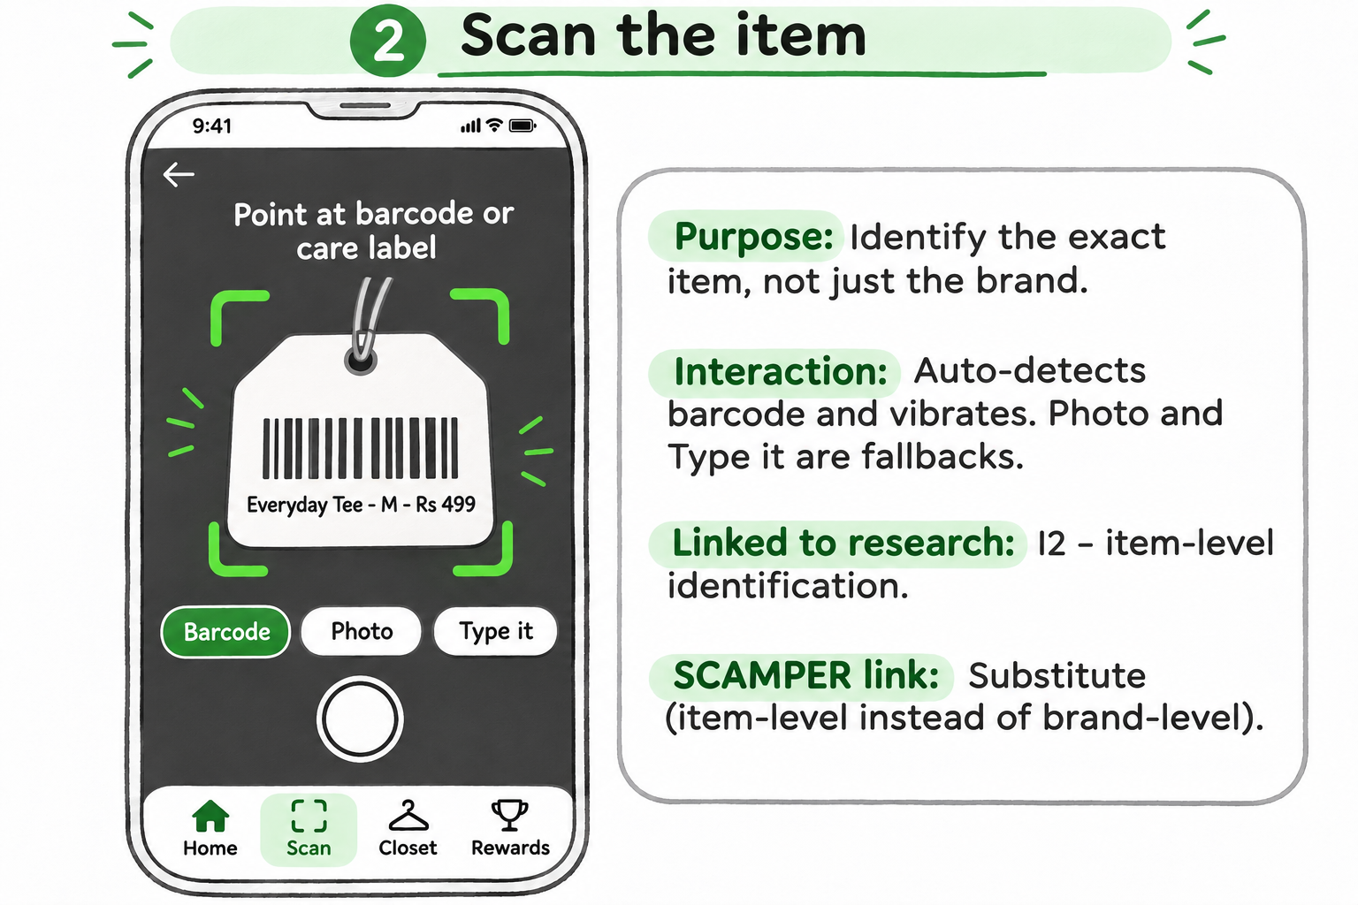

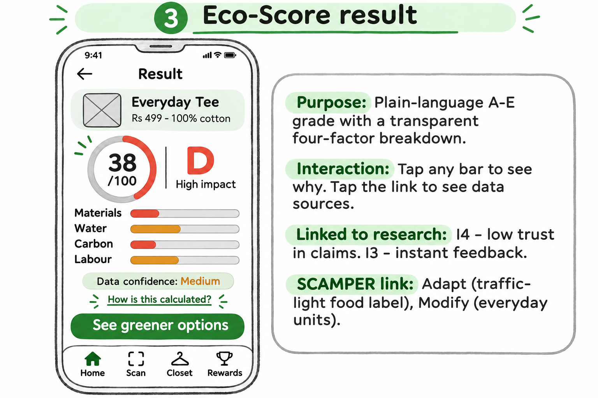

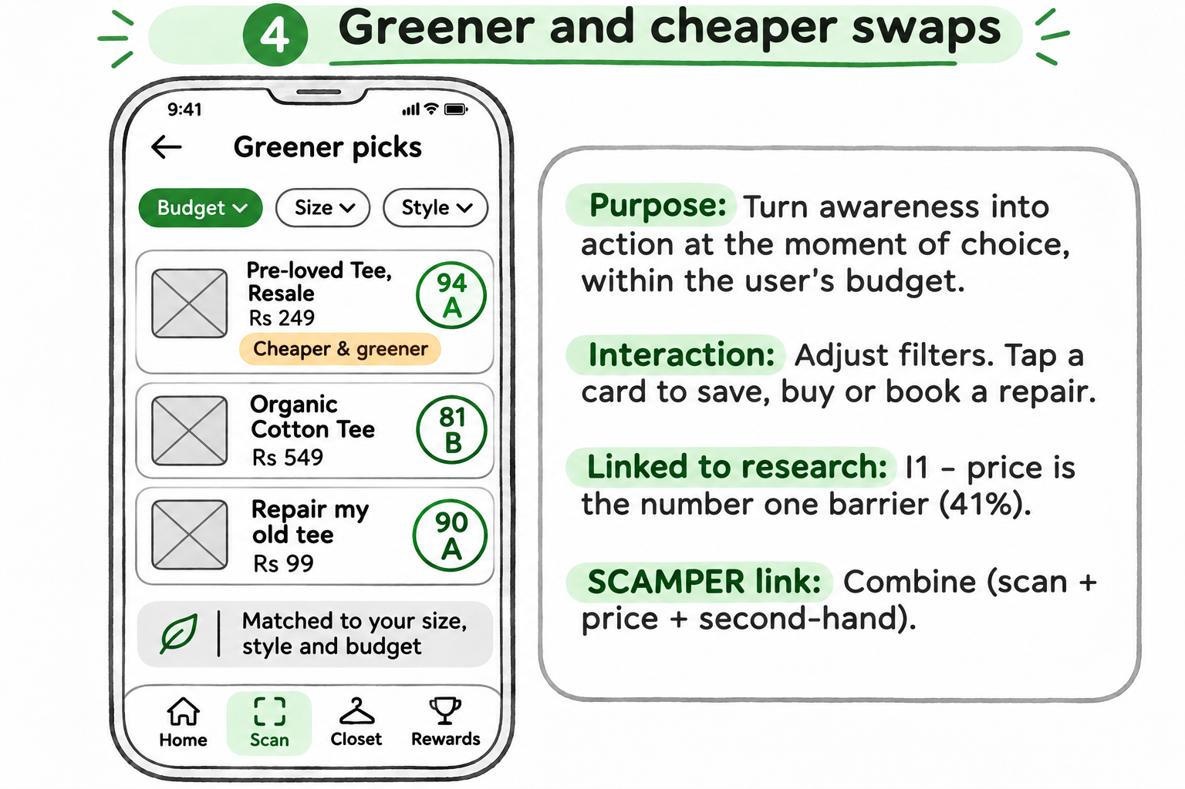

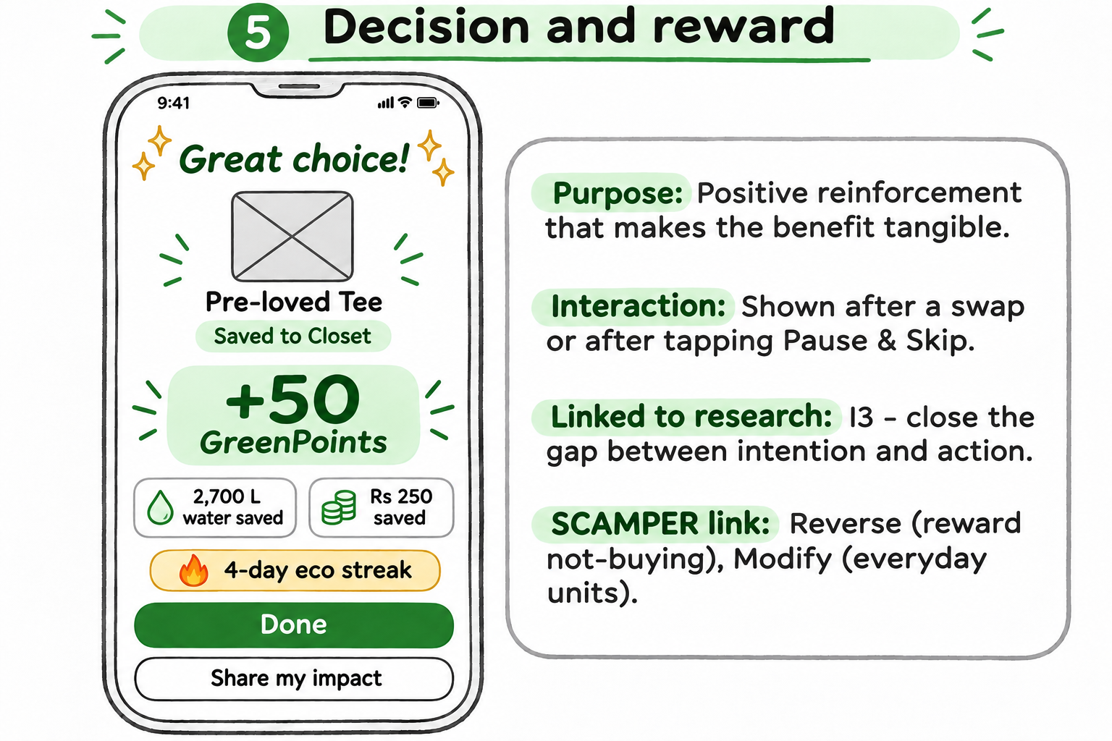

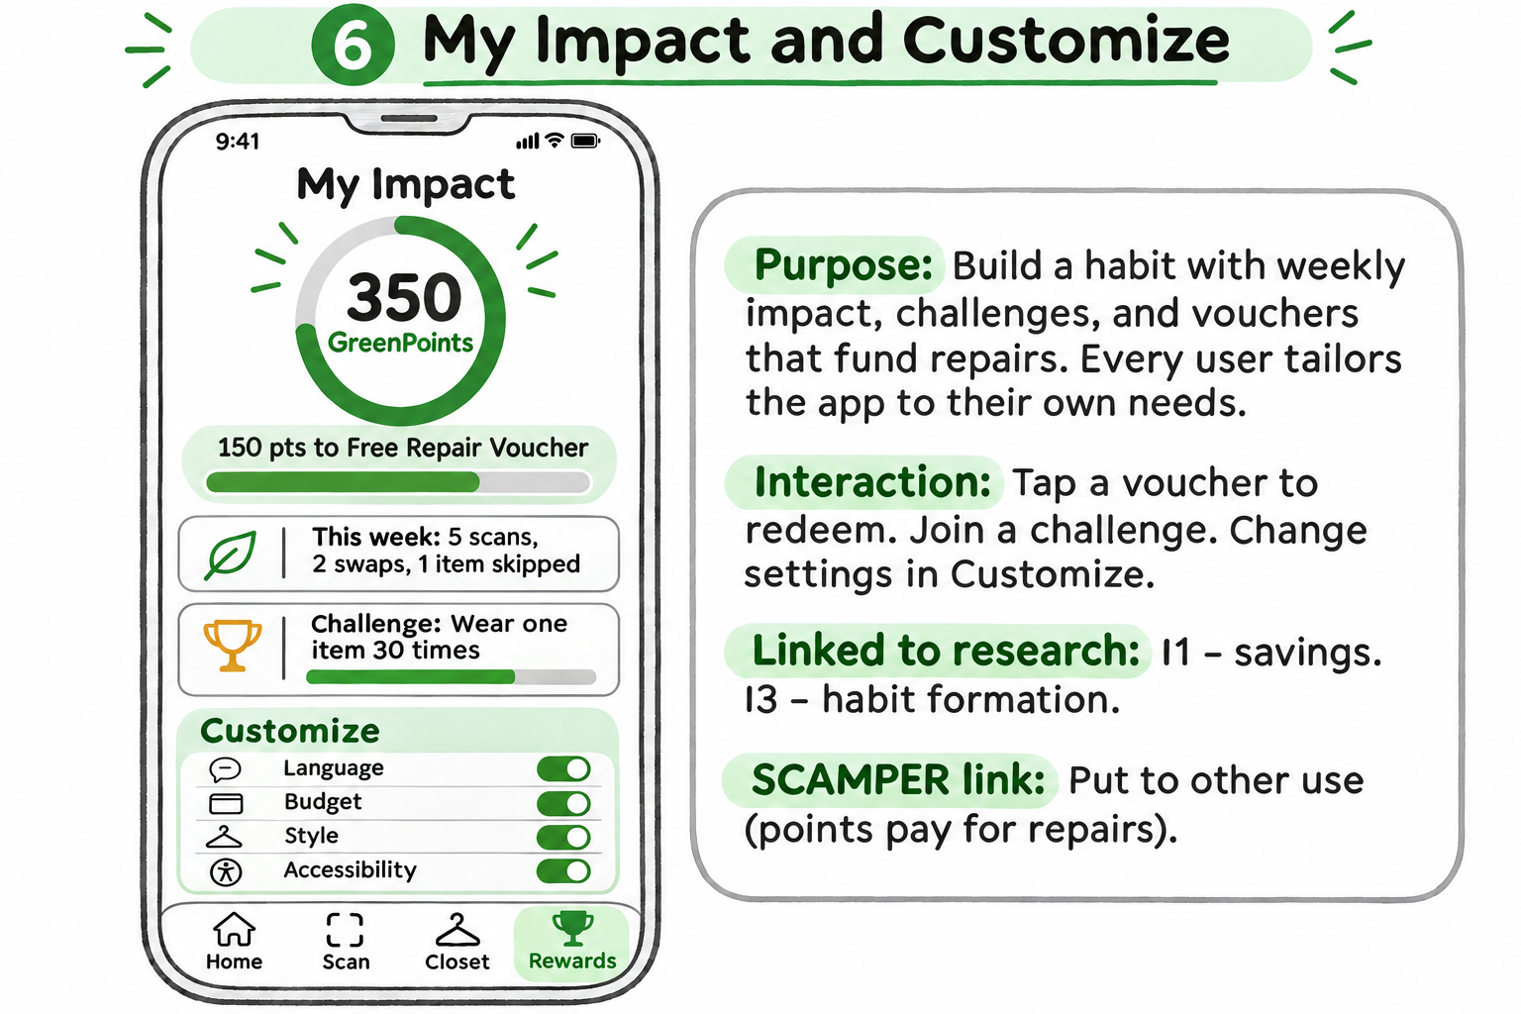

References
- Dazed Digital. Good On You app ranks fashion brands on how ethical and sustainable they are. https://dazeddigital.com/fashion/article/40643/1/good-on-you-app-ranks-fashion-brands-how-ethical-sustainable-they-are
- FashionUnited (2019). Redress shares resources on fashion's impact on the environment and economy. Figures from Ellen MacArthur Foundation (2017), Global Fashion Agenda and BCG (2017) and UNFCCC (2019). https://fashionunited.com/news/fashion/redress-shares-resources-on-fashion-s-impact-on-the-environment-and-economy/2019092530105
- Sheffield Hallam University (2022). Fast fashion survey of 60 students. https://www.shu.ac.uk/news/all-articles/latest-news/fast-fashion
- Zalando (2025). Attitude-Behaviour Gap Report 2025. https://corporate.zalando.com/en/node/10765
- Resources listed in the brief: goodonyou.eco, fashionrevolution.org, sustainyourstyle.org, hmgroup.com/sustainability, and the SCAMPER and morphological chart guides from MindTools, Interaction Design Foundation and Cambridge IfM.

