A PROJECT REPORT
ON
SKYTECH AIRLINES
Airline Reservation and Passenger Management System
Submitted in partial fulfillment of the requirement for the award of Degree of Bachelor of Technology in Computer Science & Engineering
Submitted to:

Rajasthan Technical University, Kota (Raj.)
Under the Guidance of
Er. Ram Babu Buri
Submitted By:
Mohammed Sahil | (24EARCS095)
Mukesh Sah | (24EARCS097)
Muskan Raj | (24EARCS098)
Nikhil Ranjan Choubey | (24EARCS103)
Prashant Chaudhary | (24EARCS115)

Session: 2026-27
Department of Computer Science & Engineering
ARYA COLLEGE OF ENGINEERING & I.T.
SP-42, RIICO INDUSTRIAL AREA, KUKAS, JAIPUR

Department of Computer Science & Engineering
CERTIFICATE OF APPROVAL
The Project Report entitled “SkyTech Airlines – Airline Reservation and Passenger Management System” submitted by “Mohammed Sahil (24EARCS095), Mukesh Sah (24EARCS097), Muskan Raj (24EARCS098), Nikhil Ranjan Choubey (24EARCS103) and Prashant Chaudhary (24EARCS115)” has been examined by us and is hereby approved for carrying out the project leading to the award of the degree “Bachelor of Technology in Computer Science & Engineering”. By this approval the undersigned does not necessarily endorse or approve any statement made, opinion expressed or conclusion drawn therein, but approve the pursuance of the project only for the above-mentioned purpose.

Mentor
Er. Aarti Sharma
Department of Computer Science & Engineering
CERTIFICATE
This is to certify that the work embodied in this Project entitled “SkyTech Airlines – Airline Reservation and Passenger Management System” being submitted by “Mohammed Sahil (24EARCS095), Mukesh Sah (24EARCS097), Muskan Raj (24EARCS098), Nikhil Ranjan Choubey (24EARCS103) and Prashant Chaudhary (24EARCS115)” in partial fulfillment of the requirement for the award of “Bachelor of Technology in Computer Science & Engineering” to Rajasthan Technical University, Kota (Raj.) during the academic year 2026-27 is a record of bonafide work, carried out by them under the supervision and guidance of the Project Guide in the Department of Computer Science & Engineering, Arya College of Engineering & Information Technology, Jaipur.

Project Guide  Er. Ram Babu Buri | Head of Department  Dr.Akhil Pandey
Department of Computer Science & Engineering
DECLARATION
We “Mohammed Sahil, Mukesh Sah, Muskan Raj, Nikhil Ranjan Choubey, and Prashant Chaudhary”, students of Bachelor of Technology in Computer Science & Engineering, session 2026-27, Arya College of Engineering & Information Technology, Jaipur, hereby declare that the work presented in this Project entitled “SkyTech Airlines – Airline Reservation and Passenger Management System” is the outcome of our own work, is bonafide and correct to the best of our knowledge and this work has been carried out taking care of Engineering Ethics. The work presented does not infringe any patented work and has not been submitted to any other University or anywhere else for the award of any degree or any professional diploma.

Mohammed Sahil | (24EARCS095)
Mukesh Sah | (24EARCS097)
Muskan Raj | (24EARCS098)
Nikhil Ranjan Choubey | (24EARCS103)
Prashant Chaudhary | (24EARCS115)
Date: ____________
ABSTRACT
SkyTech Airlines – Airline Reservation and Passenger Management System is a centralized web application proposed to simplify airline reservation within an academic scope. It addresses the inconsistent records, hard-to-trace booking references and limited administrative visibility that arise when flight discovery, passenger records, ticketing, cancellations and flight schedules are handled manually or through poorly coordinated tools.
The system recognizes two user categories. Passengers register, log in, search flights by origin, destination and date, view schedules, fares and database-derived seat availability, enter passenger details and create bookings that receive a unique PNR; they can then view tickets and booking history, retrieve a booking by PNR and request cancellation. Administrators use a protected dashboard to manage flights, routes, schedules and fares and to review bookings and reports, with role-based access control enforced on the server.
The proposed architecture uses Java 21, JSP, Jakarta Servlets, JDBC and MySQL, built with Apache Maven and deployed on Apache Tomcat 10.1. Presentation, request processing, business logic and data access are separated, and the work is divided into five modules, one per team member. This report presents the requirements, system design, UML diagrams, data flow diagrams, entity-relationship design, implementation approach, test plan and analysis results derived from the project’s Software Requirements Specification.
SkyTech Airlines is an academic prototype described by its requirements and design. This report does not assert that any feature has been implemented or tested, and it excludes real-time airline integration, actual payment processing, live seat inventory and email delivery unless these are later implemented and verified.
ACKNOWLEDGEMENT
We would like to express our sincere gratitude to our project guide, Er. Ram Babu Buri, for his valuable guidance, support, and encouragement throughout the development of our project, “SkyTech Airlines – Airline Reservation and Passenger Management System.” His suggestions and technical guidance helped us improve our understanding and complete this report.
We are thankful to the Department of Computer Science & Engineering and Arya College of Engineering & Information Technology, Jaipur, for providing us with the necessary facilities and learning environment to carry out this project.
We also express our gratitude to our faculty members and everyone who supported us with their valuable suggestions and feedback. Finally, we thank all our team members for their cooperation, dedication, and teamwork throughout the project.
This project has provided us with practical experience in Java development, database management, web technologies, and software system design.
TABLE OF CONTENTS
Section | Particulars | Page No.
1. | INTRODUCTION | 1
1.1 | Background | 1
1.2 | About the Project | 1
1.3 | Problem Statement | 2
1.4 | Objectives | 2
1.5 | Scope and Scope Boundary | 2
1.6 | Basis and Status of this Report | 3
2. | LITERATURE REVIEW | 4
2.1 | Airline Reservation Systems | 4
2.2 | Web Architecture and Data Management | 4
2.3 | Security in Web Applications | 4
2.4 | Requirements Engineering and Modelling | 5
2.5 | Summary and Design Implications | 5
3. | SYSTEM REQUIREMENTS ANALYSIS | 6
3.1 | Overall Description and User Classes | 6
3.2 | Operating Environment and Software Requirements | 6
3.3 | External Interface Requirements | 7
3.4 | Functional Requirements | 7
3.5 | Non-Functional Requirements | 10
3.6 | Constraints, Assumptions and Dependencies | 11
4. | SYSTEM DESIGN | 12
4.1 | Design Principles | 12
4.2 | System Architecture | 12
4.3 | Module Design | 13
4.4 | Security, Transaction and Integrity Design | 14
5. | UML DIAGRAMS | 15
5.1 | Use-Case Diagram | 15
5.2 | Sequence Diagram — Passenger Login | 15
5.3 | Sequence Diagram — Flight Search and Booking | 16
5.4 | Class Diagram | 17
5.5 | Activity Diagram — Ticket Cancellation | 18
5.6 | State Diagram | 19
6. | DATA FLOW DIAGRAMS | 21
6.1 | Introduction | 21
6.2 | Level 0 — Context Diagram | 21
6.3 | Level 1 DFD | 22
6.4 | Level 2 DFD — Process 3.0 Booking | 23
7. | DATABASE DESIGN AND ER DIAGRAM | 25
7.1 | Entity-Relationship Model | 25
7.2 | Data Dictionary | 26
7.3 | Integrity Rules and Design Notes | 26
8. | IMPLEMENTATION | 27
8.1 | Technology Stack and Architecture Mapping | 27
8.2 | Module-wise Implementation Specification | 27
8.3 | Key Logic (Pseudocode) | 28
8.4 | Database, Build and Deployment | 28
9. | TESTING | 29
9.1 | Test Strategy | 29
9.2 | Functional Test Cases | 29
9.3 | Security Test Cases | 30
9.4 | Acceptance Criteria | 30
9.5 | Test Execution Status and Coverage | 31
10. | RESULT AND DISCUSSION | 32
10.1 | Nature of the Results | 32
10.2 | Requirements and Design Outcomes | 32
10.3 | Status of Objectives | 33
10.4 | Discussion | 33
11. | CONCLUSION AND RECOMMENDATION | 34
11.1 | Conclusion | 34
11.2 | Recommendations for Future Scope | 34
12. | APPENDICES | 35
A | Appendix A: Items to Confirm Before Submission | 35
13. | REFERENCES | 36

1. INTRODUCTION

1.1 Background
Air travel depends on an orderly flow of information between the traveller and the operator. A traveller must discover which flights serve a route on a given date, compare schedules and fares, record passenger details, obtain a reference for the reservation, receive a ticket and, if plans change, cancel. The operator must keep schedules, fares and booking records consistent. These activities are interdependent: a booking needs a valid flight, a ticket needs a booking, and a cancellation must change the booking and ticket together and release the seat. When they are performed manually, or through tools that share no common data store, records drift apart and errors accumulate.

1.2 About the Project
SkyTech Airlines – Airline Reservation and Passenger Management System is an academic web application proposed by Team SkyTech of the Department of Computer Science & Engineering, Arya College of Engineering & IT, Jaipur, as a Semester V B.Tech project (session 2026-27, project period 6 July 2026 to 6 October 2026) under the mentorship of Er. Ram Babu Buri. It centralizes registration and login, flight search, passenger-detail entry, booking with a unique PNR, ticket display, booking history, PNR lookup, cancellation, and administrative flight management with a dashboard and reports. The proposed stack is Java 21, JSP, Jakarta Servlets, JDBC and MySQL, built with Apache Maven and deployed on Apache Tomcat 10.1. The work is divided into five modules, each owned by one team member, as shown in Table 1.1.
Table 1.1: Project team and module ownership
Team Member | Roll No. | Assigned Module
Mohammed Sahil (Team Leader) | 24EARCS095 | Module 1: Authentication & User Management
Nikhil Ranjan Choubey | 24EARCS103 | Module 2: Flight Search & Availability
Mukesh Sah | 24EARCS097 | Module 3: Booking & Passenger Management
Muskan Raj | 24EARCS098 | Module 4: Ticketing & Cancellation
Prashant Chaudhary | 24EARCS115 | Module 5: Admin Dashboard & Flight Management

1.3 Problem Statement
Manual or poorly coordinated reservation processes show recurring limitations:
- passenger records are hard to keep consistent and may be duplicated across registers or files;
- searching for flights is slow when schedules and fares are not held centrally, and manual entry introduces errors;
- booking references are difficult to track and retrieve, and ticket and cancellation records may disagree;
- administrators have limited visibility of flights, bookings and cancellations, and access control is not centralized.

1.4 Objectives
The project is considered to have met its objectives when each objective in Table 1.2 can be demonstrated by test evidence.
Table 1.2: Project objectives and governing requirements
No. | Objective | Requirements
O1 | Provide secure user authentication. | FR-01 to FR-08
O2 | Allow passengers to search flights by origin, destination and date. | FR-09, FR-13
O3 | Display flight schedules, fares and availability. | FR-10, FR-12
O4 | Maintain passenger and booking records. | FR-15, FR-16, FR-20
O5 | Generate a unique booking reference (PNR) for every booking. | FR-17
O6 | Support ticket retrieval and booking-history access. | FR-24 to FR-27
O7 | Record cancellations and update booking status. | FR-28 to FR-32
O8 | Give administrators controlled flight-management capabilities. | FR-34 to FR-42
O9 | Maintain database integrity through constraints and transactions. | NFR-15 to NFR-21
O10 | Support testing and extension through modular design. | NFR-26 to NFR-30

1.5 Scope and Scope Boundary
The scope covers passenger registration and login, flight search with schedules, fares and availability, passenger details, booking with PNR and seat allocation, ticket generation, history, PNR lookup and cancellation, and administrative management of flights, routes, schedules and fares with a dashboard and reports. The system is an academic application, not a production airline platform: it is not connected to airline inventory, a distribution system, a payment gateway or external airline APIs. Seat availability reflects the application’s own database only. Payment, refunds, email or SMS delivery and regulatory certification are outside the baseline scope.

1.6 Basis and Status of this Report
This report is prepared from the project’s Software Requirements Specification (SRS), document STAIR-SRS-001, Version 1.0, Draft for review, dated 13 October 2026. Material prepared specifically for this report — the data flow diagrams, the status diagram, the coverage analysis and the pseudocode — is derived from the SRS and is identified where it appears.
Implementation and testing status
The SRS describes planned capabilities. It does not assert that any function has been implemented, tested or deployed, and the source code was not inspected. All test cases are recorded as unexecuted and all acceptance criteria as “Proposed — Pending Verification”. Chapter 8 (Implementation) is therefore an implementation specification and Chapter 10 (Result and Discussion) reports the results of the requirements and design analysis; neither claims measured outcomes.

2. LITERATURE REVIEW

2.1 Airline Reservation Systems
A reservation system manages the information that connects flights, passengers and bookings: publication of schedules and fares, flight search, capture of passenger details, creation of a booking identified by a reference, ticket issue, cancellation and flight administration. In the airline industry the Passenger Name Record (PNR) is the record of a reservation; in this project PNR denotes a unique application-level booking reference, not one issued by an airline system. Production platforms depend on external inventory, distribution and payment infrastructure, which the SRS places out of scope so that the project concentrates on the core data model and workflows: consistent flight data, validated bookings, unique references, agreeing ticket and cancellation records, and role-restricted administration.

2.2 Web Architecture and Data Management
A Java web application runs in a servlet container that dispatches HTTP requests to components defined by the Jakarta Servlet specification [2]. Apache Tomcat [3] 10.1 is aligned with Servlet 6.0, the version selected by the SRS, and server pages are written in Jakarta Pages (JSP) [5]. The design applies the Model-View-Controller pattern and a layered structure that separates presentation, request handling, business logic and data access [10], [11]. Data is held in a relational database whose primary, foreign and unique keys and check constraints let the DBMS reject inconsistent data [12]; Java reaches it through JDBC [4] and MySQL [6], and the Data Access Object pattern [13] confines SQL to a small set of classes. Operations that change several related records — creating a booking and cancelling a booking — are made atomic by transactions, and are combined with a unique constraint on the PNR and conditional updates on status to prevent duplicates and double cancellation.

2.3 Security in Web Applications
Reservation data includes personal information, so security is a core requirement. The OWASP Cheat Sheet Series [8] documents practice for the risks most relevant here; Table 2.1 shows how each is addressed.
Table 2.1: Security concerns and project requirements
Concern | Established practice | Requirement
Password storage | Store only a salted, adaptive hash, never plain text. | FR-04, NFR-01
SQL injection | Use parameterized (prepared) statements. | NFR-05
Cross-site scripting | Encode dynamic output for its context. | NFR-06
Cross-site request forgery | Protect state-changing requests with tokens. | NFR-07
Session management | New session ID at login; idle expiry; invalidate at logout. | FR-02, FR-03, FR-07, NFR-03
Access control | Enforce authorization on the server for every request. | FR-05, NFR-02, NFR-10
Error handling and secrets | No stack traces or credentials in responses or source control. | FR-23, NFR-08, NFR-11

2.4 Requirements Engineering and Modelling
An SRS fixes what a system shall do before it is built. Recognized practice [10], [11] includes unique requirement identifiers, mandatory requirements phrased with “shall”, testable acceptance conditions and separation of functional from non-functional requirements; the SRS follows these but makes no claim of compliance with an IEEE standard. This report uses UML [9] for behaviour and structure (Chapter 5), data flow diagrams for the movement of data (Chapter 6) and entity-relationship diagrams for the database (Chapter 7) [12]. Apache Maven [7] provides build management and Git with GitHub supports team integration.

2.5 Summary and Design Implications
Every technology and practice the project needs is established and documented. The project’s contribution is the coherent application of these practices in a modular design whose requirements are uniquely identified, assigned to owners and linked to tests. The implications carried forward are: a four-layer structure over MySQL; authentication and authorization in a servlet filter; prepared statements, output encoding and anti-CSRF tokens in every module; transactions for booking and cancellation backed by database constraints; and tests derived directly from the requirements.

3. SYSTEM REQUIREMENTS ANALYSIS
This chapter analyses the requirements of the SRS. Functional requirements carry identifiers FR-nn and non-functional requirements NFR-nn; mandatory behaviour is expressed with “shall”. Priority is High (essential to the core workflow), Medium (important supporting functionality) or Optional (dependent on agreed scope).

3.1 Overall Description and User Classes
SkyTech Airlines is a self-contained, database-driven Java web application: users work through a standards-compliant browser, a server-side application in a servlet container processes each request, and a MySQL database stores all persistent data. No external reservation, payment or identity service is required. Module 1 authenticates users and supplies the role used by all other modules; Module 2 supplies flight information; Module 3 creates bookings from an authenticated user and a selected flight; Module 4 operates on the resulting booking and ticket records; and Module 5 maintains the flight data used by Modules 2 and 3 and reviews the booking data produced by Modules 3 and 4.
Passengers are the primary end users and need no technical expertise: they register, log in and out, manage a profile, search and book flights, view tickets and history, retrieve a booking by PNR and cancel their own bookings. They cannot reach administrative operations or another passenger’s data. Administrators are trusted, provisioned users who access the protected dashboard, manage flights, routes, schedules and fares, and review bookings and reports; their privileges are enforced on the server and do not rely on hiding interface elements.

3.2 Operating Environment and Software Requirements
Table 3.1 lists the proposed environment. None of it is claimed to be installed or verified; versions are to be recorded from the project build file. Recommended development hardware is an Intel Core i3 (or equivalent) or higher, 8 GB RAM, at least 5 GB free storage, a 1366 × 768 or larger display and internet access for dependency download and repository synchronization.
Table 3.1: Proposed software environment
Component | Proposed technology | Purpose | Status
Language / JDK | Java 21 | Compile and run the application | To be verified
Web layer | JSP and Jakarta Servlet 6.0 | Pages, filters and controllers | To be verified
Web container | Apache Tomcat 10.1 | Host the application | To be verified
Database and driver | MySQL 8.0 or compatible; JDBC driver | Relational storage and access | To be verified
Build / version control | Apache Maven; Git and GitHub | Build, WAR packaging, collaboration | To be verified
Browser / OS | Modern browser; Windows or compatible | Run and access the application | To be verified
UI framework | Bootstrap 5 (only if configured) | Responsive layout | Not confirmed

3.3 External Interface Requirements
The interface comprises registration, login, passenger dashboard, flight search and results, passenger-details, booking confirmation, ticket, booking-history and cancellation pages, plus the administrator dashboard and flight-management pages. All pages share consistent navigation and terminology, mark required fields, give clear success and error feedback and support keyboard navigation. The browser communicates with the server over HTTP or HTTPS (HTTPS recommended wherever credentials or personal data are handled); servlets call service classes and DAO classes, which use JDBC with parameterized SQL against MySQL. Payment gateways, Google Sign-In, email services and airline APIs are optional and are described as part of the system only when their integration is confirmed.

3.4 Functional Requirements
The 42 functional requirements are given by module in Table 3.2 to Table 3.6. Each has one module owner and, in the SRS, an acceptance condition that is used to derive the test cases of Chapter 9.
Table 3.2: Module 1: Authentication and User Management (Mohammed Sahil)
ID | Requirement | Description | Priority
FR-01 | Passenger Registration | Creates an account from name, email and password; validates input, checks email uniqueness, stores a salted hash with role PASSENGER. Invalid or duplicate input is rejected with a specific message. | High
FR-02 | Passenger Login | Verifies email and password against the stored hash and creates a new session. Every failure gives the same generic “Invalid email or password” message and no session. | High
FR-03 | Logout | Invalidates the session so protected pages cannot be reached with it. | High
FR-04 | Password Security | Passwords stored only as salted, adaptive hashes (for example bcrypt, PBKDF2 or Argon2); never plain text or unsalted general-purpose hashes. | High
FR-05 | Role-Based Access Control | Distinguishes PASSENGER and ADMIN; a server-side check (for example a servlet filter) verifies the role on every protected request. | High
FR-06 | Passenger Profile | An authenticated passenger views and updates permitted fields; email and role cannot be changed here. | Medium
FR-07 | Session Management | New session identifier at login; idle sessions expire; protected resources denied to unauthenticated requests. | High
FR-08 | Input Validation | All input validated on the server (presence, type, length, format, range) with field-level feedback; client checks are not relied upon. | High

Table 3.3: Module 2: Flight Search and Availability (Nikhil Ranjan Choubey)
ID | Requirement | Description | Priority
FR-09 | Search Flights | Search by origin, destination and date; all three required, date not in the past, origin different from destination. | High
FR-10 | Display Flight Results | Shows flight number, route, departure and arrival times, fare and availability for each matching flight. | High
FR-11 | Filter and Sort Results | Optional sorting by fare or time and filtering; marked implemented only when verified. | Optional
FR-12 | Availability Information | Seats available derived from the application database (not live airline inventory); if not computable, booking is not offered. | High
FR-13 | Invalid Search Handling | Clear message for invalid parameters or no matching flights; the page remains usable. | Medium
FR-14 | Flight Selection | Passes only the flight identifier to booking; the server revalidates that the flight exists, is ACTIVE and has availability; login required. | High

Table 3.4: Module 3: Booking and Passenger Management (Mukesh Sah)
ID | Requirement | Description | Priority
FR-15 | Passenger Details | Captures and validates required passenger information; only necessary personal data is collected. | High
FR-16 | Booking Creation | Creates a booking linked to the authenticated user and selected flight with status CONFIRMED (no payment step). | High
FR-17 | PNR Generation | Unique random alphanumeric reference per booking; relies on a UNIQUE constraint and retries on collision. | High
FR-18 | Seat Allocation | Where seat-level allocation exists, prevents two active bookings holding the same seat; otherwise decrements availability atomically. | High
FR-19 | Booking Confirmation | Displays PNR, flight, passengers, fare and status after a successful booking. | High
FR-20 | Booking Persistence | Booking, passenger and availability changes saved in one transaction; any exception triggers rollback. | High
FR-21 | Duplicate Booking Protection | Where supported, a one-time token or redirect-after-post prevents repeated submissions creating duplicates. | Medium
FR-22 | Booking Validation | Before commit verifies the flight exists, is ACTIVE, has not departed and has availability, and the user is authenticated. | High
FR-23 | Booking Failure Handling | Failures roll back, show a safe message and log details without exposing internals. | High

Table 3.5: Module 4: Ticketing and Cancellation (Muskan Raj)
ID | Requirement | Description | Priority
FR-24 | Ticket Generation | Generates or displays an on-screen ticket for a confirmed booking (PNR, ticket number, passengers, flight, fare, status). | High
FR-25 | Booking History | Lists only the logged-in passenger’s bookings, newest first, with an empty-state message. | Medium
FR-26 | PNR-Based Lookup | Passengers may retrieve only their own bookings, administrators any; an unknown PNR and another user’s PNR give the same “not found” response. | High
FR-27 | Ticket Details | Displays passenger records, flight, fare and statuses of an authorized booking; a missing record gives a controlled error. | High
FR-28 | Cancellation Request | Passenger requests cancellation of an own CONFIRMED booking after an explicit confirmation step. | High
FR-29 | Cancellation Validation | Verifies ownership, status and eligibility (rule to be defined) before cancelling. | High
FR-30 | Booking Status Update | Sets booking and ticket status to CANCELLED and restores availability in one transaction. | High
FR-31 | Duplicate Cancellation Prevention | Update conditioned on current status; a repeat returns “already cancelled” and changes nothing. | High
FR-32 | Cancellation Feedback | Clear success or failure message matching the actual outcome. | Medium
FR-33 | Administrative Booking Review | Authorized administrator reviews booking and cancellation records; refunds are not in baseline scope. | High

Table 3.6: Module 5: Admin Dashboard and Flight Management (Prashant Chaudhary)
ID | Requirement | Description | Priority
FR-34 | Administrator Dashboard | Summary counts (flights, bookings, cancellations, active flights) from stored data; non-admin access denied. | High
FR-35 | Add Flight | Creates a flight (number, route, times, fare, capacity) after validation; rejects invalid times, non-positive values and duplicates. | High
FR-36 | Update Flight | Modifies permitted attributes; changes that would invalidate existing bookings are rejected. | High
FR-37 | Deactivate or Remove Flight | Flights referenced by bookings are set INACTIVE, not deleted, to preserve history. | High
FR-38 | Route Management | Where routes are stored, adds, edits and deactivates origin–destination pairs; rejects duplicates. | High
FR-39 | Schedule Management | Manages departure and arrival schedules with date-time validation. | High
FR-40 | Fare Management | Fares must be positive decimals in an agreed range; existing bookings keep their stored fare. | Medium
FR-41 | Booking Management | Administrator lists booking records within permissions without unauthorized modification. | High
FR-42 | Reports | Reports from real database records (for example bookings per flight, cancellations); empty data gives an empty report. | Medium

3.5 Non-Functional Requirements
The 41 non-functional requirements are grouped in Table 3.7. The performance figures are proposed targets for a local academic deployment, to be measured, not verified results.
Table 3.7: Non-functional requirements by category
IDs | Category | Requirement summary
NFR-01 to 11 | Security | Salted adaptive password hashing; server-side authorization of every protected request; new session ID at login, idle expiry, invalidation at logout, HttpOnly cookies; server-side validation; parameterized SQL only; context-aware output encoding; anti-CSRF tokens; no stack traces, SQL, paths or credentials in errors; personal data only to its owner and authorized administrators; ADMIN-only administrative operations; secrets kept outside public source control.
NFR-12 to 14 | Performance | Typical pages within about 3 s and searches within about 2 s under a defined test load and data size (to be specified); no unnecessary queries; indexes on search fields.
NFR-15 to 21 | Reliability and integrity | Unique PNR enforced by constraint; foreign keys; transactional booking and cancellation; status changes only through defined transitions (CONFIRMED to CANCELLED, ISSUED to CANCELLED); seat uniqueness with a transactional check; history preserved by deactivating, not deleting; controlled errors and no corrupted data.
NFR-22 to 25 | Usability | Consistent navigation; required fields marked with clear messages beside the field; explicit confirmation and feedback for booking and cancellation; a new passenger can register, search and book without instructions (to be confirmed by usability testing).
NFR-26 to 30 | Maintainability | Documented module responsibilities; separation of presentation, request handling, business logic and data access; consistent naming and packages; Git with reviewed branches; one data-access pattern (DAO with prepared statements).
NFR-31, 32 | Compatibility | Builds with Java 21 and Maven; runs on Tomcat 10.1 (Servlet 6.0) with MySQL 8.0 or compatible; works in at least two named mainstream browsers.
NFR-33 to 36 | Privacy | Only necessary passenger data collected; access by permission; no passwords or session tokens in logs; test data in demonstrations.
NFR-37, 38 | Availability, recovery | Controlled error page if the database is unavailable; documented manual backup and restore (automated backup not claimed).
NFR-39 to 41 | Accessibility | Keyboard-operable forms with labels bound to controls; sufficient contrast; validation feedback not conveyed by colour alone.

3.6 Constraints, Assumptions and Dependencies
- Constraints: Java 21 and Jakarta Servlet 6.0 on Tomcat 10.1 (WAR packaging assumed); persistent data in MySQL through JDBC; session-based authentication if confirmed; server-side validation; transactions for multi-record changes; role-based authorization on the server; team development through Git and GitHub; a five-member team and the project period of 6 July to 6 October 2026.
- Assumptions (not confirmed facts): local development with a locally installed MySQL server; users provide accurate data that the system validates but cannot verify externally; administrator accounts are provisioned by seed data, not public registration; PNR values are application-level references, not airline-issued.
- Dependencies: JDK 21, Tomcat 10.1, MySQL and its JDBC driver, Maven, browser compatibility and configuration files holding connection settings.

4. SYSTEM DESIGN

4.1 Design Principles
The design follows four principles: separation of concerns (presentation, request handling, business logic and data access are separate layers, NFR-27); modularity (five modules with documented interfaces, NFR-26); server-side enforcement of validation, authentication and authorization (FR-05, FR-08); and data integrity first through constraints, transactions and defined status transitions (NFR-15 to NFR-21). The diagrams in Chapters 4 to 7 are proposed designs derived from the SRS; class names are conceptual and are not claimed to exist in the repository.

4.2 System Architecture
Figure 4.1 shows the layers and the request flow. A browser sends an HTTP or HTTPS request to a JSP page; servlet filters check authentication and role; a Jakarta Servlet acting as controller validates the input and calls service classes that apply the reservation rules (availability checks, PNR generation, cancellation eligibility); service classes call DAO classes, which use JDBC with prepared statements to query or update MySQL; and the servlet forwards to a JSP for rendering, or redirects after a state-changing request. JSP pages contain no database access, and DAO classes manage the transaction boundaries when several related records change together.
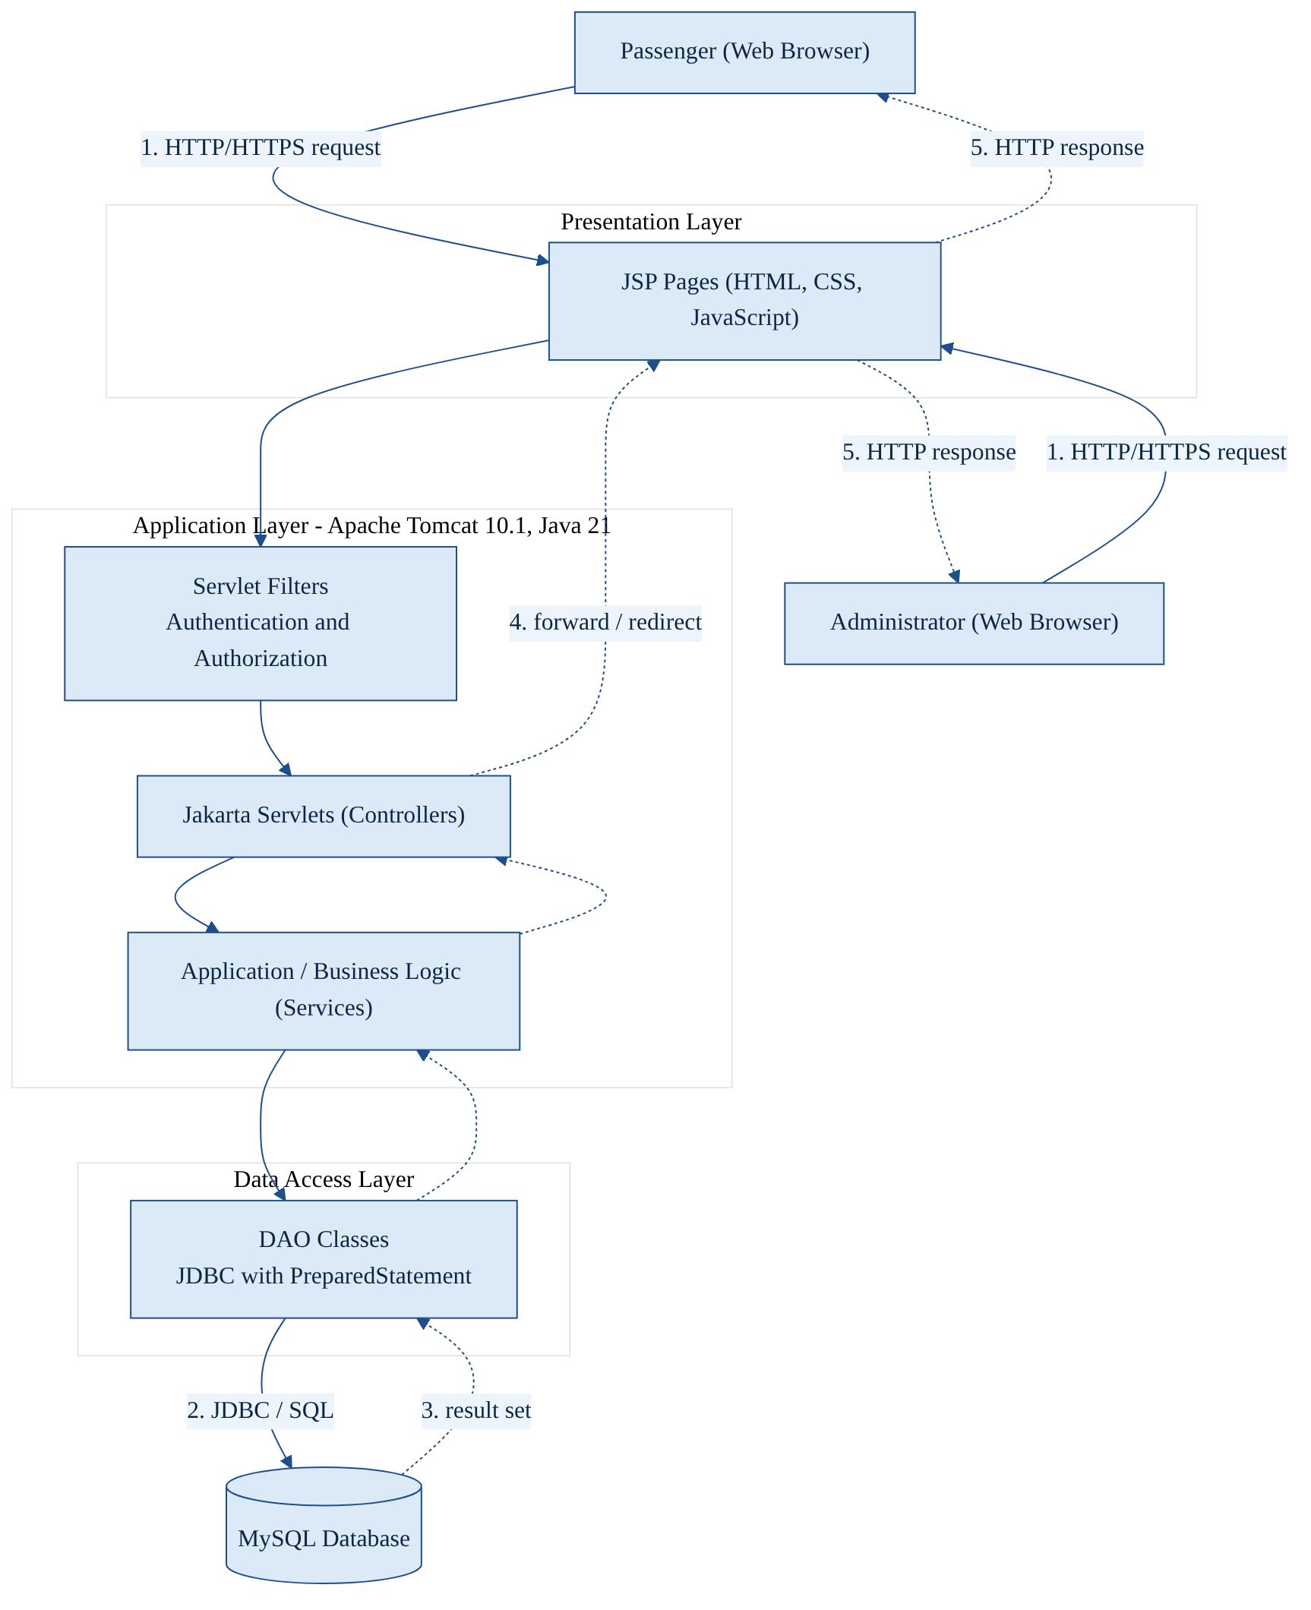
Figure 4.1: System architecture (proposed design; reproduced from SRS Figure 1)

4.3 Module Design
Table 4.1 states the responsibility of each module and the tables it uses. Module 1 supplies identity and role to every other module; Module 2 supplies the selected flight to Module 3; Module 4 operates on the bookings that Module 3 creates; and Module 5 maintains the flight data used by Modules 2 and 3 and reviews booking data from Modules 3 and 4.
Table 4.1: Module overview
Module | Main processing | Tables used
1. Authentication & User Management | Registration, salted hashing, credential check, sessions, roles, profile. | Users (read/write)
2. Flight Search & Availability | Criteria validation, query of ACTIVE flights, availability, selection. | Flights, Bookings (read)
3. Booking & Passenger Management | Revalidation, availability recheck, seat allocation, PNR, transactional save. | Bookings, Passengers (write); Flights (update seats)
4. Ticketing & Cancellation | Ticket display, history, PNR lookup, eligibility checks, status transition. | Bookings, Tickets, Passengers; Flights (restore seats)
5. Admin Dashboard & Flight Mgmt. | Authorization, flight CRUD or deactivation, schedules, fares, reports. | Flights (read/write); Bookings (read)

4.4 Security, Transaction and Integrity Design
Controllers enforce authentication, role checks, session expiry and anti-CSRF tokens; JSP pages encode all output and show controlled error pages; services apply salted password hashing, ownership checks and non-revealing responses; the data layer uses prepared statements only and keeps credentials in external configuration; and the database enforces keys, uniqueness and check constraints.
Booking creation (FR-16 to FR-23) runs in one transaction that rechecks availability, allocates a seat or decrements the count, generates a unique PNR and inserts the booking and passenger records; success commits, and any validation, availability or database failure rolls back with a safe message. Cancellation (FR-28 to FR-32) sets booking and ticket status to CANCELLED and restores availability in one transaction, conditioned on the current status so that a repeat request changes nothing. Statuses change only through the transitions of Figure 5.6, and flights referenced by bookings are deactivated, never deleted (FR-37, NFR-20).

5. UML DIAGRAMS
The use-case, sequence, class and activity diagrams are reproduced from the SRS (Figures 2 to 6); the state diagram was prepared for this report from the SRS requirements. All are proposed designs to be reconciled with the implementation.

5.1 Use-Case Diagram
Figure 5.1 shows the Passenger and Administrator actors. Login and Logout are shared; Search Flights includes View Availability; Book Flight includes Select Flight and Enter Passenger Details; and Request Cancellation includes Search Booking by PNR. The administrator manages flights, routes, schedules and fares and views the dashboard, bookings and reports.
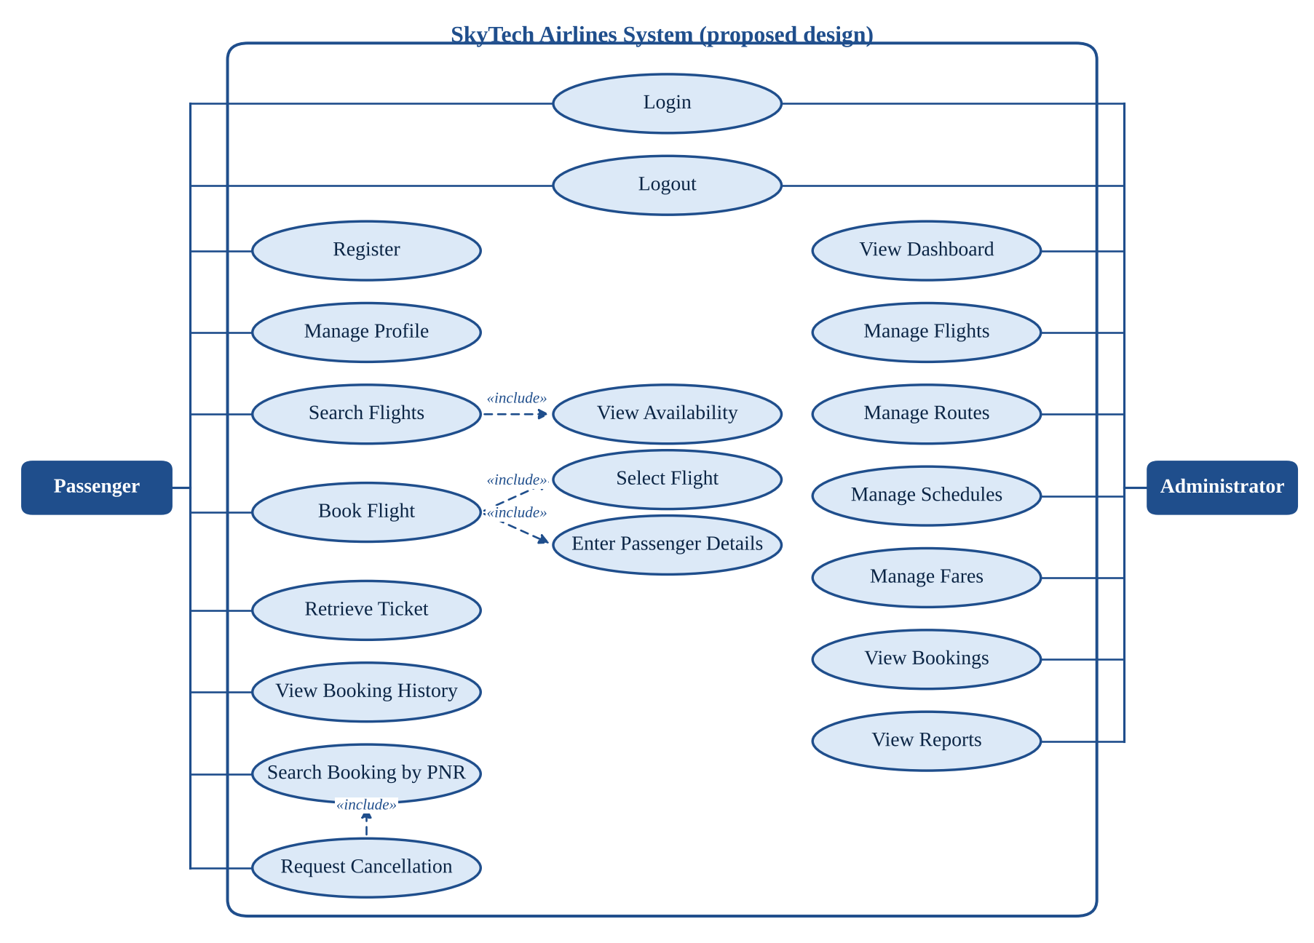
Figure 5.1: UML use-case diagram (SRS Figure 2)

5.2 Sequence Diagram — Passenger Login
Figure 5.2 shows credential processing: invalid input is rejected at once; otherwise the authentication service loads the user through the DAO and verifies the password against the salted hash. Success creates a new session and redirects by role; failure returns a generic message that does not reveal whether the email exists.
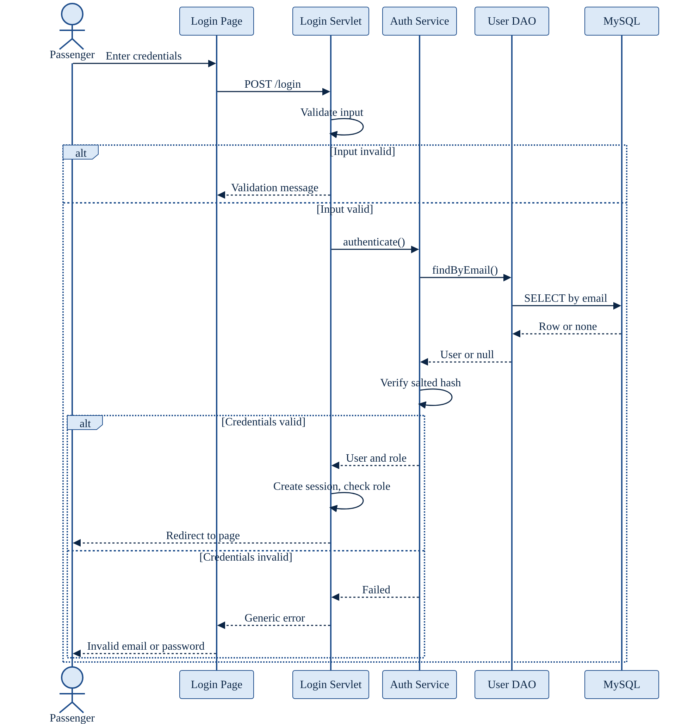
Figure 5.2: Passenger login sequence diagram (SRS Figure 3)

5.3 Sequence Diagram — Flight Search and Booking
Figure 5.3 shows the search and booking flow: validated criteria, results, server-side revalidation of the selected flight, validation of passenger details, then one transaction that rechecks availability, allocates a seat, generates a unique PNR and inserts the records. Success commits and returns a confirmation; any failure rolls back. Payment is outside the confirmed scope.
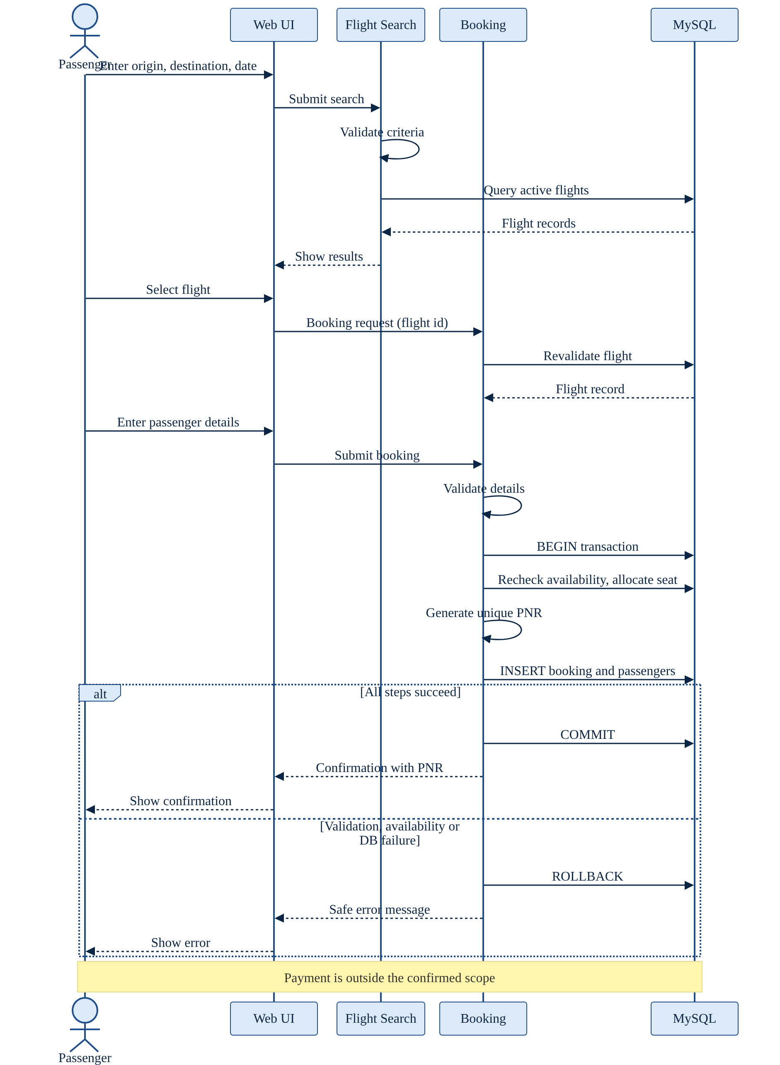
Figure 5.3: Flight search and booking sequence diagram (SRS Figure 4)

5.4 Class Diagram
Figure 5.4 shows the conceptual entities and services. A User makes zero or more Bookings; a Flight is reserved in zero or more Bookings; a Booking contains one or more Passengers and has at most one Ticket. The AuthenticationService, FlightService, BookingService, TicketService and AdminService group operations by module.
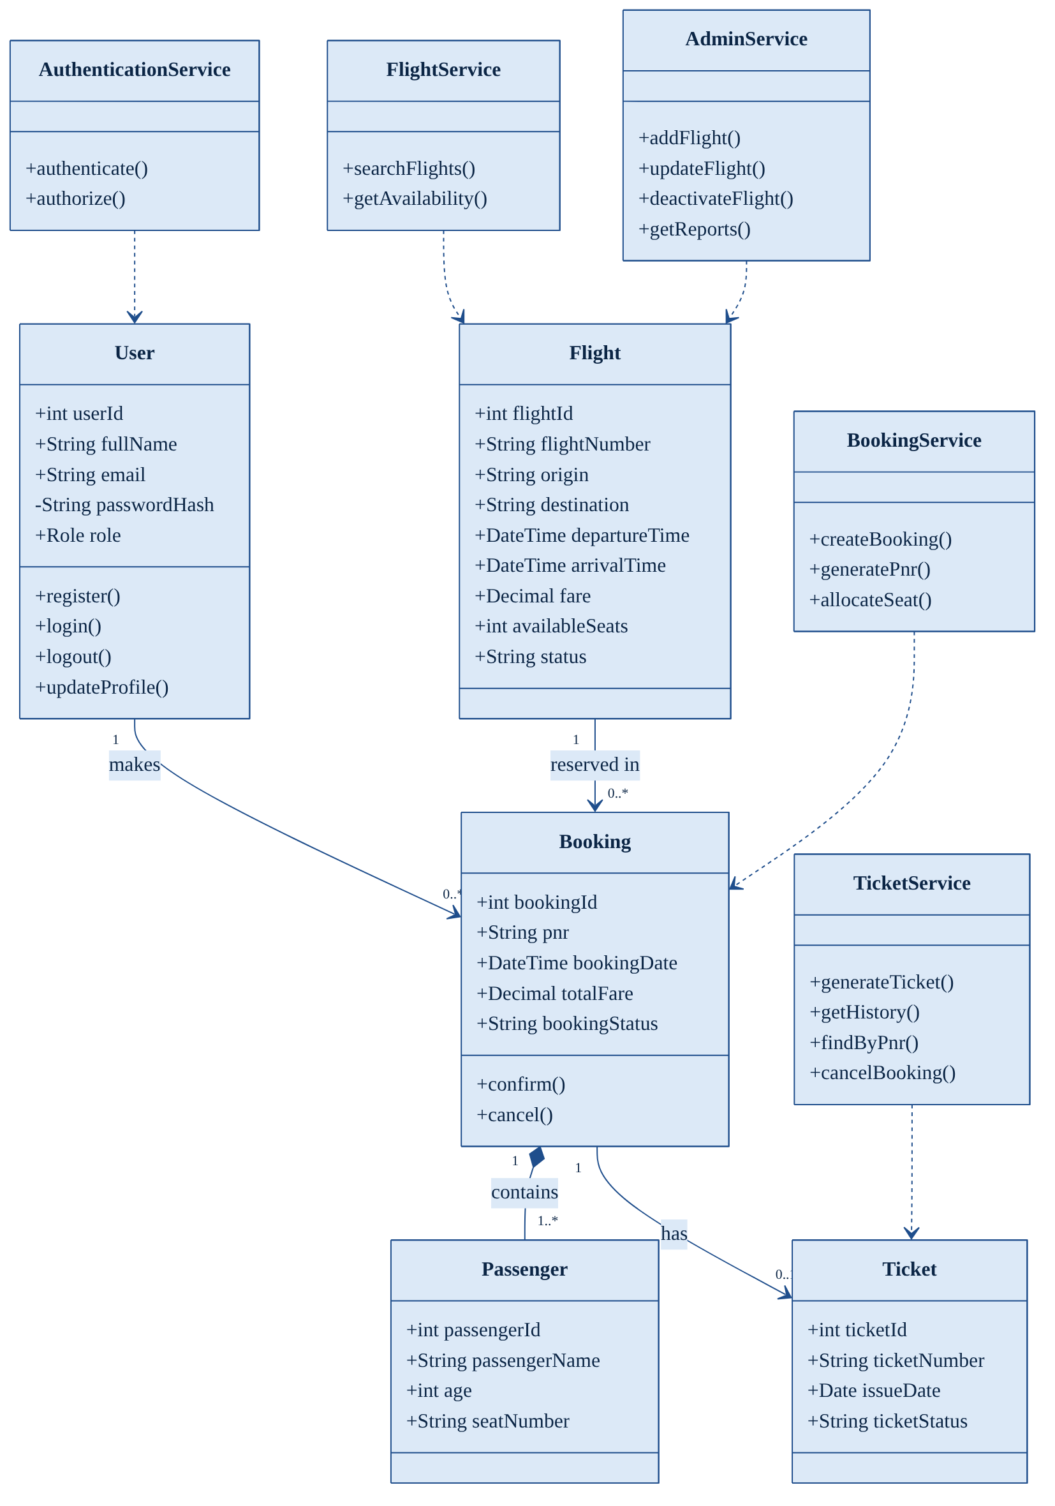
Figure 5.4: Conceptual class diagram (SRS Figure 5)

5.5 Activity Diagram — Ticket Cancellation
Figure 5.5 shows the cancellation logic: an unknown PNR, a booking owned by another user, an already cancelled booking and an ineligible booking each end with a specific message; an eligible booking is cancelled after the passenger confirms, inside a transaction that updates booking and ticket status and rolls back on failure. Refunds are not modelled.
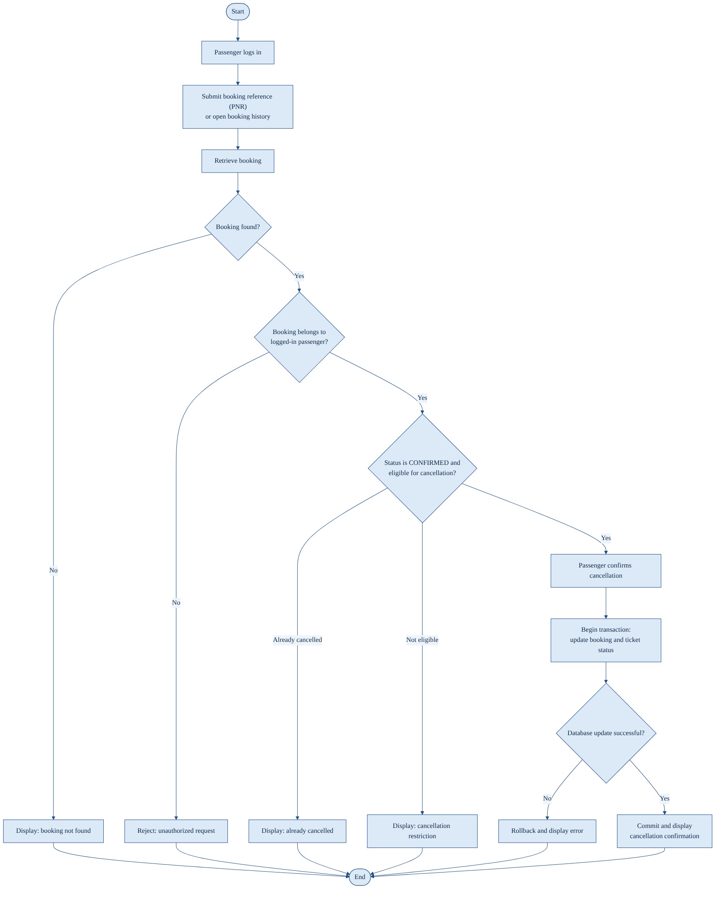
Figure 5.5: Ticket cancellation activity diagram (SRS Figure 6)

5.6 State Diagram
Figure 5.6 shows the permitted status values: a flight is created ACTIVE and may be deactivated; a booking moves from CONFIRMED to CANCELLED and a ticket from ISSUED to CANCELLED (NFR-18). The SRS defines no reactivation, so none is shown.
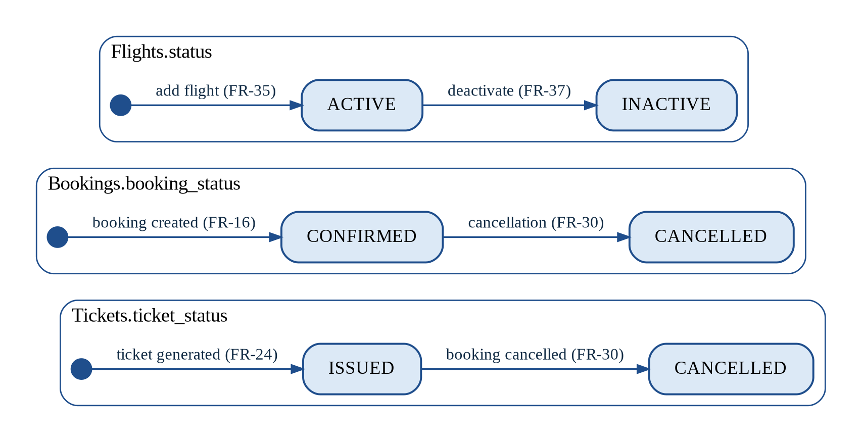
Figure 5.6: State transitions of flight, booking and ticket status (prepared for this report)

6. DATA FLOW DIAGRAMS

6.1 Introduction
A data flow diagram shows how data moves between external entities (rectangles), processes (circles) and data stores (open-ended rectangles) [10], [11]. The SRS contains no DFDs; those below were prepared for this report from the functional requirements and the module overview and are to be reviewed by the mentor. An entity or store drawn twice in one diagram is the same item, repeated to avoid crossing lines.

6.2 Level 0 — Context Diagram
Figure 6.1 treats the system as one process exchanging data with the Passenger (registration, login, search, passenger details, PNR and cancellation requests in; authentication result, flights, confirmation, ticket, history and cancellation outcome out) and the Administrator (credentials, flight, route, schedule and fare data, report requests in; dashboard, results, records and reports out).
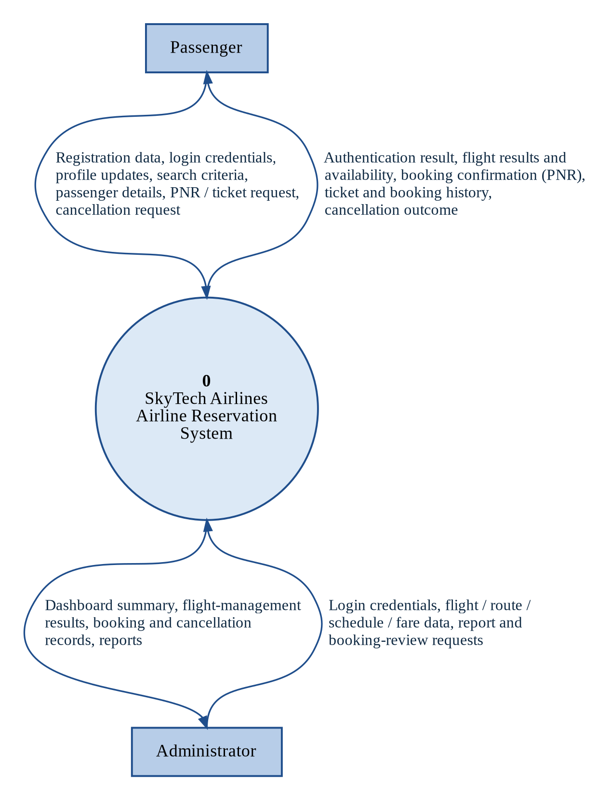
Figure 6.1: Level 0 data flow diagram (context diagram)

6.3 Level 1 DFD
Figure 6.2 decomposes the system into the five modules (processes 1.0 to 5.0) and five data stores D1 to D5. Process 1.0 also supplies the identity and role used by processes 2.0 to 5.0; these flows are not drawn. Table 6.1 summarizes each process.
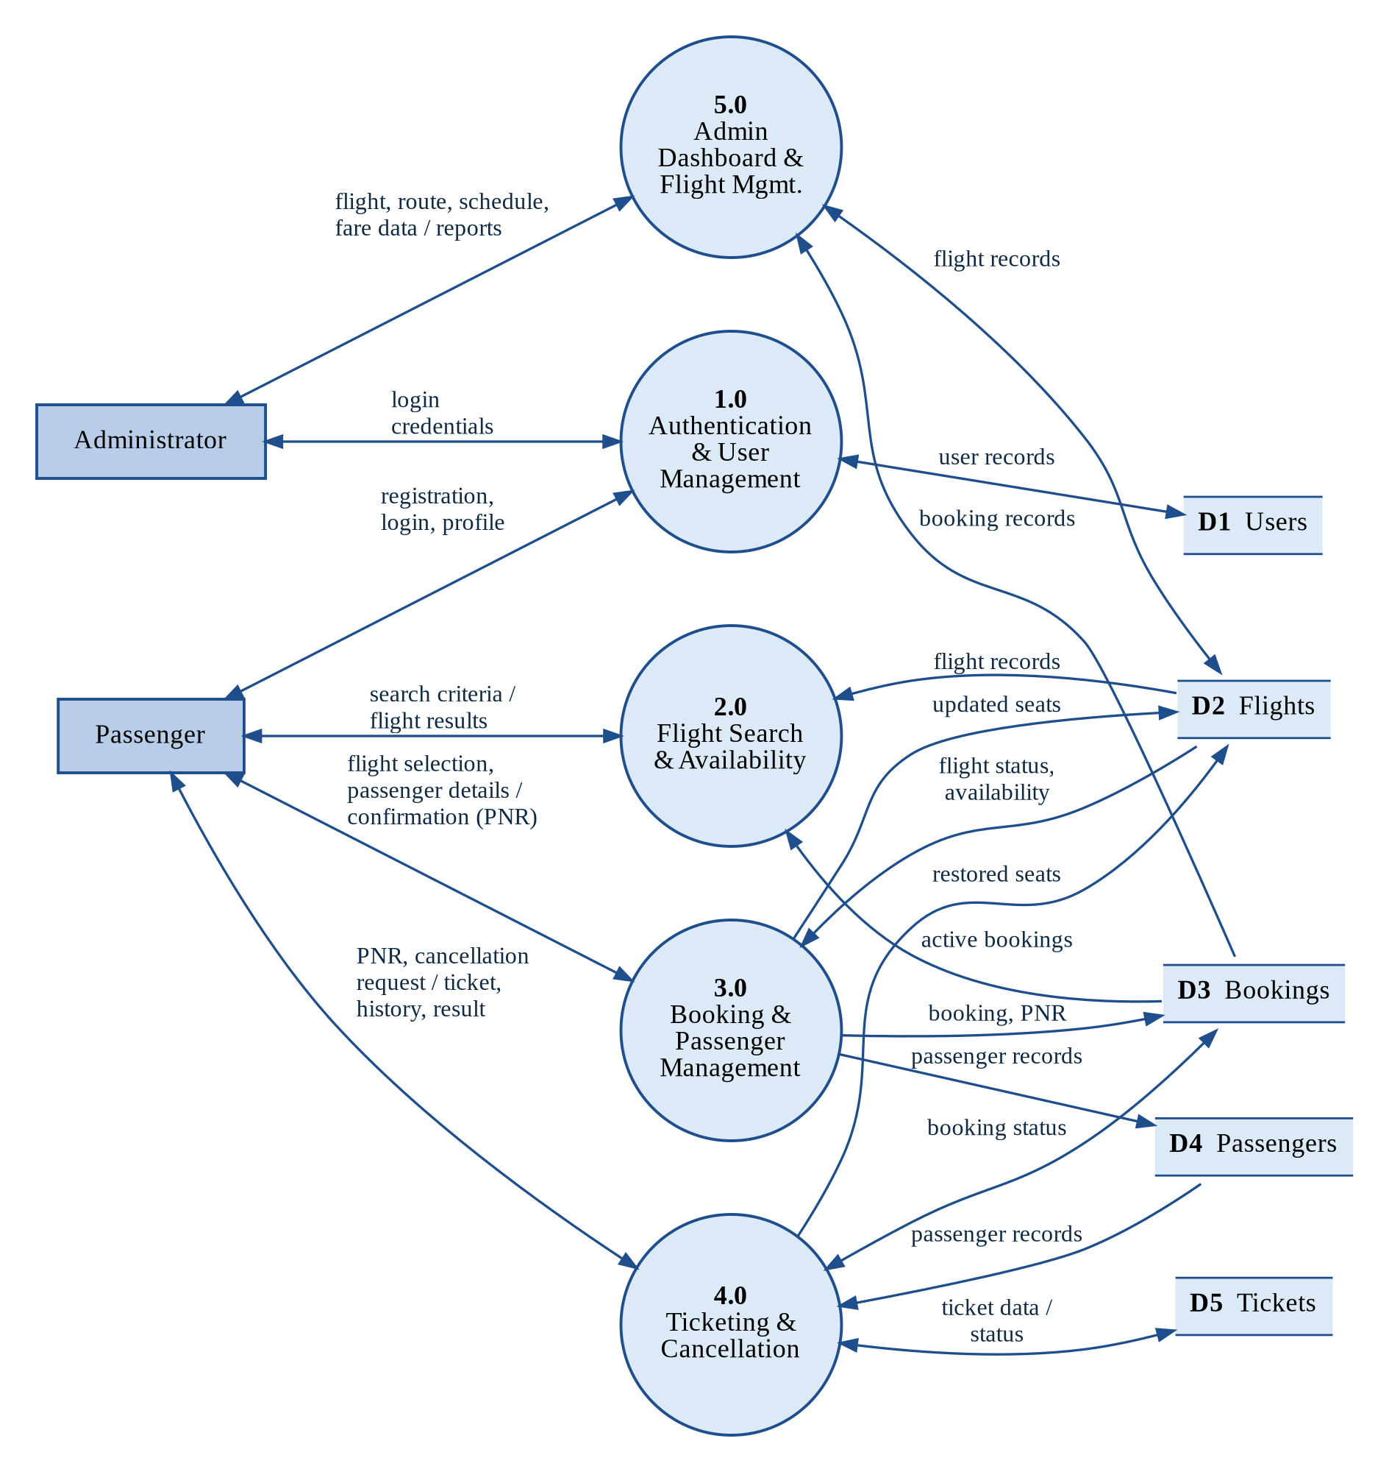
Figure 6.2: Level 1 data flow diagram
Table 6.1: Level 1 processes and data stores
Process | Function | Data stores | Requirements
1.0 Authentication & User Mgmt. | Registers users, verifies credentials, manages sessions and roles. | D1 Users | FR-01 to 08
2.0 Flight Search & Availability | Validates criteria, queries active flights, derives availability. | D2 Flights, D3 Bookings (read) | FR-09 to 14
3.0 Booking & Passenger Mgmt. | Validates, allocates seat, generates PNR, saves transactionally. | D2 (update), D3, D4 (write) | FR-15 to 23
4.0 Ticketing & Cancellation | Tickets, history, PNR lookup, validated cancellation. | D3, D4, D5; D2 (restore) | FR-24 to 33
5.0 Admin Dashboard & Flight Mgmt. | Manages flights, schedules, fares; dashboard and reports. | D2 (read/write), D3 (read) | FR-34 to 42

The SRS requires a ticket to be generated or displayed for a confirmed booking (FR-24) but does not state which module inserts the Tickets row; this is listed in Appendix A.

6.4 Level 2 DFD — Process 3.0 Booking
Figure 6.3 expands the booking process into six sub-processes that follow the sequence of Figure 5.3: revalidate the flight (3.1, FR-14, FR-22), validate passenger details (3.2, FR-15), recheck availability and allocate a seat (3.3, FR-12, FR-18), generate a unique PNR (3.4, FR-17), persist booking and passengers in one transaction (3.5, FR-16, FR-20) and return the confirmation or a safe error message (3.6, FR-19, FR-23).
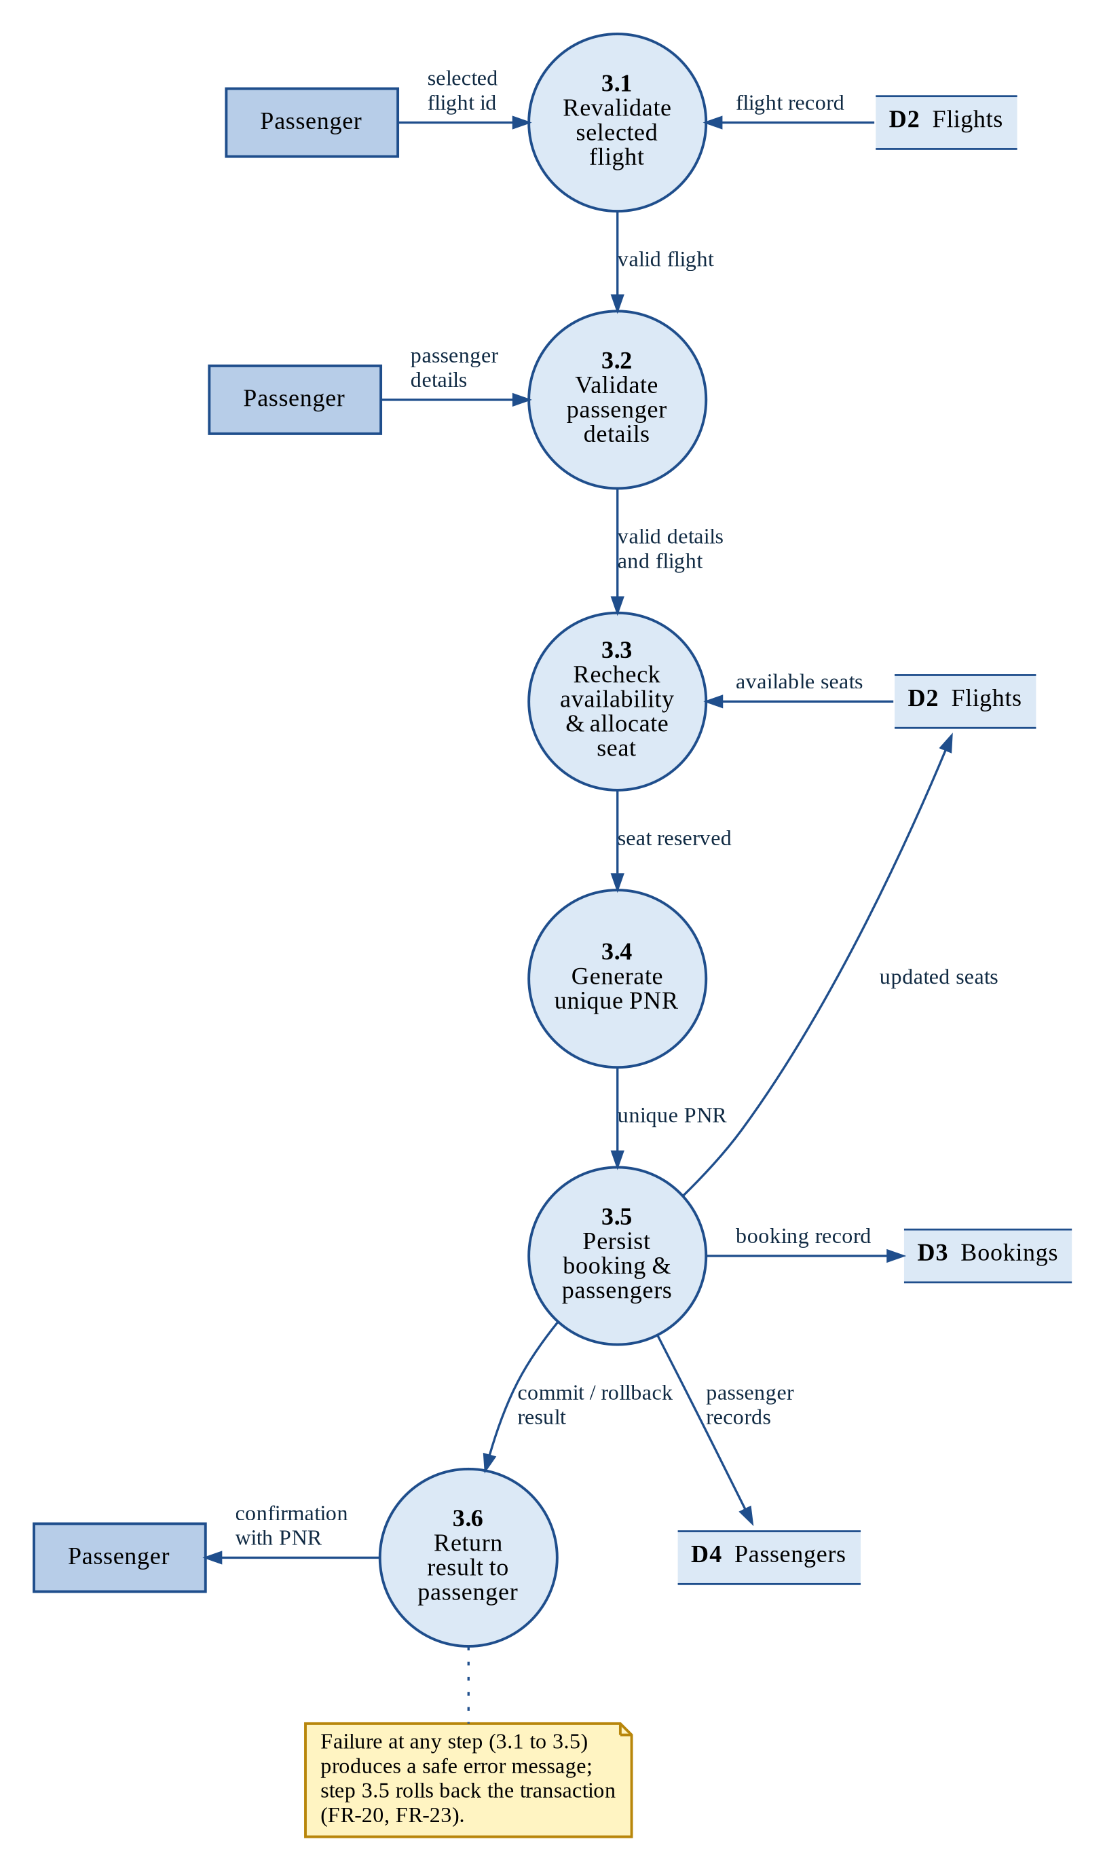
Figure 6.3: Level 2 data flow diagram of process 3.0 (booking)

7. DATABASE DESIGN AND ER DIAGRAM

7.1 Entity-Relationship Model
The database holds users, flights, bookings, passengers and tickets and is the single source of truth for availability and status. Figure 7.1 shows the five entities with primary keys (PK), foreign keys (FK) and unique keys (UK); Table 7.1 gives the relationships. The design is a proposed conceptual one, to be reconciled with the actual schema file (schema.sql).
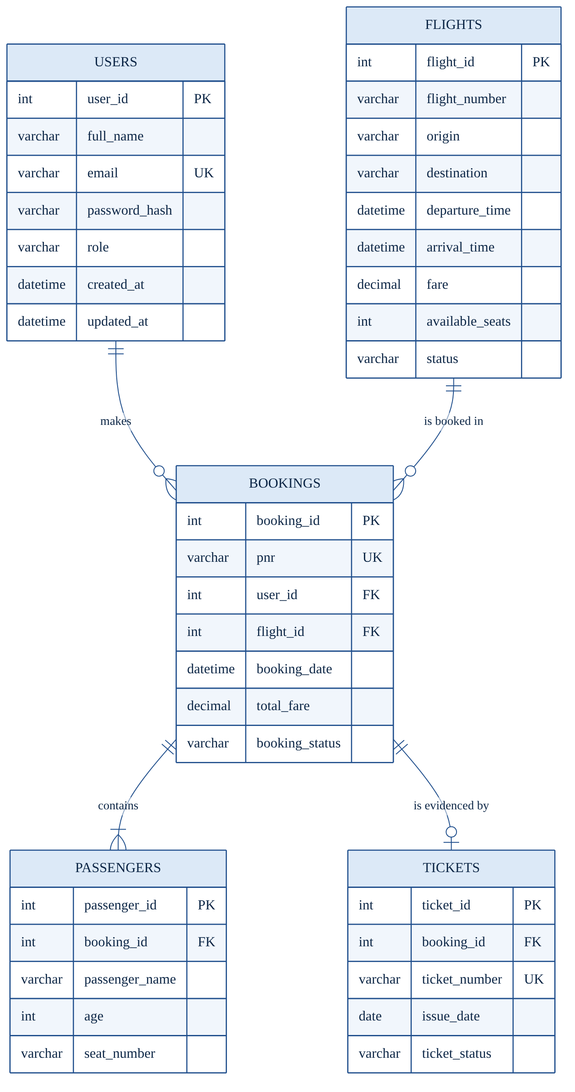
Figure 7.1: Entity-relationship diagram (proposed conceptual design; SRS Figure 7)
Table 7.1: Relationships between entities
Relationship | Cardinality | Meaning
Users – Bookings (makes) | One to zero-or-many | A user makes zero or more bookings; each booking has one user.
Flights – Bookings (is booked in) | One to zero-or-many | A flight appears in zero or more bookings; each booking is for one flight.
Bookings – Passengers (contains) | One to one-or-many | A booking contains one or more passengers.
Bookings – Tickets (is evidenced by) | One to zero-or-one | A booking has at most one ticket.

7.2 Data Dictionary
Table 7.2 lists the 33 fields of the five tables (suggested types are to be reconciled with the schema file). Fields marked NOT NULL are required.
Table 7.2: Tables, fields and constraints
Table | Fields (type) | Key constraints
Users | user_id (INT), full_name, email, password_hash, role, created_at, updated_at | PK user_id; UNIQUE email; role in (PASSENGER, ADMIN); password_hash holds only the salted hash.
Flights | flight_id (INT), flight_number, origin, destination, departure_time, arrival_time, fare (DECIMAL), available_seats (INT), status | PK flight_id; origin ≠ destination; arrival > departure; fare > 0; seats ≥ 0; status in (ACTIVE, INACTIVE); flight_number with departure_time unique.
Bookings | booking_id (INT), pnr, user_id, flight_id, booking_date, total_fare (DECIMAL), booking_status | PK booking_id; UNIQUE pnr; FK user_id, flight_id; status in (CONFIRMED, CANCELLED).
Passengers | passenger_id (INT), booking_id, passenger_name, age (INT), seat_number (nullable) | PK passenger_id; FK booking_id; seat unique per flight among active bookings where seats are allocated.
Tickets | ticket_id (INT), booking_id, ticket_number, issue_date, ticket_status | PK ticket_id; FK booking_id (UNIQUE); UNIQUE ticket_number; status in (ISSUED, CANCELLED).

7.3 Integrity Rules and Design Notes
- Primary, foreign and unique keys and check constraints enforce the rules above; booking creation and cancellation run in single transactions; ticket status agrees with booking status; historical rows are never hard-deleted.
- Fare history: total_fare is stored at booking time so later fare changes do not alter past bookings (FR-40).
- Availability: Flights stores available_seats, while FR-12 allows it to be derived from capacity; the team must decide which, and add a capacity column if derived.
- Seat uniqueness: the Passengers table has no flight reference, so a database-level unique seat constraint would require one (SRS Section 7.7).

8. IMPLEMENTATION
Status of this chapter
This chapter records the implementation approach specified in the SRS. The source code was not inspected and the SRS asserts no completed implementation, so nothing here claims that any part has been built.

8.1 Technology Stack and Architecture Mapping
The implementation uses Java 21, JSP, Jakarta Servlet 6.0 on Apache Tomcat 10.1, JDBC with MySQL 8.0 or compatible, Apache Maven and Git/GitHub (versions to be confirmed). JSP files form the views and contain no database access. Servlet filters check the session and role before any protected servlet runs (FR-05, FR-07). Servlets validate parameters, call service classes and forward to a JSP or redirect after a state-changing request (supporting FR-21). Service classes hold the reservation rules and decide transaction boundaries, and DAO classes execute parameterized SQL through JDBC.

8.2 Module-wise Implementation Specification
- Module 1 (FR-01 to FR-08): validate input on the server, check email uniqueness, hash the password with a salted adaptive algorithm and insert a PASSENGER row; at login verify the hash, create a new session and return one generic message on any failure; a filter enforces role and session expiry.
- Module 2 (FR-09 to FR-14): validate criteria, query only ACTIVE flights with a prepared statement, show fare and availability, and pass only the flight identifier on, so that the server revalidates it.
- Module 3 (FR-15 to FR-23): validate passenger details and the flight, then run the booking transaction of Section 8.3; use a one-time token or redirect-after-post against duplicate submissions.
- Module 4 (FR-24 to FR-33): display tickets and history of the logged-in passenger, look up by PNR with an ownership check, and cancel through the conditional transaction of Section 8.3.
- Module 5 (FR-34 to FR-42): restrict every page to ADMIN, compute dashboard counts from the database, validate flight data, deactivate rather than delete booked flights and produce reports from real records.

8.3 Key Logic (Pseudocode)
The pseudocode below was derived from the stated requirements for the operations with the highest integrity risk; it is not extracted from source code.
CREATE_BOOKING(user, flightId, passengers):
validate passenger details // FR-15
BEGIN TRANSACTION
flight <- read flight flightId
IF missing OR status <> 'ACTIVE' OR departed OR seats < n
THEN ROLLBACK; return specific message // FR-22
allocate seat(s) OR decrement available_seats // FR-18
pnr <- unique random code (retry on collision) // FR-17
INSERT booking(pnr, user, flightId, fare, 'CONFIRMED')
INSERT passenger rows
COMMIT; on ANY exception ROLLBACK, log, safe message // FR-20, FR-23

CANCEL_BOOKING(user, pnr, confirmed):
booking <- find by PNR; IF missing OR owner <> user THEN "not found"
IF status = 'CANCELLED' THEN "already cancelled" // FR-31
IF NOT eligible OR NOT confirmed THEN message // FR-28, FR-29
BEGIN TRANSACTION
n <- UPDATE Bookings SET status='CANCELLED'
WHERE id = ? AND status = 'CONFIRMED'
IF n = 0 THEN ROLLBACK; "already cancelled"
UPDATE Tickets SET ticket_status='CANCELLED'; restore availability
COMMIT; on failure ROLLBACK // FR-30

8.4 Database, Build and Deployment
The database is created from one schema script with the structure of Chapter 7 and seeded with one administrator, at least two passengers and several active flights; administrators are not created through public registration. The specified deployment steps are: (1) install JDK 21, Maven, Tomcat 10.1 and MySQL; (2) run the schema and seed scripts; (3) set the JDBC settings in configuration outside source control; (4) build with Maven (WAR packaging assumed); (5) deploy to Tomcat 10.1 and start it; and (6) log in with the seeded accounts to run the acceptance tests. A manual database backup and restore procedure is to be documented (NFR-38).

9. TESTING

9.1 Test Strategy
The test plan is requirement-driven. Unit and module tests cover servlet, service and DAO behaviour; integration tests follow the journey login, search, booking, ticket and cancellation against one shared database; system tests are the functional cases TC-01 to TC-22; security tests are ST-01 to ST-07; usability and accessibility are checked against NFR-22 to NFR-25 and NFR-39 to NFR-41; and acceptance testing demonstrates AC-01 to AC-12 to the mentor. Tests run on a clean database with seed data on Tomcat 10.1 using test data only; the tester records the actual result, status, date and name for each case. In the SRS every case is Not executed.

9.2 Functional Test Cases
Table 9.1: Functional test cases (all recorded as Not executed)
ID | Scenario | Expected result | Status
TC-01 | Registration with valid data | Account created with role PASSENGER; password stored as hash. | Not executed
TC-02 | Registration with duplicate email | Rejected with a duplicate-email message; no new row. | Not executed
TC-03 | Login with valid credentials | Session created; passenger dashboard opens. | Not executed
TC-04 | Login with wrong password or unknown email | Same generic message in both cases; no session. | Not executed
TC-05 | Logout, then Back and protected URL | Session invalidated; redirect to login. | Not executed
TC-06 | Passenger opens the admin URL | Access denied; no admin data returned. | Not executed
TC-07 | Valid flight search | All matching active flights with correct times, fare, availability. | Not executed
TC-08 | Search with a missing field | Validation message; no query run. | Not executed
TC-09 | Search with no matching flights | “No flights found” message. | Not executed
TC-10 | Booking with valid passenger details | Booking CONFIRMED; unique PNR shown; availability reduced. | Not executed
TC-11 | Same booking form submitted twice | Only one booking created. | Not executed
TC-12 | PNR uniqueness over 20 bookings | All PNRs distinct; duplicate insert rejected. | Not executed
TC-13 | Booking persistence after re-login | Booking, passengers and fare appear as stored. | Not executed
TC-14 | Ticket retrieval by own PNR | Ticket and booking details displayed correctly. | Not executed
TC-15 | Lookup of a non-existent PNR | “Booking not found”; no data shown. | Not executed
TC-16 | Cancel an eligible booking | Booking and ticket CANCELLED together; availability restored. | Not executed
TC-17 | Cancel an already cancelled booking | “Already cancelled”; no change; no double restore. | Not executed
TC-18 | Administrator adds a flight | Saved ACTIVE and visible in search. | Not executed
TC-19 | Administrator updates a flight | Changes shown in search; existing bookings keep fare. | Not executed
TC-20 | Negative fare or arrival before departure | Validation error; record unchanged. | Not executed
TC-21 | Database failure during booking | Rolled back; no partial rows; safe message. | Not executed
TC-22 | Passenger B opens passenger A’s booking | Denied or not found; no data of A shown. | Not executed

9.3 Security Test Cases
Table 9.2: Security test cases (all recorded as Not executed)
ID | Scenario | Expected result | Status
ST-01 | SQL injection strings in login and search fields | Treated as data; no bypass; no SQL error shown. | Not executed
ST-02 | Admin URLs as anonymous user and as passenger | Redirect to login or access denied. | Not executed
ST-03 | Old session cookie replayed after logout | Old session rejected. | Not executed
ST-04 | Request after session timeout | Redirect to login with message. | Not executed
ST-05 | Client checks bypassed; oversized or script input | Server rejects or encodes; no script runs. | Not executed
ST-06 | User B changes PNR or id to user A’s | No data of user A returned. | Not executed
ST-07 | Search and login with database stopped | Controlled error page; no stack trace or credentials. | Not executed

9.4 Acceptance Criteria
Table 9.3 is the requirements-to-acceptance matrix. Each criterion stays “Proposed — Pending Verification” until its tests are executed with recorded results; successful compilation alone does not meet them.
Table 9.3: Acceptance criteria (all pending)
No. | Acceptance criterion | Requirements | Tests
AC-01 | A passenger can register with valid information. | FR-01, 04, 08 | TC-01, 02
AC-02 | Invalid credentials do not grant access. | FR-02 | TC-04, ST-01
AC-03 | Passengers cannot perform administrator-only actions. | FR-05, 41 | TC-06, ST-02
AC-04 | Valid search criteria produce matching flights. | FR-09, 10, 13 | TC-07, 08, 09
AC-05 | A successful booking produces a unique PNR. | FR-16, 17 | TC-10, 12
AC-06 | Booking and passenger data are stored consistently. | FR-19, 20 | TC-10, 13
AC-07 | Authorized users retrieve permitted bookings; others cannot. | FR-24 to 27 | TC-14, 15, 22, ST-06
AC-08 | Eligible cancellations update statuses; repeats change nothing. | FR-28 to 32 | TC-16, 17
AC-09 | Administrators manage flights with validation. | FR-35 to 40 | TC-18, 19, 20
AC-10 | Database errors leave no partial bookings. | FR-20, 23 | TC-21, ST-07
AC-11 | The session ends at logout and at expiry. | FR-03, 07 | TC-05, ST-03, 04
AC-12 | The application builds and starts in the documented environment. | SRS 2.4, 3.2 | Deployment check

9.5 Test Execution Status and Coverage
Of the 29 test cases (22 functional, 7 security), none has been executed and all 12 acceptance criteria are pending. Mapping each functional requirement to the tests that check its acceptance condition shows that 32 of the 42 requirements (76.2%) are covered by at least one test case (Table 9.4). This analysis was performed for this report and is not stated in the SRS; for FR-41 only the denial of non-admin access is tested.
Table 9.4: Requirements coverage by module
Module | Requirements | With a test | Without a dedicated test
1. Authentication & User Management | 8 | 7 | FR-06
2. Flight Search & Availability | 6 | 4 | FR-11, FR-14
3. Booking & Passenger Management | 9 | 7 | FR-18, FR-22
4. Ticketing & Cancellation | 10 | 9 | FR-33
5. Admin Dashboard & Flight Management | 9 | 5 | FR-34, FR-37, FR-38, FR-42
Total | 42 | 32 | 10

The ten uncovered requirements should receive test cases taken from their SRS acceptance conditions, for example a concurrent booking of the last seat (FR-18) and booking an inactive, departed or full flight (FR-22).

10. RESULT AND DISCUSSION

10.1 Requirements and Design Outcomes
The work produced the SRS (STAIR-SRS-001 v1.0), 42 functional and 41 non-functional requirements, seven SRS diagrams, a five-table database design with 33 fields, 22 functional and 7 security test cases and 12 acceptance criteria; this report adds data flow diagrams, a status diagram and a coverage analysis. Table 10.1 and Figure 10.1 show the functional requirements by module and priority: 34 (81%) are High, seven Medium and one (FR-11) Optional, and Module 4 has the most requirements (10).
Table 10.1: Functional requirements by module and priority
Module | High | Medium | Optional | Total
1. Authentication & User Management | 7 | 1 | 0 | 8
2. Flight Search & Availability | 4 | 1 | 1 | 6
3. Booking & Passenger Management | 8 | 1 | 0 | 9
4. Ticketing & Cancellation | 8 | 2 | 0 | 10
5. Admin Dashboard & Flight Management | 7 | 2 | 0 | 9
Total | 34 | 7 | 1 | 42

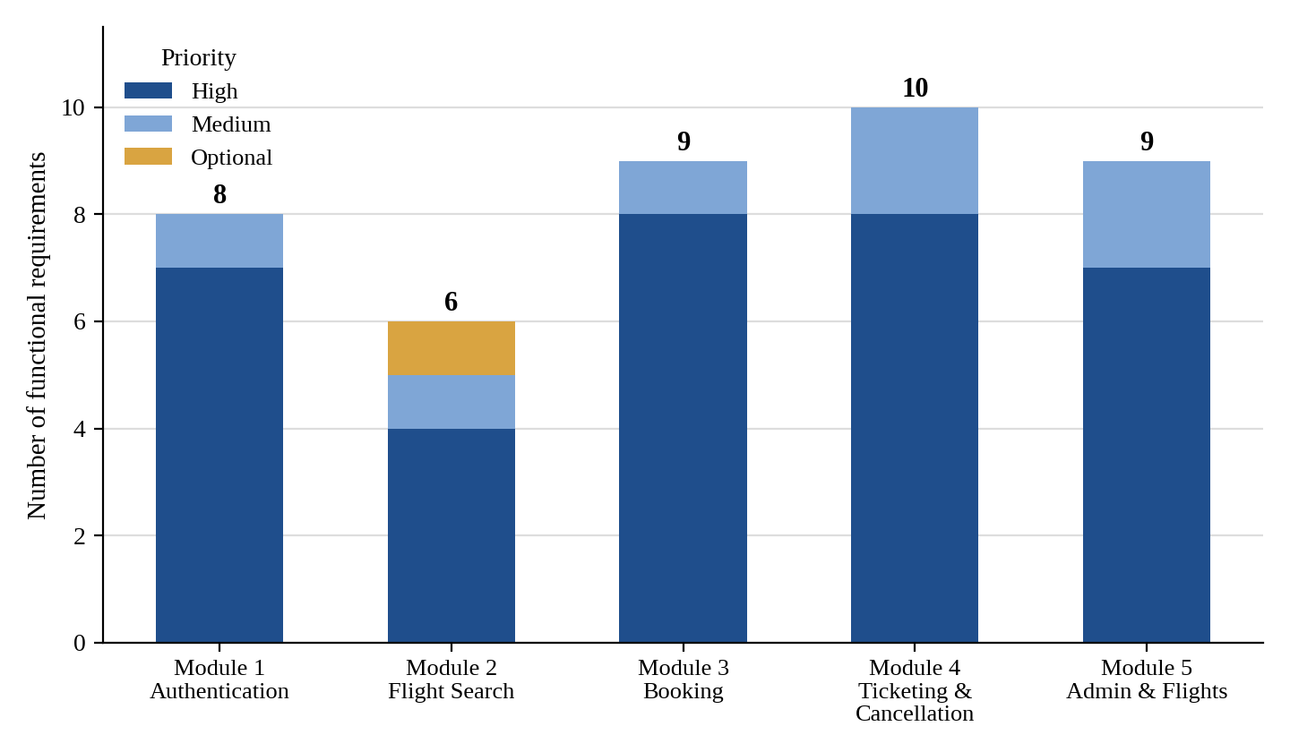
Figure 10.1: Functional requirements by module and priority (prepared from the SRS requirement tables)

10.3 Status of Objectives
Every objective O1 to O10 of Section 1.4 is specified in requirements and addressed in the design; none is yet verified by test evidence. O1 to O3 and O5 to O7 are covered by tests TC-01 to TC-17 and ST-01 to ST-06, O4 by TC-10 and TC-13, O8 by TC-18 to TC-20 and ST-02 (with partial coverage), O9 by TC-12, TC-21 and ST-07, and O10 requires inspection of the code base. All remain pending.

10.4 Discussion
- Strengths: security controls are requirements rather than extras; booking and cancellation are transactional and backed by database constraints; every requirement has an owner, priority and acceptance condition; five modules with explicit dependencies allow parallel development; and out-of-scope items are stated openly.
- Limitations: no test has been executed and ten requirements lack a dedicated test; the password policy, cancellation eligibility rule, performance load and test browsers are undefined; stored versus derived availability, seat-level allocation, route storage and ticket-record insertion remain open; the diagrams and schema are not yet reconciled with the repository; and there is no payment, refund, notification or live-airline integration.
- Resolving these items is the principal remaining work (Appendix A); once tests are run, their actual results should replace “Not executed” in Chapter 9 and be summarized here.

11. CONCLUSION AND RECOMMENDATION

11.1 Conclusion
This report has presented the analysis and design of SkyTech Airlines – Airline Reservation and Passenger Management System, a centralized web application intended to remove the inconsistency, poor traceability and limited administrative visibility of manual reservation processes. The system is defined through 42 functional and 41 non-functional requirements in five modules: authentication, flight search, booking, ticketing and cancellation, and administration. It is designed as a layered Java web architecture over MySQL in which security controls and integrity rules are core requirements, and it is documented through UML diagrams, data flow diagrams, an ER diagram, a data dictionary and a test plan linked to twelve acceptance criteria.
The report describes intended behaviour and does not assert that any function has been implemented, tested or deployed. The next steps are to implement and test the modules against this specification, reconcile the diagrams and schema with the repository, close the items of Appendix A and record the actual test results.

11.2 Recommendations for Future Scope
- Payments and refunds: secure payment-gateway integration and refund management to complete the booking and cancellation flow.
- Notifications and tickets: email or SMS confirmations and printable PDF tickets.
- Seat map: passenger selection of specific seats from an aircraft layout.
- Account security: password reset, multi-factor authentication, optional Google Sign-In (if configured and verified) and audit logging.
- Integration: live airline inventory and flight-status APIs in place of the local data set.
- Analytics: richer administrative reporting and analytics.
- Operations: automated backups and secure cloud deployment with HTTPS.
- Reach: accessibility improvements and multilingual support.

12. APPENDICES

Appendix A: Items to Confirm Before Submission
The SRS states that several items are assumptions or proposals to be checked against the actual project. They are consolidated, with the open decisions found in this report, in Table A.1.
Table A.1: Items to confirm or complete
No. | Item
1 | Verify installed versions of JDK 21, Maven, Tomcat 10.1, MySQL and the JDBC driver from the build file; confirm WAR packaging, session-based authentication and whether Bootstrap 5 is used.
2 | Reconcile the diagrams, class names, packages and pages with the repository, and the data dictionary with the actual schema file.
3 | Decide whether available seats are stored or derived, whether a flight reference is added to seat records, and which module inserts the Tickets row.
4 | Define the password policy (minimum length, character mix) and the cancellation eligibility rule (FR-01, FR-29).
5 | Define the performance test load and data size and name the two test browsers (NFR-12, 13, 32).
6 | Confirm which optional behaviours are implemented: filtering and sorting, seat-level allocation, duplicate-submission token, separate route storage, HTTPS.
7 | Execute all 29 test cases, add tests for the ten uncovered requirements, and record results; then update Chapters 8 and 10 with repository evidence.
8 | Obtain mentor review, signatures and institutional approval; verify roll numbers; add dates of access for the references.

13. REFERENCES
References [1]–[9] are those listed in the SRS; dates of access are to be added when each source is verified. References [10]–[13] are standard textbooks added in this report to support the concepts discussed in Chapter 2; they are not part of the SRS reference list.
[1] Oracle, “Java Documentation.” [Online]. Available: https://docs.oracle.com/en/java/
[2] Eclipse Foundation, “Jakarta Servlet Specification.” [Online]. Available: https://jakarta.ee/specifications/servlet/
[3] Apache Software Foundation, “Apache Tomcat Documentation.” [Online]. Available: https://tomcat.apache.org/
[4] Oracle, “Java Database Connectivity (JDBC) Documentation.” [Online]. Available: https://docs.oracle.com/javase/8/docs/technotes/guides/jdbc/
[5] Eclipse Foundation, “Jakarta Pages (JSP) Specification.” [Online]. Available: https://jakarta.ee/specifications/pages/
[6] Oracle, “MySQL Documentation.” [Online]. Available: https://dev.mysql.com/doc/
[7] Apache Software Foundation, “Apache Maven Guides.” [Online]. Available: https://maven.apache.org/guides/
[8] OWASP Foundation, “OWASP Cheat Sheet Series.” [Online]. Available: https://cheatsheetseries.owasp.org/
[9] Object Management Group, “Unified Modeling Language (UML) Specification.” [Online]. Available: https://www.omg.org/spec/UML/
[10] I. Sommerville, Software Engineering, 10th ed. Harlow, U.K.: Pearson, 2015.
[11] R. S. Pressman and B. R. Maxim, Software Engineering: A Practitioner’s Approach, 9th ed. New York, NY, USA: McGraw-Hill, 2019.
[12] R. Elmasri and S. B. Navathe, Fundamentals of Database Systems, 7th ed. Hoboken, NJ, USA: Pearson, 2016.
[13] D. Alur, J. Crupi and D. Malks, Core J2EE Patterns: Best Practices and Design Strategies, 2nd ed. Upper Saddle River, NJ, USA: Prentice Hall, 2003.

