1. Team members:
tool used for creating diagrams: Creately online app.
TEAM MEMBERS:-
1) Somu Bhargava 201501017
2) Nikhil Rayaprolu 201501090
2. Class Diagram:
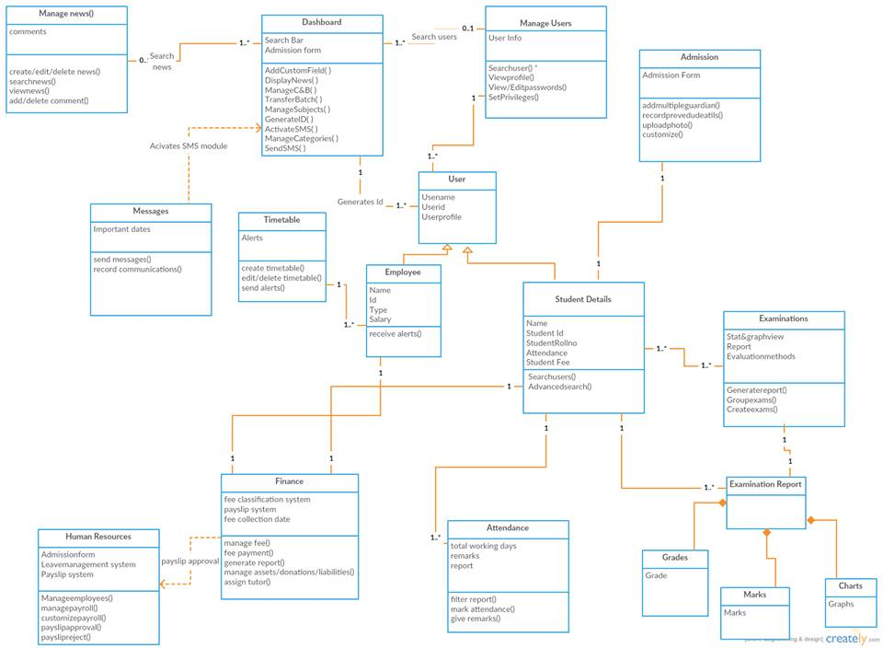
3. Summary for all the major classes

Manage Users | This helps us to view all the users based on their roles and set privileges to users. You can also change the user password and privileges. It allows organization to set standards for different roles based on their responsibilty.
Dashborad | It should have user friendly interface with highly powerful user experience design. It also displays latest news on dashboard and basic institute education information. Language, country, currency, time zone etc can be set. There should be enabling of grading system for students. Unique id for all the users. It should be managing courses batches, subjects. There is a custom field for admission form. Set SMS configuration for alerts to one single user or group of people.
Admission | It should consists of a comprehensive admission form and giving unique id to every student. There should be photo upload facility. Multiple guardian can be added. Previous education details and emergency contact can be recorded. Customize as per school standard.
Student details | This class will be used for student’s deatils. It should have normal student view facilities based on the batches. Search of existing and former students and also large number of filters to search specific student.
Examinations | It will help us create different types of exams based on grades, number of people giving exams etc. It can aslo generate report for required exams. Statistical and graohical view of all reports. Automated report generation. GPA, CCE, CWA etc evaluation method.
Human Resources | Manage all employees from admission to exit. Customizable admission form and payroll form. Manage entire payroll efficiency. Efficient leave management system available. Authenticated payslip approval system. Normal and advanced search facility.
Finance | Separate fee collection date designing system for faster finance process. Easy analysis for fee defaulter and fee structure available. Easy fee submission process. Customize and manage different categories of expense and incomes and manage and pay instant fees. Different report generation and automatic transaction facility.
Timetable | This is used by users to drag and drop to make timetable. Alert on subject limits per week stats. Alerts on employee subject limits while creating time table. Edit and delete time table.
Manage news | Create , delete, edit news. Search for any news in search bar. View all news facility. Add news in text format. Published news has facility to comment on it or delete comments by the users.
User | It is the class used for taking all the users related to the institute. It has two children, employee and student details. It will have different class to manage students and employees. It saves the unique user id, user name and user profile.

4. UML use case diagram:
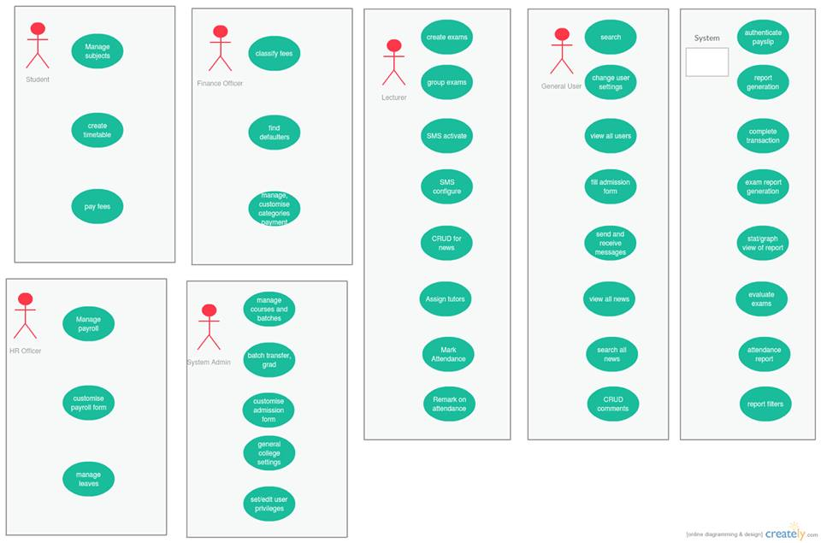
5. We can see that there is an overall low coupling in our class structure. There is also a separation of different ‘problems’. We used the modular structure given to us, and therefore there is a separation of concerns. The Laws of Demeters are also followed. No classes which are not similar are related. The only classes that are related are the ones which have interelated attributes. Information from one class is not hidden from other classes. The minimum number of attributes are placed in each class to make it as readable as possible. Since each separate functionality is put in separate classes, there is lot of room for evolution of the product. If any new feature needs to be added, it will only affect a single class since we have segregated the classes in such a way that there is a proper segregation of concerns.

6.
Two design flaws:
- In the class ‘examination report’ we see that there is unecessary coupling with the students details. We could rather just have one relationship between ‘examination’ and the ‘report’ class.
- We have inheritance to a class examination report, which does nothing in particular at all, and hence we wouldn’t need to inherit it anyways, but we have.
Two design strenghts:
- There is loose coupling between classes.
- There is a separation of concerns in such a way that each class only takes responsibility of one part of the system. Added features to this system should be easy as there is only a need to update few classes.

