REPORT FOR BEST PROMPTING APPROACHES

Often, natural language instructions are challenging for robots to grasp due to their unstructured nature. Thus, creating a robust knowledge representation for robots that can make sense of these unorganized instructions is crucial. This project targets the generation of this knowledge representation, more specifically, creating a 'task tree'. A 'task tree' stands as an ordered sequence of actions that a robot is required to carry out to achieve an intended outcome, providing a systematic breakdown of information. Each step enclosed within this task tree is depicted by what we classify as a 'functional unit'.

1. **APPROACH (A) (Best Approach)** : **Comprehensive Cooking Task Tree**

**Prompt**: This approach provides a detailed and structured prompt for generating task trees for cooking dishes. It includes specific instructions on input requirements, output format, and kitchen item references.

* **Performance Measurement**: This prompt excels in providing detailed instructions, including dish name, preferred ingredients, available kitchen items, and their states. It specifies the desired output format in JSON, ensuring adherence to inundation guidelines. The inclusion of examples and clear goal statements enhances user understanding and performance.
* **Why it's the Best**: Prompt 1 stands out due to its thoroughness and clarity. It offers explicit guidance on input requirements, output format, and the overall task objective. By providing detailed instructions and examples, it reduces ambiguity and helps users generate accurate and comprehensive task trees.

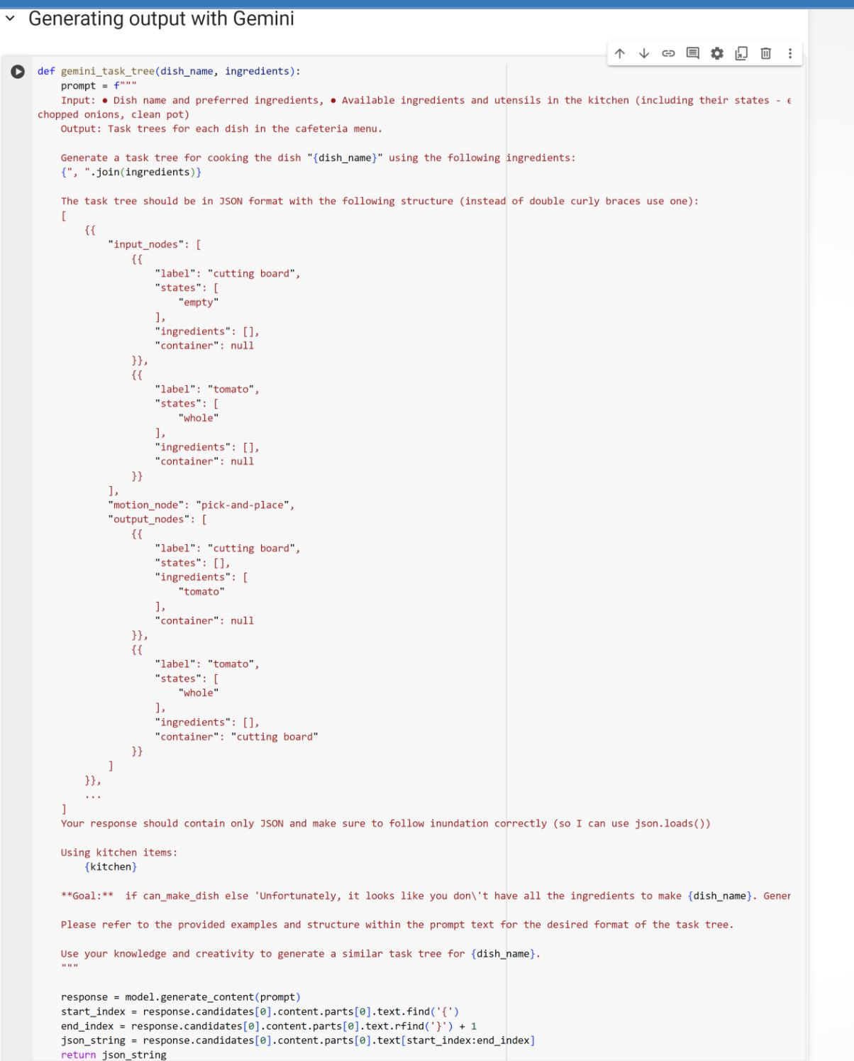

* **Input**: ● Dish name and preferred ingredients ● Available ingredients and utensils in the kitchen (including their states - e.g., chopped onions, clean pot)
* **Output**: The output adheres closely to the provided JSON format, containing input nodes, motion nodes, and output nodes. It is structured and comprehensive, reflecting the instructions in the prompt.
* [{
* "input_nodes": [
* {
* "label": "cutting board",
* "states": [
* "empty"
* ],
* "ingredients": [],
* "container": null
* },
* {
* "label": "chicken breast",
* "states": [
* "whole"
* ],
* "ingredients": [],
* "container": null
* },
* {
* "label": "bowl",
* "states": [
* "empty"
* ],
* "ingredients": [],
* "container": null
* },
* {
* "label": "orange marmalade",
* "states": [
* "sealed"
* ],
* "ingredients": [],
* "container": null
* },
* {
* "label": "chipotle peppers in sauce",
* "states": [
* "sealed"
* ],
* "ingredients": [],
* "container": null
* },
* {
* "label": "garlic pepper seasoning",
* "states": [
* "sealed"
* ],
* "ingredients": [],
* "container": null
* },
* {
* "label": "dijon mustard",
* "states": [
* "sealed"
* ],
* "ingredients": [],
* "container": null
* },
* {
* "label": "coriander",
* "states": [
* "ground"
* ],
* "ingredients": [],
* "container": null
* },
* {
* "label": "cumin",
* "states": [
* "ground"
* ],
* "ingredients": [],
* "container": null
* },
* {
* "label": "garlic",
* "states": [
* "whole"
* ],
* "ingredients": [],
* "container": null
* },
* {
* "label": "paprika",
* "states": [
* "ground"
* ],
* "ingredients": [],
* "container": null
* }
* ],
* "motion_node": "pick-and-place",
* "output_nodes": [
* {
* "label": "cutting board",
* "states": [
* "empty"
* ],
* "ingredients": [
* "chicken breast"
* ],
* "container": null
* },
* {
* "label": "chicken breast",
* "states": [
* "whole"
* ],
* "ingredients": [],
* "container": "cutting board"
* }
* ]
* },
* {
* "input_nodes": [
* {
* "label": "cutting board",
* "states": [
* "chicken breast"
* ],
* "ingredients": [],
* "container": null
* },
* {
* "label": "knife",
* "states": [],
* "ingredients": [],
* "container": null
* }
* ],
* "motion_node": "cut",
* "output_nodes": [
* {
* "label": "cutting board",
* "states": [
* "chicken breast",
* "clean"
* ],
* "ingredients": [],
* "container": null
* },
* {
* "label": "chicken breast",
* "states": [
* "diced"
* ],
* "ingredients": [],
* "container": "cutting board"
* }
* ]
* },
* {
* "input_nodes": [
* {
* "label": "bowl",
* "states": [
* "empty"
* ],
* "ingredients": [],
* "container": null
* },
* {
* "label": "diced chicken",
* "states": [],
* "ingredients": [],
* "container": null
* },
* {
* "label": "orange marmalade",
* "states": [
* "sealed"
* ],
* "ingredients": [],
* "container": null
* },
* {
* "label": "chipotle peppers in sauce",
* "states": [
* "sealed"
* ],
* "ingredients": [],
* "container": null
* },
* {
* "label": "garlic pepper seasoning",
* "states": [
* "sealed"
* ],
* "ingredients": [],
* "container": null
* },
* {
* "label": "dijon mustard",
* "states": [
* "sealed"
* ],
* "ingredients": [],
* "container": null
* },
* {
* "label": "coriander",
* "states": [
* "ground"
* ],
* "ingredients": [],
* "container": null
* },
* {
* "label": "cumin",
* "states": [
* "ground"
* ],
* "ingredients": [],
* "container": null
* },
* {
* "label": "paprika",
* "states": [
* "ground"
* ],
* "ingredients": [],
* "container": null
* }
* ],
* "motion_node": "pick-and-place",
* "output_nodes": [
* {
* "label": "bowl",
* "states": [
* "diced chicken",
* "orange marmalade",
* "chipotle peppers in sauce",
* "garlic pepper seasoning",
* "dijon mustard",
* "coriander",
* "cumin",
* "paprika"
* ],
* "ingredients": [],
* "container": null
* },
* {
* "label": "diced chicken",
* "states": [],
* "ingredients": [],
* "container": "bowl"
* },
* {
* "label": "orange marmalade",
* "states": [
* "sealed"
* ],
* "ingredients": [],
* "container": "bowl"
* },
* {
* "label": "chipotle peppers in sauce",
* "states": [
* "sealed"
* ],
* "ingredients": [],
* "container": "bowl"
* },
* {
* "label": "garlic pepper seasoning",
* "states": [
* "sealed"
* ],
* "ingredients": [],
* "container": "bowl"
* },
* {
* "label": "dijon mustard",
* "states": [
* "sealed"
* ],
* "ingredients": [],
* "container": "bowl"
* },
* {
* "label": "coriander",
* "states": [
* "ground"
* ],
* "ingredients": [],
* "container": "bowl"
* },
* {
* "label": "cumin",
* "states": [
* "ground"
* ],
* "ingredients": [],
* "container": "bowl"
* },
* {
* "label": "paprika",
* "states": [
* "ground"
* ],
* "ingredients": [],
* "container": "bowl"
* }
* ]
* },
* {
* "input_nodes": [
* {
* "label": "bowl",
* "states": [
* "diced chicken",
* "orange marmalade",
* "chipotle peppers in sauce",
* "garlic pepper seasoning",
* "dijon mustard",
* "coriander",
* "cumin",
* "paprika"
* ],
* "ingredients": [],
* "container": null
* },
* {
* "label": "spoon",
* "states": [],
* "ingredients": [],
* "container": null
* }
* ],
* "motion_node": "stir",
* "output_nodes": [
* {
* "label": "bowl",
* "states": [
* "diced chicken",
* "orange marmalade",
* "chipotle peppers in sauce",
* "garlic pepper seasoning",
* "dijon mustard",
* "coriander",
* "cumin",
* "paprika",
* "mixed"
* ],
* "ingredients": [],
* "container": null
* },
* {
* "label": "diced chicken",
* "states": [],
* "ingredients": [],
* "container": "bowl"
* },
* {
* "label": "orange marmalade",
* "states": [
* "sealed"
* ],
* "ingredients": [],
* "container": "bowl"
* },
* {
* "label": "chipotle peppers in sauce",
* "states": [
* "sealed"
* ],
* "ingredients": [],
* "container": "bowl"
* }]
* **Performance**: Approach 1 is expected to yield accurate and detailed task trees due to its clear instructions and specific template. Users are likely to produce task trees that closely match the desired format.

EDGE CASE (If Ingredient is not present in Kitchen List)

[

    "{\n    \"can_make_dish\": false,\n    \"reason\": \"Unfortunately, it looks like you don't have all the ingredients to make Beef Meatballs.\"\n}"

]

1. APPROACH (B) : **Ingredient-based Task Tree Generation**

* **Prompt**: The prompt in this approach focuses on generating task trees for preparing dishes using provided ingredients and referencing available kitchen items. It outlines the task tree structure and provides an example for clarity.
* **Output**: The output follows the JSON format provided in the prompt but may lack the same level of specificity and clarity as Approach 1. It may vary in accuracy and completeness depending on the user's interpretation.
* **Performance**: While Approach 2 offers a decent framework for generating task trees, the output may not be as detailed or accurate as Approach 1. Users may need to rely more on their own interpretation, leading to potential variations in output quality.
* **EXAMPLES are sufficient but not enough requirements for the prompt to construct tree**

* **Performance Measurement**: This prompt focuses on generating task trees based on provided ingredients and referencing available kitchen items. While it offers a structured approach and example, it lacks the level of detail and specificity found in Prompt 1. The absence of clear input states and goal statements may lead to variations in output quality.
* **Comparison**: Prompt 2 provides a decent framework for generating task trees but falls short in terms of detailed instructions and goal clarity compared to Prompt 1. Users may find it slightly more challenging to produce accurate task trees without explicit input and output specifications.

1. APPROACH C (WORST CASE) : **Vague JSON-based Task Tree Creation**

* **Prompt**: This approach instructs users to create task trees based on a provided JSON structure for preparing dishes. It offers guidance on constructing the task tree but may lack the specificity of the previous approaches.
* **Output**: Similar to the other approaches, the output is in JSON format and follows the provided structure. However, the level of detail and accuracy may depend on the user's understanding of the JSON structure and ability to accurately translate it into a task tree.
* **Performance**: Approach 3 may result in varying levels of output accuracy and completeness. Users' interpretations of the JSON structure and prompt instructions could lead to differences in the quality of task trees generated.
* **LESS EXAMPLES**

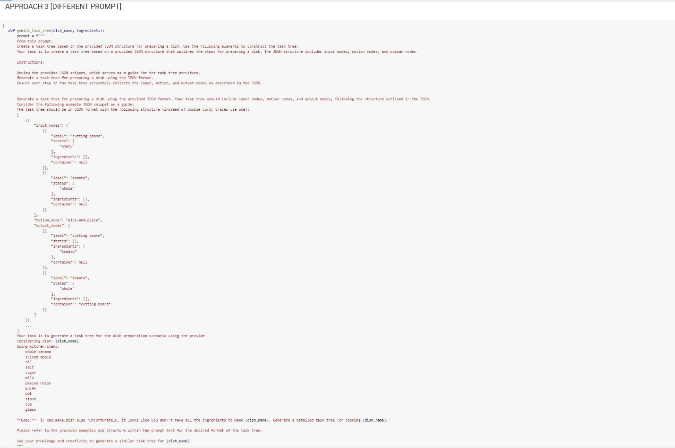

* **Performance Measurement**: This prompt instructs users to create task trees based on a provided JSON structure without offering detailed input or output guidelines. It lacks examples and clear goal statements, potentially leading to confusion and variability in output quality. Users may struggle to interpret the vague instructions and produce accurate task trees.
* **Comparison**: Prompt 3 is less effective than Prompt 1 and Prompt 2 due to its vagueness and lack of specific guidance. Without clear input requirements and goal statements, users may struggle to generate task trees that meet the desired format and accuracy levels.

In summary, Prompt 1 outperforms Prompt 2 and Prompt 3 due to its comprehensive instructions, clear examples, and specific goal statements, making it the preferred choice for generating accurate and detailed cooking task trees.

Top of Form

**Conclusion**

* **Best Prompt**: Approach 1 stands out as the best prompt due to its detailed instructions, clear template, and specific guidance on generating task trees. It is expected to produce more accurate and comprehensive task trees compared to the other approaches.
* **Runner-up**: Approach 2 follows closely behind with its structured prompt and example, providing a decent framework for generating task trees.
* **Least Preferred**: Approach 3 may require more interpretation and could lead to varying levels of output accuracy. Users' understanding of the JSON structure and prompt instructions may impact the quality of task trees generated.