FINAL PROJECT

Nikhil Reddy Addula

2022-12-08

#loading library functions  
library(dplyr)

##   
## Attaching package: 'dplyr'

## The following objects are masked from 'package:stats':  
##   
## filter, lag

## The following objects are masked from 'package:base':  
##   
## intersect, setdiff, setequal, union

library(caret)

## Loading required package: ggplot2

## Loading required package: lattice

library(tidyverse)

## ── Attaching packages  
## ───────────────────────────────────────  
## tidyverse 1.3.2 ──

## ✔ tibble 3.1.8 ✔ purrr 0.3.4  
## ✔ tidyr 1.2.1 ✔ stringr 1.4.1  
## ✔ readr 2.1.2 ✔ forcats 0.5.2  
## ── Conflicts ────────────────────────────────────────── tidyverse_conflicts() ──  
## ✖ dplyr::filter() masks stats::filter()  
## ✖ dplyr::lag() masks stats::lag()  
## ✖ purrr::lift() masks caret::lift()

library(gridExtra)

##   
## Attaching package: 'gridExtra'  
##   
## The following object is masked from 'package:dplyr':  
##   
## combine

library(factoextra)

## Welcome! Want to learn more? See two factoextra-related books at https://goo.gl/ve3WBa

library(ISLR)  
library(flexclust)

## Loading required package: grid  
## Loading required package: modeltools  
## Loading required package: stats4

library(cluster)  
library(corrplot)

## corrplot 0.92 loaded

set.seed(1789)  
#importing Data set and converting   
getwd()

## [1] "/Users/nikhilreddya/Documents/assignments/FUNDAMENTALS ML/final"

NR<-read.csv("~/Downloads/fuel_receipts_costs_eia923 (1).csv")  
  
#Replace NA values with median   
NR_1<-NR %>% replace(is.na(.), 0)  
NR_2 <- NR_1%>% mutate(across(where(is.numeric), ~replace_na(., median(., na.rm=TRUE))))

#randomly sample about 2% of your data   
Nr_model2<-NR_2%>%sample_frac(0.02)  
  
#normalizing data using scale   
norm_model<-preProcess(NR_2,method = c("scale"))  
Nr_model2_normalized<-predict(norm_model,Nr_model2)  
  
#75% of the sampled data as the training set  
Index_t<-createDataPartition(Nr_model2$fuel_cost_per_mmbtu, p = 0.75,list = FALSE)  
train<- Nr_model2_normalized[Index_t,]  
test<-Nr_model2_normalized[-Index_t,]  
  
#selecting/using the required columns for clustering   
nr<-train[,c(15:20)]

#correlation of columns selected  
corrplot(cor(nr))

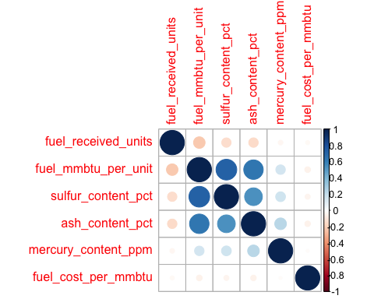

#using kmeans clustering with both the methods "WSS" & "silhouette" and getting the clusters points 'k'  
set.seed(1789)  
ANR<-Auto[,c(1,6)]  
# Scaling the data frame (z-score)   
ANR_1 <- scale(ANR)  
fviz_nbclust(ANR_1, kmeans, method = "wss")

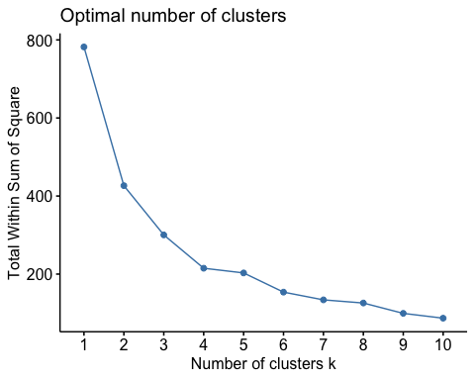

fviz_nbclust(ANR_1, kmeans, method = "silhouette")

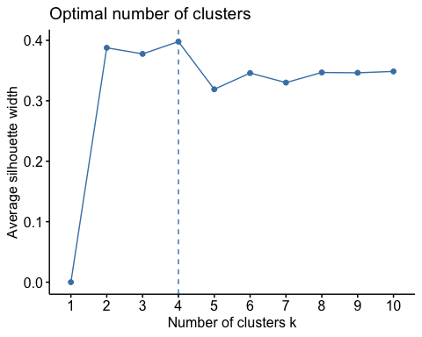

#After checking the above graph we found k=4  
set.seed(1789)  
anr <- kmeans(nr, centers = 4, nstart = 50)  
shiloh_kmeans<- kmeans(nr,centers = 4,nstart = 50)  
anr$centers # output the centers

## fuel_received_units fuel_mmbtu_per_unit sulfur_content_pct ash_content_pct  
## 1 0.18177742 0.4458332 0.07151265 0.1298978  
## 2 3.95554628 0.1033619 0.00000000 0.0000000  
## 3 0.05023818 2.3366447 1.90602700 1.8240368  
## 4 0.03445104 2.0088691 2.14128102 3.5344152  
## mercury_content_ppm fuel_cost_per_mmbtu  
## 1 0.0467504 0.0048009553  
## 2 0.0000000 0.0014246208  
## 3 0.1836899 0.0017970585  
## 4 13.1404600 0.0000770555

anr$size # Number in each cluster

## [1] 6426 438 2214 51

anr$cluster["120"] # Identify the cluster of the 120th observation as an example

## 120   
## 1

fviz_cluster(anr, data = nr) # Visualize the output

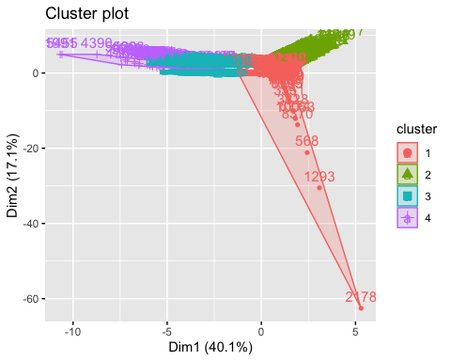

fviz_cluster(shiloh_kmeans,data = nr)

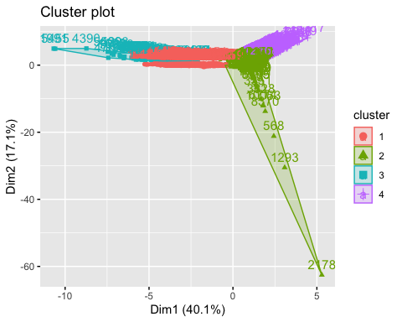

#finding the mean of clusters k=4  
train$cluster<-anr$cluster  
train%>%group_by(cluster)%>%summarise(avg_mmbtu=mean(fuel_mmbtu_per_unit),avg_fuel_recived =mean(fuel_received_units),avg_sulphur_content = mean(sulfur_content_pct),avg_ash_content = mean(ash_content_pct),avg_cost_perunit = mean(fuel_cost_per_mmbtu))

## # A tibble: 4 × 6  
## cluster avg_mmbtu avg_fuel_recived avg_sulphur_content avg_ash_content avg_c…¹  
## <int> <dbl> <dbl> <dbl> <dbl> <dbl>  
## 1 1 0.446 0.182 0.0715 0.130 4.80e-3  
## 2 2 0.103 3.96 0 0 1.42e-3  
## 3 3 2.34 0.0502 1.91 1.82 1.80e-3  
## 4 4 2.01 0.0345 2.14 3.53 7.71e-5  
## # … with abbreviated variable name ¹​avg_cost_perunit

# Other Distances

set.seed(1789)  
#kmeans clustering, using manhattan distance  
k4 = kcca(nr, k=4, kccaFamily("kmedians"))  
k4

## kcca object of family 'kmedians'   
##   
## call:  
## kcca(x = nr, k = 4, family = kccaFamily("kmedians"))  
##   
## cluster sizes:  
##   
## 1 2 3 4   
## 55 5772 1546 1756

# predict() function  
clusters_index <- predict(k4)  
dist(k4@centers)

## 1 2 3  
## 2 12.057370   
## 3 11.646943 1.884454   
## 4 11.407657 3.593256 2.196640

As for the Sulphur ,ash & mercury content are less than 0.002 m they can be neglected # Cluster 1

# This cluster recieves fuel of 0.18177742 .

# As they are receiving low fuel,sulphur & ash their heat content in fuel(fuel_mmbtu) is also low (0.4458332).

# The fuel cost per mmbtu is higher(0.0048009553) than all the 4 clusters formed.

# Due to the high cost of fuel per mmbtu, this Cluster is not a favoured one to suggest to the US government.

# Cluster 2

# This cluster receives fuel of 3.95554628 which is high than all the clusters.

# Their heat content in the fuel is very very low of 0.1033619 comapared to all the 4 clsuters.

# The fuel cost per mmbtu is lower(0.0014246208) than all the 4 clusters formed.

# This cluster is also not a preferred one to recommend for us Government because of fuel mmbtu per unit.

# Cluster 3

# This cluster receives fuel of 0.05023818 which is minimal.

# Their heat content in the fuel is 2.3366447 which is good to the fuel recieves compared to other 3 clsuters.

# The fuel cost per mmbtu is also very good(0.0017970585) to fuel recieved and the heat content.

# This Cluster is the one that the US Government should be recommended since it takes all the variables, including (fuel recieved,heat content,fuel cost per mmbtu.