**Hi there, I am front-end with Reactjs and python Django developer.**

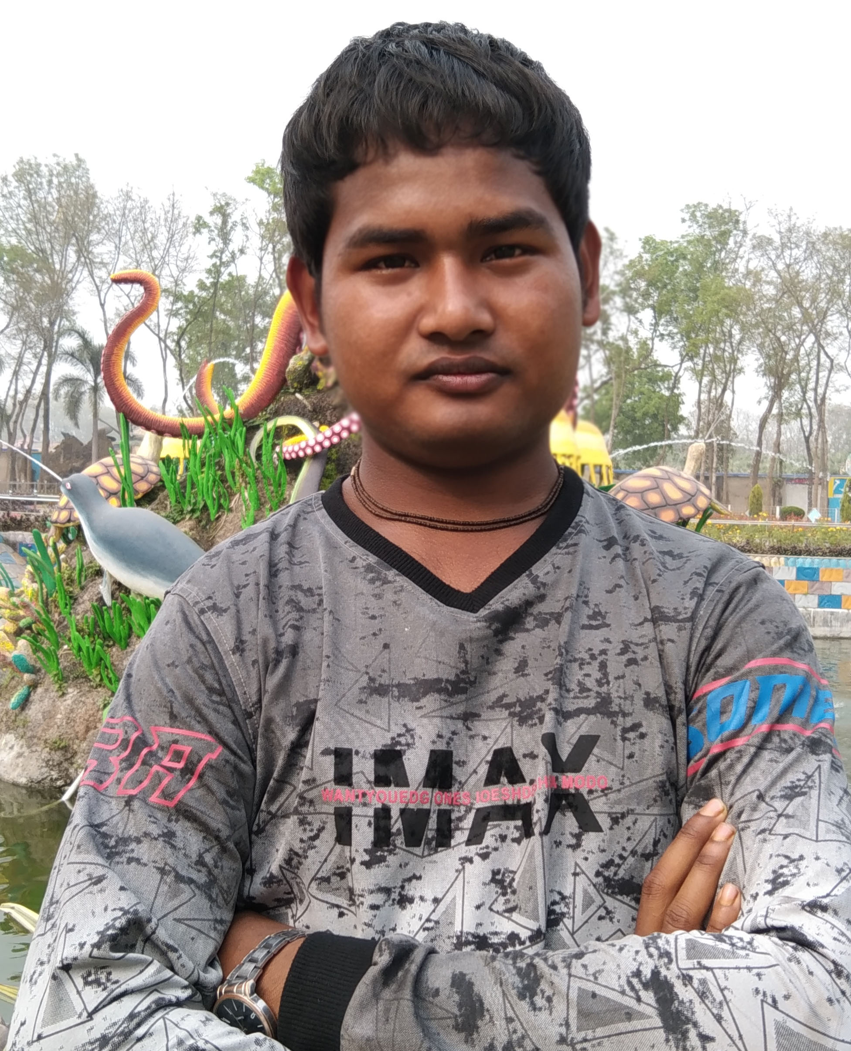

web developer

frontend reactjs and   
backend python(django)  
developer.

# Objective

According to the project description, my resume proofs my skills and all the requirements.

## Skills & Abilities

HTML,CSS, JAVASCRIPT, JQUERY,SCSS, BOOTSTRAP, MDBOOTSTRAP, REACTJS, NEXTJS, PYTHON, DJANGO AND MORE.

## Vitals

Thakurgaon, Bangladesh.

Email:

**nikhilchandraroypoet@gmail.com**

**I have more than 3 years of experience in total of web development career.**

**In this time, I had worked many projects and help them to be success there project and get up in their analysis of project requirements.**

**Skills make man perfect to fit and skills equal to money I believe.**

**So, I always maintain my existing skills and am enjoying learning new skills.**

**Regard’s Nikhil Roy**

# SITe

<http://nikhilroyjs.club>

skype

nikhilchandraroypoet@gmail.com