* Risk Assessment Diagram:

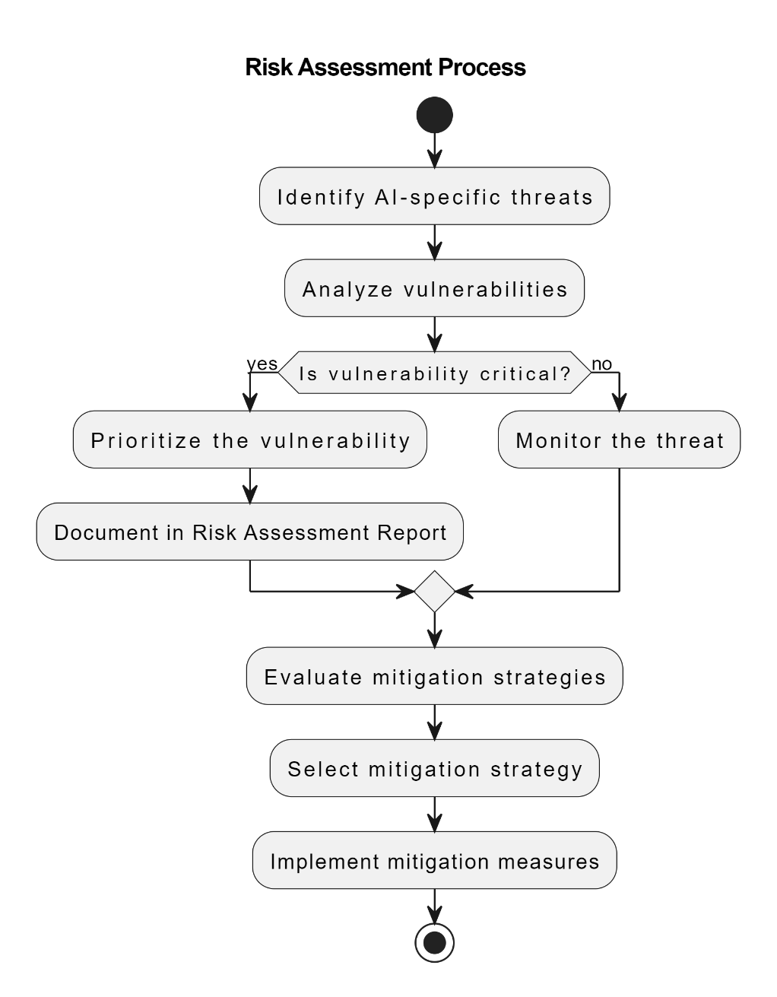

* A screen shot of a diagram

  Description automatically generatedSecurity Architecture Diagram
* Implementation Process Diagram:

