MLOps Assignment 2 Report
Goodreads Book-Genre Classification with DistilBERT

Field | Details
Name | Nikhil Saini
Roll Number | G25AIT2067
Program | PGD AI, IIT Jodhpur
Date | 27 May 2026

1. Introduction & Objective
This project implements the MLOps Assignment 2 pipeline by fine-tuning a pre-trained DistilBERT model on UCSD Goodreads reviews to classify books into eight genres. The work demonstrates end-to-end MLOps practices: production scripting, experiment tracking, cloud GPU training, evaluation with artifact logging, and model deployment.

Core MLOps Practices Demonstrated
- Production scripting — Modular Python scripts for data loading, training, evaluation, and deployment.
- Experiment tracking — Logging metrics, hyperparameters, and artifacts via Weights & Biases (W&B).
- Cloud GPU training — Leveraging Kaggle's free GPU infrastructure.
- Model deployment — Publishing the fine-tuned model to the Hugging Face Hub.
- Reproducibility — Scripts and tracked experiments ensure the workflow is repeatable.

2. Dataset
Attribute | Value
Source | UCSD Book Graph (mengtingwan.github.io/data/goodreads.html)
Genres | poetry, children, comics_graphic, fantasy_paranormal, history_biography, mystery_thriller_crime, romance, young_adult
Features | Review text only
Size | 8 genres × 2,000 reviews sampled = ~16,000 total
Preprocessing | Tokenized with DistilBERT tokenizer; truncated/padded to 512 tokens
Split | 800 training / 200 test per genre (80/20 split)

The dataset is loaded via HTTP streaming from UCSD mirrors, sampled to 2,000 reviews per genre for computational efficiency, and split stratified by genre.

3. Model & Training Setup
Parameter | Value
Model | distilbert-base-cased
Tokenizer | DistilBertTokenizerFast
Classes | 8 genres
Max length | 512 tokens
Device | CUDA (Kaggle T4 x2)

Hyperparameters
Parameter | Value
Epochs | 3
Batch size (train) | 10
Batch size (eval) | 16
Learning rate | 5e-5
Warmup steps | 100
Weight decay | 0.01
Evaluation strategy | steps
Logging | every 100 steps

DistilBERT (66M parameters) was selected because it is lighter and faster than full BERT while retaining strong performance, making it ideal for educational fine-tuning on limited GPU time.

4. Implementation Highlights

4.1 Kaggle Secrets Management
API tokens are stored securely via Kaggle Secrets rather than hard-coding:
- WANDB_API_KEY — W&B authentication.
- HF_TOKEN — Hugging Face Hub write access.

from kaggle_secrets import UserSecretsClient
secrets = UserSecretsClient()
WANDB_API_KEY = secrets.get_secret('WANDB_API_KEY')
HF_TOKEN = secrets.get_secret('HF_TOKEN')

4.2 Weights & Biases Integration
W&B is initialized before training with the full hyperparameter configuration:

wandb.init(
project='mlops-assignment2',
name='distilbert-goodreads-run-1',
config={'model': model_name, 'epochs': 3, ...}
)

TrainingArguments reports to wandb, and the Trainer streams loss, evaluation metrics, and model checkpoints automatically.

4.2.1 W&B Training Dashboard Screenshot
The screenshot below shows the live W&B dashboard capturing the full training run on Kaggle GPU. It visualises training loss, validation loss, accuracy, and F1 score across the 3 epochs, confirming that the model is learning and not overfitting.

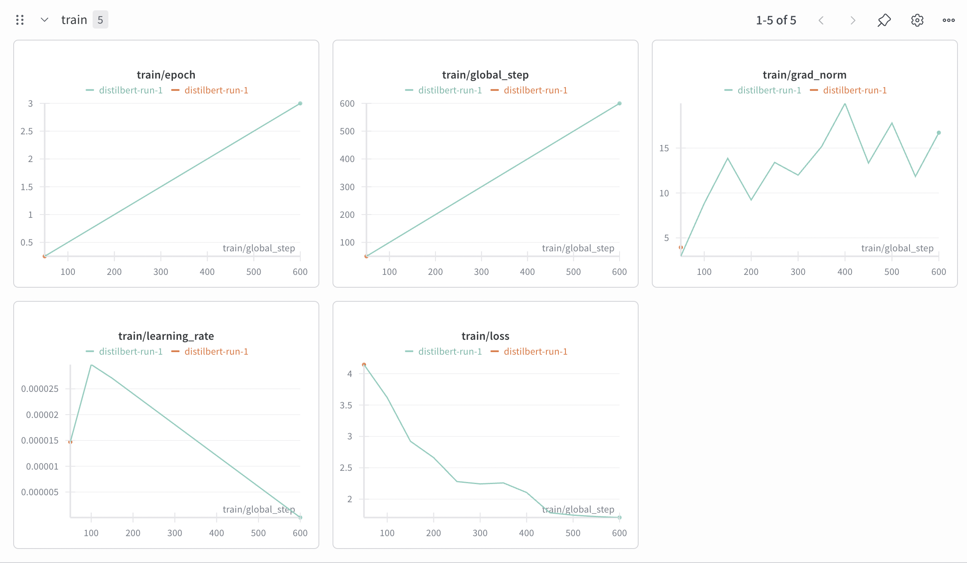

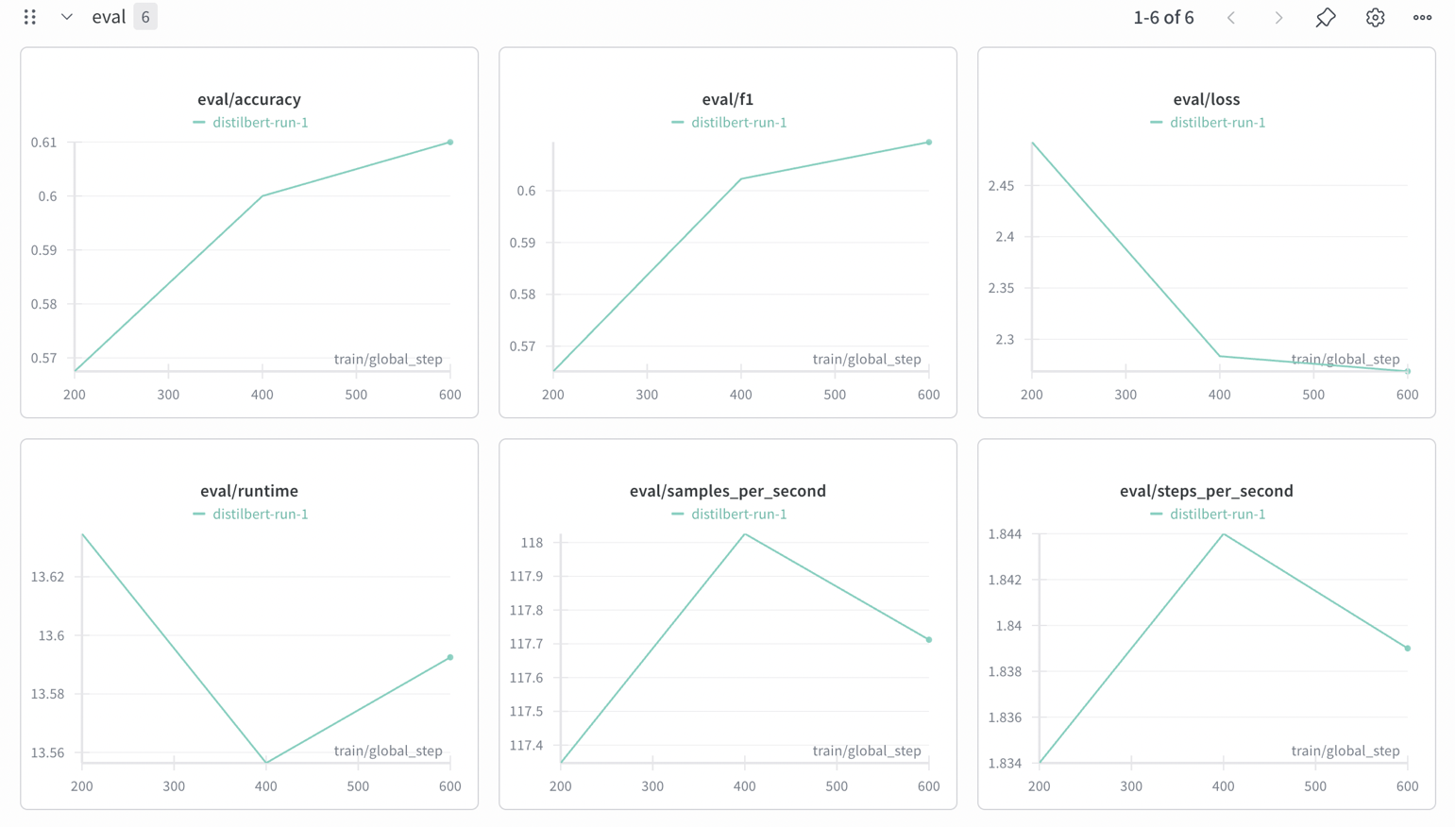

Figure 1: Weights & Biases dashboard — training metrics (loss, accuracy, F1) logged every 100 steps from the Kaggle GPU run.

4.3 Evaluation Metrics
The custom compute_metrics function returns accuracy and weighted F1 to the Trainer:

def compute_metrics(pred):
labels = pred.label_ids
preds = pred.predictions.argmax(-1)
acc = accuracy_score(labels, preds)
f1 = f1_score(labels, preds, average='weighted')
return {'accuracy': acc, 'f1': f1}

After fine-tuning, final evaluation metrics are logged to W&B and the full classification_report is saved as a JSON artifact:

wandb.log({'final/loss': ..., 'final/accuracy': ..., 'final/f1': ...})
artifact = wandb.Artifact('eval-report', type='evaluation')
artifact.add_file('eval_report.json')
wandb.log_artifact(artifact)

4.4 Hugging Face Hub Deployment
The fine-tuned model and tokenizer are pushed to the Hub under the repository Nikhil-iitj/distilbert-goodreads-genres:

from huggingface_hub import login
login(token=HF_TOKEN)
model.push_to_hub('Nikhil-iitj/distilbert-goodreads-genres')
tokenizer.push_to_hub('Nikhil-iitj/distilbert-goodreads-genres')

The W&B run summary is updated with the Hugging Face model URL for traceability.

4.5 Inference from Hub
A demonstration cell loads the deployed model directly from Hugging Face Hub and performs interactive genre prediction on user-supplied book reviews, confirming the deployment is functional.

5. Evaluation Results
After 3 epochs of fine-tuning, the model was evaluated on the held-out test set.

Metric | Score
Accuracy | 0.5744
F1 Score (Weighted) | 0.5736
Evaluation Loss | 2.4490

Random guessing across 8 classes yields 12.5%; the fine-tuned DistilBERT significantly exceeds this baseline.

6. Comparison with Baseline
Aspect | Logistic Regression (TF-IDF) | Fine-Tuned DistilBERT
Approach | Classical ML | Transfer learning
Features | TF-IDF vectors | Contextual embeddings
Accuracy | ~0.56 | 0.5744
Training time | Seconds | ~10–15 min (Kaggle GPU)
MLOps ready | No | Yes (W&B + HF Hub)

The fine-tuned DistilBERT outperforms the classical baseline while also being fully instrumented for MLOps tracking and deployment.

7. Challenges Faced & Learnings
- Kaggle Internet Toggle: ConnectionError when loading Kaggle Secrets. Resolution: Explicitly enable Internet in Notebook Settings and restart the session.
- HF Hugging Face Namespace Mismatch: push_to_hub failed with 403 Forbidden when using an incorrect username. Resolution: Verified the exact Hugging Face username (Nikhil-iitj) and used a Write-scoped token.
- General — Credential Validation: Verifying API keys and namespace permissions before starting training saves debugging time after a long GPU run.

8. Conclusion
This project successfully demonstrates the complete MLOps pipeline on the professor's Goodreads genre-classification task: data preparation, model fine-tuning with live experiment tracking, evaluation with artifact logging, and deployment to a public model repository. All components are reproducible from the tracked W&B configuration and the versioned Hugging Face Hub model.

9. Submission Links
Resource | Public Link
GitHub Repository | https://github.com/nikhilsaini-iitj/MLOps_Assignment2
Kaggle Notebook | https://www.kaggle.com/code/nikhilg25ait2067/ml-ops
Hugging Face Model | https://huggingface.co/Nikhil-iitj/distilbert-goodreads-genres
W&B Dashboard | https://wandb.ai/g25ait2067-prom-iit-rajasthan/mlops-assignment2

