TASKS

1→

List Docker Images:

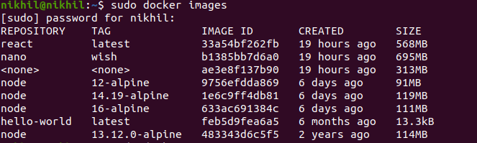

Delete Docker Image



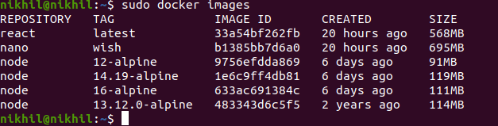

2→

List Docker container

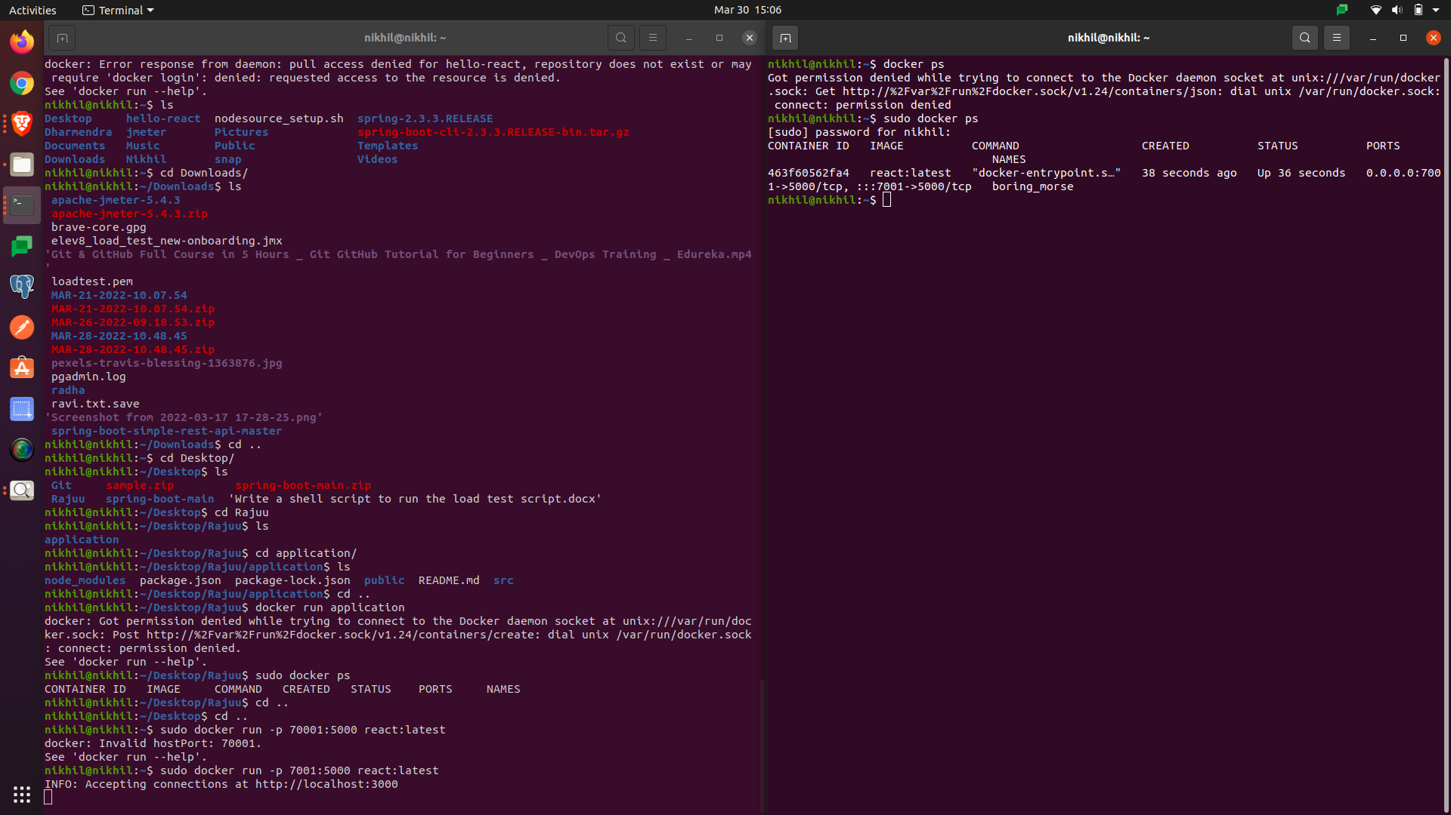

Delete Docker Container

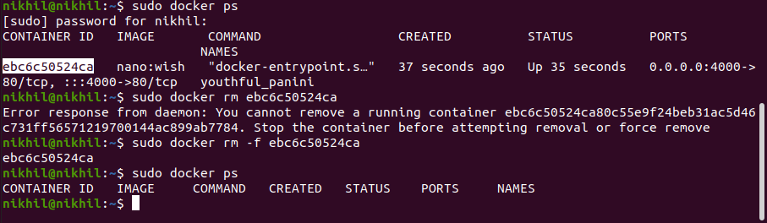

3→

Delete unused docker image and container

