Assignment 3 - Part 2

**Changes to XV6 Memory Management System**

**Files Modified:**

1. defs.h
   1. Define a initSharedPage() method to initialize the params required for memory sharing. Also, defined the methods, getSharedPage(int,int) and freeSharedPage(int)



1. main.c
   1. Invoked the initSharedPage() method that initializes the params required for memory

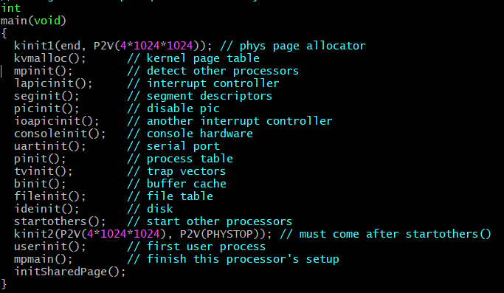

1. proc.h
   1. Added 3 new fields to the proc stuct to track keys and shared memory addresses.

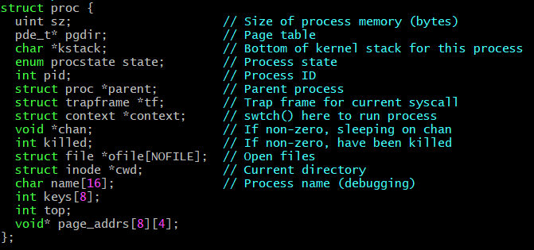

1. proc.c
   1. Modified two methods : allocproc(void) and fork(void)
      1. Allocproc is modified to initialize the newly include fields i.e. keys and page_addrs.

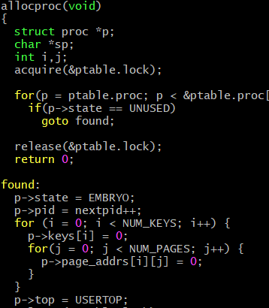

* + 1. Fork method is modified to share the details of a proc struct with the child processes.

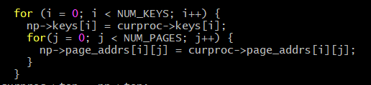

1. sysproc.c
   1. Two systemcalls are implemented in this class
      1. getSharedPage(void) method fetches the arguments from user stack to kernel stack and invokes a method getSharedPage(key,noOfPages) in vm.c.
      2. freeSharedPage(void) method fetches the arguments from user stack to kernel stack and invokes a method freeSharedPage(key) in vm.c.

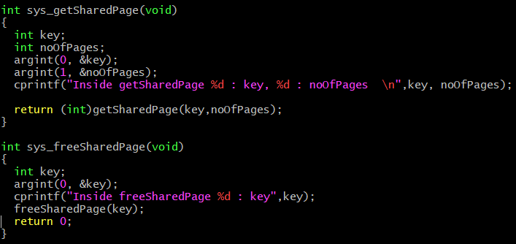

1. vm.c
   1. This file Implements total three methods: initSharedPage(), getSharedPage(key, noOfPages) and freeSharedPage(key)
      1. initSharedPage() initlaizes three arrays. The first array is is_key_used[ ], this array stores the status of the key. The second array is key_page_addrs[][], this array stores all the addresses that are needed for the shared memory. The third array is num_key_pages[] stores the number of pages needed for each key.

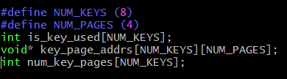

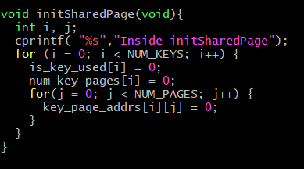

* + 1. getSharedPage(key, noOfPages) method validates the arguments passed and allocated memory for the number of pages requested. If the passed key already has memory allocated to it, the allocated memory address is converted to virtual address and is shared.

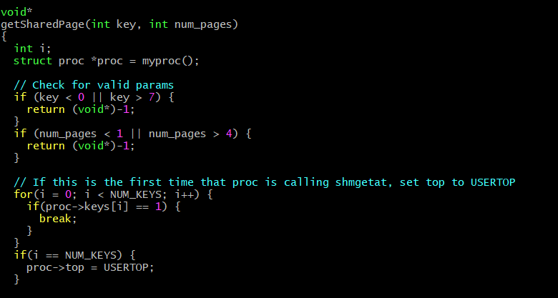

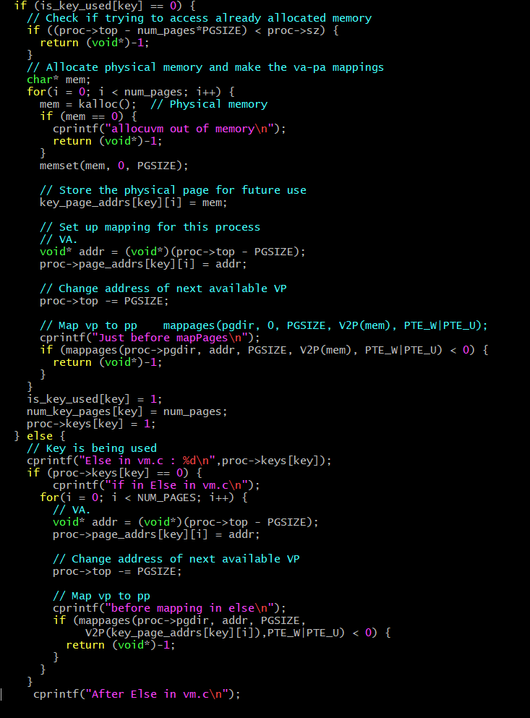

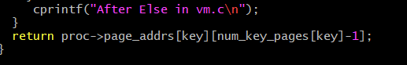

* + 1. freeSharedPage(key) method clears all the memory addresses stored in the key_page_addrs[] array

