Part 2 - Assignment 3- Test Cases

TestCase 1:

FileName: testA.c

Step1:

1. Invokes the getSharePage() method with 0 as key and 3 as noOfPages.
2. The address returned by getSharedPage is used to create a pointer for integer.
3. The Integer pointer is set to a value.
4. The returned address and the value assigned to the address are printed

Step2:

1. The getSharedPage() method is invoked with the same key as above and the address returned by the system call.
2. The value is the address is accessed and printed
3. Both the value and address printed are same as the ones returned by the first step.

Reason to choose:

* The test case validates the implementation of our shared memory by accessing the memory allocation that is previously written by a different syscall

TestCase Implementation:

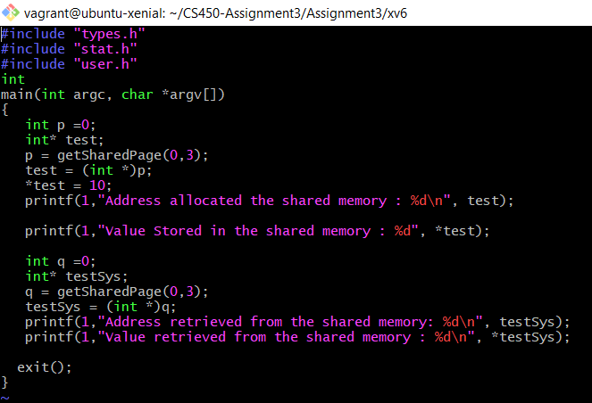

Test Output Snippet:

