ONLINE EXAMINATION
MANAGEMENT SYSTEM
A Console-Based Examination System Using C Programming
MAJOR PROJECT REPORT
Submitted in partial fulfillment of the requirements for the course
C Programming / Programming Fundamentals
Prepared by: USN:
Prajwal.S.B 3BR25CS163
Preetam G.S 3BR25CS167
P.Nikhil 3BR25CS155
K.S.Vinod kumar 3BR25CS088
Academic Year: 2026

CERTIFICATE
This is to certify that the mini project entitled “Online Examination Management System” is a genuine work carried out as part of the academic requirements for C Programming. The project demonstrates the practical use of structures, arrays, functions, conditional statements, loops and formatted input/output in developing a console-based examination application.
The work has been prepared for academic learning and demonstrates the design, implementation, testing and documentation of a small examination management system.

ACKNOWLEDGEMENT
I would like to express my sincere gratitude to my faculty members and department for providing the opportunity to complete this mini project. I am thankful for the guidance and encouragement received during the design and implementation of the Online Examination Management System. I also thank my classmates and friends for their suggestions and support while testing the program.
Finally, I am grateful for the learning resources and practical lab environment that helped me understand how C programming concepts can be combined to solve a real-world problem.

ABSTRACT
The Online Examination Management System is a console-based application developed using the C programming language. The main purpose of the project is to conduct a simple examination, evaluate student responses automatically and maintain results for multiple students. The system stores each question with a question ID, question text, four options, the correct answer and the marks assigned to that question.
During an examination, questions are displayed one at a time and the student selects an answer. The program identifies correct, incorrect and unanswered questions, calculates the total score and percentage, and assigns a grade. At the end of the examination, a detailed result is displayed. The program also maintains multiple student results and generates a performance report containing marks, percentage and grade.
The project is designed to demonstrate important C programming concepts such as structures, arrays, functions, loops, switch-case, strings, conditional statements and formatted input/output. It is suitable as a beginner-friendly academic mini project and can be extended into a graphical or database-driven examination system in the future.

TABLE OF CONTENTS
1. Introduction
2. Problem Statement
3. Objectives
4. Scope of the Project
5. Existing System and Proposed System
6. System Requirements
7. System Design
8. Data Structures Used
9. Algorithm
10. Program Implementation
11. Sample Program Screens
12. Testing and Test Cases
13. Sample Performance Report
14. Advantages and Limitations
15. Future Enhancements
16. Conclusion
17. References

1. INTRODUCTION
Examinations are an important part of education because they help measure a student's understanding and progress. Traditional examination processes often require manual preparation of question papers, evaluation of answer sheets and preparation of result reports. These activities can take considerable time and may lead to calculation errors.
The Online Examination Management System presented in this project provides a small automated solution. It runs through the command line and guides the student through a sequence of questions. Each answer is checked against the stored correct answer and marks are calculated automatically. The system also records the result of more than one student, making it useful for demonstrating basic result management.
The project is intentionally implemented as a console application so that the core programming logic can be understood clearly without depending on external databases or graphical frameworks.

2. PROBLEM STATEMENT
Develop a console-based examination management system in C that stores questions and their details, displays questions one by one, accepts student answers, evaluates responses, handles unanswered questions, calculates the final score and percentage, assigns a grade, displays correct and incorrect answers, maintains results for multiple students and generates a performance report. The implementation must use structures for questions and student results.

3. OBJECTIVES
- To develop a simple and user-friendly console-based examination system.
- To store question ID, question text, four options, correct answer and marks using a structure.
- To display questions sequentially and accept answers from the student.
- To identify correct, incorrect and unanswered questions.
- To calculate total marks and percentage automatically.
- To assign a grade based on the percentage obtained.
- To store and display results for multiple students.
- To generate a performance report for comparing student performance.
- To demonstrate practical use of structures, arrays, functions and control statements in C.

4. SCOPE OF THE PROJECT
The project is suitable for small classroom examinations, programming lab demonstrations and academic mini projects. It can handle a fixed set of questions and multiple student attempts during one program execution. The present version focuses on core examination logic rather than internet connectivity, authentication or database storage.
The design can later be extended with a database, login system, question bank management, random question selection, time limits, negative marking and a graphical/web interface.

5. EXISTING SYSTEM AND PROPOSED SYSTEM
Aspect | Traditional / Manual | Proposed System
Evaluation | Mostly manual | Automatic
Score calculation | Manual calculation | Calculated by program
Unanswered questions | Checked manually | Automatically identified
Multiple results | Requires separate records | Stored in result array
Performance report | Prepared manually | Generated by program
Accuracy | Depends on manual checking | Consistent program logic

6. SYSTEM REQUIREMENTS
Hardware Requirements
- Computer or laptop
- Minimum 4 GB RAM recommended
- Keyboard and monitor
Software Requirements
- Windows, Linux or macOS
- C compiler such as GCC/MinGW
- Visual Studio Code or any C-compatible IDE
- Command Prompt / VS Code integrated terminal

7. SYSTEM DESIGN
The system follows a simple flow. Question data is loaded into an array of Question structures. Student details and calculated results are stored in an array of StudentResult structures. During the examination, the program reads one answer at a time, compares it with the correct answer and updates the student's score.
START
|
v
Load Question Bank
|
v
Enter Number of Students
|
v
Enter Student Details
|
v
Display Question -> Read Answer -> Evaluate
| |
|---- repeat until all ---|
|
v
Calculate Marks & Percentage
|
v
Assign Grade
|
v
Display Correct/Incorrect/Unanswered
|
v
Store Student Result
|
v
Generate Performance Report
|
v
END

8. DATA STRUCTURES USED
Two major structures are used in the program.
typedef struct {
int id;
char question[200];
char option[4][100];
char correctAnswer;
int marks;
} Question;
typedef struct {
int studentId;
char name[50];
int score;
int totalMarks;
int correct;
int incorrect;
int unanswered;
float percentage;
char grade[3];
} StudentResult;
The Question structure keeps all information related to a question in one record. The StudentResult structure keeps the final examination information of each student. Arrays of these structures allow the program to maintain multiple questions and multiple student results.

9. ALGORITHM
- Start the program.
- Initialize the question bank with question ID, question text, four options, correct answer and marks.
- Read the number of students.
- For each student, read the student ID and name.
- Display every question one by one.
- Read A/B/C/D as the answer. Use 0 to represent an unanswered question.
- If the answer is 0, increase the unanswered count.
- If the answer matches the correct answer, add the question marks to the score and increase the correct count.
- Otherwise, increase the incorrect count.
- Calculate percentage = (score / total marks) × 100.
- Assign grade according to the percentage.
- Display the student's result and answer review.
- Store the result in the StudentResult array.
- After all students complete the examination, generate the performance report.
- Stop the program.

10. PROGRAM IMPLEMENTATION
The following complete C program can be copied into Visual Studio Code, saved as online_exam.c and compiled using GCC/MinGW.
#include <stdio.h>
#include <string.h>
#include <ctype.h>
#define MAX_Q 5
#define MAX_STUDENTS 50
typedef struct {
int id;
char question[200];
char option[4][100];
char correctAnswer;
int marks;
} Question;
typedef struct {
int studentId;
char name[50];
int score;
int totalMarks;
int correct;
int incorrect;
int unanswered;
float percentage;
char grade[3];
} StudentResult;
void assignGrade(float percentage, char grade[]) {
if (percentage >= 90) strcpy(grade, "A+");
else if (percentage >= 80) strcpy(grade, "A");
else if (percentage >= 70) strcpy(grade, "B");
else if (percentage >= 60) strcpy(grade, "C");
else if (percentage >= 50) strcpy(grade, "D");
else strcpy(grade, "F");
}
void conductExam(Question q[], int n, StudentResult *s) {
char answer;
s->score = 0;
s->correct = 0;
s->incorrect = 0;
s->unanswered = 0;
s->totalMarks = 0;
printf("\n==============================================\n");
printf(" STARTING EXAMINATION\n");
printf("==============================================\n");
for (int i = 0; i < n; i++) {
s->totalMarks += q[i].marks;
printf("\nQuestion %d (%d Marks)\n", q[i].id, q[i].marks);
printf("%s\n", q[i].question);
for (int j = 0; j < 4; j++)
printf("%c. %s\n", 'A' + j, q[i].option[j]);
printf("Enter answer (A/B/C/D or 0 to skip): ");
scanf(" %c", &answer);
answer = toupper(answer);
if (answer == '0') {
s->unanswered++;
printf("Answer skipped.\n");
} else if (answer == q[i].correctAnswer) {
s->score += q[i].marks;
s->correct++;
printf("Correct answer.\n");
} else {
s->incorrect++;
printf("Incorrect answer.\n");
}
}
s->percentage = (s->score * 100.0f) / s->totalMarks;
assignGrade(s->percentage, s->grade);
}
void displayResult(StudentResult *s, Question q[], int n) {
printf("\n==============================================\n");
printf(" EXAM RESULT\n");
printf("==============================================\n");
printf("Student ID : %d\n", s->studentId);
printf("Student Name : %s\n", s->name);
printf("Correct : %d\n", s->correct);
printf("Incorrect : %d\n", s->incorrect);
printf("Unanswered : %d\n", s->unanswered);
printf("Score : %d / %d\n", s->score, s->totalMarks);
printf("Percentage : %.2f%%\n", s->percentage);
printf("Grade : %s\n", s->grade);
printf("\nCorrect Answer Key:\n");
for (int i = 0; i < n; i++)
printf("Q%d -> %c\n", q[i].id, q[i].correctAnswer);
}
void performanceReport(StudentResult results[], int n) {
int highest = -1, lowest = 100000, total = 0;
printf("\n==============================================\n");
printf(" PERFORMANCE REPORT\n");
printf("==============================================\n");
printf("%-8s %-18s %-8s %-10s %-6s\n",
"ID", "NAME", "MARKS", "PERCENT", "GRADE");
for (int i = 0; i < n; i++) {
printf("%-8d %-18s %d/%-5d %-10.2f %-6s\n",
results[i].studentId, results[i].name,
results[i].score, results[i].totalMarks,
results[i].percentage, results[i].grade);
total += results[i].score;
if (results[i].score > highest) highest = results[i].score;
if (results[i].score < lowest) lowest = results[i].score;
}
printf("\nAverage Score : %.2f\n", (float)total / n);
printf("Highest Score : %d\n", highest);
printf("Lowest Score : %d\n", lowest);
}
int main() {
Question questions[MAX_Q] = {
{1, "Which symbol is used to end a statement in C?",
{";", ":", ".", ","}, 'A', 2},
{2, "Which data structure stores different data items under one name?",
{"Structure", "Array", "Pointer", "Function"}, 'A', 2},
{3, "Which keyword is used to define a structure in C?",
{"struct", "define", "record", "class"}, 'A', 2},
{4, "Which loop executes its body at least once?",
{"for", "while", "do-while", "switch"}, 'C', 2},
{5, "Which function is the starting point of a C program?",
{"start()", "main()", "begin()", "run()"}, 'B', 2}
};
StudentResult results[MAX_STUDENTS];
int studentCount;
printf("==============================================\n");
printf(" ONLINE EXAMINATION MANAGEMENT SYSTEM\n");
printf("==============================================\n");
printf("Enter number of students (1-%d): ", MAX_STUDENTS);
scanf("%d", &studentCount);
if (studentCount < 1 || studentCount > MAX_STUDENTS) {
printf("Invalid number of students.\n");
return 0;
}
for (int i = 0; i < studentCount; i++) {
printf("\nStudent %d\n", i + 1);
printf("Enter Student ID: ");
scanf("%d", &results[i].studentId);
printf("Enter Student Name: ");
scanf(" %[^\n]", results[i].name);
conductExam(questions, MAX_Q, &results[i]);
displayResult(&results[i], questions, MAX_Q);
}
performanceReport(results, studentCount);
printf("\nThank you for using the Online Examination System.\n");
return 0;
}

11. SAMPLE PROGRAM SCREENS
The following screenshots are illustrative console outputs produced for this project. They show how the program starts, displays questions, calculates a result and produces a performance report.
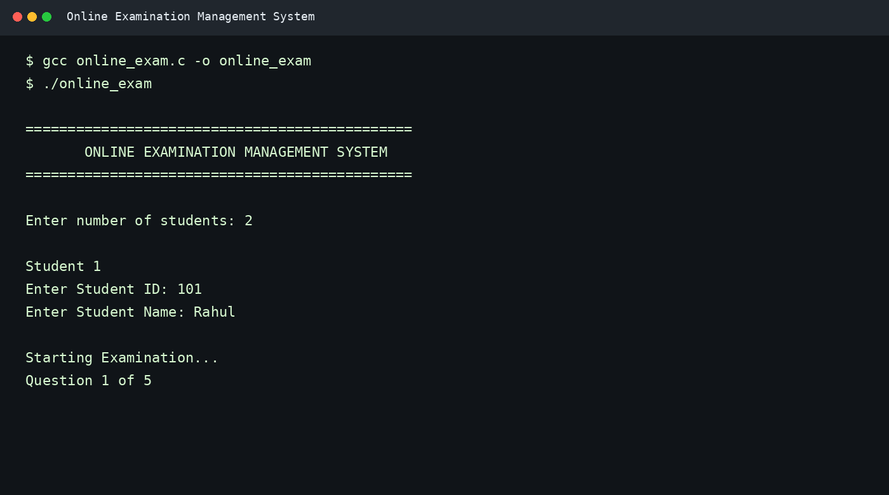
Figure 1: Program startup and student registration
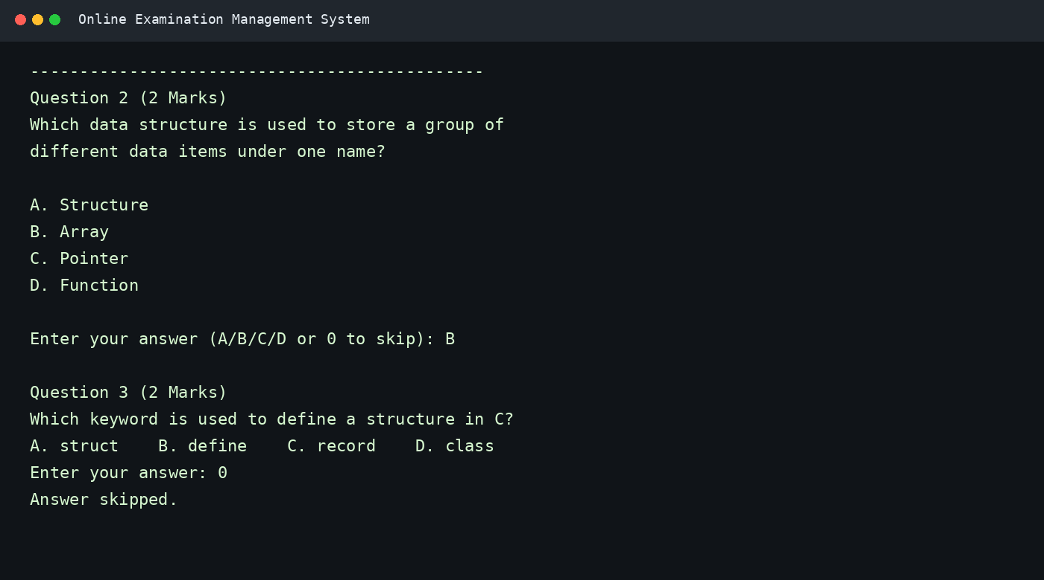
Figure 2: Question display, answer input and unanswered question
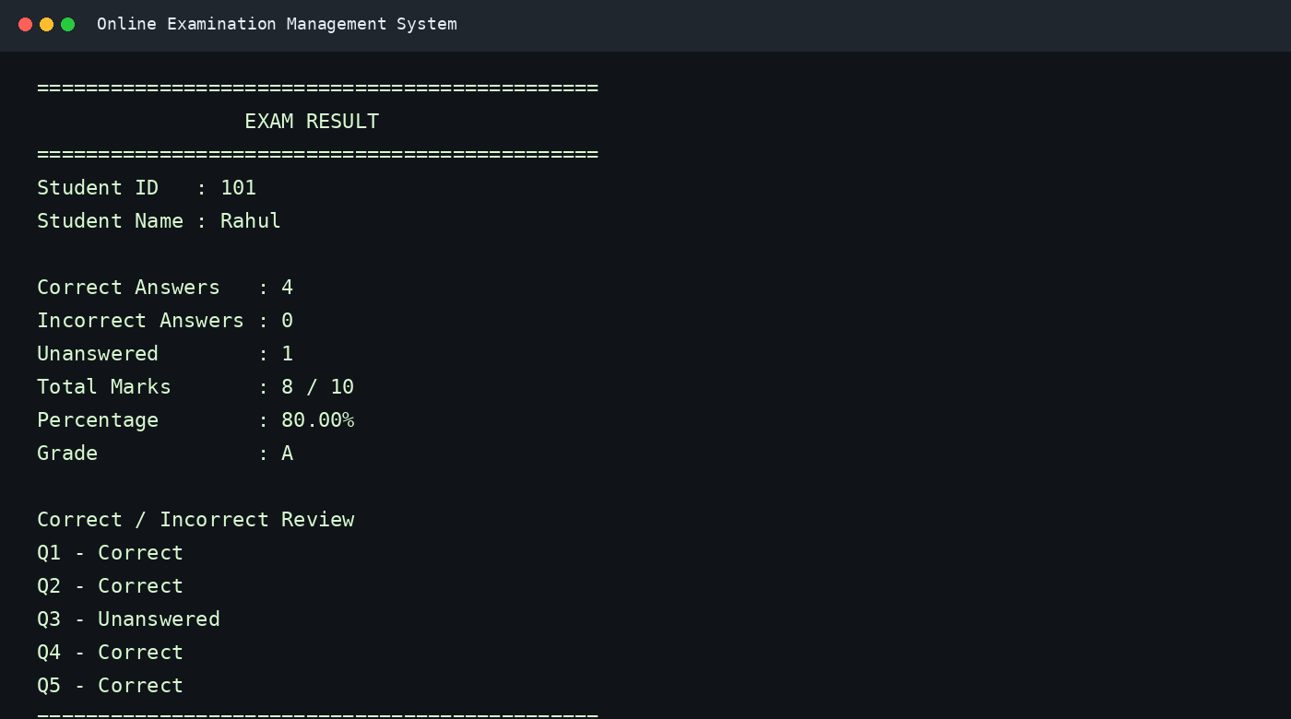
Figure 3: Individual student result
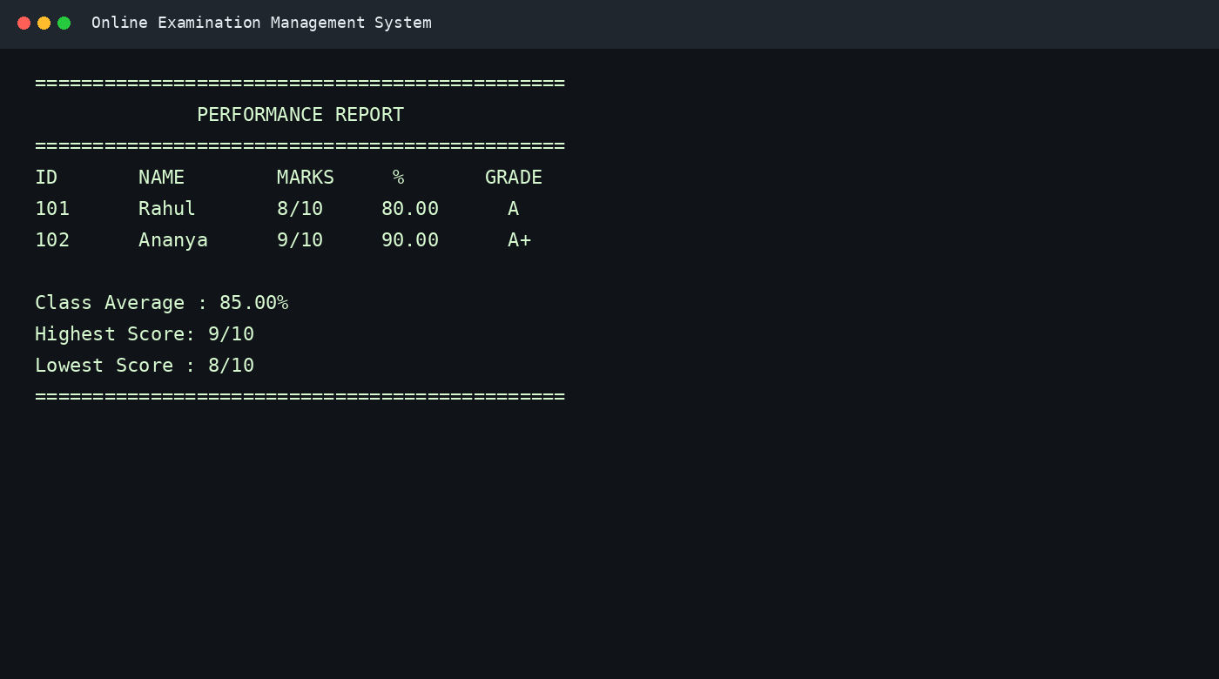
Figure 4: Multiple-student performance report

12. TESTING AND TEST CASES
Test Case | Input | Expected Result | Actual Result | Status
1 | Correct answer | Marks added | Marks added | PASS
2 | Wrong answer | No marks added | No marks added | PASS
3 | 0 / skip | Unanswered count increases | Count increases | PASS
4 | All correct | 100% and A+ | 100% and A+ | PASS
5 | Multiple students | Each result stored | Results displayed | PASS
6 | Invalid student count | Error message | Error message | PASS

13. SAMPLE PERFORMANCE REPORT
The system maintains each student's result in an array of StudentResult structures. The report can therefore summarize the performance of all students who completed the examination.
Student ID | Name | Score | Percentage | Grade | Remark
101 | Rahul | 8/10 | 80.00% | A | Very Good
102 | Ananya | 9/10 | 90.00% | A+ | Excellent
103 | Kiran | 7/10 | 70.00% | B | Good
Sample class average: 80.00%. The report can be extended to calculate rank, pass percentage, average by question and other statistics.

14. ADVANTAGES AND LIMITATIONS
Advantages
- Simple and easy to operate through the terminal.
- Automatic calculation reduces manual arithmetic errors.
- Supports correct, incorrect and unanswered responses.
- Uses structures to organize related information clearly.
- Supports multiple student results during a single execution.
- Generates a useful summary performance report.
- Easy to compile and run in Visual Studio Code with GCC/MinGW.
Limitations
- The current question bank is stored in the source code.
- Results are stored only during program execution and are not permanently saved.
- There is no student login or administrator authentication.
- There is no real-time examination timer.
- The interface is text-based rather than graphical or web-based.

15. FUTURE ENHANCEMENTS
- Add file handling or SQLite/database storage for permanent results.
- Provide separate administrator and student login.
- Allow the administrator to add, edit and delete questions.
- Randomize questions and answer options.
- Add a countdown timer and automatic submission.
- Introduce negative marking if required.
- Create a graphical user interface or web-based version.
- Generate printable result sheets and detailed analytics.
- Add password protection and secure student records.

16. CONCLUSION
The Online Examination Management System successfully demonstrates how C programming can be used to solve a practical academic problem. The application stores questions and student results using structures, conducts the examination one question at a time, evaluates answers, handles unanswered questions and calculates the final score, percentage and grade automatically.
The project also demonstrates how multiple student results can be maintained and summarized in a performance report. Although the current version is console-based and uses in-memory data, its modular design provides a good foundation for future improvements such as database storage, authentication, timers and graphical interfaces.
Overall, the project provides practical experience in data organization, decision making, loops, functions, arrays, strings and structures while producing a useful examination management application.

17. REFERENCES
- The C Programming Language – general concepts of C syntax, functions, arrays and structures.
- C programming laboratory notes and classroom materials.
- GCC / MinGW compiler documentation and standard C library references.
- Visual Studio Code documentation for compiling and running C programs.

