SUMERIX GLOBAL
Data Analytics & Business Intelligence Internship
Retail Sales & Business Performance Dashboard
Project Report - Task 1: Data Cleaning, Excel Analysis and Interactive Dashboard
Internship Organisation: Sumerix Global
Programme: Data Analytics & Business Intelligence (Excel + SQL + Power BI / Tableau)
Task: Task 1 of 6 - Data Analytics Fundamentals, Excel, Pivot Tables & Dashboards
Prepared by: [Your Name]
Date: October 2026
Tools used: Microsoft Excel (formulas, Tables, data validation, charts)

Contents
1. Introduction
2. Business Problem
3. Data and Tools
4. Methodology
5. Data Cleaning and Preparation
6. Excel Formulas and Workbook Design
7. Analysis and Summaries
8. Interactive Dashboard
9. Business Insights
10. Recommendations
11. Validation and Quality Checks
12. Assumptions and Limitations
13. Skills Gained and Next Steps
14. Acknowledgement
Appendix: Project Folder Structure

1. Introduction
This report documents the work completed for Task 1 of the Data Analytics & Business Intelligence Internship at Sumerix Global. The task builds the foundation of the analytics lifecycle: collecting and cleaning business data, applying Excel functions, summarising data with pivot-style reports, and presenting results as an interactive executive dashboard.
The project, a Retail Sales & Business Performance Dashboard, shows how raw sales records can be turned into clear, decision-ready insights. It also forms the first step of the internship roadmap that continues through Advanced Excel, SQL, Power BI / Tableau and a final enterprise capstone.

1.1 Objectives
- Clean and validate a raw retail sales dataset.
- Organise the data in a structured Excel Table and apply business formulas.
- Build summaries for monthly sales, product categories, customer segments and regions.
- Design an interactive dashboard with KPI cards and charts.
- Answer key business questions and recommend actions to management.

2. Business Problem
A retail company collects daily sales data from multiple regions but lacks an effective reporting system. Management needs one place to monitor sales performance, revenue and profit, top-selling products, customer behaviour and regional performance.
Goal: transform raw, inconsistent sales data into a trustworthy, interactive Business Intelligence dashboard that supports executive decision-making.

3. Data and Tools

3.1 Dataset
A practice dataset was used for this project: 1,240 raw order records covering calendar year 2024, with 13 fields. The data was generated to mimic a real retail dataset and deliberately contains the kinds of quality issues analysts meet in practice (duplicates, mixed date formats, numbers stored as text, inconsistent spelling and missing values). Currency is assumed to be INR.
Field group | Columns
Order | Order_ID, Order_Date
Customer | Customer_ID, Customer_Name, Segment
Geography | Region, State
Product | Category, Product, Unit_Price, Unit_Cost
Transaction | Quantity, Discount

3.2 Tools
Microsoft Excel was used for the workbook, formulas, Excel Table, data validation, conditional formatting, summaries and charts. Python was used only to generate the practice dataset and to run an independent check of the totals.

4. Methodology

4.1 Data analytics lifecycle
The project followed the standard analytics lifecycle, from defining the business problem to communicating insights and recommended actions.
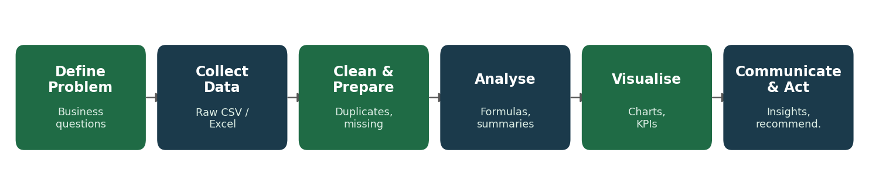
Figure 1: Data analytics lifecycle followed in this project

4.2 Business Intelligence architecture
Data flows from source records through preparation and storage into analysis and reporting. In this task the full chain lives inside Excel; later tasks will extend it with SQL databases and Power BI / Tableau.
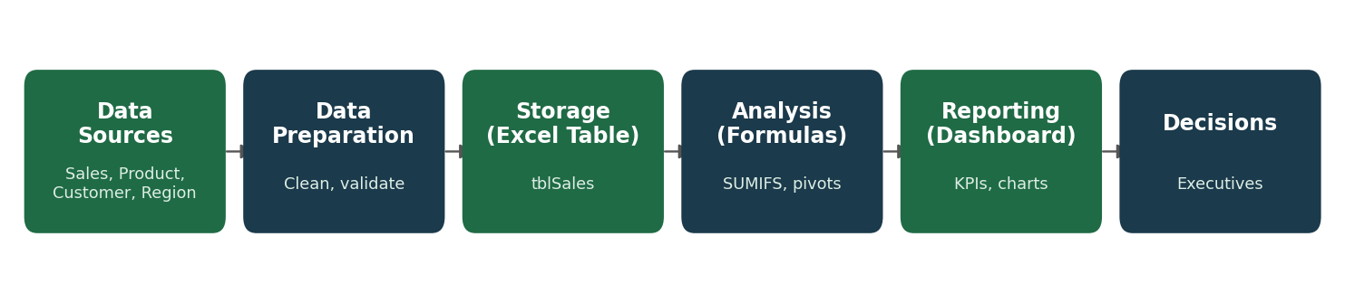
Figure 2: Business Intelligence architecture used in the project

4.3 Business reporting workflow
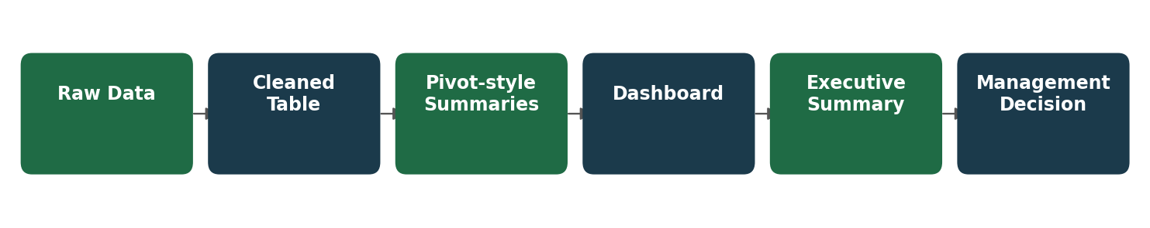
Figure 3: Business reporting workflow

5. Data Cleaning and Preparation
Raw data was kept untouched in its own sheet (and file), and all cleaning was performed on a copy. Every change was logged so the process is transparent and repeatable.
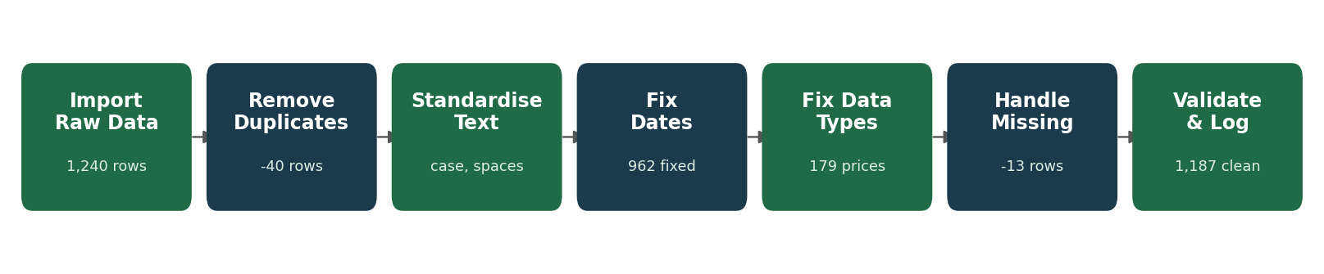
Figure 4: Data cleaning workflow with record counts
Issue | Column | Records | Action taken
Exact duplicate rows | All | 40 | Removed
Inconsistent case / spaces | Region, Segment, Category | 392 | Trimmed, proper case
Mixed date formats (3 types) | Order_Date | 962 | Converted to true dates (dd-mm-yyyy)
Numbers stored as text ("$") | Unit_Price | 179 | Converted to numbers
Missing value | Customer_Name / Region | 25 / 20 | Filled from the customer's other orders
Missing value | Unit_Price | 15 | Filled with product list price
Missing value | Discount | 30 | Assumed 0% discount
Missing, not recoverable | Quantity / Order_Date | 13 | Rows removed

Result: 1,240 raw rows became 1,187 clean rows with no blank cells. The cleaned data was converted to an Excel Table (tblSales) and protected by data validation rules: drop-down lists for Region, Segment and Category; Quantity as a whole number of at least 1; Discount between 0% and 50%; and order dates within 2024.

6. Excel Formulas and Workbook Design
All calculated fields use formulas rather than typed values, so the workbook updates automatically when data changes.
Measure | Formula logic
Revenue | ROUND(Quantity x Unit_Price x (1 - Discount), 2)
Cost | ROUND(Quantity x Unit_Cost, 2)
Profit | Revenue - Cost
Profit margin | IFERROR(Profit / Revenue, 0)
Order month | MONTH(Order_Date)
Order size | IF(Revenue >= threshold, "High", "Low")

Functions used across the workbook: SUM, ROUND, IF, IFERROR, MONTH, SUMIFS, COUNTIFS, INDEX, MATCH, MAX, ROWS and COUNTA. Conditional formatting highlights loss-making orders in red, shows data bars on revenue, and applies a colour scale to monthly margin.

6.1 Workbook structure
Sheet | Purpose
Dashboard | KPI cards, charts, Region and Category filters, live insights
Executive_Summary | Findings and recommendations
Pivot_Tables | Monthly, category, product, segment and region summaries; cross-checks
Cleaned_Data | Cleaned Excel Table with formulas and validation
Raw_Data | Original, untouched data
Cleaning_Log | Every issue, count, action and business rule
Lookups | Drop-down lists and editable threshold

7. Analysis and Summaries
Summary tables were built with SUMIFS and COUNTIFS in the same layout a PivotTable would produce. They respond to the dashboard filters, and a Region x Category matrix reproduces the classic PivotTable view.

7.1 Regional sales
Region | Revenue | Profit | Margin | Orders
West | 160,296 | 43,762 | 27.3% | 331
South | 150,975 | 39,026 | 25.8% | 297
North | 136,302 | 35,675 | 26.2% | 311
East | 76,927 | 19,968 | 26.0% | 148
Central | 47,220 | 13,352 | 28.3% | 100

7.2 Product categories
Category | Revenue | Profit | Margin | Orders
Technology | 299,421 | 61,711 | 20.6% | 352
Furniture | 144,144 | 42,819 | 29.7% | 328
Office Supplies | 128,156 | 47,254 | 36.9% | 507

7.3 Product performance
Product | Revenue | Profit | Margin
Laptop | 130,863 | 24,303 | 18.6%
Smartphone | 104,594 | 19,054 | 18.2%
Standing Desk | 73,710 | 20,230 | 27.4%
Ink Cartridge | 52,099 | 17,249 | 33.1%
Monitor | 39,466 | 9,466 | 24.0%
Printer Paper | 34,941 | 11,445 | 32.8%
Office Chair | 26,802 | 9,092 | 33.9%
Desk Organizer | 26,280 | 11,707 | 44.5%
Wireless Headphones | 24,498 | 8,888 | 36.3%
Filing Cabinet | 24,144 | 7,239 | 30.0%
Bookcase | 19,488 | 6,258 | 32.1%
Notebook Set | 14,837 | 6,854 | 46.2%

7.4 Customer segments
Segment | Revenue | Profit | Orders | Avg order value
Consumer | 288,352 | 77,170 | 637 | 453
Corporate | 173,422 | 46,260 | 350 | 495
Home Office | 109,946 | 28,353 | 200 | 550

7.5 Monthly sales
Month | Revenue | Profit
Jan | 34,036 | 10,093
Feb | 28,589 | 7,979
Mar | 41,603 | 10,683
Apr | 42,011 | 10,822
May | 44,419 | 11,162
Jun | 36,402 | 10,284
Jul | 52,842 | 14,495
Aug | 54,626 | 13,193
Sep | 66,908 | 17,477
Oct | 34,205 | 9,418
Nov | 73,127 | 19,511
Dec | 62,952 | 16,666

7.6 Region x Category (PivotTable layout)
Region | Furniture | Technology | Office Supplies | Grand Total
North | 33,166 | 70,765 | 32,371 | 136,302
South | 39,120 | 81,726 | 30,129 | 150,975
East | 20,811 | 38,665 | 17,451 | 76,927
West | 42,029 | 82,163 | 36,104 | 160,296
Central | 9,018 | 26,103 | 12,099 | 47,220
Grand Total | 144,144 | 299,421 | 128,156 | 571,720

8. Interactive Dashboard
The dashboard presents the most important information first: five KPI cards across the top, followed by trend, category, regional, segment and product charts. Two yellow drop-down filters (Region and Category) update every KPI, table, chart and the "live insights" block at the bottom.
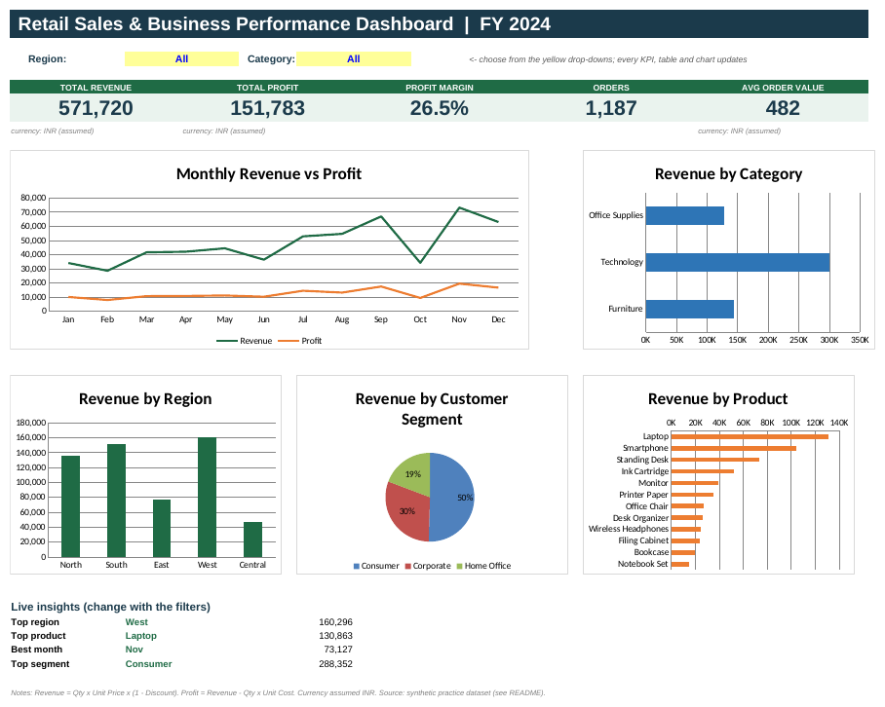
Figure 5: KPI dashboard layout

8.1 Design principles applied
- Clear visual hierarchy: KPIs first, then trends, then breakdowns.
- Consistent colour scheme and one message per chart.
- Simple and uncluttered: five charts only, focused on decisions.
- Interactive: filters change all numbers without touching the data.
- Documented assumptions and notes on the dashboard itself.

9. Business Insights
KPI | Value
Total revenue | 571,720
Total profit | 151,783
Profit margin | 26.5%
Orders | 1,187
Average order value | 482

Q1. Which region generated the highest sales?
West led with 160,296 (28.0% of revenue), followed by South (150,975). Central was lowest at 47,220, less than a third of the leader.

Q2. Which products performed best?
By revenue the top products were Laptop (130,863), Smartphone (104,594) and Standing Desk (73,710). Technology is the largest category at 52.4% of revenue. By margin, Notebook Set is strongest (46.2%) while Smartphone is weakest (18.2%), so high revenue does not always mean high profitability.

Q3. Which months had the highest revenue?
Nov (73,127), Sep (66,908) and Dec (62,952) were the strongest. Q4 (October to December) contributes 29.8% of annual revenue. The weakest month was Feb (28,589).

Other findings
- Customers: the Consumer segment is the largest at 50.4% of revenue.
- Discounting: margin drops from 31.5% on full-price orders to 1.8% at a 30% discount, and 10 orders were sold at a loss.

10. Recommendations
- Control discounts. Require approval for discounts above 20%; deep discounts erode margin and create loss-making orders.
- Prepare for the Q4 peak. Build inventory and staffing in September and October, and use promotions to lift weaker months.
- Grow the lowest region. Run a targeted campaign in Central while protecting the lead in West.
- Focus on profitable products. Promote high-margin items such as Notebook Set; review pricing or supplier cost for Smartphone.
- Reward the core segment. Introduce loyalty and bundle offers for Consumer customers and test bulk pricing for corporate buyers.

11. Validation and Quality Checks
- Total revenue (571,720.25) matches across the Excel formulas, an independent Python calculation, and the Region x Category matrix.
- A filtered test (West + Technology) matched an independent calculation exactly: 82,162.50 revenue across 105 orders.
- Built-in cross-checks on the Pivot_Tables sheet confirm matrix total, row count and Profit = Revenue - Cost.
- The workbook recalculates with zero formula errors (6,151 formulas).

12. Assumptions and Limitations
- The dataset is a practice dataset; findings illustrate the method rather than a real company's results.
- Currency is assumed to be INR and all orders fall in 2024.
- Missing discounts were assumed to be 0%; missing prices were filled with the product list price.
- Summaries use SUMIFS formulas and drop-down filters. Native PivotTables, PivotCharts, slicers and timelines can be added on top of the same cleaned table as a next step.
- Each order is a single product line, so customer-level lifetime analysis was out of scope.

13. Skills Gained and Next Steps
Through this task I practised data cleaning and validation, structured Excel Tables, business formulas, summary reporting, KPI and dashboard design, business storytelling and project documentation. These are the foundations for the rest of the internship at Sumerix Global.
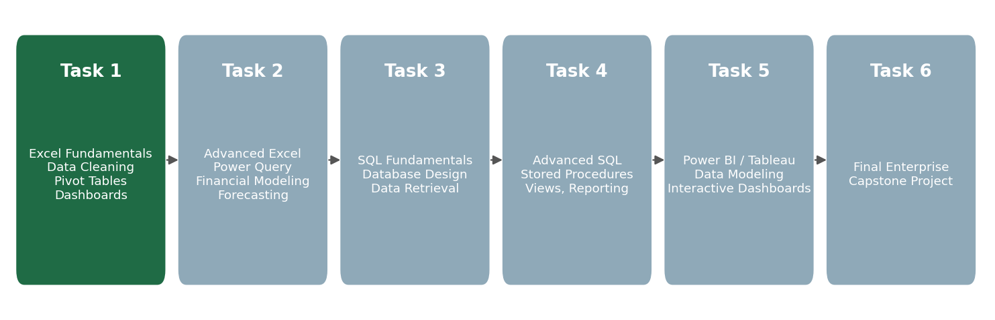
Figure 6: Internship roadmap (Tasks 1-6); Task 1 completed
Next, Task 2 covers Advanced Excel, Power Query, financial modelling and forecasting, followed by SQL for data retrieval, and Power BI / Tableau for enterprise dashboards in the final capstone.

14. Acknowledgement
I would like to thank Sumerix Global for the structured, project-based internship programme and the opportunity to build practical, industry-oriented skills in Data Analytics and Business Intelligence.

Appendix: Project Folder Structure
Retail-Sales-Analytics/
datasets/raw/ - Raw_Data.xlsx, Raw_Data.csv
datasets/cleaned/ - Cleaned_Data.xlsx, Cleaned_Data.csv
excel/ - Retail_Sales_Analytics.xlsx
documentation/ - this report, scripts, PivotTable guide
screenshots/ - dashboard.png
README.md

