**Manual for Assignment tasks 4, 5 and 6.**

4. Save the inputted text by HTML form to DB on a server, respond the table of saved records by JSON and show it up.

5. Edit the text on the table display.

Purpose: To understand and implement DB access (i.e. update record).

6. Delete the text on the table display.

Purpose: To understand and implement DB access (i.e. delete record).

**STEPS:**

* Run the application on Tomcat server.

This is the first page that will be visible after the application is launched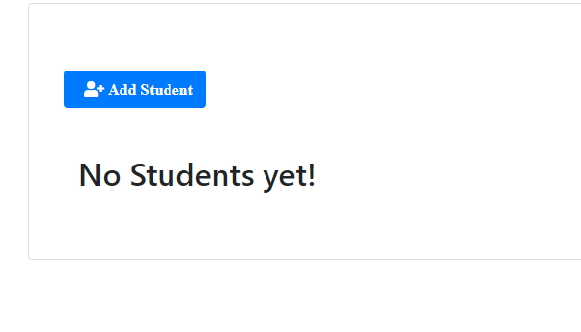

url: <http://localhost:8080/students>

* Click on “Add Student” button. This will take us to the next page where we can add student’s details.

Fill the from and click on the button below. Now the student’s details are stored in the postgres Database.

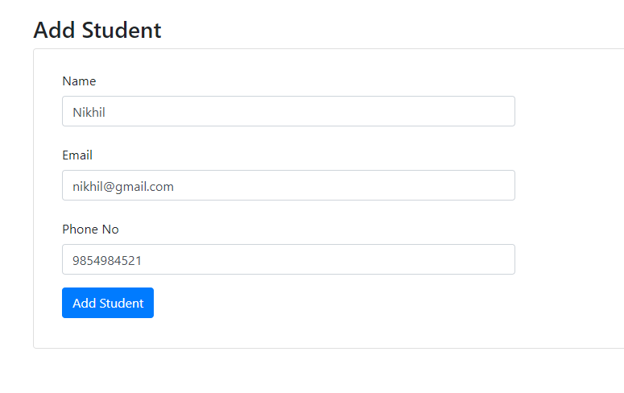

url for signup page: <http://localhost:8080/students/signup>

* Now on the next page, we can view the list of all the students who are added to the database.

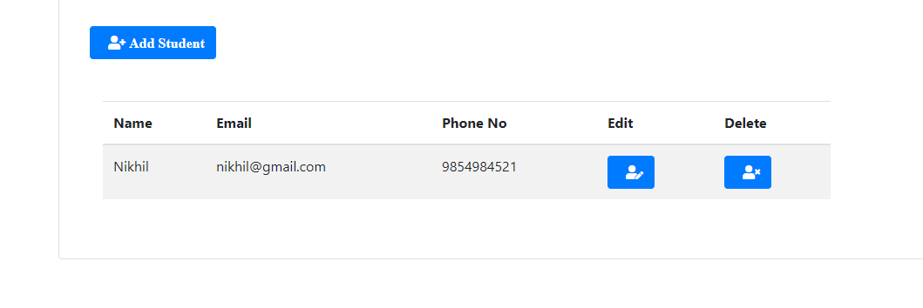Here, we can edit or delete the details by pressing on the respective buttons.

url for list: <http://localhost:8080/students/list>

url for update: [http://localhost:8080/students/edit/{id}](http://localhost:8080/students/edit/%7bid%7d)

url for delete: http://localhost:8080/students/delete/{id}