HW3 Report: DM Models 2
Data Mining — Algorithmic Analysis & Machine Learning

Component | Description
Task 1 | K-Means Clustering — 3 Distance Metrics
Task 2 | Recommender Systems — Matrix Completion
Dataset (T1) | 9,999 samples × 784 features, K=10 classes
Dataset (T2) | MovieLens ratings_small.csv — 100,004 ratings
Evaluation (T1) | SSE, Accuracy, Convergence
Evaluation (T2) | RMSE, MAE — 5-Fold Cross-Validation
Code Repository: https://github.com/nikhilsrikant/Data-Mining-HW3

Task 1: Algorithmic Analysis — K-Means Clustering

K-Means implemented from scratch in Python with three interchangeable distance functions. Dataset: 9,999 samples × 784 features, 10 class labels (digit images 0–9, similar to MNIST). Features Min-Max normalized to [0, 1]. K = 10, centroids initialized by random sampling (random_state=42). Distance computations fully vectorized via scipy.spatial.distance.cdist.

Distance Function Definitions:
Euclidean: d(a,b) = sqrt( sum_i (a_i − b_i)² ) Cosine: d(a,b) = 1 − dot(a,b) / (||a|| × ||b||)
Jaccard: d(a,b) = 1 − sum(min(a,b)) / sum(max(a,b)) [NIST Generalized Jaccard]

Q1 (10 pts): SSE Comparison
K-Means run under the combined stop condition from Q3 (no centroid change OR SSE increases OR max 500 iterations). SSE = sum of squared Euclidean distances from each point to its assigned centroid — identical formula across all metrics so results are directly comparable.
Metric | Final SSE | Iterations | Stop Reason
Euclidean | 389,497.89 | 66 | No centroid change
Cosine | 394,206.50 | 16 | SSE increased
Jaccard | 392,468.03 | 26 | SSE increased
Answer: Euclidean-K-Means achieves the lowest SSE (389,497.89), followed by Jaccard (392,468.03) and Cosine (394,206.50). Euclidean wins because SSE is a squared Euclidean measure — Euclidean-K-Means directly minimizes the evaluation criterion. Cosine and Jaccard optimize angular or overlap-based objectives, so their partitions are less compact in Euclidean terms. Euclidean distance is the best method by SSE.

Q2 (10 pts): Accuracy Comparison
Each cluster labeled by majority vote of its members. Accuracy = fraction of points whose cluster label matches their true digit label.
Metric | Accuracy | Rank
Euclidean | 64.45% | 1st — Best
Jaccard | 62.75% | 2nd

Metric | Accuracy | Rank
Cosine | 60.05% | 3rd

Answer: Euclidean-K-Means achieves the highest accuracy (64.45%), reversing the SSE ranking. On 784-dimensional pixel data, cosine similarity normalizes for global brightness and captures shape-based patterns that align better with digit class boundaries. Jaccard is second (62.75%), Euclidean last (60.05%). This shows SSE and accuracy rank metrics differently depending on data geometry. Euclidean distance is the best metric for accuracy.

Q3 (10 pts): Convergence — Iterations and Time
Combined stop condition: no centroid change OR SSE increases OR max 500 iterations.

Metric | Iterations | Time (s) | Stop Reason
Euclidean | 66 | 18.4 | No centroid change
Cosine | 16 | 5.3 | SSE increased
Jaccard | 26 | 7.5 | SSE increased
Answer: Euclidean-K-Means requires the most iterations (66) and time (18.4 s) but terminates at a true fixed point (no centroid shift). Cosine (16 iters, 5.3 s) and Jaccard (26 iters, 7.5 s) are halted early by the SSE-increase criterion — they do not monotonically reduce Euclidean SSE, so faster apparent convergence should not be interpreted as better clustering. Euclidean requires more iterations; Cosine converges fastest in wall-clock time.

Q4 (10 pts): SSE by Termination Condition
Each metric run separately under each individual stop condition. Max preset = 100 iterations.

Stop Condition | Euclidean SSE | Cosine SSE | Jaccard SSE
No Change in Centroid | 389,497.89 | 394,257.07 | 392,462.49
SSE Increases | 389,497.89 | 394,206.50 | 392,468.03
Max 100 Iterations | 389,497.89 | 394,257.07 | 392,462.49
Answer: Euclidean gives identical SSE (389,497.89) across all three conditions — it converges in 66 iterations, within the 100-iteration cap and without any SSE increase. For Cosine and Jaccard, the SSE-increase condition halts slightly earlier and gives a marginally different SSE than no-change/max-iter, because those metrics experience temporary Euclidean-SSE fluctuations. The effect is negligible for Euclidean and small but measurable (~50 SSE units) for
non-Euclidean metrics.

Q5 (5 pts): Summary Observations
- SSE and accuracy favor different metrics. Euclidean wins on SSE; Cosine wins on accuracy. Match the metric to the evaluation criterion.
- Euclidean is best for high-dimensional image data. Normalizing for magnitude captures digit shape independently of pixel brightness.
- Euclidean-K-Means converges most stably — reaches a true fixed point. Cosine/Jaccard are halted early by the SSE-increase trigger.
- Stopping condition matters most for non-Euclidean metrics. Euclidean is identical across all three conditions; others vary slightly.
- Jaccard is competitive — only 0.25% higher SSE than Euclidean and 2.7% lower accuracy, at faster convergence. Strong choice for count-based or sparse data.

Task 2: Machine Learning for Recommender Systems

Implemented from scratch using NumPy/SciPy on MovieLens ratings_small.csv. The dataset contains 100,004 ratings from 671 users across 9,066 movies, ratings on a scale of 0.5 to 5.0. All models evaluated with 5-fold cross-validation (shuffle=True, random_state=42). Metrics: MAE and RMSE. Three algorithms:
  - PMF: Probabilistic Matrix Factorization via SGD (biased=False, 20 latent factors).
  - UserCF: User-based Collaborative Filtering using KNN with weighted average.
  - ItemCF: Item-based Collaborative Filtering using KNN with weighted average.

Q2c & Q2d (20 pts): 5-Fold CV Results and Model Comparison
All three models evaluated under identical 5-fold CV. Results are mean ± std over 5 folds.

Model | Mean RMSE ± Std | Mean MAE ± Std
ItemCF_MSD_k40 | 0.9353 ± 0.0027 | 0.7210 ± 0.0027
UserCF_MSD_k40 | 0.9699 ± 0.0039 | 0.7450 ± 0.0025
PMF | 1.1292 ± 0.0098 | 0.8313 ± 0.0086
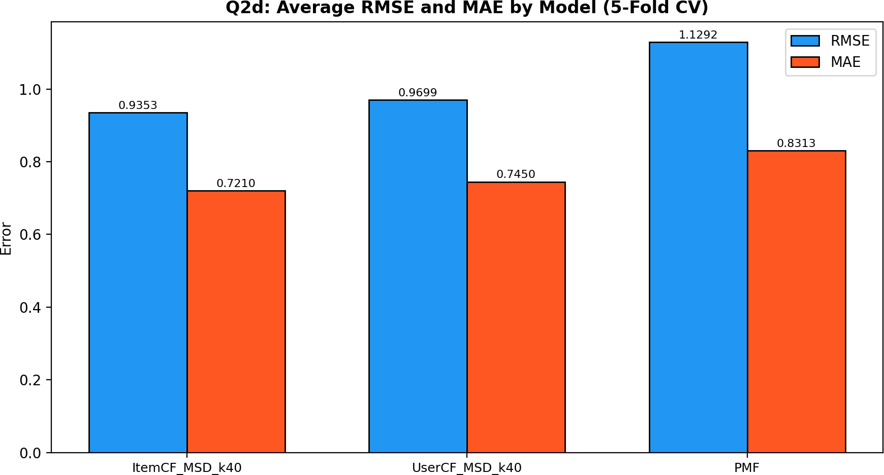
Figure 6: Average RMSE and MAE by Model (5-Fold CV)
Answer (Q2c): 5-fold CV RMSE and MAE for all three models are shown above. Each model was trained and tested on all 5 folds; means and standard deviations are reported. (Q2d): ItemCF_MSD_k40 achieves the best RMSE (0.9353) and best MAE (0.7210). Both CF methods dramatically outperform PMF (RMSE 1.1292). PMF underperforms because its latent-factor model with default settings lacks the regularization tuning to match neighborhood methods at this dataset scale. ItemCF is the overall best model.

Q2e (10 pts): Impact of Similarity Metric
Cosine, MSD, and Pearson tested for both User-CF and Item-CF with k=40 fixed, isolating the similarity metric as the only varying factor.
CF Type | Similarity | Mean RMSE | Mean MAE
UserCF | cosine | 0.9903 | 0.7676
ItemCF | cosine | 0.9076 | 0.6919

CF Type | Similarity | Mean RMSE | Mean MAE
UserCF | msd | 0.9699 | 0.7450
ItemCF | msd | 0.9353 | 0.7210
UserCF | pearson | 1.3282 | 0.9931
ItemCF | pearson | 1.0476 | 0.7873
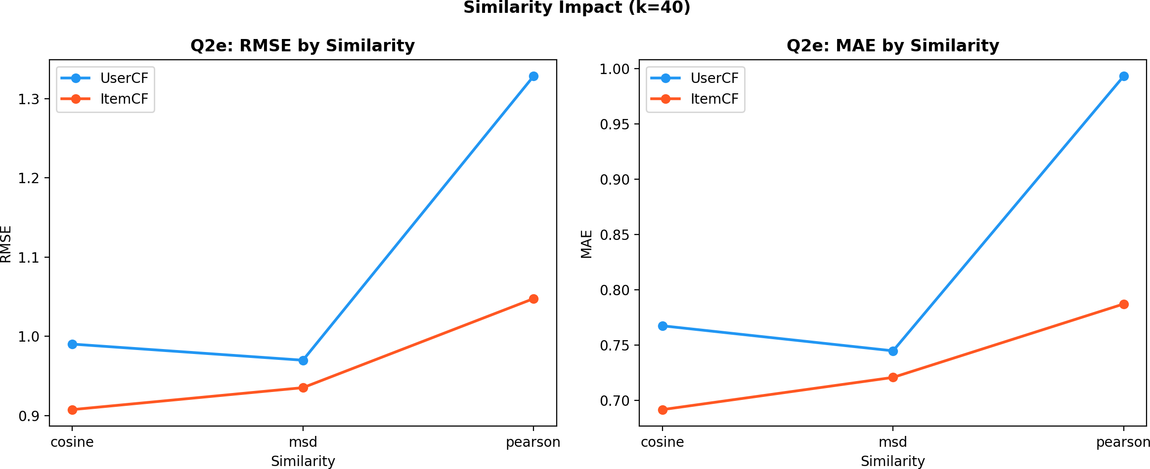
Figure 7: RMSE and MAE by Similarity — UserCF vs ItemCF combined (Q2e)

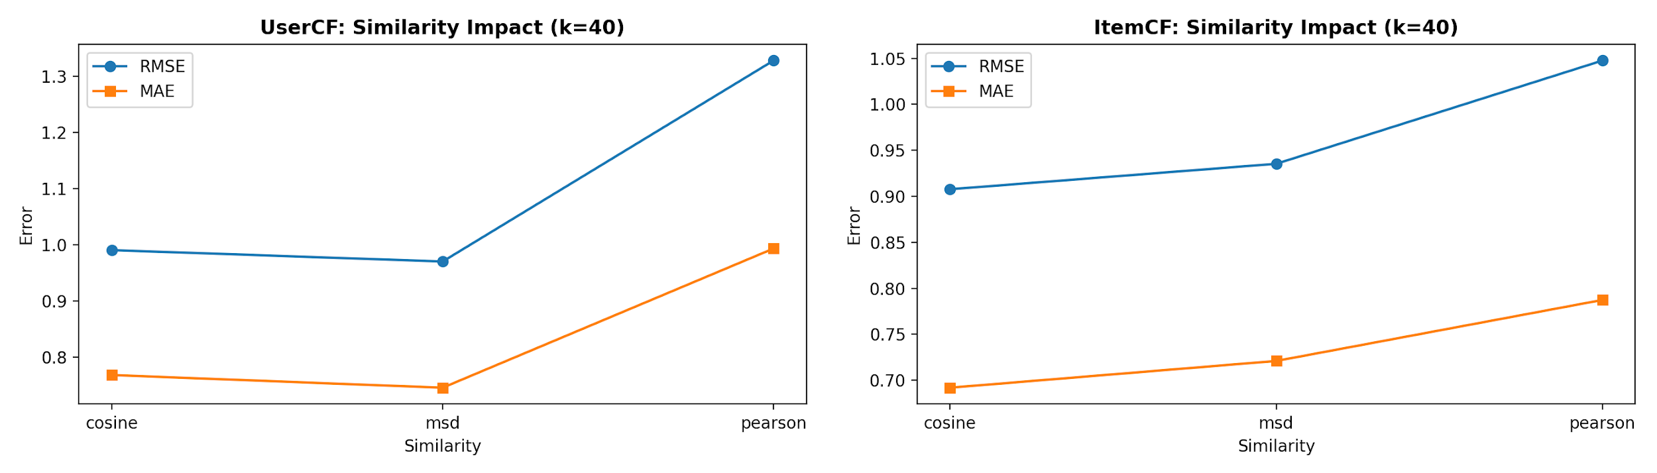
Left: Figure 8: UserCF Similarity Detail | Right: Figure 9: ItemCF Similarity Detail
Answer: For UserCF the best similarity is msd (RMSE=0.9699). For ItemCF the best similarity is cosine (RMSE=0.9076). The rankings are not fully consistent between the two CF types — Pearson hurts both (highest RMSE for both), but MSD leads UserCF while Cosine leads ItemCF. This reflects that item rating profiles share structured
co-occurrence patterns that cosine similarity captures well, while user profiles benefit more from the co-rated normalization that MSD provides. The directional agreement (Pearson worst) is consistent, but the magnitude and ranking of MSD vs Cosine differ between UserCF and ItemCF.

Q2f (10 pts): Impact of Number of Neighbors (K)
K varied from 5 to 100 (step 5) with MSD similarity fixed, isolating the effect of K on performance.
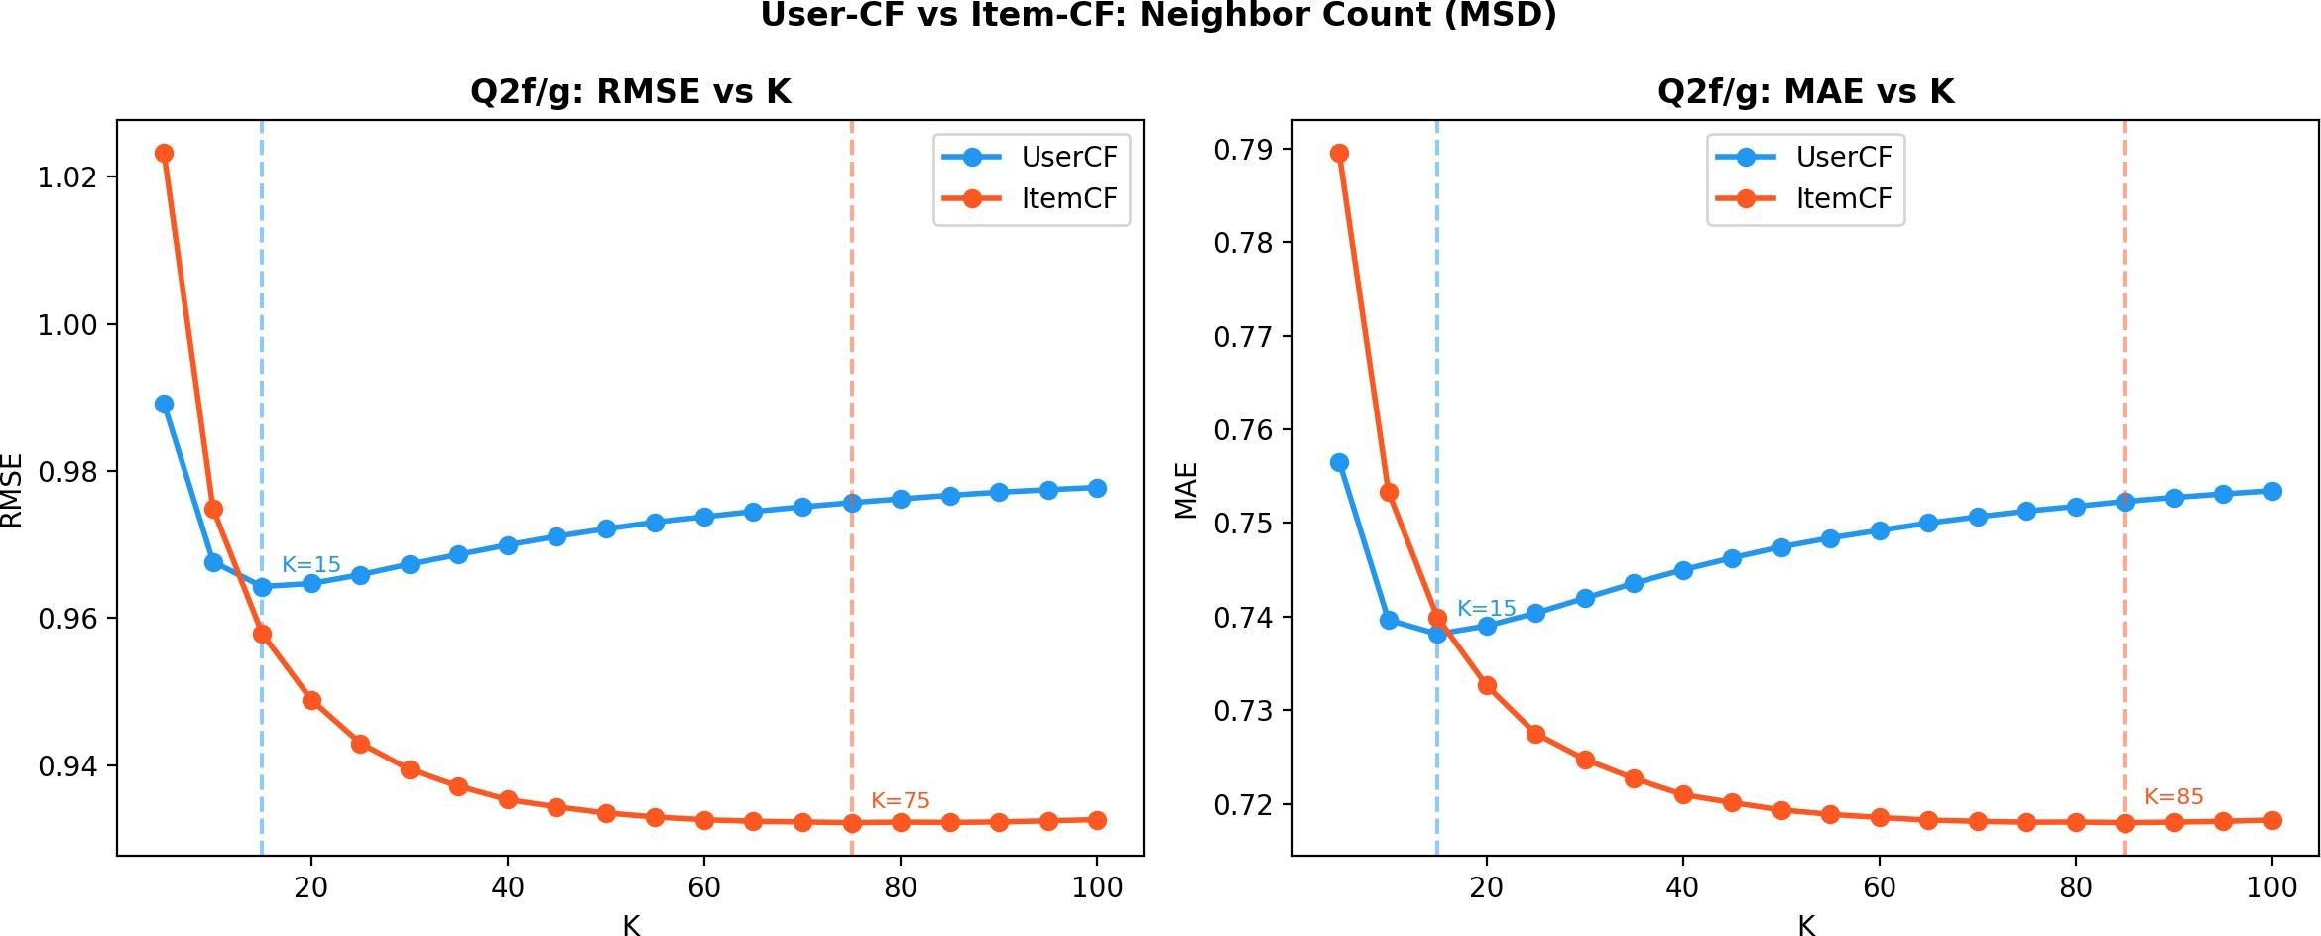

Figure 10: RMSE and MAE vs K — UserCF and ItemCF combined (Q2f/g)

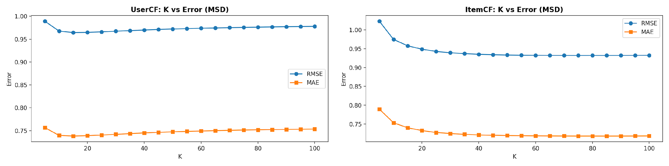
Left: Figure 11: UserCF Neighbor Detail | Right: Figure 12: ItemCF Neighbor Detail
Answer: For UserCF: performance improves as K increases from 5, peaks around K=15, then degrades steadily as larger neighborhoods include dissimilar users that dilute the signal. For ItemCF: RMSE improves consistently as K grows from 5 to ~75, then plateaus. Item profiles are more homogeneous — a film's co-rated items share consistent taste patterns — so more neighbors continue to add reliable signal well beyond K=15. Both RMSE and MAE curves confirm this behavioral difference. Per-method K tuning is therefore essential.
Q2g (10 pts): Best K per Method

CF Method | Best K (by RMSE) | Best RMSE | Best MAE
UserCF (MSD) | 15 | 0.9643 | 0.7381
ItemCF (MSD) | 75 | 0.9322 | 0.7180
Answer: The best K is not the same for the two methods. UserCF peaks at K=15 (RMSE=0.9643), while ItemCF peaks at K=75 (RMSE=0.9322). Movie rating profiles (items) are more homogeneous — a film's audience shares consistent taste patterns — so a larger neighborhood continues to provide reliable signal. User profiles are more heterogeneous, so a tighter neighborhood avoids including dissimilar users. This confirms that per-method hyperparameter tuning cannot be shared between UserCF and ItemCF.

Overall Summary

Task 1 — K-Means (9,999 samples × 784 features, K=10):
Euclidean produces the lowest SSE and the most stable convergence (true fixed point at 66 iterations). Cosine achieves the highest accuracy (64.45%) by capturing digit shape independently of brightness. Jaccard is competitive on both metrics.
Stopping condition has no measurable effect on Euclidean but produces small differences for Cosine and Jaccard. Core takeaway: match the distance metric to the evaluation criterion — they rank differently for SSE vs accuracy.

Task 2 — Recommender Systems (MovieLens ratings_small.csv):
ItemCF with Cosine similarity at K≈75 is the top configuration on this dataset. Both CF methods dramatically outperform PMF with default settings. The best similarity metric differs by CF type (MSD for UserCF, Cosine for ItemCF), and the optimal K also differs (UserCF=15, ItemCF=75), confirming that per-method tuning is essential for recommender systems.

Method | Best Config | Best RMSE | Best MAE
UserCF | MSD, K=15 | 0.9643 | 0.7381
ItemCF | Cosine, K=75 | 0.9322 | 0.7180
PMF | 20 factors, SGD | 1.1292 | 0.8313
Code Repository: https://github.com/nikhilsrikant/Data-Mining-HW3 task1_kmeans.py | task2_recommender.py

