CHAPTER 1
INTRODUCTION
Due to the enhancement in micro electro-mechanical system (MEMS), production of small wireless sensor nodes is easy. Wireless sensor networks may be deployed for general as well as dedicated purpose. Wireless sensor network contains wireless nodes, with limited energy source, memory and computational capability. Radio frequencies used by Sensor devices for communication purpose. Generally Sensor networks are deployed in war like areas so if it once deployed in specified area, it is not possible to physical interaction with sensor nodes.
1.1 Overview
Wireless sensor nodes consist of five units as power unit, processing unit, communication unit and sensing unit. Architecture of sensor node given below in fig 1.1.
1. Communication Unit
2. Processing Unit
3. Sensing Unit
4. Power Supply
5. Memory Unit
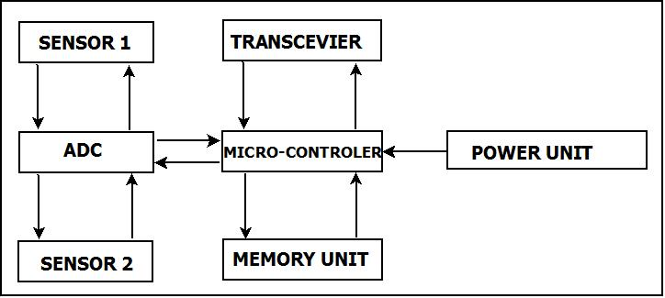
Figure 1.1: Architecture of Sensor Node
Figure1.1 depicts sensor node architecture in which sensing unit consist of sensors and analog to digital converter (ADC)/ digital to analog converter (DAC) having responsibility converting sensed analog signal to digital/ digital signal to analog. Processing unit contains microcontroller to process sensed data or signals and generate control signals to other units of sensor nodes. Memory unit associated with microcontroller to store processed or intermediate processed data. Communication unit consist transmitter and receiver called as transceivers to transmit and receive the data to base station (BS). Most important unit in all five units defined above is power unit because wireless sensor network life time completely depend on power source. Sensor nodes in wireless sensor network operated by batteries which is non rechargeable in nature and replacement of batteries is not feasible. Whole network life time depend mostly on sensor nodes power source. Energy of sensor nodes may be used efficiently using cluster based approach. In cluster based approach only some node allowed to communicate with Base Station [2, 5, 17]. Nodes having this characteristic called cluster head (CH). To control and manage energy consumption is major problem in wireless sensor networks. Data Communication process is more energy consuming with respect to data processing at nodes. We can reduce energy consumption may be reduce by making efficient communication between nodes, because to execute 3000 instruction, energy consumption is equivalent to 1 bit data transmission at 100 meters [18]. Cluster head accountability to gathered data from other member nodes of cluster and send processed data to BS using aggregation. Proper CH selection can significantly reduce consumption and prolong the life time of WSNs. One of the main protocols for clustering algorithms is LEACH. Probabilistic approach [5, 8, 9] is used to choose the cluster head schematically. It makes decision on the basis of local information for cluster formation. Number of research activities has been carried out to find out and overcome the constraints of WSNs and solve design and application issues.
Without clustering scheme sensor node can direct or multi hope communication with base station. WSNs based on clustering scheme, network is divided into clusters. And each node share data with respective cluster heads. Cluster head accountable for aggregation and transmission of data to base station.to reduce the communication cost between source and base station, aggregation is used in clustering [10]. Generally TDMA approach is used to data transmission. Various centralized and distributed has developed to select cluster head and to form clusters. When network size increases centralized schemes not suitable. For large scale networks, distributed schemes are more suitable. In distributed schemes nodes within a cluster locally decides its cluster head and its cluster members on the basis of various parameters. Clustering protocol may be dynamic and static. In dynamic clustering [2, 7, 8, 9] protocol operation has various rounds, and cluster is formed in each round. Because of this, energy depletion rate is high.
Many clustering algorithms [1, 2, 6, 14, 15, 16] based on fuzzy logic that is useful for taking real time decisions without exact information of system.
1.2 Fuzzy Inference System
Some of the clustering algorithms employ fuzzy logic to handle uncertainties in WSNs. I. Zedah introduced fuzzy logic [4] is much easier to use with compare to probabilistic theory based algorithms. Fuzzy inference model is shown below in figure 1.2.
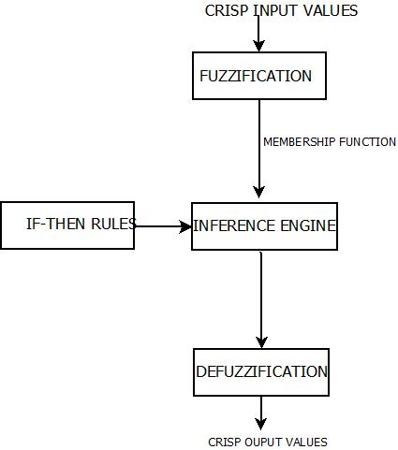
Figure 1.2: fuzzy Inference Model
Figure 1.2 depicts fuzzy inference model that consist four major components
- Fuzzification
- Rule Base
- Fuzzy Inference Engine
- Defuzzification
Crisp variables or input to the fuzzy inference model and output of fuzzy inference model is also crisp to make real decisions. Fuzzification process provide membership value to each input and transform into a variable with fuzzy nature. Rule base contains a set of rules that help fuzzy inference to take human like decisions. Fuzzy inference engine generate

CHAPTER 2
RELATED WORKS
Literature review commenced few clustering protocols based on fuzzy logic researched by the active authors. It is assume that selection of effective cluster head may prolong wireless sensor network life time. Clustering protocols based on fuzzy logic parameters to create cluster head. Some fuzzy based clustering algorithms are.
4.1 Low Energy Adaptive Clustering Hierarchy (LEACH)
This section briefly describes few famous clustering protocols. LEACH [ ] is basic protocol for all clustering protocols. LEACH operations performed in two phases. First is setup phase in which a random number between 0 and 1 is selected by wireless sensor nodes. Cluster formation in LEACH uses distributed approach in which each node make decisions without any centralized support. At the starting of each round every node select itself as a cluster head with probability Pi(t) with k number of cluster heads in current round..

$Pi\left(t\right)=\left\{ \begin{aligned}\frac{k}{N-k*(r mod N/k)} Ci(t)=1 \\ 0 Ci\left(t\right)=0\end{aligned}\right.$ (1)

This randomly generated value between 0 and 1 compared with threshold value T (n), if the value is less than T(n), the nodes becomes a cluster head. T (n) is calculated by eq. (1).
$T\left(n\right)=\left\{\begin{aligned}\frac{p}{1-p*(r mod \frac{1}{P})} if n ∈G \\ 0 otherwise\end{aligned} (2)\right.$
Where current round represented by r, desired percentage for becoming cluster head is represented by p, nodes not elected as cluster head in last 1/p rounds represented by G. second phase is steady state phase. Main advantage of LEACH protocol is fully distributive and does not need global knowledge of network.
Some disadvantages also associated with EACH protocol such as cluster head selection is totally probabilistic and poor clustering.
4.2 Fuzzy LEACH
In wireless sensor networks, fuzzy logic introduced by Gupta et al. [10]. Fuzzy LEACH is based on LEACH protocol. Cluster heads selection performed using a threshold value in LEACH protocol that is fixed according to eq. 2. To refine poor clustering issue in LEACH, fuzzy logic play role in CH selection process in Fuzzy LEACH to overcome the problem encountered by pure probabilistic models. Three fuzzy descriptors is used in Fuzzy-LEACH approach are energy of node, concentration and centrality to enhance process of cluster head (CH) selection. Node centrality represent how central the node is to the cluster and calculated using formula of sum of the squared distance of other nodes from predefined node. In F-LEACH BS performs the election process of CH in all rounds by computing chance for every ode to become the cluster head by evaluating three input fuzzy variable. Total 27 fuzzy IF-THEN rules predefined at the base station. In F-LEACH assumed that BS generates appropriate CH because BS has complete information about the whole network. All n nodes of the cluster sends k bit message to CH. Cluster head received and processed it into cnk bit messages where value c≤1 known as compression coefficient. Working way of F-LEACH is almost same as LEACH. In F-LEACH cluster head selection process performed into two phases each consists of setup phase and steady state phase. Cluster heads are chosen in setup phase using fuzzy logic knowledge processing and collection, various data processing performed in steady state phase.
4.3 Cluster Head Election using Fuzzy Logic (CHEF)
Cluster Head Election mechanism using Fuzzy Logic (CHEF) proposed by Kim et al. [11] to election of cluster head (CH) by applying two input fuzzy variables as energy and proximity distance. Proximity distance defined as the addition of distances between the cluster head and nodes inside r radius distance. Here r referred as average radius of cluster and is given by r by eq. (3).
$$r= \sqrt{\frac{area}{πnp}} (3)$$
Where n represents total number of nodes in the Wireless Sensor Network, P represents Battery level. This approach provides the node with high energy level and locally optimal node to chosen as a cluster head. The sensor node contains more energy has higher chance to become a CH. Because of energy is considered in calculating a chance in fuzzy logic. Locally optimal node selected as a cluster head using fuzzy variable local distance. Energy consumption in wireless sensor networks almost depends to the distance between two nodes. CHEF considers two factors energy as well as local distance, to choose the suitable cluster heads may prolong the wireless sensor network lifetime. CHEF take care that more than cluster heads formed within r distance by candidate method.
This approach based on totally probabilistic model for selection of cluster head. So there is a chance that distribution of CH is not perfect and some node may not have any cluster head.
  - Cluster Head Election using Fuzzy Logic (CHEF)
Fuzzy based energy aware routing protocol for wireless sensor networks (FEAR) proposed by Imam M. ALMomani to reduce energy consumption associated with routing process in wireless sensor networks. This protocol used cross layer approach. This protocol has different phases. Construction of logical tree occurs at first phase between nodes of network, logical id generated and neighbor table constructed. In second phase transmission of data packets using link of neighbors and at this stage power and depth of intermediate nodes considered and finally tree is constructed. In the phase of tree construction and reconstruction ranking system used and that is decided by fuzzy inference. Different type of control message used in FEAR such as ready, unready, engagement, Engagement-acceptance , new node, request parent, inform, change id. There are five stages in FEAR protocol: Tree construction, new node Engagement, Message Transmission and Tree reconstruction. This protocol analyzed on two parameters, first is number of sent and received messages and second one is consumed power.in FEAR protocol three stages of fuzzy ranking system is used. In first stage of fuzzy stage, distance and depth are inputs and transmission cost as output. In second stage transmission cost and residual power are inputs and neighbor rank as output. In third stage neighbor ranks and neighbor status as inputs and new rank as output.

4.5 LEACH – ERE
LEACH-ERE using fuzzy logic proposed by Jin-Shyan Lee [ ]. Concept of expected residual energy is introduced in this paper to prolong lifetime of wireless sensor networks by equal workload distribution. The model used in probability reasoning for cluster head election is given below.

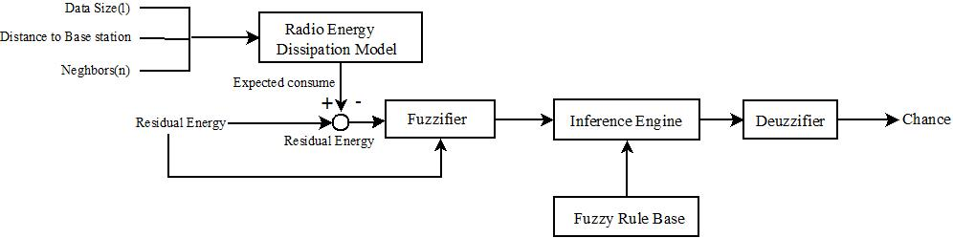

Fig 2.5 Probability Reasoning during Cluster head selection
This scheme gives better result than LEACH, LEACH-C and CHEF.
4.6 Energy Efficient Clustering Algorithm for WSNs using fuzzy logic
Energy efficient clustering algorithm for wireless sensor network using fuzzy logic was proposed by M. Taheri [ ]. This approach used to prolong lifetime of wireless sensor networks. To prolong the life time of wireless sensor networks this paper apply multi-hop clustering approach. Election of cluster head (CH) based on four fuzzy variables as residual energy, node centrality, base station distance from node and concentration of nodes. In all these four variables residual energy is the highest priority fuzzy variable. In this paper hierarchical approach of clustering used for the purpose of efficient energy consumption. This approach having four steps: first step is fussy logic in which all four fuzzy variables apply as input for each node and respective output generated in the form of chance. Second step is the cluster formation or cluster setup phase and the third step is the communication between clusters that used multi-hop communication to reduce energy consumption in data transmission. And last and fourth step is communication inside the cluster that is inter cluster communication where cluster member send the sensed data to elected cluster head. This algorithm produce better result than LEACH [ ], TLCP [ ], EHEED [ ].
4.7 A Routing Algorithm Based on fuzzy Logic Approach to Prolong the Lifetime of WSNs.
A routing algorithm based on fuzzy logic approach to prolong the lifetime of wireless sensor networks proposed by Mourad hadjila [ ]. This approach used hybrid technique to form clusters by using Fuzzy C Mean approach to reduce energy consumption and prolong network life time. Cluster head (CH) selection activity performs on the basis of two fuzzy variables, first is level of energy and centrality. This approach used multi-hop fashion to communicate with other closet cluster head until reached to the base station (BS).
4.8 Cluster Head Selection using Two Level Fuzzy Logic in WSNs
Cluster head selection using a two level fuzzy logic in wireless sensor networks proposed by Nasrin Abazari Torghabeh [ ]. In this approach two level of fuzzy logic is used for decide a node to become a cluster head (CH). Local level is the first level where appropriate sensor nodes chosen as qualified nodes on the basis of fuzzy variables energy of nodes and node neighbors. Second level of this approach is called as global level where the best node chosen as cluster head (CH) using three fuzzy variables: first is centrality, base station proximity and inter cluster distance.
  - An energy balancing LEACH
An energy balancing LEACH algorithm for wireless sensor networks proposed by Hasong Gou et. Al [ ]. This paper introduced improved LEACH (LEACH-C) called as pLEACH. In this whole network divided in optimal sectors and a sensor node with maximum energy chosen as cluster head (CH) in every sectors. This is centralized approach.

CHAPTER 3
PROPOSED WORK
We discussed various fuzzy logic based clustering approaches to enhance the wireless sensor network life time with their merit and demerit. The idea of proposed scheme is initiated by merit and demerit of above discussed approaches. In all previous dynamic clustering scheme two major demerits.
- Decide the cluster area by chosen cluster head in each round.
This process consumes valuable energy resource in processing and communicating among node to fix cluster head and cluster region.
- Overlapping of cluster head range.
It may possible that two nodes chosen as cluster head, close with each other.
In our proposed scheme we try to reduce these two overcoming of existing schemes using grid based dynamic cluster head selection approach in wireless sensor network.
Both demerits may be overcomes by using proposed approach Grid Based Dynamic Cluster Head Selection using fuzzy logic to prolong lifetime in WSNs.
In our proposed approach network area is divided in to grids where wireless sensor nodes will be deployed randomly. The advantage of doing such kind of arrangement is all sensor nodes have unique grid means there will be no sensor nodes belongs to more than one grid. It reduce the energy consumption taken place at the time of dynamic clustering approach.
In proposed approach each grid contains equal number of homogeneous wireless sensor nodes but we may also use this approach where each grid contains different number of wireless sensor nodes with heterogeneous nature of nodes. In homogeneous environment all sensor nodes having similar characteristics and functionality in term of energy and processing capabilities. In heterogeneous environment wireless sensor nodes having different characteristics and functionalities in term of energy and processing capabilities.
Various cluster head selection schemes like CHEF [ ] and F-LEACH [ ] used probabilistic approach to select cluster head and then decide the cluster area using fixed threshold value compare with randomly generated number. Because of this inappropriate node may be selected as cluster head for that round. This drawback may leads to reduce the whole network life time.

5.1 System Model
System model consist of network model and radio model
5.1.1 Network model
- Base station situated away from the sensor nodes.
- Base station as well as sensor nodes are stationary.
- Nodes are homogeneous in terms of power and processing.
- Initial energy of each node is same.
- Propagation channel is symmetric.
- Cluster head selection perform locally no role of base station.
- Nodes have no mobility.
- Nodes are location unaware.
- Base station has unlimited resources in terms of power and processing.
- Node failure due to energy consumption.
5.1.2 Radio model

In this proposed scheme energy dissipations takes place according to eq. (3)(4)(5).

Each node assume to transmit k bit data to a node at distance d with electronic energy E_{elect}.

$E_{TX}=\left\{\begin{aligned}k.E_{elec}+k.E_{fs}.d^{2} if d≤d_{0} \\ k.E_{elec}+k.E_{mp}.d^{4} ifd>d_{0} \end{aligned}\right. (4)$

${ d}_{0}=\sqrt{\frac{E_{fs}}{E_{mp}} } (5)$
Where
$E_{elec }$ is the amount of energy consumption per bit to operate transmitter or receiver, $E_{fs}$ is energy in free space, $E_{mp}$ is energy in multipath model.
The amount of energy needed in receiving packet size of k bit is given in eq. (5)
$E_{RX}=k.E_{elec} (6)$

5.2 Network Area model
In proposed approach (GAPFL), Whole area of network divided into grids for efficient consumption of sensor nodes energy shown in figure 7.2.
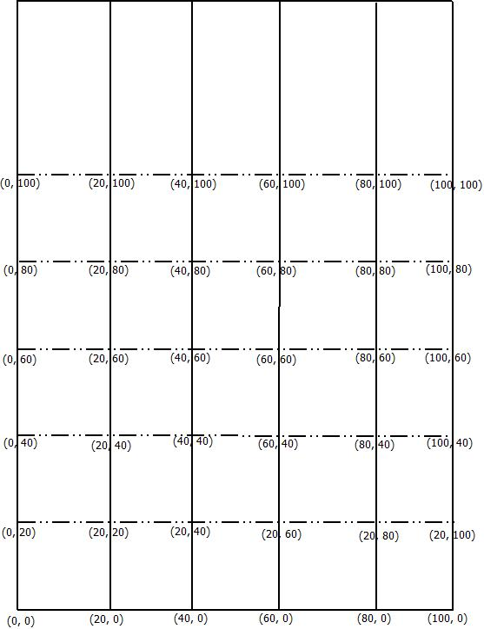
Fig. 5.2.1 Network area model
Figure 7.2.1dipicts network area model for node deployment. In above figure it is clearly shown that whole network divided into five grids and each grid divided into five parts. So we divided network area in 25 regions where node will be deployed.

5.3 Model of Deployed Nodes and Base Station
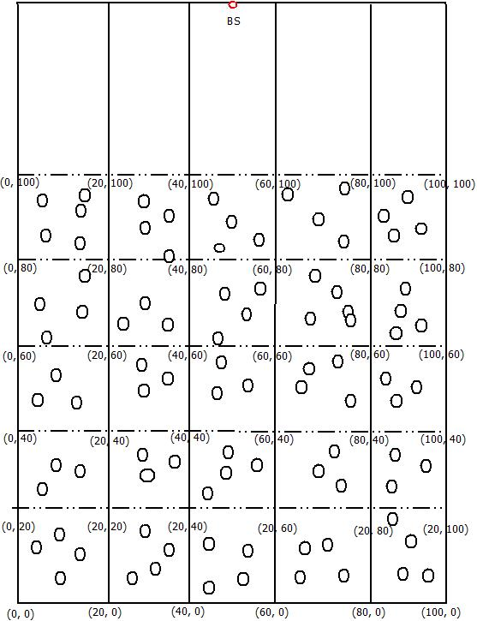
Fig. 5.3.1 Model of deployed nodes and base station
Figure 7.2 depicts model of deployed nodes and base station. Nodes deployed almost uniformly in the network area represented by black circle and base station (BS) represented by red circle.

5.4 Input and Output for Fuzzy System
Grid head chance calculation of each node of network is based on two fuzzy variables. And output is calculated based on defuzzification method.
5.4.1 Input Variables
- Residual Energy -- Residual calculate as remaining energy of sensor nodes till current round. In self-organization scheme, CH consume much power than member nodes because CH has responsibility of data aggregation, processing of data, routing of data etc. fuzzy variable residual energy shown below in fig.3.
Residual Energy of sensor node = Initial Energy of sensor node – consumed energy till current round.
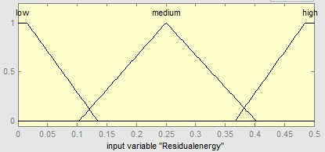
Fig.5.4.1.1. Membership Function for Residual energy

- Base Station Distance -- Distance of grid head from base station. It is calculated using distance square method.
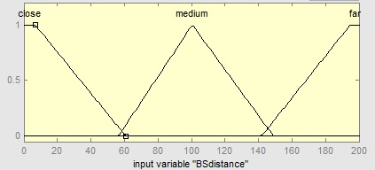
Fig.5.4.1.2Membership Function for Base Station Distance.
5.4.2 Output
- Grid Head Chance -- Output produces by fuzzy system must be crisp for real time implementation. In fuzzy inference system we apply fuzzified value as input but output must be defuzzified value. In this proposed approach we us centroid method of defuzzifiation to get crisp output for select of grid head.
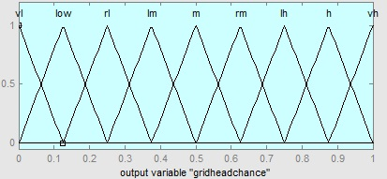
Fig.7.4.2 Membership Function for Grid Head Chance
vl=Very low, rl=Rather low, lm= Low medium, m= Medium, rm= Rather medium, lh= Low high, vh= Very high

Table 2. Fuzzy System Rule Base
S. No | Base Station Distance | Residual Energy | Grid Head Chance
1. | Close | Low | Low high
2. | Close | Medium | High
3. | Close | High | Very high
4. | Medium | Low | Rather medium
5. | Medium | Medium | Medium
6. | Medium | High | Low medium
7. | High | Low | Very low
8. | High | Medium | Low
9. | High | high | Rather Low

5.4.3 An Instance of Input and Output
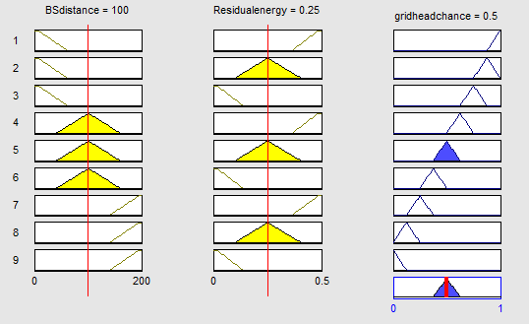
Fig. 7.4.3 An Instance of Input and Output
5.4.4 Fuzzy Surface view of Input and Output
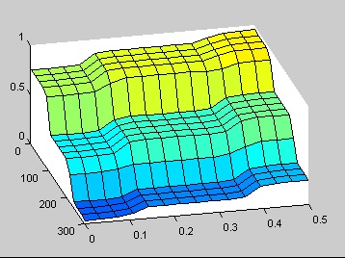
Fig.7.4.4 Surface view of Input and Output

7.5 Steps in Proposed Approach
- Take network area n x n meters.
- Divide network area in to small size area (k x l in meters) called as grid.
- Randomly deployed sensor nodes each predefined grid.
- For each round r =1 to rmax
- Calculate grid head chance of each node using fuzzy variables node residual energy and base station distance.
- Node having the maximum grid head chance selected as grid head.
- Grid head receive data and forward to next appropriate grid head or base station.
- Goto step 4 until last node died.
- End.
Proposed approach uses no randomized function to decide or selection of cluster head within grid. We uses fuzzy logic to decide the head node of grid at current round. Two fuzzy variables residual energy of nodes and distance from base station is taken to calculate the chance of nodes to be grid head at current round. And the node having maximum chance select as grid head for current round. Selected grid head has responsibility to receive data from other grid member and send it to appropriate grid head, because it used multi hope communication, or to base station.

CHAPTER 4
SIMULATION AND RESULT
Proposed approach simulated by using the MATLAB simulation environment to compare the performance of our proposed A Grid Based Approach to prolong WSNs lifetime using Fuzzy logic (GAPFL) protocol with the Low Energy Adaptive Clustering Hierarchy (LEACH). The results show that proposed approach (GAPFL) extends the network lifetime, reduces the energy consumption, and optimizes the number of cluster heads. In this chapter, simulation parameters used for our experiments are given in section 5.1. The simulation results are discussed in section 5.2.
5.1 Simulation Parameters

The nodes are randomly deployed within the area of 100m X 100m. The base station is located at the outside from the node deployment area with coordinates 40m X 150m. The population of nodes for this simulation is 200. A sample of randomly deployed nodes for our experiments is shown in Figure 5-1. The equation 2.2 can be used to determine the density of the nodes in the sensor field.

Table 3: Simulation parameter
Parameter | Value
Area of Network | 100m*100m
Location of Base Station | 50m,140m
Number of Nodes | 200
Initial Energy of Nodes (E₀) | 0.5J
Packet Size | 4000 bit
Transmission Energy (E_{TX}) | 50 nJ/bit
Receiving Energy (E_{RX}) | 50 nJ/bit
E_{fs} | 10pJ/bit/m²
E_{amp} | 0.0013 pJ/bit/m⁴

5.2 Simulation Result
MATLAB [11] tool is used to get the simulation results. GAPFL protocol prolong WSNs lifetime in terms on number of rounds. We simulated and compare GAPFL with LEACH in various number of rounds. Simulation result shown in below.
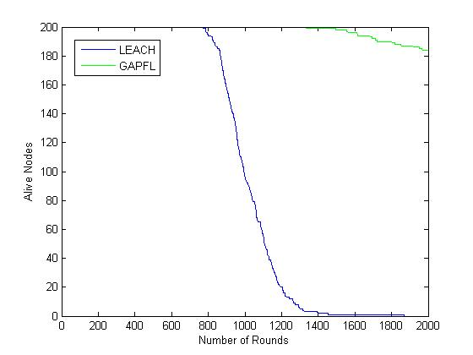
Figure 5.1: comparison of number of Alive Nodes in GAPFL and LEACH

The above graph represents the total number of alive nodes in LEACH. In the above graph, till 2000 rounds, no nodes alive in LEACH protocol but using proposed (GAPFL) approach near about 182 nodes are still alive.

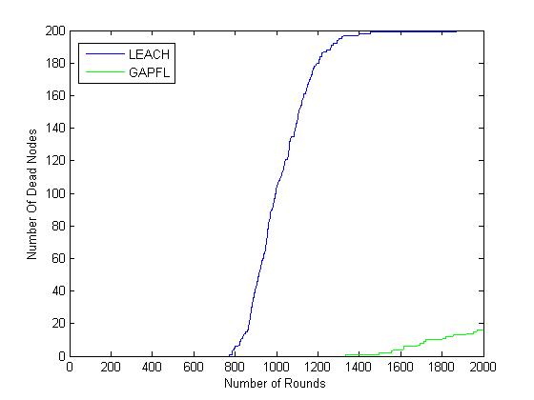 Figure 5.2: comparison of number of dead nodes in LEACH and GAPFL
The above graph represents the total number of dead nodes in LEACH and GAPFL. It shows that the first node dies in the LEACH at near about 790 rounds and in proposed approach GAPFL first node dies near about 1350 rounds. And in total 2000 rounds of simulation all nodes dies using LEACH protocol and only 18 nodes dies using GAPFL.
Form above simulation result it is clear that network life time may increase using A Grid Based Approach to Prolong WSNs Lifetime Using Fuzzy Logic.

CHAPTER 6
CONCLUSION AND FUTURE WORK
In this paper, we proposed a grid based approach to prolong wireless sensor networks life time using fuzzy logic which may resolve the issues related with probabilistic approaches. Presented scheme is fully non-probabilistic, no random () function is used like CHEF that used rand (0, 1). Simulation results shown that proposed scheme helpful to prolong the life time of wireless sensor networks. Because grid based approach used in proposed work and fixed routing scheme that reduce consumption of power used in extra transmission and processing of data. Our approach use fuzzy logic to make decision easier. Our main aim to reduce no of unnecessary communication and processing of data in order to prolong the life time of wireless sensor networks.
Finding appropriate cluster head is one of the most important research area in wireless sensor networks. There are scope for applying artificial intelligence concepts to find cluster head and routing in network.

References
- Iman M. ALMomani, Maha K. Saadeh, “FEAR: Fuzzy-Based Energy Aware Routing Protocol For Wireless Sensor Networks”, International Journal of communications, Network and System Science, Vol. 4, pp. 403-415, 2011.
- W.B. Heinzelman, A.P. Chandrakasan, H. Balakrishnan, “An application-specific protocol architecture for wireless microsensor networks”, IEEE Transactions on Wireless Communications, vol. 1, Issue 4, pp. 660–670, 2002.
- W.Heinzelman, A. Chandrakasan and H. Balakrishnan “Energy- Efficient Communication Protocol for Wireless Micro sensor Networks“ Published in the Proceedings of the Hawaii International Conference on System Sciences-2000.
- L. A. Zadeh, “Fuzzy Sets”, Information and Control, Vol. 8, pp. 338-353, 1965.
- Hemavathi Natarajan, SudhaSelvaraj, “A Fuzzy Based Predictive Cluster Head Selection Scheme For Wireless Sensor Networks”, International Conference on Sensing Technology, pp. 560-566, 2014.
- J. Dastagheib & H. Oulia, “An efficient approach for clustering in wireless sensor network using fuzzy logic”, International Conference on Computer Science and Network Technology (ICCSNT), Vol. 3, pp. 1481-1486, 2011.
- S .Soro, W. Heinzelman, Cluster head election techniques for coverage preservation in wireless sensor networks, Ad Hoc Networks vol. 5, pp. 955–972, 2009.
- M.C.M. Thein, T. Thein, An energy efficient cluster-head selection for wireless sensor networks, in: International Conference on Intelligent Systems, Modeling and Simulation, pp. 287–291, 2010.
- S. Bandyopadhyay, E.J. Coyle, An energy efficient hierarchical clustering algorithm for wireless sensor networks, Proceeding of IEEE INFOCOM, vol. 3, pp. 1713–1723, 2003.
- Nurhayati, S. lindsey, C. Raghvendra, K. M. Shivlingam, ”Data gathering algorithms in sensor networks using energy metrics”, IEEE Transaction on Parallel and Distributed System, vol. 13, no. 9, pp. 924-935, 2002.
- I. Gupta, D. Riordan and S. Sampalli, “Cluster-head Election using Fuzzy Logic for Wireless Sensor Networks,” Annual Conference on Communication Networks Services, pp. 255–260, 2005.
- J.M. Kim, S.H. Park, Y. Han and T.M. Chung, “CHEF: Cluster Head Election mechanism using Fuzzy Logic in Wireless Sensor Networks”, International Conference on Advance Communications Technology, pp. 654-659, 2008.
- T. Sharma and B. Kumar, “F-MCHEL: Fuzzy Based Master Cluster Head Election Leach Protocol in Wireless Sensor Network”, International Journal of Computer Science and Telecommunications, Vol. 3, Issue 10, pp. 8-13, 2012.
- James C. Bezdek, Robert Ehrlich and William Full, “FCM: The Fuzzy c-Means Clustering Algorithm” Computers and Geosciences, Vol. 10, pp. 191-203, 1984.
- Nikhil R Pal, James M. Keller, Kuhu Pal and James C. Bezdek. “A Possiibilistic Fuzzy c-Means Clustering Algorithms”, IEEE Transactions on Fuzzy Systems, Vol. 13, pp. 517-530, 2005.
- Sachin Gajjar, Mohanchur Sarkar, Kankar Dasgupta, “ Cluster Head Selection Protocol using Fuzzy Logic for Wireless sensor Networks”, International Journal of Computer Application, vol. 97, pp. 38-43, 2014.
- K. Akkaya, M. Younis, A survey on routing protocols for wireless sensor networks, Ad Hoc Networks, vol. 3, Issue 3, pp. 325–349, 2005.
- O. Younis, M. Krunz, S. Ramasubramanian, “Node clustering in wireless sensor networks: recent developments and deployment challenges”, IEEE Network, vol. 20, Issue 3, pp. 20–25, 2006.
- H. Ando, L. Barolli, A. Durresi, F. Xhafa, and A. Koyama, “An intelligent fuzzy-based cluster head selection system for wireless sensor networks and its performance evaluation,” in Proc. Int. Conf. Network Based Inform. Syst., pp. 55–61, 2010.
- [7] N. Behboudi and A. Abhari. , "A Weighted Energy Efficient Clustering (WEEC) for Wireless Sensor Networks. Seventh International Conference on Mobile Ad-hoc and Sensor Networks (MSN), pp.146-151, 2011
- [8] B. G Celler, T. Hesketh, W. Earnshaw and E. Ilsar. An instrumentation system for the remote monitoring of changes in functional health status of the elderly at home, Proceedings of the 16th Annual International Conference of the IEEE-EMBS , vol 2, pp.908-909, 1994.
- [9] G. Coyle, L. Boydell and L. Brown. Home telecare for the elderly. Journal of Telemedicine and Telecare, vol 1, pp183-184, 1995.
- [10] X. Li, L. Xu, H. Wang, J. Song, S. X. Yang. A Differential Evolution-Based Routing Algorithm for Environmental Monitoring Wireless Sensor Networks. Sensors, vol. 10, pp. 5425-5442, 2010.
- [12] K. Lorincz, D. Malan, T.R.F. Fulford-Jones, A. Nawoj, A. Clavel, V.Shnayder, G. Mainland, M. Welsh, S. Moulton. Sensor networks for emergency response: challenges and opportunities," Pervasive Computing, IEEE , vol.3, no.4, pp. 16- 23, 2004.
- [13] M. Castillo-Effen, D.H. Quintela, R. Jordan, W. Westhoff, W. Moreno. Wireless sensor networks for flash-flood alerting. Proceedings of the Fifth IEEE International Caracas Conference on Devices, Circuits and Systems, vol. 1, pp. 142- 146, 2004.
- [14] I. F. Akyildiz, W. Su, Y. Sankarasubramaniam, and E. Cayirci. A survey on sensor networks. IEEE Communications Magazine, vol. 40, pp. 102–114, 2002.
- [15] G. Asada, M. Dong, T. S. Lin, F. Newberg, G. Pottie, W. J Kaiser and H. O. Marcy. Wireless integrated network sensor: Low power systems on a chip. Proceedings of the 24th European Solid-State Circuits Conference, pp. 9-16, 1998.
- [16] E. Shih, S. H. Cho, N. Ickes, R. Min, A. Sinha, A. Wang and A. Chandrakasan. Physical Layer Driven Protocol and Algorithm Design for Energy-Efficient Wireless Sensor Networks. Proceedings of the 7th annual international conference on Mobile computing and networking, pp. 272-287, 2001.
- [17] J.M Rabaey, M.J. Ammer, J. J. L. da Silva, D. Patel, and S. Roundy. PicoRadio supports ad hoc ultra-low power wireless networking, IEEE Computer, vol. 33, no.7, pp.42-48, 2000.
- [18] M. A. M. Vieira, J. C. N. Coelho, J. D. C. da Silva, and J.M. da Mata. Survey on wireless sensor network devices. Proceedings of the ninth IEEE Conference on Emerging Technologies and Factory Automation. vol.1, pp. 537- 544, 2003.
- [19] W. Ye, J. Heidemann, and D. Estrin. An energy-efficient MAC protocol for wireless sensor networks. Twenty-First Annual Joint Conference of the IEEE Computer and Communications Societies. vol.3, pp. 1567- 1576, 2002.
- [20] V. Cionca, T. Newe and V. Dadarlat. TDMA Protocol Requirements for Wireless Sensor Networks. Second International Conference on Sensor Technologies and Applications, pp.30-35,25, 2008.
- [21] T. van Dam and K. Langendoen. An adaptive energy-efficient mac protocol for wireless sensor networks. In Proceedings of the First ACM Conference on Embedded Networked Sensor Systems, pp. 171-180, 2003.
- [22] L. van Hoesel and P. Havinga. A lightweight medium access protocol (LMAC) for wireless sensor networks. In Proceedings of the 3rdInternational Symposium on Information Processing in Sensor Networks (IPSN), pp. 55–60, 2004.
- [23] T. Nieberg, S. Dulman, P. Havinga, L. V. Hoesel and J. Wu. ―Collaborative Algorithms for Communication in Wireless Sensor Networks‖ in Ambient Intelligence: Impact on Embedded Systems, T. Basten, M. Geilen and H. Groot, Springer US, pp. 271-294, 2004.
- [24] S. Dulman, T. Nieberg, J. Wu, and P. Havinga, ―Trade-off between traffic overhead and reliability in multipath routing for wireless sensor networks,‖ in Proceedings of the Wireless Communications and Networking Conference, vol.3, pp. 1918–1922, 2003.
- [25] D. Braginsky and D. Estrin. Rumor routing algorthim for sensor networks. In Proceedings of the 1st ACM international workshop on Wireless sensor networks and applications. ACM, pp. 22-31, 2002.
- [26] S. Capkun, M. Hamdi, J. Hubaux, GPS-free positioning in mobile ad-hoc networks. In processing of the 34th Hawaii International Conference on System Sciences, pp. 3481–3490, 2001.
- [27] Q. Fang, F. Zhao, and L. Guibas. Lightweight sensing and communication protocols for target enumeration and aggregation. In Proceedings of the 4th ACM international symposium on Mobile ad hoc networking, pp. 165-176, 2003.
- [28] C. Karlof and D. Wagner. Secure Routing in Wireless Sensor Networks: Attacks and Countermeasures. Ad Hoc Networks, vol. 1, pp. 293–315, 2003.
- [29] K. Sohrabi, J. Gao, V. Ailawadhi and G. J. Pottie. Protocols for self-organization of a wireless sensor network. IEEE Personal Communications, vol. 7, no. 5, pp.16-27, 2000.
- [30] N. Bulusu, D. Estrin, L. Girod and J. Heidemann. Scalable coordination for wireless sensor networks: self-configuring localization systems, In processing of sixth International Symposium on Communication Theory and Applications, 2001.
- [31] A. Perrig, R. Szewczyk, J. D. Tygar, V. Wen, and D. E. Culler. 2002. SPINS: security protocols for sensor networks. Wireless Networks, vol. 8, no. 5, pp.521-534, 2002.
- [32] Y. Yu, D. Estrin, and R. Govindan, ―Geographical and Energy-Aware Routing: A Recursive Data Dissemination Protocol for Wireless Sensor Networks,‖ UCLA Computer Science Department, UCLA-CSD TR-010023, 2001
- [33] W. R. Heinzelman, J. Kulik, and H. Balakrishnan. Adaptive protocols for information dissemination in wireless sensor networks. In Proceedings of the 5th annual ACM/IEEE international conference on Mobile computing and networking, pp. 174-185, 1999.
- [34] C. Intanagonwiwat, R. Govindan, D. Estrin, J. Heidemann and F. Silva. Directed diffusion for wireless sensor networking. IEEE/ACM Transactions on Networking,, vol.11, no.1, pp. 2- 16, 2003.
- [35] O. Younis, M.Krunz, and S.Ramasubramanian. Node clustering in wireless sensornetworks: recent developments and deployment challenges. IEEE Network , vol.20, no.3, pp. 20- 25, 2006.
- [36] K. Akkaya and M. Younis. A survey on routing protocols for wireless sensor networks. Ad Hoc Networks, vol. 3, no.3, pp. 325-349, 2005.
- [37] W. B. Heinzelman, A. P. Chandrakasan and H. Balakrishnan. An application-specific protocol architecture for wireless microsensor networks. IEEE Transactions on Wireless Communications, vol. 1, no. 4, pp. 660- 670, 2002.
- [38] S. S. Satapathy and N. Sarma. TREEPSI: tree based energy efficient protocol for sensor information. IFIP International Conference on Wireless and Optical Communications Networks, pp.4, 2006.
- [39] K. T. Kim, C. H. Lyu, S. S. Moon and H. Y. Youn. Tree-Based Clustering (TBC) for Energy Efficient Wireless Sensor Networks. The twenty-fourth IEEE International Conference on Advanced Information Networking and Applications Workshops, pp.680-685, 2010.
- Nikhil Marriwala, Priyanka Rathee “An Approach to Increase the Wireless Sensor Netwrok Lifetime” IEEE 2012.
- T. He et al., SPEED: a stateless protocol for real-time communication in sensor networks, in: Proceedings of International Conference on Distributed Computing Systems, Providence, RI, May 2003.
- V. Rodoplu, T.H. Ming, “Minimum energy mobile wireless networks”, IEEE Journal of Selected Areas in Communications vol. 17 (8), pp. 1333–1344, 1999.
- L. Li, J. Y Halpern, Minimum energy mobile wireless networks revisited, in: Proceedings of IEEE International Conference on Communications (ICC01), Helsinki, Finland, June 2001.
[12] K. Lorincz, D. Malan, T.R.F. Fulford-Jones, A. Nawoj, A. Clavel, V.Shnayder, G.
Mainland, M. Welsh, S. Moulton. Sensor networks for emergency response: challenges and opportunities," Pervasive Computing, IEEE , vol.3, no.4, pp. 16- 23, 2004.

[13] M. Castillo-Effen, D.H. Quintela, R. Jordan, W. Westhoff, W. Moreno. Wireless sensor networks for flash-flood alerting. Proceedings of the Fifth IEEE International Caracas Conference on Devices, Circuits and Systems, vol. 1, pp. 142- 146, 2004.

[14] I. F. Akyildiz, W. Su, Y. Sankarasubramaniam, and E. Cayirci. A survey on sensor
networks. IEEE Communications Magazine, vol. 40, pp. 102–114, 2002.

[15] G. Asada, M. Dong, T. S. Lin, F. Newberg, G. Pottie, W. J Kaiser and H. O. Marcy. Wireless integrated network sensor: Low power systems on a chip. Proceedings of the 24th European Solid-State Circuits Conference, pp. 9-16, 1998.

[16] E. Shih, S. H. Cho, N. Ickes, R. Min, A. Sinha, A. Wang and A. Chandrakasan. Physical Layer Driven Protocol and Algorithm Design for Energy-Efficient Wireless Sensor Networks. Proceedings of the 7th annual international conference on Mobile computing and networking, pp. 272-287, 2001.

[17] J.M Rabaey, M.J. Ammer, J. J. L. da Silva, D. Patel, and S. Roundy. PicoRadio supports ad hoc ultra-low power wireless networking, IEEE Computer, vol. 33, no.7, pp.42-48, 2000.

[18] M. A. M. Vieira, J. C. N. Coelho, J. D. C. da Silva, and J.M. da Mata. Survey on wireless sensor network devices. Proceedings of the ninth IEEE Conference on Emerging Technologies and Factory Automation. vol.1, pp. 537- 544, 2003.

[19] W. Ye, J. Heidemann, and D. Estrin. An energy-efficient MAC protocol for wireless sensor networks. Twenty-First Annual Joint Conference of the IEEE Computer and Communications Societies. vol.3, pp. 1567- 1576, 2002.

[20] V. Cionca, T. Newe and V. Dadarlat. TDMA Protocol Requirements for Wireless Sensor Networks. Second International Conference on Sensor Technologies and Applications, pp.30-35,25, 2008.

[21] T. van Dam and K. Langendoen. An adaptive energy-efficient mac protocol for wireless sensor networks. In Proceedings of the First ACM Conference on Embedded Networked Sensor Systems, pp. 171-180, 2003.

[22] L. van Hoesel and P. Havinga. A lightweight medium access protocol (LMAC) for wireless sensor networks. In Proceedings of the 3rdInternational Symposium on Information Processing in Sensor Networks (IPSN), pp. 55–60, 2004.

[23] T. Nieberg, S. Dulman, P. Havinga, L. V. Hoesel and J. Wu. ―Collaborative Algorithms for Communication in Wireless Sensor Networks‖ in Ambient Intelligence: Impact on Embedded Systems, T. Basten, M. Geilen and H. Groot, Springer US, pp. 271-294, 2004.

[24] S. Dulman, T. Nieberg, J. Wu, and P. Havinga, ―Trade-off between traffic overhead and reliability in multipath routing for wireless sensor networks,‖ in Proceedings of the Wireless Communications and Networking Conference, vol.3, pp. 1918–1922, 2003.
[25] D. Braginsky and D. Estrin. Rumor routing algorthim for sensor networks. In Proceedings of the 1st ACM international workshop on Wireless sensor networks and applications. ACM, pp. 22-31, 2002.

[26] S. Capkun, M. Hamdi, J. Hubaux, GPS-free positioning in mobile ad-hoc networks. In processing of the 34th Hawaii International Conference on System Sciences, pp. 3481–3490, 2001.

[27] Q. Fang, F. Zhao, and L. Guibas. Lightweight sensing and communication protocols for target enumeration and aggregation. In Proceedings of the 4th ACM international symposium on Mobile ad hoc networking, pp. 165-176, 2003.

[28] C. Karlof and D. Wagner. Secure Routing in Wireless Sensor Networks: Attacks and Countermeasures. Ad Hoc Networks, vol. 1, pp. 293–315, 2003.

[29] K. Sohrabi, J. Gao, V. Ailawadhi and G. J. Pottie. Protocols for self-organization of a wireless sensor network. IEEE Personal Communications, vol. 7, no. 5, pp.16-27, 2000.

[30] N. Bulusu, D. Estrin, L. Girod and J. Heidemann. Scalable coordination for wireless sensor networks: self-configuring localization systems, In processing of sixth International Symposium on Communication Theory and Applications, 2001.

[31] A. Perrig, R. Szewczyk, J. D. Tygar, V. Wen, and D. E. Culler. 2002. SPINS: security protocols for sensor networks. Wireless Networks, vol. 8, no. 5, pp.521-534, 2002.

[32] Y. Yu, D. Estrin, and R. Govindan, ―Geographical and Energy-Aware Routing: A Recursive Data Dissemination Protocol for Wireless Sensor Networks,‖ UCLA Computer Science Department, UCLA-CSD TR-010023, 2001

[33] W. R. Heinzelman, J. Kulik, and H. Balakrishnan. Adaptive protocols for information dissemination in wireless sensor networks. In Proceedings of the 5th annual ACM/IEEE international conference on Mobile computing and networking, pp. 174-185, 1999.

[34] C. Intanagonwiwat, R. Govindan, D. Estrin, J. Heidemann and F. Silva. Directed diffusion for wireless sensor networking. IEEE/ACM Transactions on Networking,, vol.11, no.1, pp. 2- 16, 2003.

[35] O. Younis, M.Krunz, and S.Ramasubramanian. Node clustering in wireless sensor
networks: recent developments and deployment challenges. IEEE Network , vol.20, no.3, pp. 20- 25, 2006.

[36] K. Akkaya and M. Younis. A survey on routing protocols for wireless sensor networks. Ad Hoc Networks, vol. 3, no.3, pp. 325-349, 2005.

[37] W. B. Heinzelman, A. P. Chandrakasan and H. Balakrishnan. An application-specific protocol architecture for wireless microsensor networks. IEEE Transactions on Wireless Communications, vol. 1, no. 4, pp. 660- 670, 2002.
[38] S. S. Satapathy and N. Sarma. TREEPSI: tree based energy efficient protocol for sensor information. IFIP International Conference on Wireless and Optical Communications Networks, pp.4, 2006.

[39] K. T. Kim, C. H. Lyu, S. S. Moon and H. Y. Youn. Tree-Based Clustering (TBC) for Energy Efficient Wireless Sensor Networks. The twenty-fourth IEEE International Conference on Advanced Information Networking and Applications Workshops, pp.680-685, 2010.

