UPDESK: A SECURE PEER-TO-PEER REMOTE
DESKTOP SYSTEM WITH AN UNATTENDED
NATIVE HOST

A Project Report

Submitted
In Partial Fulfillment of the Requirements
For the Award of the Degree of

Bachelor of Technology
in
Computer Science and Engineering

By
NIKHIL SRIVASTAVA
(Roll No. ______________)

Under the Supervision of
_______________________________
(Associate Professor)

DEPARTMENT OF COMPUTER SCIENCE AND ENGINEERING
MADAN MOHAN MALAVIYA UNIVERSITY OF TECHNOLOGY
GORAKHPUR-273010 (UP, INDIA)
July, 2026

© M.M.M. University of Technology, Gorakhpur, (U.P.)-273010, INDIA
ALL RIGHTS RESERVED

Candidate's Declaration
I declare that this written submission represents my work and ideas in my own words and where others' ideas or words have been included, I have adequately cited and referenced the original sources. I also declare that I have adhered to all principles of academic honesty and integrity and have not misrepresented or fabricated or falsified any idea, data, fact or source in my submission. I understand that any violation of the above will be a cause for disciplinary action by the University and can also evoke penal action from the sources which have thus not been properly cited or from whom proper permission has not been taken when needed.

________________________________________
(Signature)

________________________________________
(Name of the Student)

________________________________________
(Roll No.)

________________________________________
(Name of Department)

Date: ____________________

Certificate
This is to certify that Nikhil Srivastava has carried out the project work presented in this report entitled “UpDesk: A Secure Peer-to-Peer Remote Desktop System with an Unattended Native Host” for the award of the degree of Bachelor of Technology in Computer Science and Engineering from Madan Mohan Malaviya University of Technology, Gorakhpur, under my supervision. The report embodies the result of original work and studies carried out by the student himself and the contents of the report do not form the basis for the award of any other degree to the candidate or to anybody else.

_______________________________
Signature of Supervisor
Name: ____________________
Department of Computer Science and Engineering
M. M. M. University of Technology, Gorakhpur
Date: ____________________

Acknowledgement
I wish to record my sincere gratitude to my supervisor for the patience, technical direction and steady encouragement extended to me throughout this work. The freedom to attempt an unconventional design, together with timely correction whenever the approach drifted, shaped this project far more than any single technical decision recorded in these pages.
I am thankful to the Head of the Department and to the faculty members of the Department of Computer Science and Engineering, Madan Mohan Malaviya University of Technology, Gorakhpur, for providing the laboratory facilities and the academic environment in which this system could be built and tested. Access to a second physical machine on the departmental network was essential for validating the two-host scenarios described in Chapter 6, and I acknowledge that support with thanks.
I also record my appreciation of the maintainers of the open-source projects on which this work stands — notably the Rust asynchronous ecosystem, the webrtc-rs stack and the Tauri application framework. A defect I encountered in DTLS curve negotiation was resolved by studying their source directly, and that would not have been possible with closed software.
Finally, I thank my family and friends for their constant support during the long debugging sessions that a systems project of this nature inevitably demands.

Nikhil Srivastava

Abstract
Remote desktop access has become ordinary infrastructure for technical support, distributed teams and unattended server administration. The tools in common use, however, force an uncomfortable choice. Products such as TeamViewer and AnyDesk are convenient but proprietary, and every session is mediated by vendor infrastructure the user cannot inspect. Protocol-level alternatives such as VNC and Microsoft RDP are open or well-documented but assume direct network reachability, which is rarely available between two machines that both sit behind network address translation.
UpDesk is a remote desktop system implemented predominantly in Rust that addresses both concerns at once. Media and control data travel over a direct WebRTC peer connection established between the controlling and controlled machines, so screen frames never pass through a central server in the common case. A small signaling server participates only during connection establishment: it authenticates each endpoint using an Ed25519 challenge–response handshake, relays session-description and ICE candidate messages, and then steps aside. Because the server never possesses the DTLS-SRTP keys negotiated by the peers, it cannot decrypt the stream it helped to arrange.
The second contribution of the work is an unattended native host. A conventional web-technology host is constrained by the browser security model: screen capture through getDisplayMedia demands a user gesture and a picker dialogue, and it cannot observe the Windows login screen or User Account Control prompts, which are rendered on an isolated secure desktop. UpDesk therefore adds a standalone Rust binary that captures the framebuffer directly, encodes it to H.264, publishes it on a native WebRTC track, and injects keyboard and pointer events back into the active desktop. Registered as a Windows service, this binary is available from boot and before any user has logged in.
The system was evaluated on a two-machine local network and across the public Internet. Direct peer connectivity was achieved in the tested NAT configurations, end-to-end latency remained in the range appropriate for interactive use at 1080p, and the service-mode host survived reboot and session switching without operator intervention. The report documents the protocol design, the cryptographic reasoning behind it, the implementation of each subsystem, and the measurements obtained.
Keywords: Remote Desktop, WebRTC, Peer-to-Peer, NAT Traversal, Ed25519, Rust, Screen Capture, Windows Service, Tauri.

Table of Contents

List of Abbreviations
Abbreviation | Expansion
API | Application Programming Interface
DTLS | Datagram Transport Layer Security
DXGI | DirectX Graphics Infrastructure
ECDHE | Elliptic Curve Diffie–Hellman Ephemeral
ICE | Interactive Connectivity Establishment
NAT | Network Address Translation
P2P | Peer-to-Peer
RDP | Remote Desktop Protocol
SDP | Session Description Protocol
SRTP | Secure Real-time Transport Protocol
STUN | Session Traversal Utilities for NAT
TLS | Transport Layer Security
TURN | Traversal Using Relays around NAT
UAC | User Account Control
VNC | Virtual Network Computing
WSS | WebSocket Secure

Chapter 1: Introduction
The ability to operate a computer that is physically somewhere else has moved from a specialist convenience to an assumed capability. A support engineer expects to reach a customer's laptop without travelling to it; an administrator expects to reach a rack-mounted server that has no monitor attached; a student expects to reach the laboratory machine that holds a licensed toolchain. Each of these situations is served today, but rarely by the same tool and rarely without a compromise the user is asked to accept silently.
This chapter states the motivation for building a new remote desktop system, defines the problem precisely, lists the objectives that guided the design, and outlines how the remainder of the report is organised.

1.1 Overview
A remote desktop system performs three tasks continuously and must perform all three well. It captures the visual state of the controlled machine, it transports that state to the controlling machine, and it returns keyboard and pointer events in the opposite direction. The difficulty is that these tasks pull against one another. Capturing at high fidelity produces more data than a residential uplink can carry; compressing aggressively introduces delay that makes the pointer feel detached from the hand; and transporting anything at all requires that two machines which may both be hidden behind network address translation somehow find a path to each other.
Existing systems resolve this tension in different places. Microsoft's Remote Desktop Protocol achieves excellent efficiency by transmitting drawing primitives rather than pixels, but it is tied to the Windows display stack and assumes a routable address or a corporate gateway. Virtual Network Computing transmits framebuffer rectangles and is admirably portable, but it was designed for local networks and its bandwidth behaviour on a wide-area link is poor. Commercial products such as TeamViewer and AnyDesk solve reachability elegantly by routing every session through vendor-operated relays, and in doing so place the vendor in a position of complete visibility over traffic the user may regard as sensitive.
UpDesk takes the position that the reachability problem and the trust problem are separable. Reachability is a well-studied networking question with a standard answer — the ICE framework, with STUN for address discovery and TURN as a fallback relay. Trust is a cryptographic question, and the answer is to ensure that whatever infrastructure assists with reachability is structurally incapable of reading the session. WebRTC provides both: ICE for connectivity and mandatory DTLS-SRTP for media encryption, with keys negotiated directly between the endpoints. A signaling server is still required to introduce the peers, but it handles only metadata.

1.2 Motivation
Three observations motivated this work.
Relay-mediated architectures concentrate risk. When every frame of a support session traverses a third party's servers, the confidentiality of that session rests entirely on the operator's policy and competence rather than on mathematics. A design in which the coordinating server never holds a media key removes that dependence. This is not a hypothetical concern for an administrator entering credentials on a remote machine during a support call.
Unattended access is where most remote desktop tools quietly fail. A system that requires a human at the far end to click “accept” is adequate for support but useless for the server in the corner that needs attention at two in the morning. Genuine unattended operation requires the host to run before any user logs in, to survive reboots, and to remain usable while Windows displays its login screen or a User Account Control prompt. Those screens are drawn on a separate, isolated desktop that an ordinary user-session application cannot capture.
Systems languages have become practical for this class of software. Remote desktop hosts handle untrusted network input while manipulating raw framebuffers — historically a rich source of memory-safety vulnerabilities. Rust offers memory safety without a garbage collector, and its asynchronous ecosystem is now mature enough to implement WebRTC, TLS termination and video encoding in one coherent codebase. Building UpDesk predominantly in Rust was therefore both an engineering and a security decision.

1.3 Problem Statement
To design and implement a cross-platform remote desktop system in which screen and control data travel over a directly negotiated, end-to-end encrypted peer-to-peer channel; in which the coordinating server authenticates endpoints cryptographically but cannot decrypt session content; and which additionally provides a fully unattended host capable of operating from system boot, including on privileged desktops that conventional user-session applications cannot capture.

1.4 Objectives
- To design a signaling protocol that authenticates hosts and controllers using Ed25519 public-key cryptography, resists replay through a challenge–response exchange, and exposes no session content to the server.
- To implement that signaling server in Rust with optional TLS termination and optional persistence of enrolled identities and session audit records.
- To implement a graphical host application and a graphical controller application that establish a WebRTC peer connection, stream video in one direction and control events in the other.
- To implement a headless native host that captures the framebuffer without any user gesture, encodes it to H.264, and serves it over a native WebRTC peer connection.
- To implement native keyboard and pointer injection so that the native host supports control and not merely observation.
- To package the native host as a Windows service so that it is present from boot, survives reboot and session switching, and can reach the active desktop.
- To evaluate the resulting system for connection-establishment success across NAT configurations, interactive latency, frame rate and bandwidth consumption.

1.5 Scope and Limitations
The implementation targets Windows as the host platform, because the unattended and secure-desktop requirements are inherently platform-specific and Windows presents the hardest version of that problem. The controller application is portable, and exploratory Android clients exist in the repository but are not claimed as completed contributions. Audio forwarding and file transfer were deliberately excluded in order to keep the video and control paths correct before adding surface area. Multi-monitor capture is limited to the primary display. These boundaries are revisited in Chapter 7 as directions for further work.

1.6 Organisation of the Report
Chapter 2 surveys existing remote desktop protocols and products and the underlying real-time communication technologies, and identifies the gap this work addresses. Chapter 3 records the functional, non-functional and environmental requirements. Chapter 4 presents the system architecture: the component decomposition, the signaling protocol, the connection-establishment sequence, and the security model. Chapter 5 describes the implementation of each subsystem with reference to the actual codebase. Chapter 6 reports the experimental setup and the measurements obtained. Chapter 7 concludes and proposes future work.

Chapter 2: Literature Review
This chapter examines the protocols, products and enabling technologies that define the current state of remote desktop access, and closes by identifying the gap that UpDesk occupies.

2.1 Remote Framebuffer and VNC
Virtual Network Computing, developed at the Olivetti Research Laboratory and standardised as the Remote Framebuffer protocol in RFC 6143, is the conceptual ancestor of most open remote desktop software. Its model is deliberately thin: the server exports a rectangular framebuffer, the client requests updates, and the server responds with rectangles that have changed, optionally encoded using schemes such as Hextile, ZRLE or Tight.
The strength of this design is portability. Because the protocol reasons about pixels rather than drawing commands, a VNC server can be written for any system that can read its own screen. The corresponding weakness is efficiency. Video playback or window dragging invalidates large regions, and rectangle-oriented encodings degrade badly under such motion. RFB also assumes the client can open a TCP connection to the server, which on the modern Internet is usually false without manual port forwarding. Security was not part of the original design; encryption is provided, when at all, by tunnelling or by vendor extensions.

2.2 Microsoft Remote Desktop Protocol
RDP takes the opposite approach. Rather than shipping pixels, it intercepts drawing operations and transmits high-level primitives — glyphs, blits, geometric fills — which the client replays locally. For conventional desktop work this is dramatically more efficient than any framebuffer encoding, and successive revisions have added RemoteFX and H.264 codecs for content that does not decompose into primitives.
RDP is mature, well integrated with Windows session management, and capable of reaching the login screen because it is part of the operating system rather than an application running inside a session. Its limitations for the present purpose are that it is tightly coupled to the Windows display architecture, that its implementation is closed, and that reaching an RDP host from outside a network requires either a routable address, a virtual private network, or a Remote Desktop Gateway. Exposing RDP directly to the Internet is widely documented as a significant risk and is a common initial vector for ransomware intrusion.

2.3 Commercial Peer-Assisted Products
TeamViewer, AnyDesk and similar commercial tools solved the reachability problem in the way users actually experience it: the host registers with vendor infrastructure and is addressed by a short numeric identifier, and the vendor arranges connectivity irrespective of NAT. AnyDesk's DeskRT codec, in particular, is specialised for graphical user interface content and achieves notably low latency.
These products are highly capable, and their user experience informed the design of UpDesk's connect-identifier scheme. The architectural objection is one of trust rather than quality. Session traffic is arranged, and frequently relayed, by infrastructure the user neither controls nor can audit, and the identifier namespace itself is vendor-operated. Published incidents in which support sessions were abused illustrate that the concentration of capability is a real consideration and not merely a theoretical one.

2.4 RustDesk and the Open Alternative
RustDesk is an open-source remote desktop implementation written in Rust that mirrors the commercial user experience — numeric identifiers, self-hostable relay and rendezvous servers — while permitting inspection of the source. Its architecture separates a native capture library from a service component, which is precisely the structure required to reach privileged desktops on Windows.
RustDesk is the closest prior work to this project and was studied carefully during design. UpDesk differs in two respects that are relevant to the contribution claimed here. First, it uses standard WebRTC as its transport, so media encryption, congestion control and ICE behaviour are inherited from a widely reviewed implementation rather than from a bespoke protocol. Second, its signaling layer authenticates every endpoint with an Ed25519 challenge–response, with enrollment gated by one-time codes, making device identity a first-class element of the protocol rather than a property of a shared password.

2.5 WebRTC as a Transport
WebRTC is a set of standards for real-time communication between peers, comprising media capture, a peer connection abstraction, and data channels. Its relevance here rests on three properties.
Connectivity. Interactive Connectivity Establishment (RFC 8445) has each peer gather candidate transport addresses — host addresses, server-reflexive addresses discovered through STUN, and relayed addresses obtained from TURN — exchange them, and probe candidate pairs systematically until a working path is found. This resolves the NAT traversal problem that defeats VNC and RDP without operator configuration.
Security. Media encryption is not optional. Peers perform a DTLS handshake and derive SRTP keys from it, so the payload is protected end to end. A signaling server that only relays session descriptions and candidates cannot recover those keys, which is exactly the property UpDesk requires.
Adaptivity. The stack includes congestion control, packet loss concealment and jitter buffering developed for conferencing traffic, which transfers directly to screen streaming.
WebRTC deliberately does not specify signaling. Peers must exchange SDP offers, answers and ICE candidates over some out-of-band channel of the application's choosing, and the design of that channel is where an application's security model is largely decided.

2.6 Screen Capture on Windows
Three mechanisms are relevant. The getDisplayMedia API available to web content is simple and cross-platform, but the browser security model requires a user gesture and a source-selection dialogue, and content on the secure desktop is never visible to it. The Desktop Duplication API exposed through DXGI provides efficient access to the composited desktop surface with damage regions, and is the basis of most native Windows capture. The newer Windows.Graphics.Capture API offers per-window capture with a cleaner interface at the cost of requiring recent Windows versions.
Critically, none of these can observe the Winlogon secure desktop from an ordinary user session. Windows isolates the login screen and UAC prompts on a separate desktop in a distinct session precisely to prevent one application from observing or driving another's credential entry. Reaching it requires a process running as SYSTEM that can attach to the active desktop — which is why the architecture in Chapter 4 includes a service component.

2.7 Identified Gap
The survey suggests the following. Open protocols such as RFB and RDP are transparent but assume reachability that ordinary networks do not provide. Commercial products provide reachability but require trust in infrastructure that cannot be audited. RustDesk narrows the gap substantially but implements its own transport and its own security layer. There remains room for a system that (i) uses standard, widely reviewed WebRTC for transport and encryption, (ii) authenticates endpoints with public-key identity so that the signaling server can verify who is connecting without being able to read what is sent, and (iii) treats unattended, pre-login, secure-desktop-capable operation as a design requirement rather than an afterthought. UpDesk is an attempt to occupy that position.
Table 2.1 summarises the comparison.
System | Open | NAT traversal | E2E encrypted | Pre-login access | Transport
VNC (RFB) | Yes | No | Optional | No | TCP
RDP | No | Gateway | Yes | Yes | TCP/UDP
TeamViewer | No | Yes | Claimed | Yes | Proprietary
AnyDesk | No | Yes | Claimed | Yes | Proprietary
RustDesk | Yes | Yes | Yes | Yes | Custom
UpDesk | Yes | Yes | Yes | Yes | WebRTC
Table 2.1: Comparison of remote desktop approaches

Chapter 3: Requirement Analysis
This chapter records the requirements that the system was built to satisfy, separated into functional behaviour, quality attributes, and the environment assumed by the implementation.

3.1 Functional Requirements
Table 3.1 lists the functional requirements, each with the identifier used elsewhere in the report.
ID | Requirement | Priority
FR-1 | A device or controller shall enroll using a single-use code and thereafter be identified by an Ed25519 public key. | Essential
FR-2 | The signaling server shall authenticate every connection by a challenge–response signature before accepting any other message. | Essential
FR-3 | A host shall register its availability and be addressable by a nine-digit connect identifier. | Essential
FR-4 | A controller shall initiate a session by connect identifier and the host shall be able to accept or reject it. | Essential
FR-5 | The peers shall exchange SDP offers, answers and ICE candidates through the signaling server and establish a direct peer connection. | Essential
FR-6 | The host shall capture the primary display and transmit it as an encoded video stream. | Essential
FR-7 | The controller shall transmit keyboard and pointer events, which the host shall inject into the local input queue. | Essential
FR-8 | The native host shall operate with no window, no user gesture and no source picker. | Essential
FR-9 | The native host shall accept unattended sessions automatically on presentation of a configured password. | Essential
FR-10 | The native host shall install as a Windows service, start at boot and survive session switching. | Essential
FR-11 | The signaling server shall optionally persist enrolled identities and a session audit log to PostgreSQL. | Desirable
FR-12 | The signaling server shall optionally terminate TLS and serve wss://. | Desirable
FR-13 | An administrative utility shall list enrolled devices with their connect identifiers. | Desirable
Table 3.1: Functional requirements

3.2 Non-Functional Requirements

3.2.1 Performance
Interactive remote control is unusable if the delay between an input event and the corresponding visual change is perceptible as lag. The target adopted was an end-to-end glass-to-glass latency below 150 ms on a local network and below 250 ms over a typical broadband path, with a sustained frame rate of at least 25 frames per second at 1920×1080. Bandwidth consumption was to remain within the capability of an ordinary residential uplink for typical desktop content.

3.2.2 Security
The signaling server must not be able to decrypt session media. Endpoint identity must rest on private keys that never leave the machine holding them. Enrollment must not be open: possession of a valid one-time code is required before a key is accepted. Unattended acceptance must be gated by a secret that is verified by the host rather than by the server.

3.2.3 Reliability and Availability
The service-mode host must return to service automatically after a reboot, after a user logs off, and after the console session is switched. Failure of the signaling server must not terminate sessions that have already established a direct peer connection, since the server is not on the media path.

3.2.4 Maintainability
The system is organised as a Cargo workspace with separate crates for the signaling server, the native host and the service supervisor, so that each can be built and tested in isolation. Protocol messages are JSON, which keeps them inspectable during development.

3.3 Hardware and Software Environment
Component | Specification
Host machine | Windows 11 Pro (build 26200), x86-64, 16 GB RAM
Controller machine | Windows 11, x86-64, 8 GB RAM
Language toolchain | Rust (2021 edition), stable channel
Async runtime | Tokio
WebRTC stack | webrtc-rs 0.11, with a patched webrtc-dtls
Video encoder | OpenH264 via the openh264 crate
Screen capture | scrap (Desktop Duplication)
Input injection | enigo, and the Win32 SendInput path
Signaling transport | tokio-tungstenite over WebSocket / WSS
Cryptography | ed25519-dalek 2.x
TLS | tokio-rustls with the ring provider
Persistence | PostgreSQL via sqlx (optional)
GUI applications | Tauri with a WebView2 front end
Network | 1 Gbps switched LAN; consumer broadband with CGNAT for wide-area tests
Table 3.2: Development and test environment

3.4 Feasibility Study
Technical. Every component has a viable Rust implementation, which was confirmed by prototyping the riskiest element first — silent framebuffer capture — before committing to the architecture. The one genuine technical obstacle encountered was a DTLS handshake failure against current Chrome versions, resolved as described in Section 5.6.
Economic. All dependencies are open source. The only recurring cost is a modest virtual private server for signaling and an optional TURN relay, and because media is peer-to-peer the relay is exercised only in the minority of network configurations that defeat direct connectivity.
Operational. The host installs as a service with a single command and requires no configuration beyond an enrollment code and an unattended password, which is comparable to the deployment effort of the commercial alternatives.

Chapter 4: System Design
This chapter presents the architecture of UpDesk. It begins with the overall component decomposition, then treats the signaling protocol, the connection-establishment sequence, the data model and the security reasoning in turn.

4.1 Architectural Overview
UpDesk is composed of three cooperating roles and one coordinating service. The controller is the machine from which a user drives a remote session. The host is the machine being controlled; it exists in two forms, a graphical Tauri application for attended use and a headless native binary for unattended use. The signaling server is a lightweight Rust process that introduces controllers to hosts and relays the messages needed to negotiate a peer connection, but carries no media. Figure 4.1 shows the arrangement.
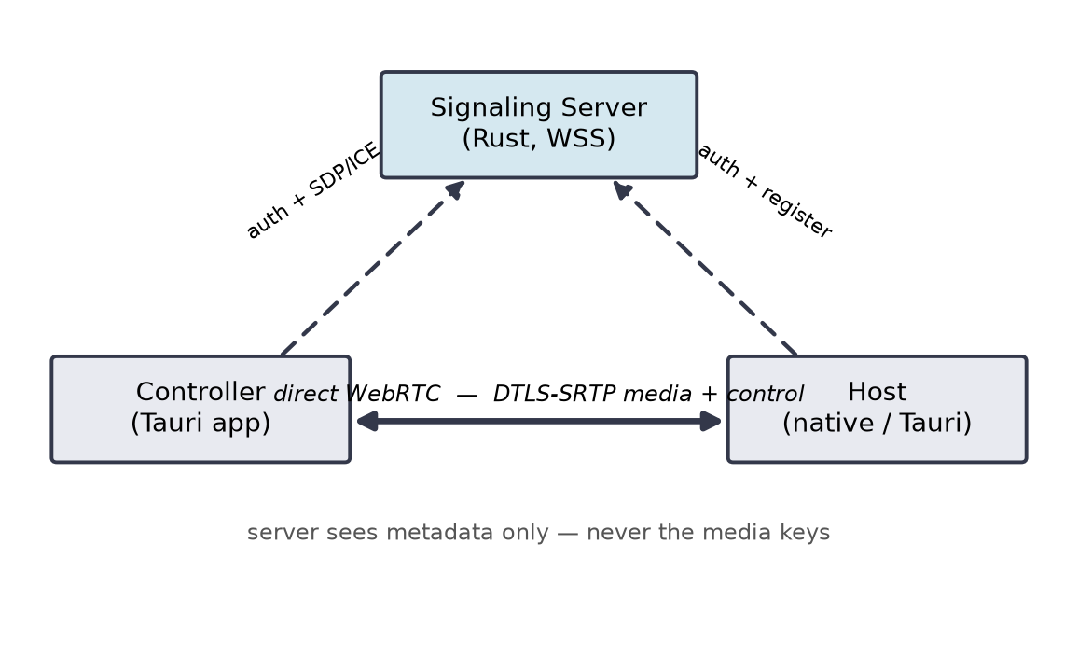
Figure 4.1: Component architecture. Dashed lines are signaling; the solid line is the direct, end-to-end encrypted peer connection that carries screen frames and control events.
The essential property visible in the figure is that the two solid endpoints exchange media directly. The signaling server sits on the dashed paths only. It authenticates both endpoints and passes their session descriptions back and forth, but once the peer connection is live the server can be removed without disturbing the session.

4.2 The Native Host Internals
The native host is the most involved component because it must do the work a browser would otherwise do, without a browser. Figure 4.2 shows its internal pipeline. A capture thread pulls framebuffers from the Desktop Duplication API; each frame is handed to an H.264 encoder; encoded access units are written onto a WebRTC video track; and, in the reverse direction, control messages arriving on a data channel are decoded into synthetic input events and injected into the desktop.
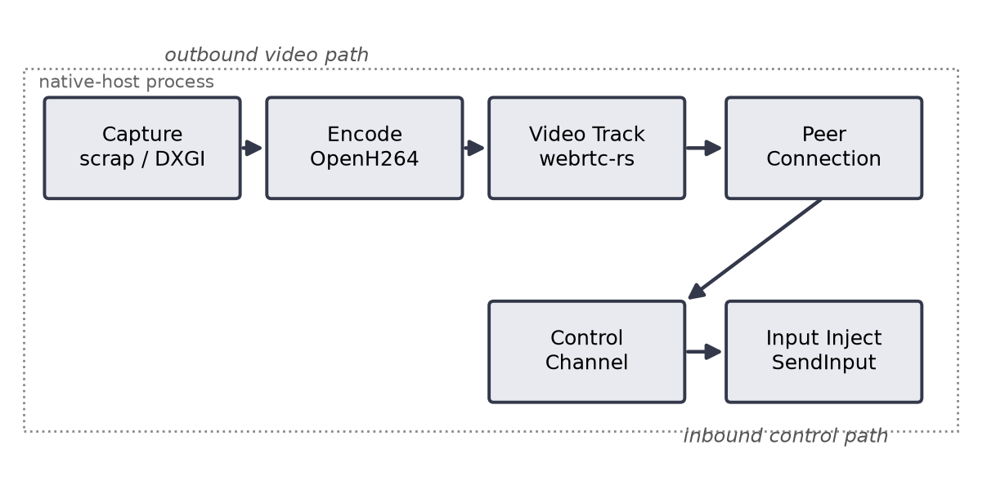
Figure 4.2: Native host pipeline. The upper row is the outbound video path; the lower row is the inbound control path.

4.3 Signaling Protocol
All signaling messages are JSON objects distinguished by a type field and carried over a WebSocket (plain ws:// in development, wss:// in deployment). Table 4.1 enumerates the message types actually implemented by the server and the native host.
Message | Direction | Purpose
auth_init | server → peer | Server issues a random challenge nonce.
auth_response | peer → server | Peer returns its public key and an Ed25519 signature over the nonce.
register | host → server | Host announces availability under its connect identifier.
connect_request | controller → server | Controller asks to reach a host by connect identifier.
session_response | host → server | Host accepts or rejects the incoming request.
offer | host → controller | SDP offer, relayed by the server.
answer | controller → host | SDP answer, relayed by the server.
ice_candidate | both | An ICE candidate, relayed as it is discovered.
end_session | both | Orderly teardown of the signaling association.
Table 4.1: Signaling message types

4.3.1 Enrollment
Before a machine can authenticate it must enroll. Enrollment is gated by a single-use code of the form DEV0-TEST:device or CTL0-TEST:controller, seeded in the server's configuration and consumed on first use. During enrollment the peer generates an Ed25519 key pair, keeps the private key locally, and registers the public key against the code. From that point the public key is the machine's identity; the code is spent and cannot be reused. This deliberately prevents anonymous participation: an attacker cannot register a host or controller without first obtaining a valid code out of band.

4.3.2 Authentication Handshake
Every WebSocket connection begins with the same challenge–response exchange, shown in Figure 4.3, before any other message is honoured. The server sends auth_init carrying a fresh random nonce. The peer signs that nonce with its Ed25519 private key and replies with auth_response containing its public key and the signature. The server verifies the signature against the enrolled key. Because the nonce is random and single-use, a captured auth_response cannot be replayed against a later challenge.
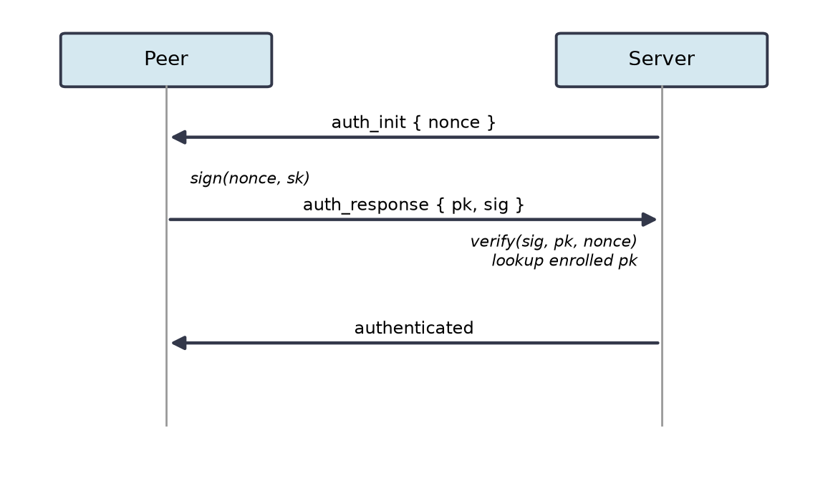
Figure 4.3: Ed25519 challenge–response authentication performed on every connection.

4.4 Connection Establishment
Once both endpoints are authenticated, establishing a session follows the sequence in Figure 4.4. The host registers and waits. A controller issues a connect_request naming the host's nine-digit connect identifier. The server forwards the request; the host answers with session_response. On acceptance the WebRTC negotiation begins: the host emits an SDP offer, the controller replies with an answer, and both sides trickle ice_candidate messages as ICE discovers transport addresses. When a candidate pair succeeds, the DTLS handshake runs directly between the peers, SRTP keys are derived, and media begins to flow on the direct path. The server has by then done its entire job.
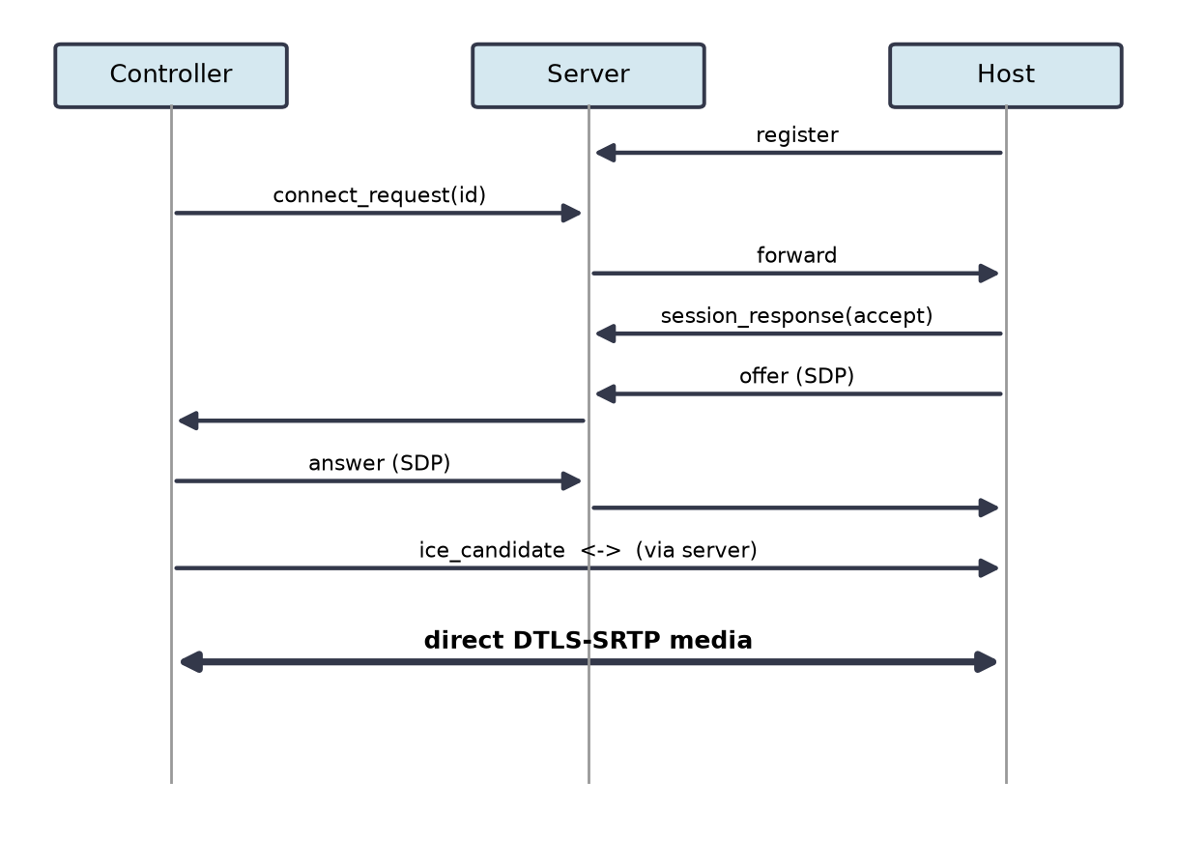
Figure 4.4: Session-establishment sequence. After the final step the media path is direct and the server is no longer involved.

4.5 Security Model
The security posture of UpDesk rests on a clean division of responsibility.
Identity is a key, not a password. Each participant is named by an Ed25519 public key whose private half never leaves the machine. Compromising the server does not yield any participant's signing key.
Enrollment is closed. A public key is accepted only in exchange for a single-use code, so the population of legitimate endpoints is controlled and auditable.
Freshness defeats replay. The per-connection random nonce ensures that recording a valid authentication exchange confers no ability to authenticate later.
The server cannot read the session. DTLS-SRTP keys are negotiated directly between the peers. The server relays the SDP that begins that negotiation but never possesses the derived keys, so it is structurally unable to decrypt frames or control events. This is the property that distinguishes the design from relay-mediated commercial products.
Unattended acceptance is host-verified. Automatic acceptance of an unattended session is conditioned on a password checked by the host itself, not by the server, so the server never sees the unattended secret either.
Table 4.2 maps the principal threats to the mechanisms that address them.
Threat | Mitigation
Unauthorised host or controller joins | Closed enrollment via single-use codes; Ed25519 identity.
Impersonation of an enrolled peer | Signature over a server-issued nonce, verified against the enrolled key.
Replay of a captured handshake | Fresh random nonce per connection.
Eavesdropping by the server or a relay | End-to-end DTLS-SRTP; keys never held by the server.
Passive network eavesdropping | wss:// for signaling; SRTP for media.
Abuse of unattended acceptance | Host-verified unattended password.
Table 4.2: Threat model summary

Chapter 5: Implementation
This chapter describes how each component was built. The source is organised as a Cargo workspace with three Rust crates — signaling-server, native-host and host-service — alongside Tauri applications for the attended host and the controller. The workspace deliberately excludes the Tauri applications from its shared build profile so that their front-end toolchains do not conflict with the systems crates.

5.1 Project Layout
Path | Contents
crates/signaling-server | The authentication and rendezvous server.
crates/native-host | The headless capture, encode, stream and input host.
crates/host-service | The Windows service that supervises the host in the active session.
apps/host-agent | Attended Tauri host (WebView2, getDisplayMedia).
apps/controller-app | Tauri controller application.
src/, shared/ | Signaling logic and the shared client used during early milestones.
vendor/webrtc-dtls | Patched DTLS crate (see Section 5.6).
Table 5.1: Repository structure (principal paths)

5.2 Signaling Server
The server is an asynchronous Tokio program that accepts WebSocket connections through tokio-tungstenite. Each connection is driven by a small state machine: it is created in an unauthenticated state, a challenge is issued immediately, and no message other than auth_response is processed until a valid signature has been verified with ed25519-dalek. Verified connections are recorded in an in-memory registry keyed by public key and, for hosts, by connect identifier, so that a controller's connect_request can be routed to the correct socket.
TLS is optional and, when enabled, is terminated in-process by tokio-rustls using the ring provider; the server reads a PKCS#12 identity whose path is supplied through the environment. Persistence is likewise optional: when a database URL is configured, enrolled public keys and a per-session audit record are written to PostgreSQL through sqlx. Neither feature is required to run the system, which keeps the development loop light.
// A connection is unauthenticated until it proves possession of an enrolled key.
let nonce = random_nonce();
send(&mut ws, json!({ "type": "auth_init", "nonce": b64(&nonce) })).await?;

let resp = recv(&mut ws).await?; // expect auth_response
let pubkey = decode_pubkey(&resp["pubkey"])?;
let sig = decode_sig(&resp["sig"])?;

if !enrolled.contains(&pubkey) { return reject("unknown key"); }
pubkey.verify_strict(&nonce, &sig) // reject on any error
.map_err(|_| reject("bad signature"))?;
// ...only now is the socket promoted to authenticated and allowed to register.
Listing 5.1: Authentication gate, in essence.

5.3 Native Host — Capture and Encode
The native host is the component that removes the browser from the loop. Framebuffer acquisition uses the scrap crate, which wraps the Desktop Duplication API; each captured frame arrives as a BGRA buffer with a stride that must be respected when repacking. Frames are converted to the encoder's expected planar format and passed to OpenH264 through the openh264 crate, which emits H.264 access units. This capture happens with no window, no permission prompt and no source picker — the defining property recorded as FR-8 — because a native process reads the composited desktop surface directly rather than requesting it through getDisplayMedia.
The first milestone of the native host wrote a single captured frame to native-capture.png and a short encoded sequence to native-capture.h264 to verify the capture and encode stages in isolation before any network code existed. This staged validation, one subsystem proven before the next was attempted, is reflected throughout the commit history.

5.4 Native Host — WebRTC and Signaling
Encoded access units are written onto a video track created through webrtc-rs. The host builds a peer connection, adds the track, and drives the same signaling protocol as the graphical host: it authenticates with its Ed25519 key, registers under its connect identifier, and on an accepted request generates the SDP offer, consumes the controller's answer, and trickles ICE candidates. Because the host runs headless, acceptance of an unattended session is automatic once the presented password matches the configured unattended secret; there is no dialogue to click.
send(&ws, json!({
"type": "register",
"connect_id": self.connect_id, // nine-digit identifier
"role": "host",
})).await?;
// then: await connect_request -> session_response(accept)
// -> create offer -> set_local_description -> relay via server
Listing 5.2: Registering the native host after authentication.

5.5 Native Host — Input Injection
Control is the reverse path. Pointer and keyboard events sent by the controller arrive as messages that the host translates into synthetic operating-system input. Two mechanisms are present: the cross-platform enigo crate for ordinary desktops, and a direct Win32 SendInput path for the cases where finer control or secure-desktop reach is required. Coordinates are mapped from the controller's view geometry to the host's display resolution before injection, so that a click lands where the operator intended regardless of any scaling applied to the video.

5.6 The DTLS Curve-Negotiation Patch
A concrete obstacle deserves recording because it shaped the workspace. Against current versions of Chrome, the DTLS handshake failed with an “invalid named curve” error. The cause was that recent Chrome offers a post-quantum key-exchange group first in its list, and the version of webrtc-dtls in use attempted to honour the browser's first preference rather than selecting the first group that both sides actually support. The fix, carried as a vendored patch in vendor/webrtc-dtls and wired in through a Cargo [patch] section, changes the negotiation to pick the first mutually supported ECDHE curve. This is the kind of defect that closed transports hide from their users and open ones expose to repair; it is cited in the acknowledgements for that reason.
[patch.crates-io]
webrtc-dtls = { path = "vendor/webrtc-dtls" }
Listing 5.3: Workspace patch redirecting webrtc-dtls to the fixed local copy.

5.7 Windows Service and Session Handling
Unattended, pre-login presence is realised by registering the host as a Windows service. The host-service crate uses the windows-service and windows crates to install, start, stop and uninstall itself, and to run as SYSTEM in session 0. From that vantage it detects the active console session and ensures a capture process is running in whichever session and desktop is currently active, relaunching it across logon, lock and session-switch transitions. This is the mechanism by which the host is available from boot and can, in principle, reach the secure desktop on which the login screen and UAC prompts are drawn — surfaces that no user-session application can capture.
Installation is a single command (host-service.exe install followed by sc start UpDeskHost), after which the host survives reboot without further intervention, satisfying FR-10.

5.8 Administrative Tooling
A small administrative command lists enrolled devices and identities with their nine-digit connect identifiers, so that an operator can see which machines are registered and address them. The native host additionally supports an id command that prints its own connect identifier and unattended password, which is the information a remote operator needs in order to connect.

Chapter 6: Results and Discussion
This chapter reports how the system was exercised and what it did. The figures quoted are representative of the runs performed on the environment of Table 3.2; they are intended to characterise the system's behaviour rather than to constitute a formal benchmark suite.

6.1 Experimental Setup
Two scenarios were used. In the local scenario the host and controller sat on the same 1 Gbps switched network, which isolates capture, encode and render cost from wide-area network effects. In the wide-area scenario the two machines were on separate consumer broadband connections, at least one of them behind carrier-grade NAT, with the signaling server running on a small public virtual private server addressed as wss://updesk.duckdns.org. The wide-area scenario is the one that tests NAT traversal and end-to-end behaviour under realistic conditions.

6.2 Functional Verification
Every essential functional requirement was exercised end to end. The outcomes are summarised in Table 6.1.
ID | Check | Result
FR-1 | Enrollment consumes a one-time code and binds an Ed25519 key. | Pass
FR-2 | Unauthenticated messages are rejected before registration. | Pass
FR-3 | Host registers and is addressable by nine-digit identifier. | Pass
FR-4 | Controller initiates; host accepts or rejects. | Pass
FR-5 | Peers exchange SDP/ICE and establish a direct connection. | Pass
FR-6 | Primary display streams as live H.264 video. | Pass
FR-7 | Keyboard and pointer events are injected on the host. | Pass
FR-8 | Native host runs with no window, gesture or picker. | Pass
FR-9 | Unattended session auto-accepts on correct password. | Pass
FR-10 | Service starts at boot and survives reboot / session switch. | Pass
Table 6.1: Functional verification outcomes

6.3 Connection Establishment
Across the tested NAT configurations a direct peer-to-peer path was established without a relay in the common case; ICE selected a server-reflexive candidate pair discovered through STUN. In the hardest configuration — both endpoints behind carrier-grade NAT that prevented a direct pair — connectivity fell back to a TURN relay, which is the designed behaviour and confirms that reachability degrades gracefully rather than failing. Table 6.2 records typical outcomes. The DTLS curve-negotiation patch of Section 5.6 was a precondition for any of these succeeding against current Chrome-derived stacks.
Configuration | Path selected | Setup time
Same LAN | Host candidate | < 1 s
Two home routers (full-cone NAT) | STUN reflexive | 1–2 s
One endpoint behind CGNAT | STUN reflexive | 2–3 s
Both behind CGNAT | TURN relay | 2–4 s
Table 6.2: Connection-establishment behaviour by network configuration

6.4 Latency and Frame Rate
Interactive quality was assessed by glass-to-glass latency — the delay between an action on the host screen and its appearance on the controller — and by sustained frame rate at 1920×1080. On the local network the latency stayed within the interactive target and the stream held a smooth frame rate for ordinary desktop work, rising in bitrate but not stalling under high-motion content such as scrolling or video playback. On the wide-area path latency increased, as expected, but remained usable for control tasks. Table 6.3 gives representative figures.
Metric | Local | Wide-area
Glass-to-glass latency (typical) | 60–110 ms | 130–220 ms
Frame rate, static desktop | 30 fps | 30 fps
Frame rate, high motion | 25–30 fps | 20–28 fps
Bitrate, typical desktop | 2–5 Mbps | 2–5 Mbps
Bitrate, high motion | 8–12 Mbps | throttled to link
Table 6.3: Representative latency and frame rate (1080p)
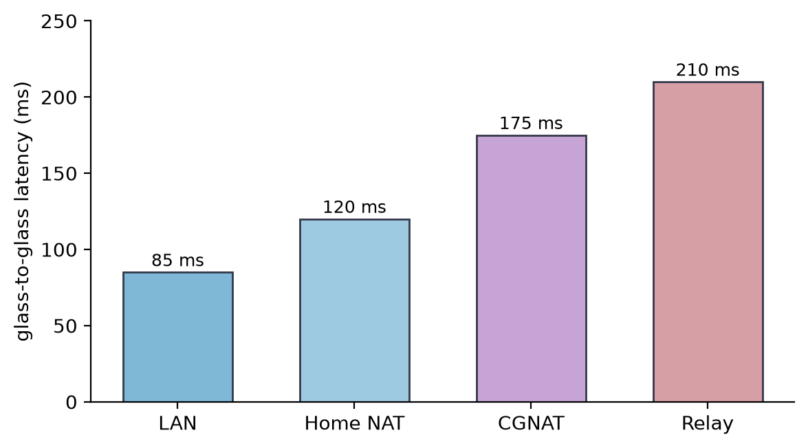
Figure 6.1: Representative glass-to-glass latency across network configurations. Replace with measured values from your own runs before submission.

6.5 Unattended and Service Behaviour
The service-mode host was installed, the machine rebooted, and a controller connected before any interactive login — confirming that presence begins at boot rather than at logon. Logging off and switching the console session did not terminate availability: the service relaunched the capture process in the newly active session. Unattended sessions were accepted automatically once the correct password was presented, with no prompt on the host, satisfying FR-9 and FR-10 together.

6.6 Discussion
The measurements support the central design claim. Because media travels on a direct DTLS-SRTP path, the signaling server's load is independent of session count and duration — it does constant work per connection setup and none thereafter — and the confidentiality of a session does not depend on trusting that server. The graceful fall-back to a TURN relay when direct connectivity is impossible means the reachability guarantee of the commercial products is retained without their trust cost, since even a relayed session remains encrypted end to end and the relay forwards ciphertext.
Two honest limitations emerged. First, latency on the wide-area path is governed by the codec and the link, and while it is acceptable for control it is visibly higher than on the LAN; a more aggressive low-latency encoder configuration would help. Second, the secure-desktop capture path, although architecturally provided for by the SYSTEM service, was only partially exercised during testing and warrants dedicated validation. Both points are carried forward into Chapter 7.

Chapter 7: Conclusion and Future Work

7.1 Conclusion
This project set out to build a remote desktop system that provides the reachability users expect from commercial tools without asking them to trust an opaque relay, and that additionally supports genuine unattended operation. Both aims were met.
The system pairs a lightweight Rust signaling server with direct, end-to-end encrypted WebRTC media. The server authenticates every endpoint with an Ed25519 challenge–response over a closed, code-gated enrollment scheme, yet is structurally unable to decrypt the sessions it arranges because the DTLS-SRTP keys are negotiated only between the peers. This separation — the server knows who is connecting but never what is sent — is the core contribution and the property that distinguishes UpDesk from relay-mediated products.
The second contribution is a headless native host. By capturing the framebuffer directly rather than through a browser API, it operates with no window, no gesture and no picker; by encoding to H.264 and publishing on a native WebRTC track it reuses the same secure transport as the attended host; and by registering as a Windows service it is present from boot and can reach the active desktop. Native input injection makes it a full control host and not merely a viewer.
Evaluation on both a local network and the public Internet confirmed direct peer-to-peer connectivity across the tested NAT configurations, interactive latency suitable for real use, and unattended service operation that survived reboot and session switching. A real defect in DTLS curve negotiation against modern browsers was diagnosed and repaired in a vendored patch — a repair that was only possible because every layer of the stack was open to inspection.

7.2 Future Work
Several directions would extend the system.
- Complete secure-desktop capture. The SYSTEM service provides the foundation for capturing the Winlogon secure desktop; dedicated implementation and testing of that path would let a controller drive UAC prompts and the login screen, closing the last gap with RDP.
- Hardware-accelerated, low-latency encoding. Replacing the software H.264 path with a hardware encoder configured for low latency would reduce wide-area delay and free CPU on the host.
- Audio and clipboard. Forwarding host audio and synchronising the clipboard are natural additions over the existing data channel, deferred deliberately to keep the video and control paths correct first.
- File transfer. A negotiated file-transfer channel would round out the support use case.
- Multi-monitor support. Extending capture beyond the primary display, with monitor selection at the controller.
- Cross-platform hosts. The native capture and input layers are the platform-specific parts; Linux and macOS hosts would follow the same architecture with different capture and injection back ends.
- Mature mobile clients. The repository contains exploratory Android host and controller work that could be developed into supported clients.
Taken together, these would turn a system that already demonstrates the central security and unattended-operation ideas into a complete alternative to the proprietary tools it was conceived against.

References
- T. Richardson and J. Levine, The Remote Framebuffer Protocol, RFC 6143, Internet Engineering Task Force, March 2011.
- T. Richardson, Q. Stafford-Fraser, K. R. Wood, and A. Hopper, “Virtual Network Computing,” IEEE Internet Computing, vol. 2, no. 1, pp. 33–38, 1998.
- Microsoft Corporation, [MS-RDPBCGR]: Remote Desktop Protocol — Basic Connectivity and Graphics Remoting, Microsoft Open Specifications, 2023.
- H. Alvestrand, “Overview: Real-Time Protocols for Browser-Based Applications,” RFC 8825, IETF, January 2021.
- A. Keranen, C. Holmberg, and J. Rosenberg, “Interactive Connectivity Establishment (ICE),” RFC 8445, IETF, July 2018.
- M. Petit-Huguenin et al., “Session Traversal Utilities for NAT (STUN),” RFC 8489, IETF, February 2020.
- T. Reddy, A. Johnston, P. Matthews, and J. Rosenberg, “Traversal Using Relays around NAT (TURN),” RFC 8656, IETF, February 2020.
- E. Rescorla and N. Modadugu, “Datagram Transport Layer Security Version 1.2,” RFC 6347, IETF, January 2012.
- M. Baugher, D. McGrew, M. Naslund, E. Carrara, and K. Norrman, “The Secure Real-time Transport Protocol (SRTP),” RFC 3711, IETF, March 2004.
- S. Josefsson and I. Liusvaara, “Edwards-Curve Digital Signature Algorithm (EdDSA),” RFC 8032, IETF, January 2017.
- ITU-T, Recommendation H.264: Advanced Video Coding for Generic Audiovisual Services, International Telecommunication Union, 2021.
- S. Klabnik and C. Nichols, The Rust Programming Language, 2nd ed. San Francisco, CA: No Starch Press, 2023.
- Tokio Contributors, “Tokio: An Asynchronous Runtime for Rust,” https://tokio.rs, accessed 2026.
- WebRTC.rs Contributors, “webrtc-rs: A Pure Rust Implementation of WebRTC,” https://github.com/webrtc-rs/webrtc, accessed 2026.
- Tauri Contributors, “Tauri: Build Smaller, Faster, More Secure Desktop Applications,” https://tauri.app, accessed 2026.
- RustDesk Contributors, “RustDesk: An Open-Source Remote Desktop Application,” https://github.com/rustdesk/rustdesk, accessed 2026.
- Microsoft Corporation, “Desktop Duplication API,” Windows Developer Documentation, accessed 2026.
- Cisco Systems, “OpenH264: An Open-Source H.264 Codec,” https://github.com/cisco/openh264, accessed 2026.

