**HOMEWORK 4**

**Nikhil Sanjay Thorat**

**Spring 2020 ALY 6020**

**Predictive Analytics Instructor: Prof. Marco Montes de Oca**

**Introduction to Neural Networks:**

Neural networks refer to the representation we make using the brain. The human brain consists of millions of neurons interconnected with each other which helps in processing information. Thus, artificial neural networks are the computational model used to identify or recognize patterns, speech recognition, text processing, etc. based on the principle of human brain neural networks.

**Operation of Neural network:**

Variables are entered as inputs (for example, an image that needs to be recognized), after passing the input through the computational model, output i.e. the image is recognized. Artificial neural networks are organized in columns such that neurons of one column n is connected to neurons from column n-1 and n+1.

**Advantages of Neural network:**

* Output obtained after the processing of inputs through a neural network model is not limited to the input provided to the model.
* Loss of data is presented as the input data is not stored in an external database but its networks.
* Model works for real-time events as networks can learn from similar examples and apply the same when similar event occurs.
* System performance is not affected as multi-tasking is performed in parallel.

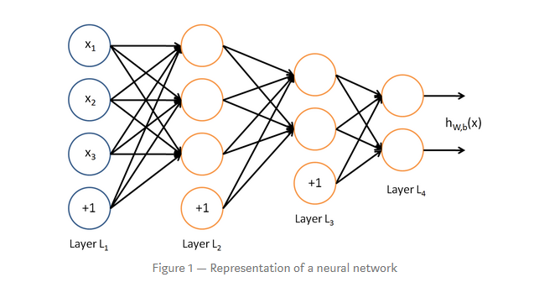

**Fig.1**

Fig.1 represents the simplified form of the working pattern of the neural network.

**Homework Outline:** The goal of the assignment is to build a neural network model to add four-bit numbers whose result is encoded as five-bit numbers.

**Dataset description:** The given dataset was downloaded from the link mentioned below:

<https://drive.google.com/file/d/1MFx5BhjZswJepc9VOXdZp6fbwynCVZk8/view>

The dataset has binary numbers x and y divided into 4 bits each. The result of the addition of the four bits is encoded as five-bit binary numbers that include a +1 carry (bit). Using various combinations of layers, activation, and loss functions, a neural network model is to be designed.

**Step1**

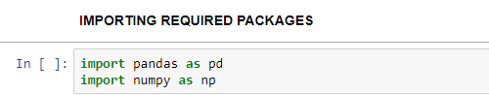

**Fig.2**

From fig.2, the necessary packages required to start the process of building a neural network model is imported. Pandas is called using variable pd and NumPy using np.

**Step 2:**

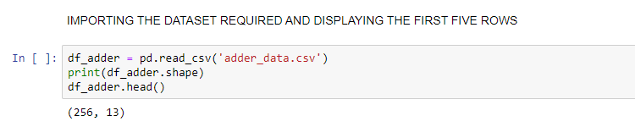

**Fig.3**

In Fig.3, it is seen that the dataset is imported and it is stored in a data frame named df_adder. Head function is used, and the first five rows are checked.

**Step 3:**

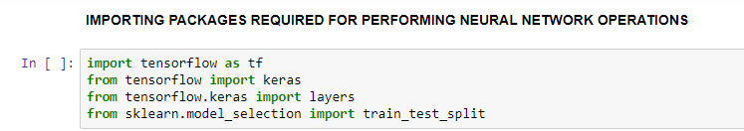

**Fig.4**

In fig.4 it is seen that important packages to build and run neural network models are imported. The main package to build a neural network model is TensorFlow. TensorFlow is an open-source platform that has tools and libraries that are mainly used for machine learning concentrated towards artificial intelligence. Tensor flow package is called using variable tf. Keras is another library in tensor flow that is an open-source used for neural networks written in python. Layers is a library in tensor flow. Keras is used to build a neural network model. Train_test_split is used for splitting the dataset into a train and test which belongs to sklearn package.

**Step 4:**

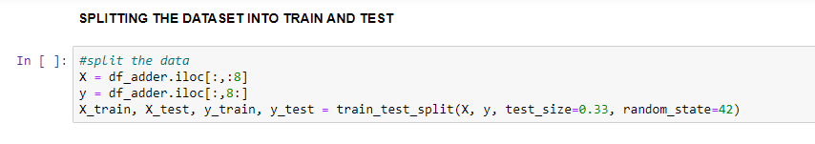

**Fig.5**

In fig.5 it is seen that the dataset imported is first separated into x and y variable. X variable accounts for the independent variable or feature variables and Y refers to the target variable. First 8 bits, 4 X, and 4 Y input bit binary numbers are the X variable. Thus, the first 8 columns are chosen to be X variable, and the columns after 8, which includes the four-bit binary number obtained after the addition of input number along with the carry is taken as a Y variable. This data is split into test and train using train_test_split function and setting the test size to 0.33 which is 33% of the dataset.

**Step 5:**

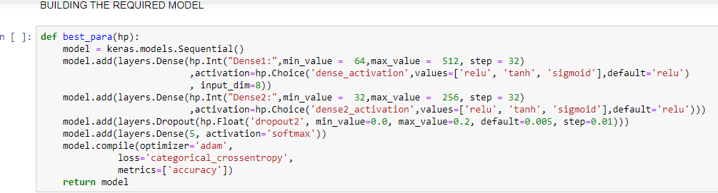

**Fig.6**

In fig.6, it is seen that a sequential neural network model is built using the function Keras.model.sequential (). A sequential model is defined to be the simplest model in the neural network which has the layers in a linear format. This linear format of layer has exactly one input tensor, one output tensor. Once the model is defined, the layers are added to the model. The dense layer is most commonly used in the neural network model. A dense layer function has the following arguments: units, activation, input, drop out values, loss values. Relu, Tanh, Sigmoid are the activation functions used in the neural network. The values for these arguments are passed through the function model. add (layers. Dense ()) and the model is built and complied using the optimizer in Keras library “adam” and loss value “ Categorical cross-entropy”. Categorical cross-entropy is mainly used for multi-class classification which is also called softmax activation. To test the accuracy of the model, metrics “accuracy” is defined. Thus, a sequential neural network model is built.

**Step 6:**

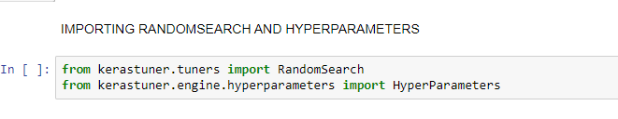

**Fig.7**

Fig.7. shows the required packages to be imported to tune the model. Random Search is a method of hyperparameter tuning that is implemented to boost the accuracy. This belongs to the package kerastuner. tuners and HyperParameters is a library under the package kerastuner. engine. Hyperparameters. This is imported after installing the Keras tuner.

**Step 7:**

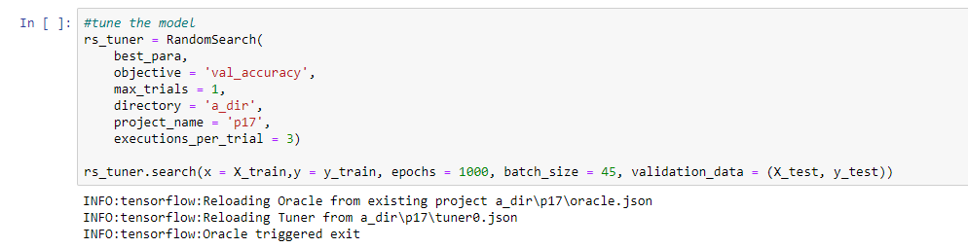

**Fig.8**

Using the Random Search function, the model is tuned by passing the values for arguments that include objective, maximum value of trials, directory, project name, and executions per trial. After defining the values, it is stored in a variable called rs_tuner. Later using the function model. Search (), the X and Y variables are assigned to X_train and y_train values respectively, epoch value is set to 1000, the batch size is set to 45, and validation data is set to X_test and Y_test. Thus, the model is tuned using the RandomSearch function.

**Step 8:**

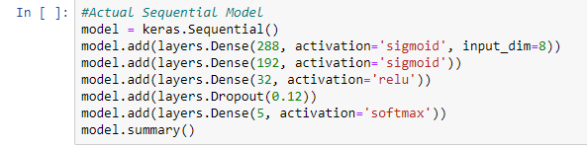

**Fig.9**

Fig 9. Shows the building of the actual sequential model by adding appropriate dense layers and the setting the activation function to sigmoid, relu, and softmax with drop out value to be 0.12 and storing it in a variable called model. This statistic is viewed using the model. Summary () function.

**Step 9:**

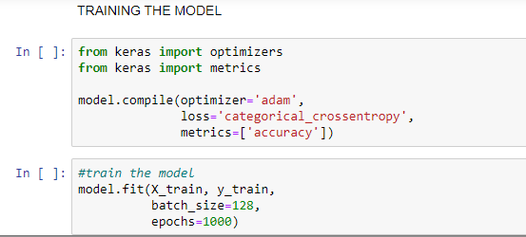

**Fig.10**

Fig 10. Shows that the model defined is trained by importing optimizers and accuracy is calculated by importing metrics. Using compile function the optimizer and loss value is mentioned. This model is trained using the function model. Fit () where X_train and y_train values are passed with batch size set to 128 and epoch value set to 1000. Epoch value is generally set to divide the training data into phases which helps in periodic evaluation. After training the model, this is executed, and accuracy is checked.

**Step 10:**

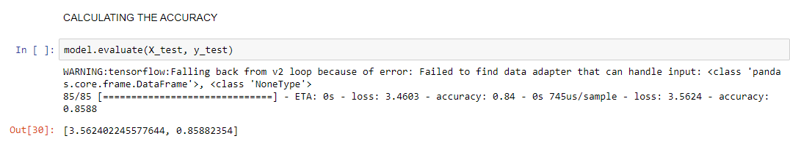

**Fig 11.**

Accuracy is calculated using the function model. evaluate () by passing the X_test, y_test values, and the best accuracy obtained by training this sequential model is 0.858 which is approximately equal to 86% with the loss value equal to 3.56.

**Results:**

The accuracy obtained for the sequential model built for the neural network is 86%. The maximum accuracy obtained was using the combination of epoch value to be 1000 and batch size equal to 128 while using the optimizer value to be “adam” and the loss value to be “Categorical cross-entropy”. Since the purpose of the model is to predict the output obtained after adding two four-bit binary numbers X and Y, a simple neural network model called the sequential model was built which gave the accuracy of 86%.

**References:**

[1] First Neural Network For Beginners Explained (with Code)

ArthurArnx-<https://towardsdatascience.com/first-neural-network-for-beginners-explained-with-code-4cfd37e06eaf>

**Dataset:**

<https://drive.google.com/file/d/1MFx5BhjZswJepc9VOXdZp6fbwynCVZk8/view>