C Programming Mini Project
Digital Assignment II

Employee Payroll System

Student Name: Nikhil Thomas
Register Number: 25BCE5061
Department: Computer Science and Engineering
Course Name: BACSE104
Faculty Name: DINAKARAN M
Submission Date: 10/04/2026
GitHub Repository Link:
https://github.com/nikhilthomas2025/DA-II BACSE104

Problem Statement:
Many small and medium-sized businesses use manual entry or simple spreadsheets to figure out how much to pay their employees each month. This method is very likely to lead to mistakes by people, especially when dealing with changing overtime hours and tax brackets that get higher as you earn more money. Errors in these calculations can cause problems with payroll, make employees unhappy, and put you at risk of not following tax laws.

- Features Implemented:
- Add Employee Details
- Alter Overtime hours
- Generate Payroll Slip
- View Highest paid Employee
- Input validation

- System Design:
  - Class Definition:
class Employee {
private:
int empID;
string name;
double basicPay;
double otHours;
const double OT_RATE = 25.0;

public:
Employee(int id, string n, double bp, double ot)
double calculateGross()
double calculateTax()
double calculateNetPay()
int getID()
string getName()
void setOT(double hours)
void displaySlip()

empID | Unique ID to track every employee
name | Contains the First and Last name of the employee
basicPay | Contains the base salary of the employee
otHours | Contains the hours of overtime of the employee

class PayrollSystem {
private:
vector<Employee> employees;

public:
void addEmployee()
void updateOT()
void generatePayslip()
void showReports()
};
employees | Stores all employee records

  - Function List:
Function Name | Purpose | Inputs | Outputs
calculateGross() | Calculates Gross pay amount | Basic pay, OverTime hours | Gross pay
calculateTax() | Calculates Tax amount | Gross Pay | Tax amount
calculateNetPay() | Calculates final salary after tax | Gross pay, Tax | Final Salary amount
getID() | Returns ID | ID | ID
getName() | Returns Name | Name | Name
setOT() | Returns Overtime hours | Overtime hours | Overtime hours
displaySlip() | Displays payslip | ID,Name,OT hours, Gross Pay  Tax,Net pay | Printslip

Function Name | Purpose | Inputs | Outputs
addEmployee() | Adds Employee record | ID,Name,OT hours, | Success Message
updateOT() | Updates Over time hours | ID,new OT hours | Success Message
generatePayslip() | Generates Payslip | ID | Payslip
showReports() | Shows Highest Salary | none | Employee with Highest Salary

- Program Flow Explanation:
- Main menu: Displays all 5 possible Choices to the user. The user enters the corresponding number to select a given choice.
- Add Employee: Takes ID, name, basic pay, OverTime hours and creates the record
- Update OT: Takes the OverTime hours and updates entry of the employee
- Generate Payslip: Takes the ID and Displays the Pay Slip.
- Show Report: Displays the Details of highest Salary employee.
- Exit: Exits the menu and ends the program.

- Core Logic Explanation:
- Core logic revolves around ID to search and edit each Employee.
- Checks for existance of ID every time.

- Screenshots:
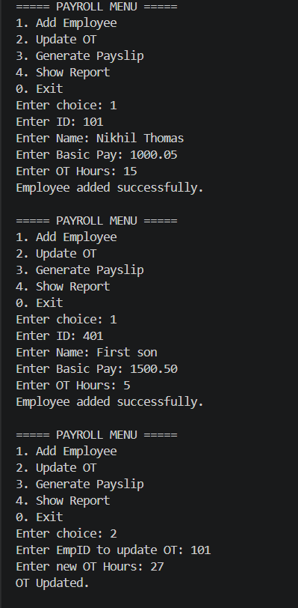
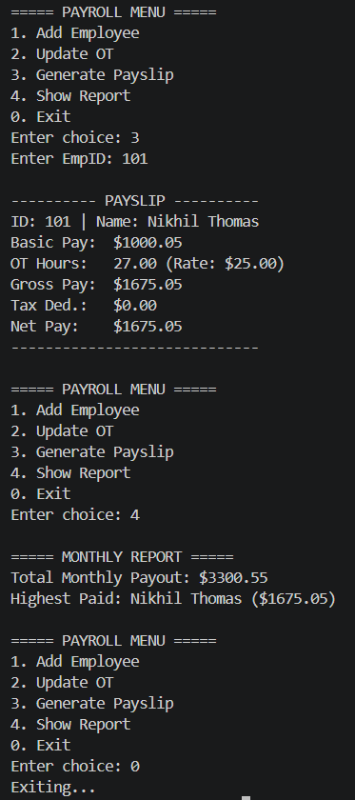

- Deployment Explanation:
Entire project is on github with the source code and exe file which can be downloaded and run natively.

- Challenges Faced:
Unable to get the C code to be compatable with WebAssembly and modern browser website norms. Norms of C conflict with norms of websites which cause errors, crashes, and inefficiencies.

- AI Usage Declaration:
Gemini:
Basic structure and syntaxing

- Complete Source Code:
#include <iostream>
#include <vector>
#include <string>
#include <iomanip>
#include <algorithm>

using namespace std;

class Employee {
private:
int empID;
string name;
double basicPay;
double otHours;
const double OT_RATE = 25.0;

public:
Employee(int id, string n, double bp, double ot)
: empID(id), name(n), basicPay(bp), otHours(ot) {}

// Calculation Methods
double calculateGross() const {
return basicPay + (otHours * OT_RATE);
}

double calculateTax() const {
double gross = calculateGross();
if (gross <= 2000) return 0;
if (gross <= 5000) return (gross - 2000) * 0.10;
return (3000 * 0.10) + (gross - 5000) * 0.20;
}

double calculateNetPay() const {
return calculateGross() - calculateTax();
}

// Getters & Setters
int getID() const { return empID; }
string getName() const { return name; }
void setOT(double hours) { otHours = hours; }

void displaySlip() const {
cout << "\n---------- PAYSLIP ----------" << endl;
cout << "ID: " << empID << " | Name: " << name << endl;
cout << "Basic Pay: $" << fixed << setprecision(2) << basicPay << endl;
cout << "OT Hours: " << otHours << " (Rate: $" << OT_RATE << ")" << endl;
cout << "Gross Pay: $" << calculateGross() << endl;
cout << "Tax Ded.: $" << calculateTax() << endl;
cout << "Net Pay: $" << calculateNetPay() << endl;
cout << "-----------------------------" << endl;
}
};

class PayrollSystem {
private:
vector<Employee> employees;
public:
void addEmployee() {
int id;
string name;
double bp, ot;

cout << "Enter ID: "; cin >> id;

for (const auto& e : employees) {
if (e.getID() == id) {
cout << "Error: ID already exists!\n";
return;
}
}

cout << "Enter Name: "; cin.ignore(); getline(cin, name);
cout << "Enter Basic Pay: "; cin >> bp;
cout << "Enter OT Hours: "; cin >> ot;

if (bp < 0 || ot < 0) {
cout << "Error: Pay/Hours cannot be negative.\n";
} else {
employees.emplace_back(id, name, bp, ot);
cout << "Employee added successfully.\n";
}
}

void updateOT() {
int id;
double hours;
cout << "Enter EmpID to update OT: "; cin >> id;
for (auto& e : employees) {
if (e.getID() == id) {
cout << "Enter new OT Hours: "; cin >> hours;
if (hours >= 0) {
e.setOT(hours);
cout << "OT Updated.\n";
} else cout << "Invalid hours.\n";
return;
}
}
cout << "Employee not found.\n";
}

void generatePayslip() {
int id;
cout << "Enter EmpID: "; cin >> id;
for (const auto& e : employees) {
if (e.getID() == id) {
e.displaySlip();
return;
}
}
cout << "Employee not found.\n";
}

void showReports() {
if (employees.empty()) return;

double totalPayout = 0;
Employee* highest = &employees[0];

for (auto& e : employees) {
double net = e.calculateNetPay();
totalPayout += net;
if (net > highest->calculateNetPay()) {
highest = &e;
}
}

cout << "\n===== MONTHLY REPORT =====" << endl;
cout << "Total Monthly Payout: $" << totalPayout << endl;
cout << "Highest Paid: " << highest->getName() << " ($" << highest->calculateNetPay() << ")" << endl;
}
};

int main() {
PayrollSystem ps;
int choice;

do {
cout << "\n===== PAYROLL MENU =====\n";
cout << "1. Add Employee\n";
cout << "2. Update OT\n";
cout << "3. Generate Payslip\n";
cout << "4. Show Report\n";
cout << "0. Exit\n";
cout << "Enter choice: ";
if (!(cin >> choice)) {
cout << "Invalid input! Please enter a number." << endl;
cin.clear(); // Clear error flags
cin.ignore(1000, '\n'); // Discard buffer
continue;
}

switch (choice) {
case 1: ps.addEmployee(); break;
case 2: ps.updateOT(); break;
case 3: ps.generatePayslip(); break;
case 4: ps.showReports(); break;
case 0: cout << "Exiting...\n"; break;
default: cout << "Invalid choice.\n";
}
} while (choice != 0);

return 0;
}

- Conclusion:
This project shows how Object-Oriented Programming (OOP) can be used to solve real-world administrative payroll problems. I made the switch from a manual payroll process to an automated C++ system. This made my data more secure through encapsulation and made my system more scalable by using the Standard Template Library (STL).

LLM AIs has helped tweak and catch mistakes saving on human time and energy.

