Git ASSIGNMENTS.

NAME : NIKHILTHOTA

1.Create a directory ‘project_dir’ & cd to ‘project_dir’.

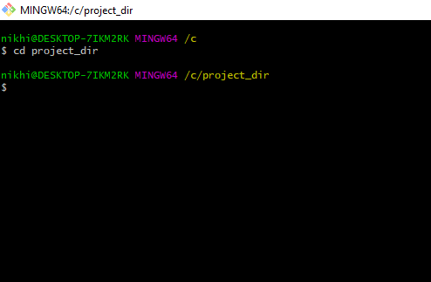

2.Initialize git version database. (git init)

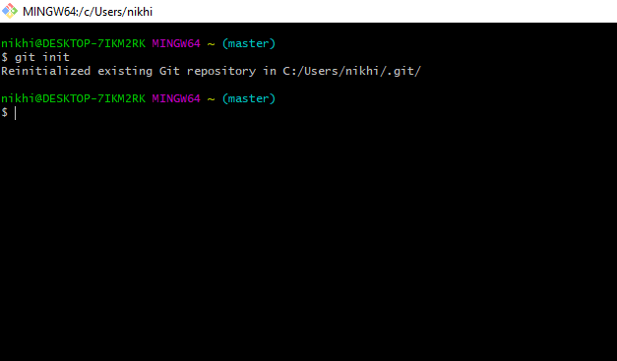

3. Create a new file index.html.

(both)

4. Check the git status. You should find index.html as untracked file.

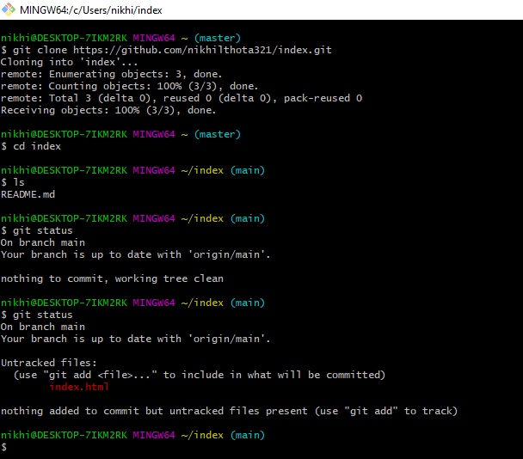

5. Stage the index.html file.

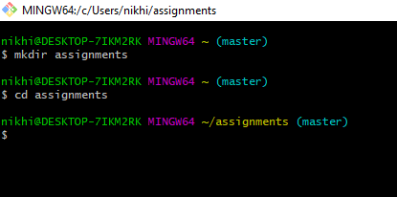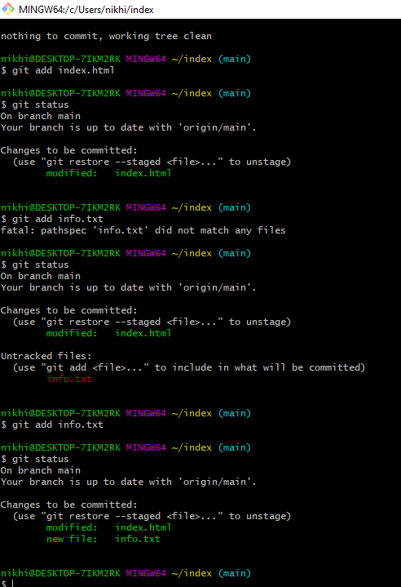

7. Make few changes in index.html & create a new file info.txt file.

both

8. Check git status. You should find index.html & info.txt as untracked files

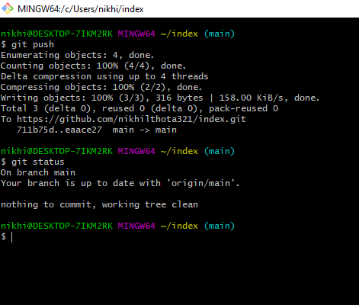

9. Configure GIT to ignore all txt files.

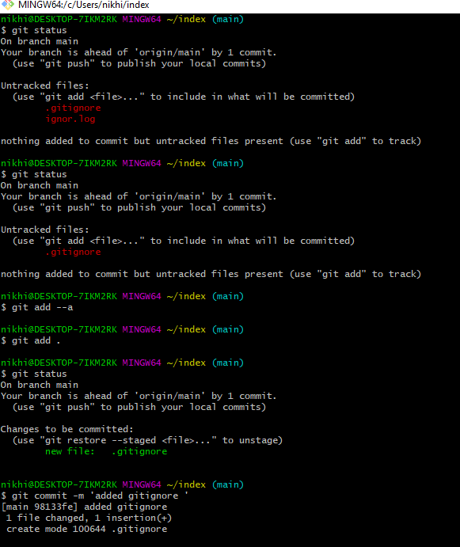

10. Again check the git status. You should find only index.html as untracked file.

both

11. State & commit index.html

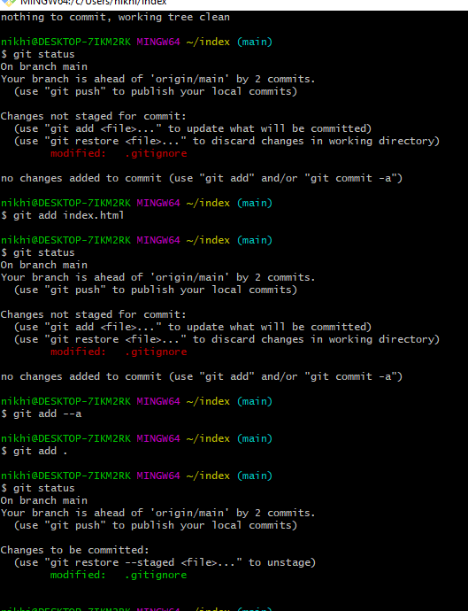

12. Log all your comments so far.

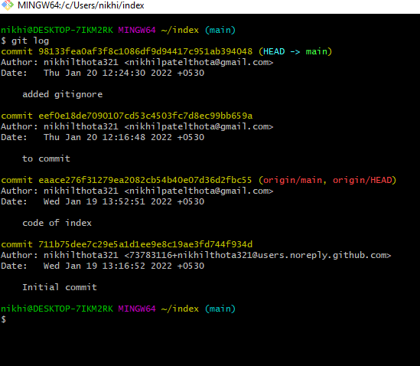

13. Make some changes in index.html.

both

14. Revert the change made in the previous step using git command.

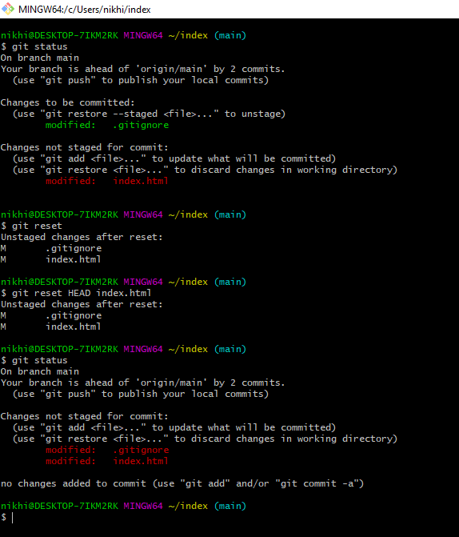

15. Again change index.html.

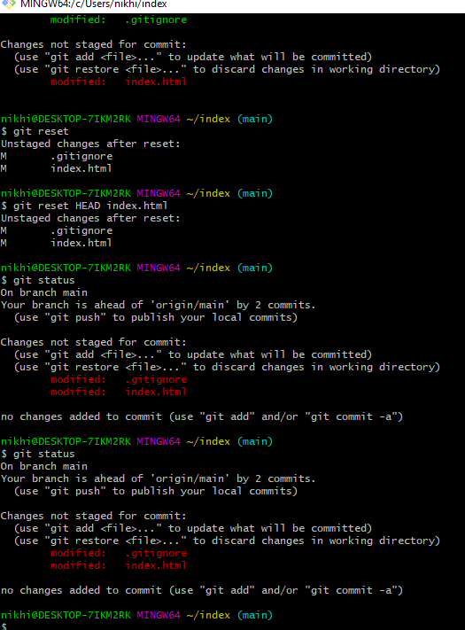

16. Stage index.html.

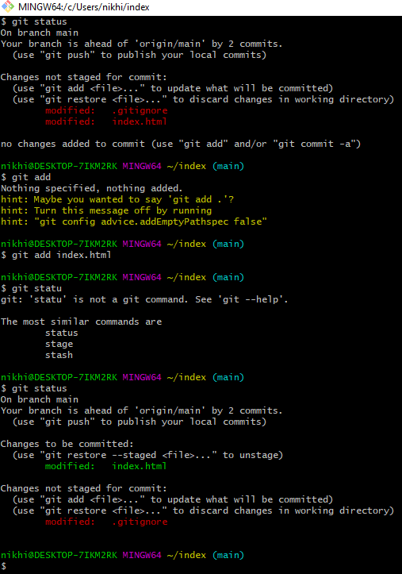

22. Create an empty directory ‘Assignments’ & cd to ‘Assignments’.

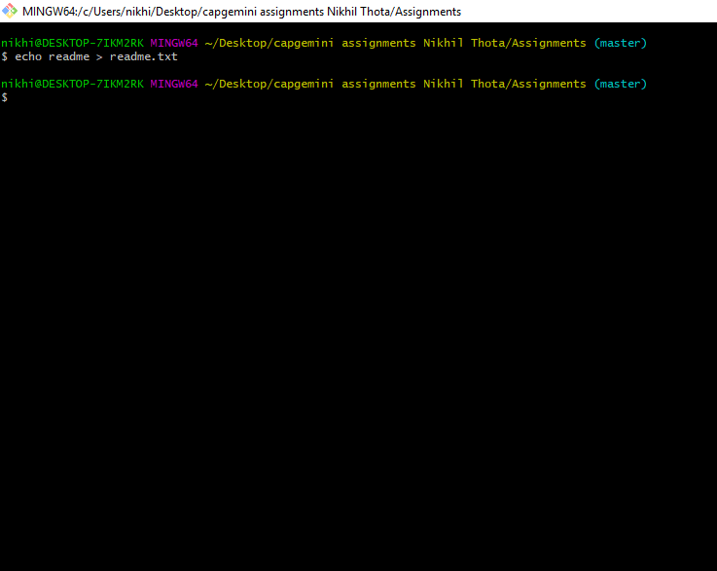

23. Create a file README.txt inside ‘Assignments’ & write few lines about the contents of ‘Assignments’ folder.

.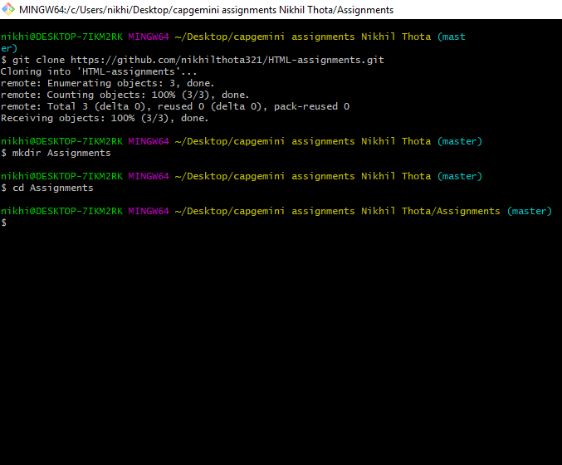

24. Commit README.txt file.

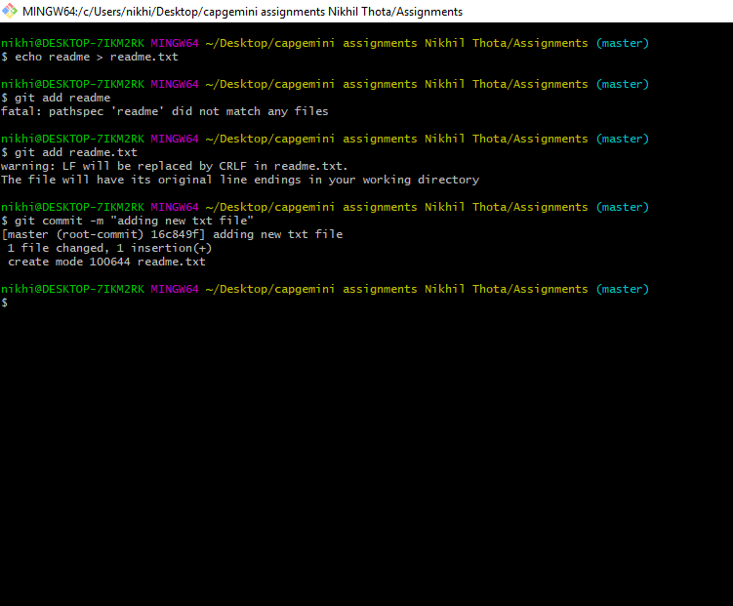

25. Now create a new branch ‘html-assignments’.

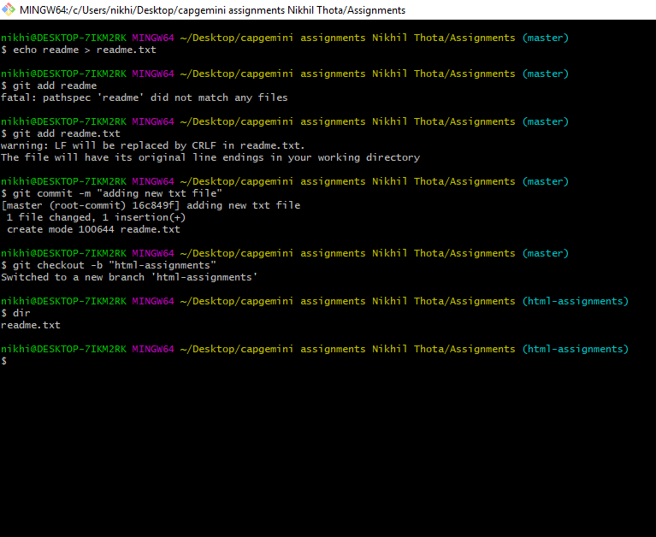

26. Switch to ‘html-assignments’ branch.

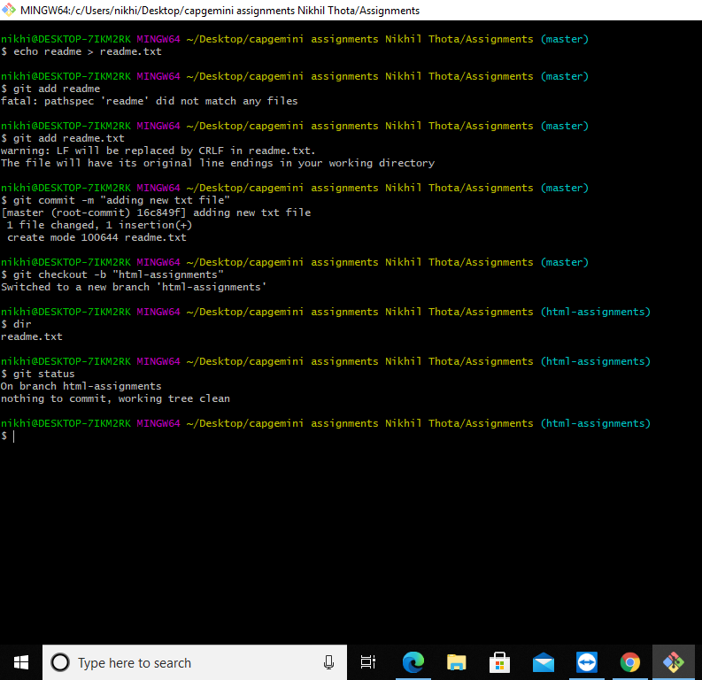

27. Copy all HTML assignments inside ‘Assignments’ folder.

both

28. Commit HTML assignments into ‘html-assignments’ branch

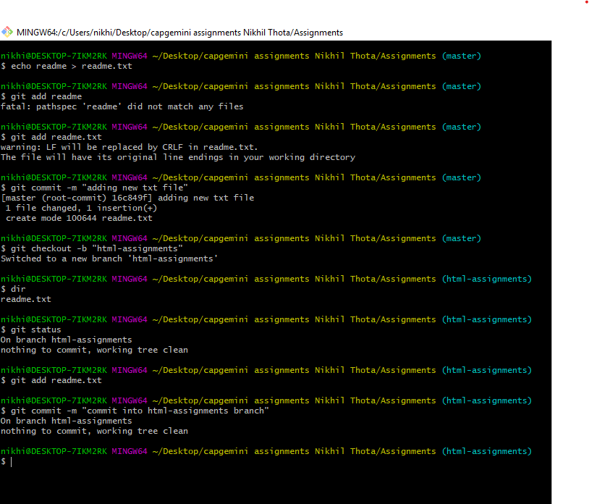

29. Make minor changes into few files belonging to ‘html-assignments’ branch.

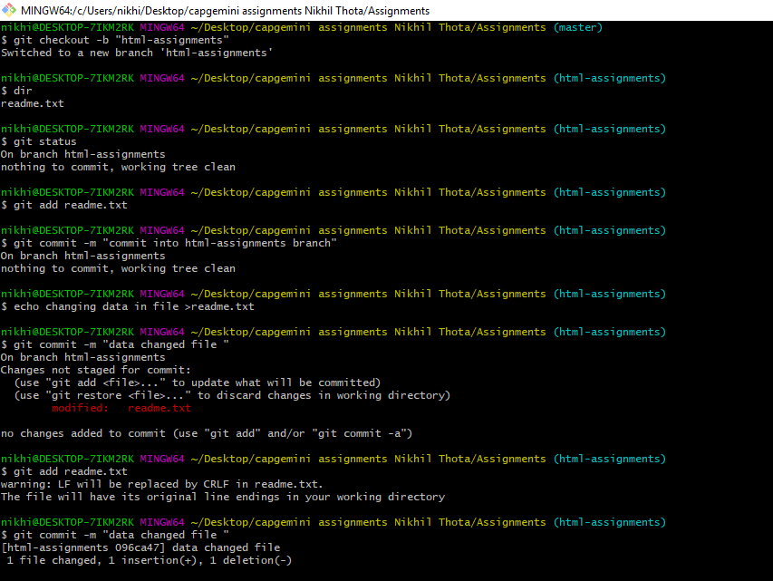

30. Commit those changed files.

31. Switch to master branch.

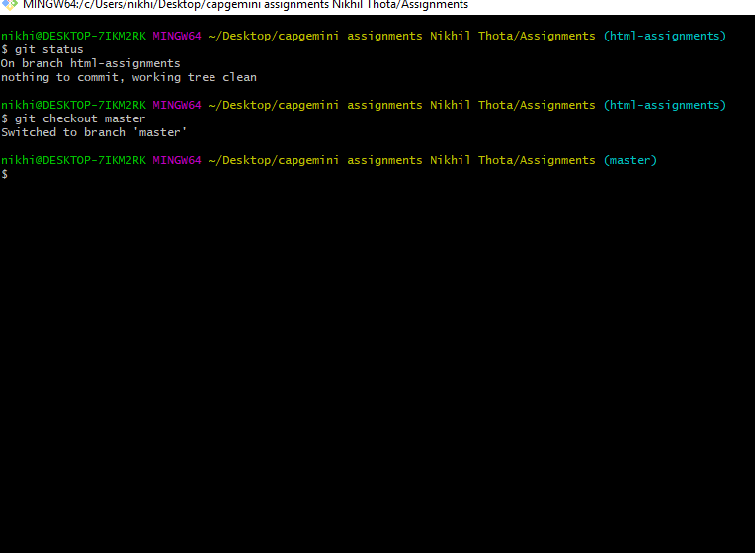

32. Make minor changes into README.txt file & commit those changes into master.

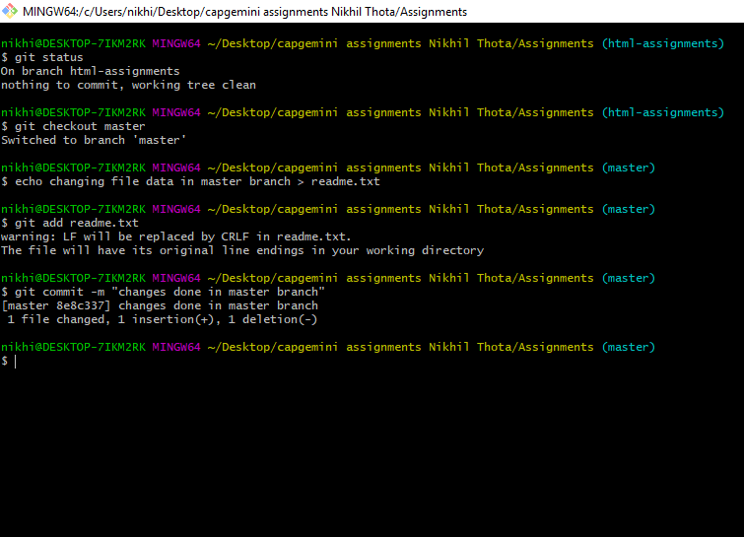

33. Again switch to ‘html-assignments’ branch.

34. Make minor changes into few files belonging to ‘html-assignments’ branch.

35. Commit those changes. 36. Switch to master.

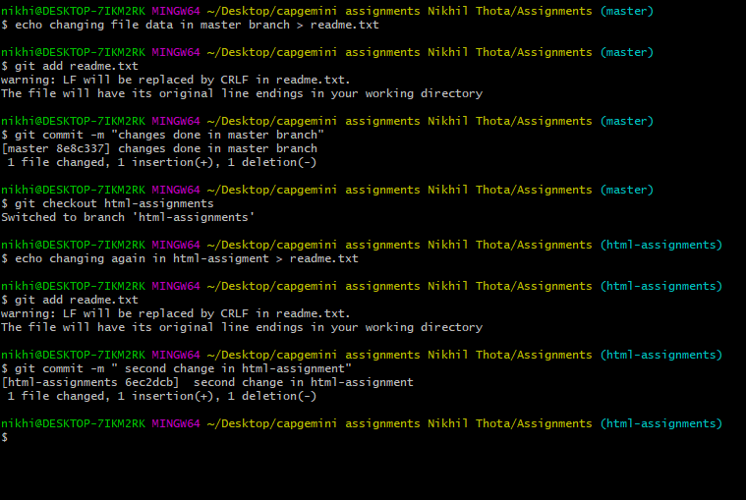

36. Switch to master.

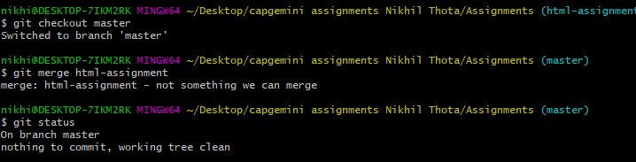

37. Merge ‘html-assignments’ branch into master. Confirm all html assignments are shown in master.

38. Finally delete the ‘html-assignments’ branch.

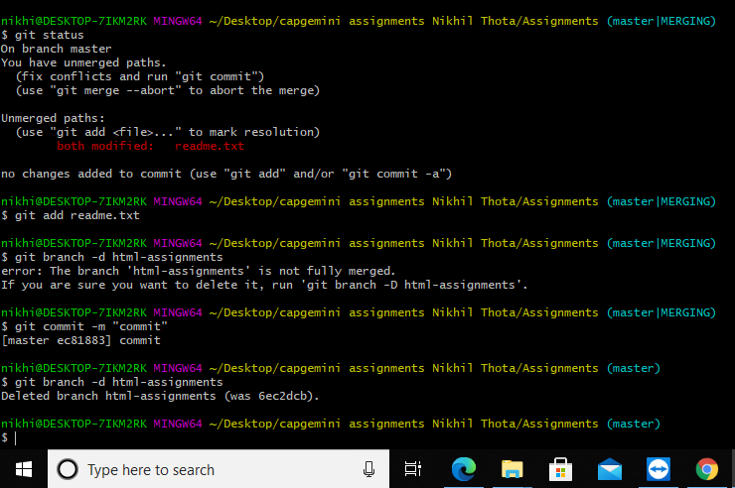

Objective: Pushing source code into GITHUB & collaborate team members.

SECTION-1 (Pushing assignments to remote repository) - Steps to follow:

39. Create a github account if you do not have already.

40. Login on into github account.

41. Create new public repository ‘freshersbatch-oct16’.

42. Commit & push any sample file to this repository under ‘Assignments’ directory.

