**MONGODB BASIC ASSIGNMENTS**

**1. get all documents**

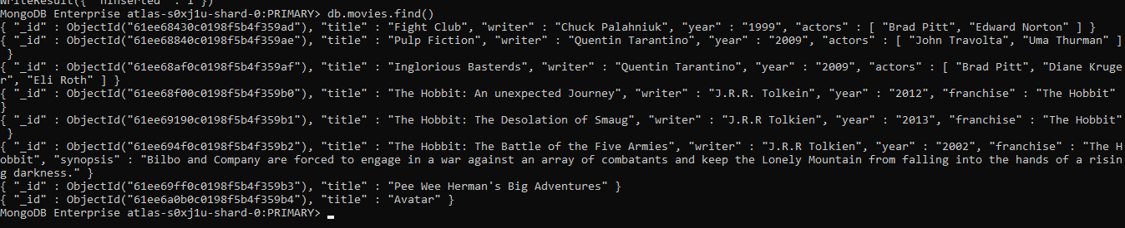

2. get all documents with writer set to "Quentin Tarantino"



3. get all documents where actors include "Brad Pitt"



4. get all documents with franchise set to "The Hobbit"

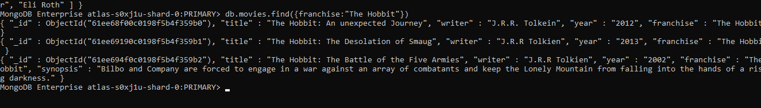

5. get all movies released in the 90s

6. get all movies released before the year 2000 or after 2010

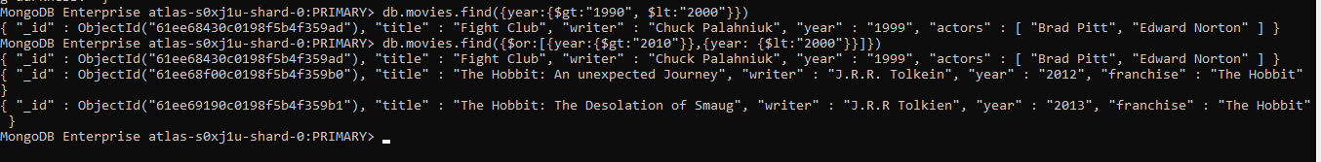

1. find all users

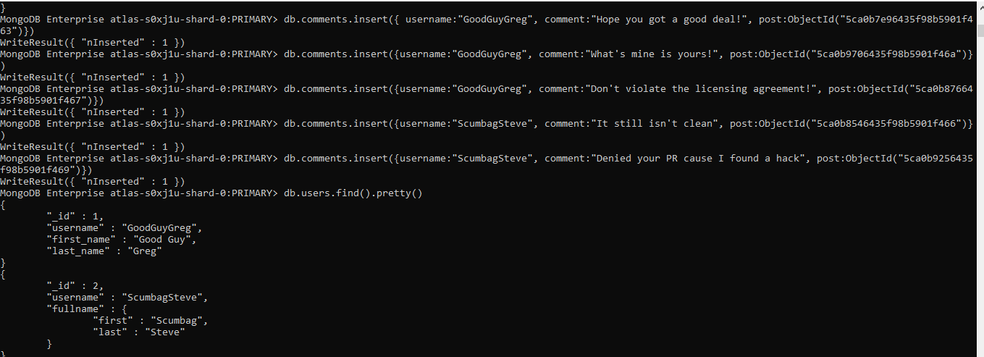

2. find all posts

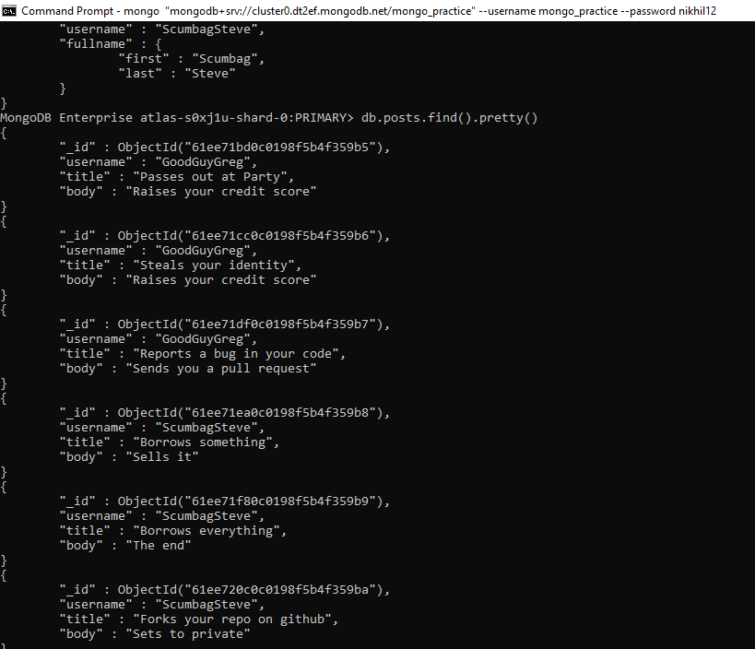

3. find all posts that was authored by "GoodGuyGreg"

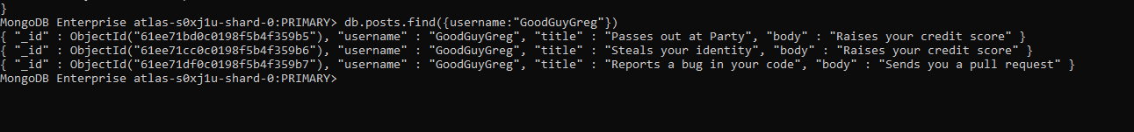

4. find all posts that was authored by "ScumbagSteve"

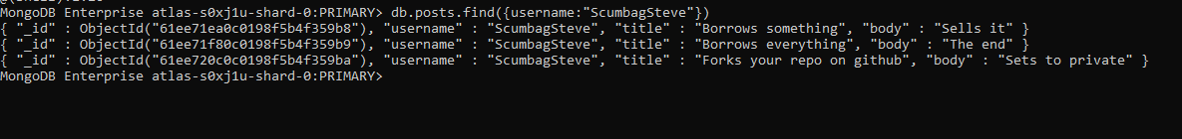

5. find all comments

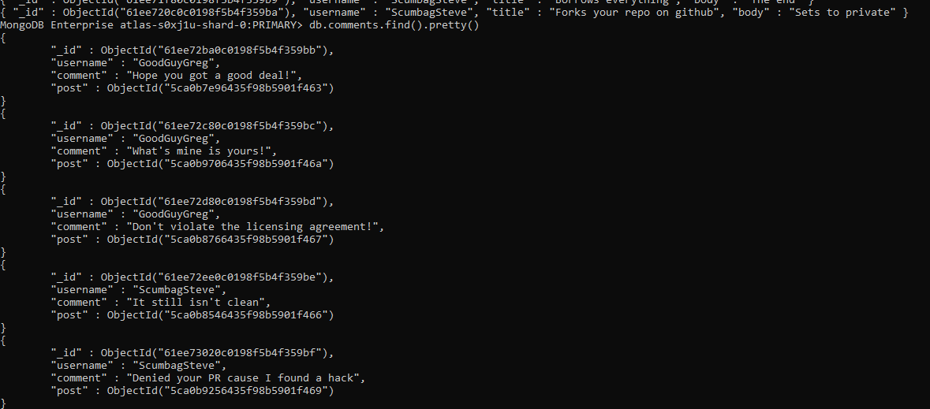

6. find all comments that was authored by "GoodGuyGreg"

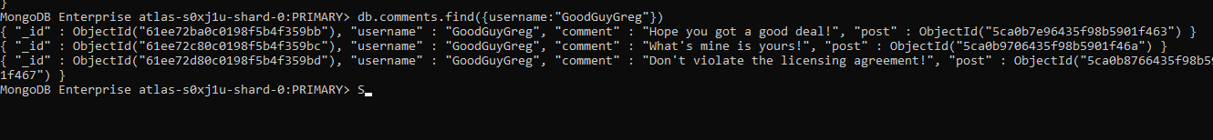

7. find all comments that was authored by "ScumbagSteve"

