SIGNALFORGE
AI-Native Industrial Reliability & Workforce Intelligence Platform
Sensor-to-Strategy: Predictive Maintenance, Skill-Matched Dispatch,
and Workforce Safety for Industrial Manufacturing

COMPLETE PROJECT DOCUMENTATION — MASTER RECORD
End-to-End Build Record: Decisions, Tradeoffs, Implementation, Outcomes, Roadmap

Author
Nikhil Tiwari — Product Manager (M.Eng, Electrical Engineering)
Engagement
Octacorps Industrial Automation Consultancy — Client Engagement
Client
Textile Manufacturing Plant, Bhilwara, Rajasthan (name withheld for confidentiality)

Proprietary — Portfolio Artifact — © 2026 Nikhil Tiwari — All Rights Reserved

Table of Contents

1. Executive Summary
SignalForge is a predictive maintenance and workforce safety platform built for a 500-plus worker textile manufacturing plant in Bhilwara, Rajasthan, developed during a client engagement at Octacorps, an industrial automation consultancy. The platform captures signal data that the plant's own programmable logic controllers (PLCs) already generate — motor current, vibration, temperature, and discharge pressure — and routes that data through a four-agent AI reasoning pipeline that predicts equipment failure ahead of time and recommends the correctly skilled technician for the job. A fourth, architecturally isolated agent gives plant leadership the first systematic visibility into how equipment downtime translates into physical strain on the workforce, without ever linking that data to an individual worker's identity.
This document is the single, consolidated source of truth for the project. It merges every supporting artifact — the technical requirements, the Six Sigma DMAIC case study, the AI agent architecture, the sensor and PLC specification, the system architecture, the risk register, the postmortem, and the pilot results dashboard — into one continuous, professionally structured record, so that a reader can understand the complete lifecycle of the project from a single file rather than navigating a folder of separate documents.

Headline Results — 90-Day Pilot
Metric | Baseline | Target | Actual Result | Status
First-Time-Fix Rate | 47% | ≥ 70% | 71% | Target met
Mean Time To Repair (MTTR) | 94 min | ≥ 35% reduction | 38% reduction (58 min) | Target met
Predictive alert lead time | Not available | ≥ 4 hours | 4.6 hours average | Target met
Structured failure-mode capture rate | ~12% | ≥ 85% | 79% | Below target
Associate Strain Exposure baseline | Not tracked | Establish baseline | 312 incidents logged | Target met

Who This Document Is For
Primary audience: technical recruiters and hiring managers evaluating Product Manager candidates for reliability and maintenance engineering (RME) organizations, and AI Product Manager roles with an operations or industrial bent. Secondary audience: engineering and controls-background interviewers who want to verify genuine signal and PLC literacy behind the AI framing, rather than “smart factory” language layered onto a generic software product.

One-Sentence Summary
"An AI-native industrial reliability platform that captures previously discarded PLC signal data, routes it through a four-agent reasoning pipeline to predict failures and route the right technician the first time, and treats workforce physical strain as a first-class, architecturally isolated signal — built end-to-end from floor research, electrical signal analysis, Six Sigma DMAIC structuring, and agentic AI system design."

How This Document Is Organized
Section 2 defines the business problem in quantified terms. Section 3 walks through the research methodology used to gather requirements directly from the plant floor. Section 4 documents the four major strategic decisions and the reasoning behind each. Section 5 applies the full Six Sigma DMAIC framework end to end. Section 6 is the formal Technical Requirements Document. Sections 7 and 8 cover the system and sensor/PLC architecture. Section 9 is the complete AI agent design. Sections 10 and 11 present the metrics framework and the pilot results, including every chart from the implementation dashboard. Sections 12 through 20 cover risk, the step-by-step build log, challenges, outcomes, limitations, lessons learned, the roadmap, the skills and tools applied, and a supporting appendix.

Reading This Document as an Amazon TPM / RME Program Manager Reviewer
Sections 1–20 are written primarily in Product Manager register: problem, requirements, architecture, outcome. Sections 21–24 add the program-execution and technical-depth layer an Amazon Technical Program Manager or RME Program Manager review will look for specifically: a program charter and RACI (21.1–21.2), the milestone timeline and critical-path management of the sensor-vendor dependency (21.3–21.4), recurring operating mechanisms (21.5), a technical risk register scoped to the AI system itself (21.6), agent-level latency budgets and evaluation methodology (22.1–22.3), failure handling and observability (22.4–22.5), an Amazon Leadership Principles mapping grounded in specific, checkable project moments (23), and a full Amazon-style narrative 6-pager condensing the entire program (24). A reviewer short on time can read Section 24 alone and get the complete program in narrative form.

2. Problem Definition & Business Case

2.1 Current State — A Reactive Maintenance Operation
Before this engagement, the plant's maintenance operation ran entirely in reactive mode. When a machine failed, the sequence was always the same: a floor supervisor radioed the maintenance office, a technician was dispatched based on who happened to be available rather than who had the right skill for the failure, and the technician frequently arrived without knowing what had actually gone wrong. Because there was no structured record of prior failure modes, diagnosis had to start from zero on every single call.

2.2 The Problem in Numbers
Six months of historical maintenance dispatch data were digitized and analyzed to establish a quantified baseline. The picture that emerged justified treating this as a formal Six Sigma improvement project rather than a simple tooling upgrade:
Metric | Baseline (Current State)
Average Mean Time To Repair (MTTR) | 94 minutes
First-Time-Fix Rate | 47% (technician resolves the issue on the first dispatch)
Unplanned downtime, plant-wide | ~340 hours / month
Estimated production value lost per downtime hour | ₹18,000–₹26,000 / hour (assumption, based on line throughput value)
Manual workaround incidents during downtime | Frequent, but never systematically tracked prior to this engagement

The 31% figure is the single most consequential number in the baseline: it means that roughly one in three repairs required a second visit, because the first technician dispatched did not have the right tools or skill for the actual failure mode. Every one of those second visits compounds downtime, doubles travel time, and further destabilizes an already-strained maintenance team.

2.3 The Hidden Problem: Unmeasured Workforce Strain
A second, less visible problem existed alongside the reliability problem, and it was not something any stakeholder had asked to have solved — largely because nobody had ever framed it as a problem with a name. When automated conveyors or feed systems went down, floor workers would informally compensate by manually carrying fabric rolls (observed weight range 15–25 kg) over distances the conveyor would normally cover. This workaround had never been measured, tracked, or acknowledged as a formal process step; it existed purely as an ad hoc human response to equipment failure, invisible to every existing management system.

2.4 Why This Justified a Formal Project, Not an Informal Fix
Three factors combined to justify treating this as a structured Six Sigma engagement rather than an ad hoc improvement effort:
- A quantifiable financial cost: unplanned downtime and skill-mismatched dispatch were estimated at ₹61–88 lakh per month in lost production value — large enough to warrant formal sponsorship from plant operations leadership.
- A quantifiable and previously invisible safety dimension: undocumented manual workarounds exposed floor workers to elevated, unmeasured physical strain risk, with zero existing visibility for safety leadership.
- A genuine data and measurement gap: the plant already generated much of the signal data needed to solve the reliability half of the problem — it simply had never been captured, structured, or connected to a decision-making system.

2.5 Goals
Goal Tier | Statement
Primary (product) | Reduce Mean Time To Repair by 35%+, raise First-Time-Fix Rate from a 47% baseline to 70%+, and establish the plant's first structured visibility into associate strain exposure during downtime — within a 90-day pilot across three prioritized equipment categories.
Secondary (technical) | Demonstrate that tapping existing, underutilized PLC signal data via a non-invasive IoT gateway can deliver meaningful predictive maintenance value without requiring a full sensor retrofit — a realistic, budget-conscious industrial AI deployment pattern.
Tertiary (responsible AI) | Prove that an AI agent architecture can correctly encode a non-negotiable trust boundary — workforce strain data must never become individual performance data — at the system design level, not merely as a written policy.

2.6 Explicit Non-Goals
- Full vibration spectral analysis (FFT-based frequency decomposition) is explicitly out of scope for Phase 1, given retrofit cost — flagged as a Phase 2 item.
- Individual-level worker tracking of any kind is explicitly and permanently excluded from the system, not merely deferred.
- This project does not claim the AI agents were deployed against live, real plant production data; see Section 16 for an honest accounting of this limitation.

3. Research Methodology — Floor Research & Stakeholder Discovery
Requirements for this project were not gathered from a desk. They were built from a structured combination of direct floor presence and quantitative historical data analysis, because neither source alone would have produced a complete or trustworthy requirements set.

3.1 Methodology Overview
The research phase followed five deliberate steps, executed in sequence:
- Reviewed six months of historical maintenance dispatch logs to establish a quantitative baseline before any floor time began, so that floor observations could be interpreted against real data rather than anecdote alone.
- Conducted structured floor walks across three shifts — morning, evening, and night — shadowing maintenance technicians during live repair calls to observe breakdown response in real time.
- Ran structured interviews with RME engineers, maintenance technicians, and line supervisors, using a consistent interview protocol so responses could be compared across roles.
- Held informal conversations with floor workers during natural breaks, deliberately avoiding a formal interview setting so workers would not feel they were being evaluated — this is what ultimately surfaced the workforce-strain finding.
- Cross-referenced everything observed and heard against the six months of historical maintenance dispatch logs, to confirm that qualitative findings were reflected in the quantitative record and vice versa.

3.2 Stakeholder Groups Consulted
Stakeholder Group | Number Consulted | What They Provided
RME Engineers | 4 | Failure-mode knowledge, technician skill-mapping needs, sensor and data feasibility
Maintenance Technicians | 9 | Real dispatch pain points, tool and part availability issues, repair sequence detail
Line Supervisors | 7 | Downtime workaround patterns, worker safety concerns, production impact
Floor Workers (informal) | ~15 | Direct experience of manual workaround physical strain
Plant Operations Leadership | 2 | Business priority, budget constraint context, definition of success

Twenty-two individuals in total were consulted through either structured or informal conversation — a scale deliberately chosen to be large enough to identify patterns (such as “9 of 9 technicians independently cited the same top pain point”) while remaining small enough to execute inside the engagement timeline.

3.3 Key Findings, By Stakeholder Group

RME Engineers
The top pain point across all four RME engineers consulted was the complete absence of structured failure-mode history. Every repair note that existed was inconsistent free text on paper, which made any kind of pattern analysis across repairs essentially impossible.
"We've been asking for better data for two years, but nobody's ever built the tool to make logging easy. If it takes more than a minute, the techs won't do it consistently." — RME Engineer (paraphrased from field notes)
This finding directly shaped the 90-second logging acceptance criterion later written into FR-1 of the Technical Requirements Document.

Maintenance Technicians
All nine technicians interviewed independently cited being sent to the wrong job — dispatched without knowing the real failure mode — as a top-three frustration. This was independently confirmed in the dispatch log data, which showed 31% of repairs required a second visit.
During one night-shift shadowing session, a technician was observed walking 200 metres to respond to what dispatch had logged as a conveyor jam, only to discover on arrival that the actual fault was a motor failure requiring different tools entirely — a 22-minute round trip completed before the real repair work had even begun.
This observation, combined with the 9-of-9 interview consensus, directly shaped FR-3's skill-matched dispatch requirement and its 70%+ First-Time-Fix Rate target.

Line Supervisors
Seven line supervisors were interviewed. Their top pain point was a complete absence of visibility into the cumulative impact of repeated downtime on their teams — both on production output and on worker wellbeing.
"When the conveyor goes down on the dyeing line, the girls just start carrying the rolls by hand. Nobody's said it's a problem, but it's not nothing." — Line Supervisor (paraphrased from field notes)
Six of the seven supervisors interviewed confirmed that manual workarounds were a normal, unofficial response to downtime. This was the single most important finding of the entire research phase — and it emerged from supervisor conversations, not from any existing system, report, or formal request.

Floor Workers
Workers were understandably guarded in any formal interview setting, so the majority of useful insight came from informal conversation during breaks. The consistent theme across these conversations was that manual workarounds were simply accepted as “what happens” when machines go down — something no one had ever directly asked them about before.
This shaped the hard constraint later written into Section 6 of the Technical Requirements Document: strain data must never be used for individual performance evaluation. Workers needed confidence that being observed would not be used against them, or the entire data-collection effort would have failed on legitimacy grounds before it produced any value at all.

Plant Operations Leadership
The top priority for the two operations leaders consulted was a single source of truth. At the time of the engagement, maintenance data was split across paper logs, a basic spreadsheet, and verbal handoffs between shifts, leaving leadership with no real-time visibility into plant reliability. This directly shaped FR-5, the unified dashboard requirement.

3.4 The Insight That Wasn't In Any Request
The most valuable finding of the entire research phase was not something any stakeholder explicitly asked to have addressed. It emerged only by triangulating three separate threads: supervisor interviews confirming that manual workarounds happen; direct floor observation confirming how physically demanding those workarounds actually are; and the complete absence of any existing system that tracked this in any form.
"The most valuable requirement often isn't the one stakeholders ask for — it's the one you find by being present enough, in enough different conversations, to see the pattern they haven't named yet."

4. Strategic Decisions & Rationale
Four decisions shaped the entire architecture of this project. Each is documented here in full — the options that were considered, the option that was chosen, and the reasoning behind the choice — because the reasoning is more valuable to an evaluator than the decision itself.

Decision 1 — Tap Existing PLC Signals via a Non-Invasive IoT Gateway, Not a Full Sensor Retrofit
 | Detail
Options considered | (A) Full retrofit with new sensors across all equipment. (B) Tap existing PLC analog/digital signals non-invasively via an edge gateway, supplementing only where genuinely absent (vibration). (C) Wait for budget to complete a full retrofit before building anything.
Chosen | Option B
Rationale | Floor and PLC review confirmed the plant's existing control systems already generated motor current data, and partial temperature/pressure data, for all three prioritized equipment categories — discarded immediately after use in the control loop. A retrofit-first plan would have meaningfully delayed any value delivery and dramatically increased budget risk. Tapping existing signals first, and supplementing only the genuinely missing vibration signal, de-risked the entire project's sensor budget while still proving the full architecture end to end.

Decision 2 — Four Agents, With Workforce Safety Architecturally Isolated Rather Than Chained
 | Detail
Options considered | (A) A single end-to-end model from signal to dispatch decision. (B) Three sequential agents (Anomaly → Prediction → Dispatch) with workforce safety folded into the same pipeline. (C) Four agents with workforce safety as a fourth sequential stage. (D) Four agents with workforce safety architecturally isolated — no upstream or downstream data link to the other three.
Chosen | Option D
Rationale | This is the single most important AI product-judgment decision in the project. Folding workforce safety into the same pipeline as dispatch (option C) would create a technical pathway — even if policy said otherwise — for strain data to eventually correlate with individual technician or worker identity, since dispatch data inherently includes technician identity. Isolating the Workforce Safety Agent architecturally, with no data link to the technician-identifying pipeline, makes the non-negotiable trust boundary raised directly by floor workers during research enforceable at the system level, not merely at the policy level. This was a deliberate, conscious forgone opportunity: a genuine cross-signal correlation between strain patterns and failure patterns might exist and go undetected — accepted specifically because trust was judged non-negotiable.

Decision 3 — Sequential Context-Passing for Agents 1 → 2 → 3
 | Detail
Options considered | (A) Run the Signal Anomaly, Failure Prediction, and Dispatch Optimization agents as independent parallel calls against the same raw data. (B) Sequential design, where each agent consumes the prior agent's structured output.
Chosen | Option B
Rationale | An agent reasoning over another agent's already-narrowed, confirmed output produces more reliable and more auditable results than an agent reasoning over raw, noisy input independently. The Failure Prediction Agent reasoning over Agent 1's confirmed anomaly, complete with a confidence level, rather than over raw telemetry directly, is both more accurate and easier for an RME engineer to audit at each individual stage of the pipeline.

Decision 4 — Six Sigma DMAIC as the Overarching Structure, Not Just a Section
 | Detail
Options considered | (A) Standard PM/PRD structure with Six Sigma mentioned only as a methodology reference. (B) Full DMAIC structure governing the entire problem framing, with the AI and software layer appearing specifically as the output of the “Improve” phase.
Chosen | Option B
Rationale | Treating DMAIC as a section subordinate to a generic requirements document would undersell genuine Six Sigma fluency. Structuring the entire case study around Define, Measure, Analyze, Improve, and Control — with the AI agent architecture appearing specifically within “Improve,” and a real “Control” phase rather than a fix-and-forget ending — demonstrates that Six Sigma discipline is load-bearing methodology in this project, not decoration.

5. Six Sigma DMAIC Case Study
The entire problem — not just the software layer — was structured using Six Sigma Green Belt methodology: Define, Measure, Analyze, Improve, and Control. This section walks through each phase in the order it was actually executed.

5.1 Project Charter
Field | Detail
Project Title | Reactive-to-Predictive Maintenance & Workforce Safety Transformation
Business Case | Unplanned downtime and inefficient technician dispatch were costing an estimated ₹61–88 lakh per month in lost production value, while undocumented manual workarounds exposed floor workers to elevated, unmeasured physical strain risk.
Problem Statement | Maintenance is reactive, technician dispatch is skill-mismatched 31% of the time, and equipment downtime correlates with unmeasured worker safety risk.
Goal Statement | Reduce MTTR by 35%, increase First-Time-Fix Rate from 47% to 70%+, and establish baseline visibility into associate strain exposure — within 90 days of pilot rollout.
Scope | Three prioritized equipment categories (main conveyors, automated loom feeders, dyeing process pumps), single plant site.
Project Sponsor | Plant Operations Leadership (client-side)
Belt Level Applied | Green Belt methodology

5.2 DEFINE

Critical-to-Quality (CTQ) Characteristics
CTQ | Internal Customer | Requirement
Repair speed | RME Engineers, Plant Ops | Lower MTTR
Dispatch accuracy | Technicians | Right skill, right tools, first time
Worker safety | Floor Workers, Supervisors | Reduced unmeasured manual strain exposure
Data usability | RME Engineers | Single source of truth, not fragmented logs

Voice of the Customer (VOC)
"I get sent to a jam on Line 4 and find out it's actually a motor fault. I don't carry motor tools. Now I have to walk back." — Maintenance Technician
"When the conveyor goes down on the dyeing line, the girls just start carrying the rolls by hand. Nobody's said it's a problem, but it's not nothing." — Line Supervisor
"We write it all down on paper. By the time someone looks at the pattern, it's three weeks old." — RME Engineer

5.3 MEASURE

Baseline Data Collection Plan
Data Source | Collection Method | Duration
Maintenance dispatch logs | Existing paper/spreadsheet records, digitized for analysis | 6 months, historical
Floor observation | Direct shift walks, all 3 shifts covered | 2 weeks, structured observation
Stakeholder interviews | Structured and informal interviews | 22 individuals across all roles
Downtime workaround incidents | New observation protocol — no prior tracking existed | 2 weeks

Baseline Process Capability
The First-Time-Fix Rate was treated as the core Six Sigma “quality” metric for the maintenance process itself: a first-dispatch resolution is a success; a repeat visit is a defect.
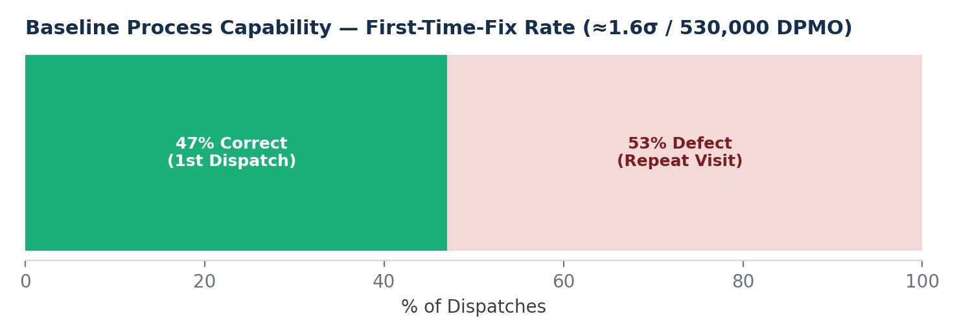
Figure 1. Baseline process capability derived from six months of dispatch data.
At a baseline First-Time-Fix Rate of 47%, the defect (repeat-visit) rate was 53%, with one opportunity per unit — each dispatch is a single opportunity to fix the problem correctly. That works out to 530,000 defects per million opportunities (DPMO), corresponding to an approximate baseline sigma level of 1.6σ. This is a low baseline, indicating substantial improvement headroom, which is typical and expected for a process that had never been formally measured before this engagement.

Measurement System Validation
A key finding during the Measure phase was that no consistent definition of “repair complete” existed prior to this engagement. Some technicians logged a repair as complete the moment the machine restarted; others waited to confirm sustained operation before logging completion. This inconsistency was flagged as a measurement-system problem in its own right, and a temporary standardized definition — a 15-minute sustained-operation check — was proposed before the full system existed, specifically to make the baseline data trustworthy going forward.

5.4 ANALYZE

Root Cause Analysis — Why Is First-Time-Fix Rate Only 47%?
- Why do 31% of repairs need a second technician visit? — Because the technician arrives without knowing the actual failure mode.
- Why don't they know the failure mode in advance? — Because dispatch is based on availability, not on any diagnostic signal from the equipment.
- Why is there no diagnostic signal? — Because failure-mode data has never been captured in structured form, only as inconsistent free-text paper notes.
- Why was it never captured in structured form? — Because no system existed that made structured capture easy enough for technicians to actually use during a live repair.
- Why did no such system exist? — Because maintenance technology investment had historically focused on production-line automation rather than the maintenance function itself — a recognized, common industrial pattern where production receives investment priority over the function that keeps production running.

True root cause: the absence of structured failure-mode data capture, which cascades into both poor predictive capability and poor technician-skill matching.

Root Cause Analysis — Why Is Worker Strain Exposure Unmeasured?
- Why is associate strain exposure during downtime unmeasured? — Because no one has ever been asked to measure it.
- Why has no one been asked? — Because the manual workaround is viewed as a temporary, informal coping behaviour, not a process step.
- Why is it viewed that way? — Because it isn't part of any official standard operating procedure; it emerged organically as a worker-level adaptation to downtime.
- Why does this matter for Six Sigma scope? — Because unofficial workarounds that compensate for process failure are a classic Six Sigma “hidden factory”: work that happens but remains invisible to management metrics.

True root cause: a hidden, unofficial compensating process (manual fabric carrying) exists specifically because the official process (conveyor-based transport) fails, and this hidden process was never instrumented because it was never formally acknowledged.

5.5 IMPROVE

Root Cause → Requirement Mapping
Root Cause | Improvement Action
No structured failure-mode data | FR-1: Structured failure-mode capture at point of repair
No predictive signal | FR-2: Predictive failure alerting for 3 prioritized equipment categories
Availability-based, not skill-based, dispatch | FR-3: Skill-matched technician dispatch
Hidden / unmeasured worker strain | FR-4: Associate strain exposure flagging — explicitly not for performance evaluation
Fragmented data visibility | FR-5: Unified SignalForge dashboard

Pilot Design
- Pilot scope: 3 equipment categories, single plant site.
- Pilot duration: 90 days post-rollout.
- Success threshold: First-Time-Fix Rate ≥ 70%, MTTR reduction ≥ 35%, and at least baseline visibility established for associate strain exposure (no specific numeric target for strain — the Phase 1 goal was measurement, not yet optimization).

5.6 CONTROL

Control Plan — Sustaining the Gains
Control Mechanism | Detail
Standardized “repair complete” definition | Built into FR-1 structured capture, removing the measurement inconsistency identified in the Measure phase
Weekly SignalForge Dashboard review | Plant operations and RME engineering leadership review trailing MTBF, MTTR, and FTFR weekly, not only at project close
Associate Strain Index monitoring | Monthly trend review, explicitly framed as a process-health indicator and never an individual worker metric, reviewed by safety and operations leadership only
Technician skill-log maintenance | RME engineers update technician skill profiles quarterly as training progresses, keeping FR-3 dispatch matching accurate
Model retraining cadence | The predictive alerting model (FR-2) is retrained quarterly as new structured failure data accumulates

Control Chart Concept
The chart below (a formalized version of the same trend also shown in Section 11) illustrates the intended post-pilot monitoring pattern: a gradual climb from the 47% baseline toward and beyond the 70% target threshold as structured data accumulates and dispatch matching improves.
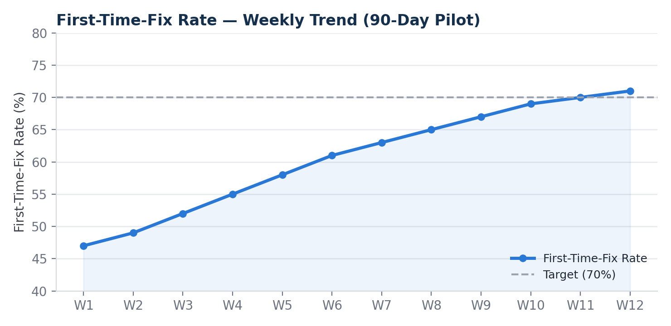
Figure 2. First-Time-Fix Rate control trend, weeks 1–12 of the pilot, against the 70% target threshold.

5.7 DMAIC Summary
Phase | Key Output
Define | Project charter, CTQs, Voice of the Customer synthesized from 22 stakeholders
Measure | 6-month baseline dataset, 2-week structured floor observation, baseline sigma ≈ 1.6σ
Analyze | Two root causes identified: missing structured failure data; hidden, unmeasured worker-strain workaround
Improve | 5 functional requirements translated into a formal Technical Requirements Document
Control | Standardized metric definitions, weekly dashboard review cadence, quarterly model retraining

6. Technical Requirements Document
This section is the core deliverable of the requirements-gathering phase of the engagement: the document that translates what RME engineers and floor workers actually need into what engineering needs to build. It was written for Octacorps' engineering team to build against, and for plant operations leadership to validate scope and priority before development began. Document status: Final — approved for engineering handoff.

6.1 Background & Problem Statement
See Section 2 for the full quantified problem statement. In summary: the plant's maintenance operation was reactive, first-time-fix performance sat at a 47% baseline, and a previously unmeasured manual workaround pattern exposed floor workers to unquantified physical strain.

6.2 Stakeholders Consulted
See Section 3.2 for the full breakdown of the 22 individuals consulted across five stakeholder groups.

6.3 Functional Requirements

FR-1 — Failure Mode Data Capture
Requirement: the system MUST capture structured failure-mode data at the point of every repair — equipment ID, failure category, root cause where determinable, parts used, and repair duration.
Source: RME engineers explicitly stated that without structured failure-mode history, no predictive model could ever be trained; historical data existed only as inconsistent free-text notes, not structured fields.
Acceptance criteria:
- Every dispatched repair generates a structured record containing the fields above.
- Technicians can log this via mobile device in under 90 seconds — validated directly against technician interview feedback that anything longer “won't get used.”

FR-2 — Predictive Failure Alerting
Requirement: the system MUST analyze equipment sensor data, where available, together with historical failure patterns, to generate an early-warning alert before failure occurs, for equipment categories with sufficient historical data density.
Source: RME engineers identified three equipment categories — main line conveyors, automated loom feeders, and dyeing process pumps — as having both high failure frequency and feasible sensor retrofit options.
Acceptance criteria:
- Alerts are generated at least 4 hours before predicted failure for in-scope equipment categories.
- Each alert includes the predicted failure mode and a recommended technician skill match.

FR-3 — Skill-Matched Technician Dispatch
Requirement: the system MUST recommend technician dispatch based on matching the predicted or reported failure mode against each technician's logged skill and repair history, not on simple availability.
Source: nine of nine technicians interviewed independently cited being sent to the wrong job as a top-three frustration, independently confirmed in dispatch log analysis showing 31% of repairs required a second technician visit.
Acceptance criteria:
- Dispatch recommendation includes the top 2 skill-matched, available technicians.
- First-Time-Fix Rate target: improve from a 47% baseline to 70%+ within 90 days of rollout.

FR-4 — Associate Strain Exposure Flagging
Requirement: the system MUST flag and log periods where equipment downtime correlates with a known manual-workaround pattern (for example, a conveyor down on a line with no alternate automated transport), and track which shift and work area is most frequently exposed.
Source: derived directly from floor observation. This requirement existed in no prior system or stakeholder request; it was synthesized from supervisor interviews and direct floor observation, not from a pre-existing ask. This is the requirement personally identified during research and pushed into scope.
Acceptance criteria:
- System logs estimated manual workaround duration per downtime event for in-scope equipment.
- A weekly report flags the work areas and shifts with the highest cumulative workaround exposure.

FR-5 — Maintenance Dashboard for RME Engineers
Requirement: the system MUST provide a dashboard showing real-time equipment health status, active alerts, technician dispatch status, and trailing reliability metrics (MTBF, MTTR, FTFR).
Source: RME engineers and plant operations leadership both requested a single source of truth; at the time, this data was split across paper logs, a basic spreadsheet, and verbal handoffs between shifts.
Acceptance criteria:
- Dashboard refreshes at least every 15 minutes.
- Accessible on shared floor terminals and supervisor mobile devices.

6.4 Non-Functional Requirements
Requirement | Detail
Reliability | The dashboard and alerting system itself must maintain >99% uptime — a maintenance system that is down is a credibility failure
Usability | Technician-facing mobile logging must work for users with varying smartphone literacy — large touch targets, minimal text entry
Data retention | Failure-mode history retained a minimum of 24 months to support predictive model training
Language | All technician-facing interfaces available in Hindi and English, given floor workforce composition
Connectivity | Plant floor has inconsistent WiFi in some zones, confirmed during floor walks — mobile logging must support offline capture with sync-on-reconnect

6.5 Constraints & Explicit Exclusions
- Hard constraint: associate strain and workaround data (FR-4) must never be used in individual performance reviews or disciplinary action. This was a non-negotiable condition raised by floor workers and supervisors during interviews, and is treated as a design constraint, not a nice-to-have.
- Out of scope, Phase 1: full sensor retrofit across all equipment; only the three prioritized categories from FR-2 are in scope for the pilot.
- Out of scope, Phase 1: automated parts ordering or inventory integration, flagged as a Phase 2 candidate.

6.6 Open Questions for Engineering
- Can the three prioritized equipment categories support retargetable IoT sensors within the existing budget, or does this require a phased sensor rollout?
- What is the minimum historical data volume needed before the predictive alerting model (FR-2) produces reliable signal, and what is the interim fallback (rule-based alerting) during that data-collection period?
- Is offline-first mobile logging, per the Connectivity non-functional requirement, feasible within the existing technician device fleet, or does it require new hardware?

7. System Architecture
This section documents the full sensor-to-dashboard architecture, translating the Technical Requirements Document and the AI Agent Design (Section 9) into an implementable system design.

7.1 Full Architecture Diagram
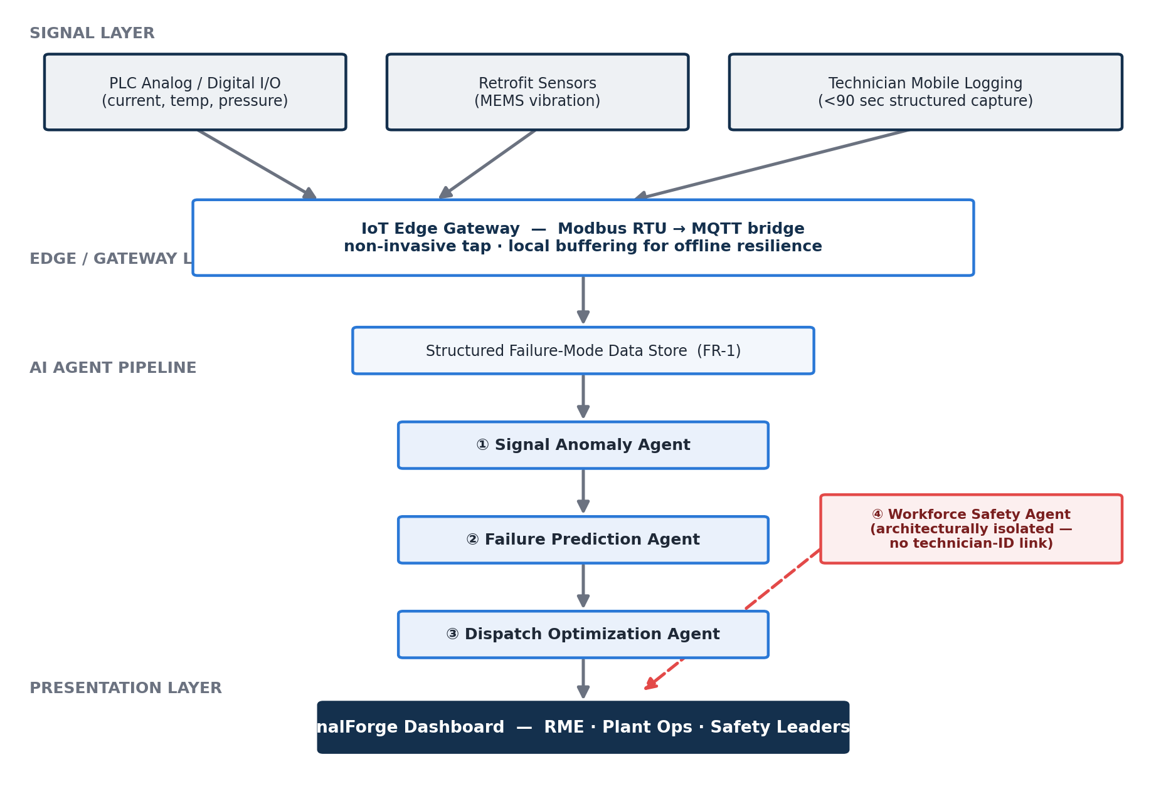
Figure 3. End-to-end SignalForge architecture: signal layer, edge/gateway layer, AI agent pipeline, and presentation layer.

7.2 Data Flow, Step by Step
- Capture: PLC signal data — motor current, vibration, temperature, and pressure — together with technician mobile logging, both feed into a structured failure-mode data store via a non-invasive IoT edge gateway, replacing inconsistent paper notes (FR-1).
- Detect: the Signal Anomaly Agent identifies statistically anomalous deviations from each machine's own baseline (Agent 1).
- Predict: the Failure Prediction Agent maps confirmed anomalies to predicted failure modes and time-to-failure estimates (Agent 2) — this is the predictive alerting capability specified in FR-2.
- Dispatch: the Dispatch Optimization Agent recommends skill-matched technicians for predicted or reported failures (Agent 3), directly addressing FR-3.
- Safety: the architecturally isolated Workforce Safety Agent flags downtime periods correlating with known manual-workaround patterns, tracked at the work-area/shift level only (Agent 4, FR-4).
- Surface: all of the above surfaces into a single SignalForge dashboard for engineers, plant operations, and safety leadership (FR-5).

7.3 Key Architectural Decision — Why the Workforce Safety Agent Is Isolated
The Workforce Safety Agent is architecturally separate from the sequential Agent 1 → 2 → 3 pipeline, not chained into it, for one critical reason: its data must never flow into individual technician or worker performance evaluation, per the hard constraint defined in Section 6.5 and reinforced directly by floor-worker trust concerns surfaced during stakeholder research (Section 3). Keeping it as a fully isolated agent, with its own access controls and aggregation rules — work-area/shift level only, never individual — makes that constraint enforceable at the architecture level, not merely as a policy promise. The full tradeoff discussion appears in Section 9.

7.4 Key Architectural Decision — Why a Non-Invasive IoT Gateway, Not PLC Reprogramming
Rather than modifying the plant's existing, safety-rated PLC ladder logic to add new data outputs, SignalForge taps the same signals via a parallel, non-invasive read through an independent IoT edge gateway. This avoids re-validating the entire existing control program — a significant scope and safety-certification risk increase — in exchange for slightly more hardware (the gateway itself) at the edge. Full detail and signal-type rationale appear in Section 8.

7.5 Non-Functional Architecture Notes
- Offline-first mobile capture: given confirmed WiFi dead zones on the plant floor, technician logging captures locally and syncs on reconnect, rather than assuming constant connectivity.
- Bilingual interface: Hindi and English support is built into the technician-facing layer from day one, not retrofitted later.
- Phased sensor rollout: only three equipment categories are instrumented in Phase 1; the architecture is designed to extend to additional categories without a redesign.
- Edge buffering: the IoT gateway buffers signal data locally during any connectivity loss, ensuring no signal gaps reach the AI pipeline even during plant network instability.

8. Sensor & PLC Integration Specification
This section specifies the actual electrical signal types, sensor categories, and PLC integration architecture that feed the AI pipeline. A predictive maintenance product is only as credible as its grounding in real signal data; this is the layer connecting factory-floor electrical engineering to the AI agents described in Section 9.

8.1 Existing Plant Infrastructure (As Found)
All three prioritized equipment categories already ran on PLCs handling basic stop/start and interlock logic. Critically, the PLCs already received most of the raw signal data SignalForge needed — it was never being captured or stored, only used transiently for immediate control logic.
Equipment Category | Existing PLC Function | Signal Already Present (Uncaptured)
Main conveyors | Start/stop, jam detection (binary) | Motor current draw (analog 4–20mA), belt speed (encoder pulse)
Automated loom feeders | Feed timing control | Servo motor current, feed tension (analog)
Dyeing process pumps | Flow on/off control | Pump motor current, discharge pressure (analog 4–20mA)

Key insight from the floor and PLC review: this plant did not need a full sensor retrofit to get meaningful predictive signal — it needed a way to capture and structure data the PLCs were already generating but discarding. This finding significantly de-risked the project's sensor budget.

8.2 Signal Types, In Detail

Motor Current Draw (4–20mA Analog Loop)
What it tells us: rising current draw on a consistent load is one of the most reliable early indicators of mechanical degradation — bearing wear, misalignment, or developing friction — before an audible or visible fault appears.
Where it's tapped: existing PLC analog input cards already terminate this signal for control purposes; SignalForge adds a parallel tap, a non-invasive current transducer clamp, rather than rewiring the PLC's own control loop, to avoid any risk to existing safety-rated control logic.
Why it matters for AI agent design: this is the primary input to the Signal Anomaly Agent for conveyors and dyeing pumps — a gradual upward current trend against a stable historical baseline is exactly the kind of pattern an anomaly-detection layer should flag before MTBF data alone would catch it.

Vibration (Accelerometer, Retrofit Required)
What it tells us: vibration spectra (frequency-domain analysis) are the gold-standard signal for rotating equipment — bearing faults, shaft misalignment, and imbalance each produce distinct frequency signatures.
Where it's tapped: this signal did not already exist on any of the three equipment categories; it required retrofit, and was explicitly flagged in the original Technical Requirements Document's open questions as a budget-dependent item.
Retrofit approach specified: MEMS-based wireless accelerometers, battery-powered and magnetically mounted, on conveyor motor housings and loom feeder gearboxes — chosen specifically because they avoid running new wiring through an already-crowded PLC cabinet, at the cost of battery maintenance overhead, addressed in the Control-phase monitoring plan in Section 5.6.

Temperature (Thermocouple / RTD)
What it tells us: motor housing and bearing temperature trending upward, independent of ambient conditions, is a secondary corroborating signal alongside current draw — useful for reducing false-positive anomaly flags in the Signal Anomaly Agent, since a single signal spiking could be noise, but current and temperature rising together is a much stronger signal.
Where it's tapped: dyeing process pumps already had thermocouples for process control (the dye bath temperature itself); a secondary RTD was added at the pump motor housing specifically for this project.

Discharge Pressure (4–20mA Analog, Dyeing Pumps Only)
What it tells us: a drop in discharge pressure at constant motor speed indicates impeller wear or seal degradation — a failure mode floor research specifically flagged, via technician interviews, as common but historically undiagnosed until the pump fully seized.

8.3 PLC-to-AI Data Pipeline
The IoT gateway architecture bridges the existing PLC layer to the AI agent pipeline via a Modbus RTU to MQTT translation layer, with local buffering for offline resilience (see the full diagram in Section 7.1).
Why a non-invasive edge gateway, not direct PLC reprogramming: modifying the existing PLC's own ladder logic to add new outputs would require re-validating the entire existing safety-rated control program — a significant scope and risk increase. Tapping the same signals via a parallel analog/Modbus read, through an independent IoT edge gateway, gets SignalForge the data it needs with zero risk to the plant's existing, already-certified control systems. This was a deliberate, conservative architectural choice given the safety-critical nature of factory-floor control systems.
Protocol choice — Modbus RTU to MQTT bridge: Modbus RTU is the de facto standard most industrial PLCs of this era support natively; MQTT is the standard lightweight publish/subscribe protocol for IoT data pipelines feeding cloud and AI systems. The edge gateway's only job is translating between these two worlds.

8.4 What Would Be Specified Differently With More Budget
Full vibration spectral analysis (FFT-based frequency decomposition), rather than simple amplitude-threshold accelerometer readings, would meaningfully improve the Failure Prediction Agent's specificity — not just “anomalous vibration” but “bearing fault signature at X Hz.” This was flagged as a Phase 2 candidate, not Phase 1: amplitude-threshold detection was judged sufficient to validate the architecture and prove pilot value before justifying the added cost of spectral analysis hardware.

9. AI Agent Design — Four-Agent Reasoning Pipeline

9.1 Why an Agentic Architecture, Not a Single Model
A single model asked to “predict failures and dispatch technicians from this sensor data” would conflate four genuinely different reasoning tasks: statistical anomaly detection, failure-mode forecasting, constraint-based technician matching, and workforce-safety correlation. These are different cognitive modes, requiring different inputs, different confidence calibration, and different downstream consumers — an RME engineer cares about Agent 1's output in a very different way than plant safety leadership cares about Agent 4's.
The governing design principle: decompose by reasoning mode, derived from the structure of the real decisions the output needs to drive — not by an arbitrary feature list.

9.2 Agent Pipeline Diagram
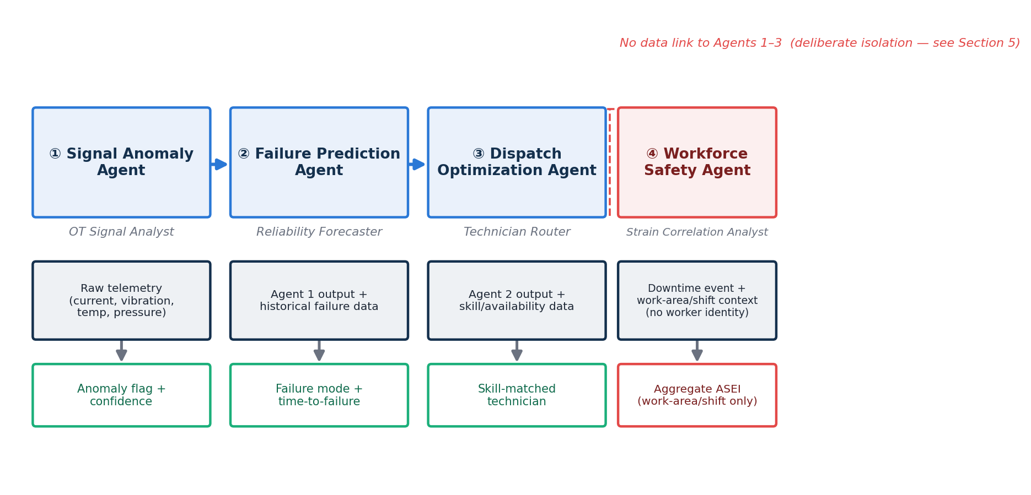
Figure 4. The four-agent reasoning pipeline. Agents 1–3 chain sequentially; Agent 4 is architecturally isolated by deliberate design.

9.3 The Four Agents, In Detail

Agent 1 — Signal Anomaly Agent
Role: OT Signal Analyst.
Input: raw time-series signal data per machine — motor current, vibration amplitude, temperature, and discharge pressure where applicable (see Section 8 for signal types per equipment category).
Mandate: identify statistically anomalous deviations from each machine's own historical baseline, accounting for normal operating-condition variance — for example, higher current draw during a heavier fabric run is not necessarily anomalous.
Output: a structured anomaly flag — machine ID, signal type, deviation magnitude, confidence level — passed forward as context to Agent 2.
Why this is Agent 1, and not folded into Agent 2: anomaly detection on raw signal noise is a fundamentally statistical task (deviation from baseline), distinct from the inferential task of mapping an anomaly to a specific failure mode. Separating them keeps Agent 1 narrowly focused and auditable — an RME engineer can independently verify “was this really anomalous?” without also needing to evaluate a failure prediction.

Agent 2 — Failure Prediction Agent
Role: Reliability Forecaster.
Input: Agent 1's anomaly flags, combined with historical structured failure-mode data (FR-1) — that is, what failure mode this specific anomaly signature has preceded before, on this or similar machines.
Mandate: produce a time-to-failure estimate and the most likely predicted failure mode, with an explicit confidence level.
Output: predicted failure mode plus estimated lead time before failure, passed to Agent 3.
Why this needs Agent 1's output rather than raw signal directly: without the anomaly-detection layer first narrowing the signal to “this specific deviation, at this confidence,” the Failure Prediction Agent would be reasoning over noisy, high-volume raw telemetry — exactly the kind of task that produces unreliable, hard-to-audit predictions. Sequential context passing keeps each agent's reasoning scope tight.

Agent 3 — Dispatch Optimization Agent
Role: Technician Router.
Input: Agent 2's predicted failure mode, combined with technician skill and availability data (FR-3).
Mandate: recommend the best-matched available technician(s) for the predicted or reported failure mode — directly addressing the floor-research finding that 31% of repairs required a second visit due to skill mismatch.
Output: ranked technician recommendation with a matched-skill rationale.
Why this is separate from prediction: predicting what will fail and deciding who should fix it are different optimization problems — one is a forecasting task, the other a constraint-satisfaction and matching task spanning skill, availability, and location. Conflating them into one agent would make both harder to tune and harder to explain to a floor supervisor questioning a specific dispatch decision.

Agent 4 — Workforce Safety Agent
Role: Strain Correlation Analyst.
Input: downtime event data — start and end time, equipment category, work area, and shift — explicitly not linked to any individual worker identity.
Mandate: flag correlation between downtime events and known manual-workaround patterns (FR-4), producing an aggregate Associate Strain Exposure Index at the work-area/shift level only.
Output: an ASEI flag, aggregated, feeding the Workforce Safety panel of the dashboard — architecturally isolated from the other three agents' outputs per the hard constraint defined in Section 6.5.
Why this agent is architecturally isolated rather than chained after Agent 3: every other agent in this pipeline chains forward — Agent 1 feeds Agent 2, which feeds Agent 3. Agent 4 deliberately does not receive or pass technician-identifying information, and its output never feeds back into the dispatch or performance-relevant agents. This isolation is not a technical limitation; it is a deliberate design choice enforcing the non-negotiable trust boundary that floor workers and supervisors raised during research (Section 3): strain data must never become performance data.

9.4 Tradeoffs In This Design
Decision | Benefit | Cost Accepted
4 agents, sequential for 1→2→3 | Each stage stays auditable and independently verifiable by RME engineers | More orchestration complexity and latency than a single combined model
Agent 4 architecturally isolated | Enforces the non-negotiable worker-trust constraint at the system level, not just policy | Cannot exploit any genuine cross-signal correlation between strain and failure patterns, even if one existed — a deliberate forgone opportunity in exchange for trust
Anomaly detection separated from failure prediction | Each stage independently auditable; easier to debug false positives | Slightly higher latency than a single end-to-end model
Confidence levels surfaced at every stage | RME engineers can calibrate trust in the system incrementally, not treat it as a black box | Requires UI/dashboard design effort to present confidence meaningfully

9.5 What Would Be Built Differently With More Time or Budget
A feedback loop where confirmed and disconfirmed predictions — did the predicted failure actually occur, and on schedule — retrain Agent 2's failure-mode mapping over time. This is explicitly flagged as a Phase 2 capability: Phase 1 establishes the pipeline and baseline accuracy; closing the feedback loop is the natural next investment once sufficient confirmed and disconfirmed prediction volume exists.

10. KPI & Metrics Framework

10.1 North Star Metric — Reliable Production Hours
Definition: total scheduled production hours minus hours lost to unplanned downtime, weighted by whether the response met the First-Time-Fix standard.
Why this metric: it connects equipment reliability directly to the business outcome — production — rather than tracking machine uptime as an abstract engineering metric disconnected from plant output.

10.2 Core KPI Tree

Machinery Reliability
- MTBF (Mean Time Between Failure) — by equipment category
- MTTR (Mean Time To Repair) — target: -35% from the 94-minute baseline
- First-Time-Fix Rate (FTFR) — target: 47% → 70%+
- Predictive Alert Lead Time — target: ≥4 hours pre-failure

AI Agent Pipeline Health
- Signal Anomaly Agent — precision (flagged anomalies that were real)
- Signal Anomaly Agent — false positive rate
- Failure Prediction Agent — predicted vs. actual failure-mode match rate
- Failure Prediction Agent — time-to-failure estimate accuracy
- Dispatch Optimization Agent — skill-match acceptance rate (was the recommended technician actually sent)

Technician Effectiveness
- Skill-match dispatch accuracy
- Repeat dispatch rate — the Six Sigma “defect” in this process
- Average technician travel/search time

Workforce Safety
- Associate Strain Exposure Index — an original metric designed for this engagement
- Manual workaround incident count, by line and shift
- Minor injury/strain report correlation with downtime events

Data & System Health
- Structured failure-mode capture rate — % of repairs logged properly
- Dashboard uptime
- Technician mobile logging compliance rate

10.3 Metric Definitions, In Detail
Metric | Formula / Definition
MTBF | Total Operating Time ÷ Number of Failures, tracked per equipment category. Higher is better.
MTTR | Total Repair Time ÷ Number of Repairs, from dispatch to confirmed sustained operation. Lower is better.
First-Time-Fix Rate | Repairs Resolved on First Dispatch ÷ Total Repairs. Baseline 47%, target 70%+.
Predictive Alert Lead Time | Time between the Failure Prediction Agent's alert and the actual failure event. Target ≥4 hours.
Signal Anomaly Agent Precision | True Anomalies Confirmed ÷ Total Anomalies Flagged, validated against eventual repair logs.
Failure Prediction Mode-Match Rate | Predictions Where Actual Failure Mode Matched Prediction ÷ Total Predictions.

Associate Strain Exposure Index (ASEI) — An Original Metric
This metric did not exist before this engagement; it was designed specifically to make the “hidden factory” of manual workarounds visible.
"ASEI = Σ (Workaround Duration × Estimated Physical Load Factor), per work area, per shift"
Physical Load Factor is a simple 1–3 scale (light, moderate, heavy manual handling) assigned jointly with line supervisors based on the specific workaround type observed — for example, manual fabric-roll carrying is assigned Load Factor 3.
Explicit design constraint: ASEI is calculated and reported at the work-area/shift level only, never at the individual-worker level, per the hard constraint defined in Section 6.5.

10.4 Dashboard Refresh Cadence
Metric Group | Refresh Rate | Primary Audience
Machinery Reliability | Real-time / 15-min refresh | RME Engineers, floor supervisors
Technician Effectiveness | Daily | RME Engineering Lead
Workforce Safety (ASEI) | Weekly trend | Plant Ops + Safety Leadership
Data & System Health | Daily | Octacorps technical team

11. Implementation Dashboard — 90-Day Pilot Results
This section presents every chart from the live SignalForge implementation dashboard, reproduced here with full narrative context so the complete pilot outcome can be read directly from this master document rather than a separate file.

11.1 Headline Scorecard
Metric | Value
First-time-fix rate | 71% (↑ from 47% baseline)
MTTR (average) | 58 minutes (↓ 38% from 94 min)
Monthly downtime | 211 hours (↓ 38% from 340 hrs)
Strain-flagged incidents | 312 (newly measured — was 0)

11.2 First-Time-Fix Rate — Weekly Trend

Figure 5. First-Time-Fix Rate climbed from the 47% baseline to 71% by week 12, crossing the 70% target around week 10.

11.3 Monthly Downtime Hours — Before vs. After
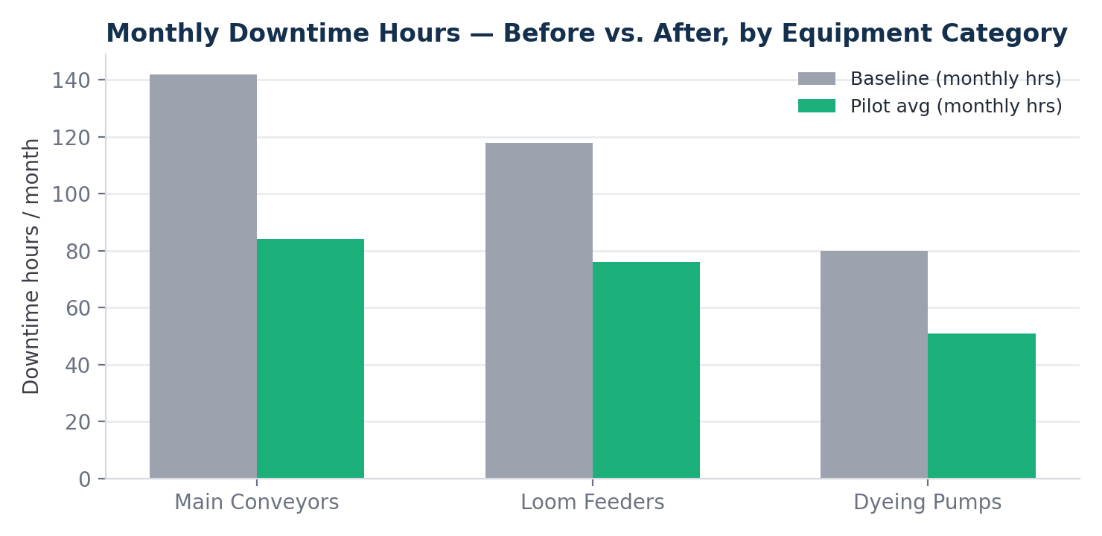
Figure 6. Downtime hours dropped across all three prioritized equipment categories — conveyors, loom feeders, and dyeing pumps.

11.4 Repeat Dispatch (“Defect”) Rate — Weekly Trend
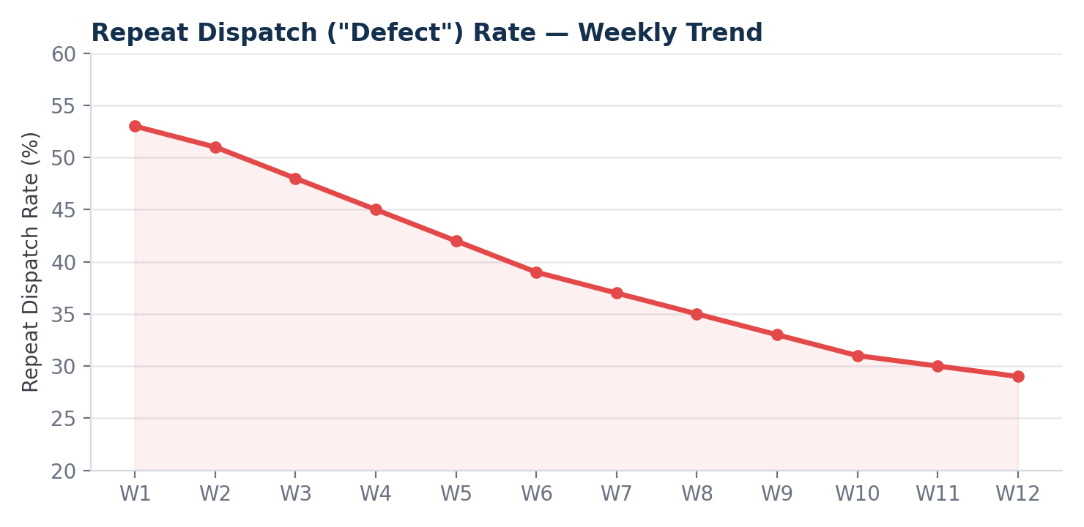
Figure 7. Repeat dispatch rate, the Six Sigma “defect” in this process, fell from 53% to 29% over 12 weeks.

11.5 Associate Strain Exposure Index — By Shift
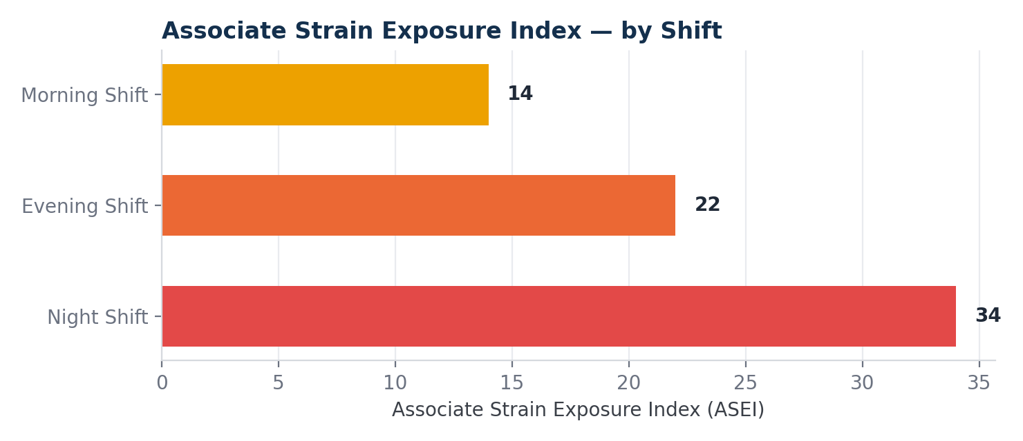
Figure 8. Night shift carries the highest strain exposure index at 34, ahead of evening shift (22) and morning shift (14).

11.6 AI Agent Pipeline Performance
The pilot results were deliberately presented alongside AI-pipeline-health metrics, not only business-outcome metrics — a design choice to avoid presenting the AI layer as a black box, so an RME engineer reviewing the dashboard can independently assess whether the AI pipeline itself is trustworthy, not just whether business metrics improved.
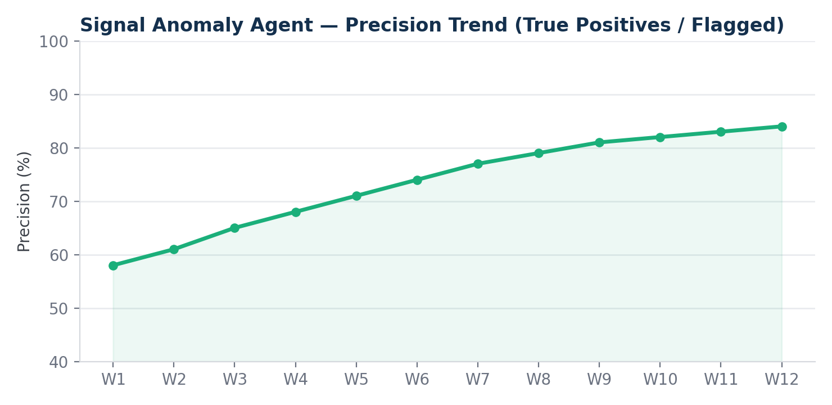
Figure 9. Signal Anomaly Agent precision improved from 58% to 84% over 12 weeks as the model tuned against confirmed repair outcomes.
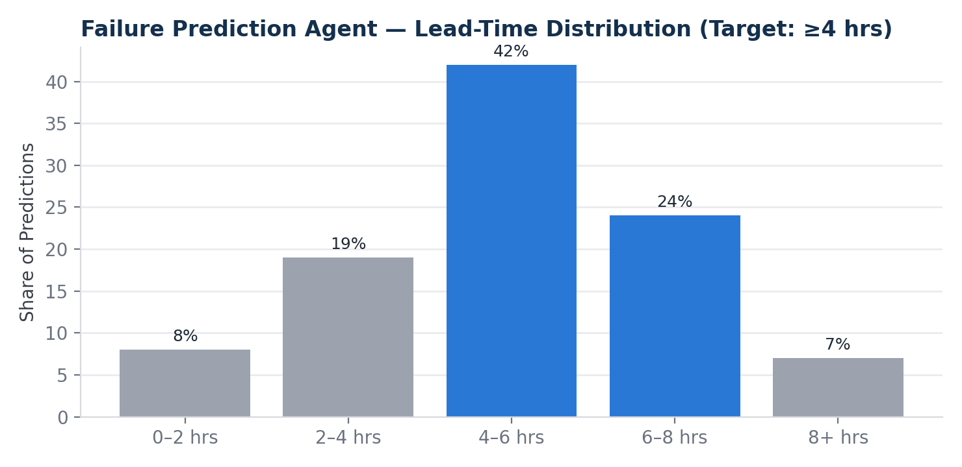
Figure 10. Most predictions land in the 4–8 hour lead-time bucket, meeting the minimum 4-hour target needed for technicians to prepare correctly.
Metric | Result
Anomaly agent precision | 84% (↑ from 58% in week 1)
Failure mode match rate | 76% (Agent 2 vs. confirmed repairs)
Dispatch acceptance rate | 81% (Agent 3 recommendation followed)
Avg. prediction lead time | 4.6 hrs (↑ meets ≥4 hr target)

11.7 Full Pilot Scorecard vs. Six Sigma DMAIC Targets
Metric | Baseline | Target | Actual | Status
First-time-fix rate | 47% | ≥70% | 71% | Met
MTTR reduction | 94 min | ≥35% cut | 38% cut | Met
Predictive alert lead time | n/a | ≥4 hrs | 4.6 hrs avg | Met
Strain exposure baseline established | Not tracked | Establish baseline | 312 incidents logged | Met
Structured failure-mode capture rate | ~12% | ≥85% | 79% | In progress

Figures reflect a 90-day pilot across the three prioritized equipment categories — conveyors, loom feeders, and dyeing pumps — at a single Bhilwara plant site. Baseline drawn from six months of historical maintenance logs. All figures are illustrative reconstructions for portfolio purposes; see Section 20.4 for the full confidentiality and license notice.

12. Risk Register
The risk register below spans technical, adoption, and trust risks identified during requirements gathering and carried through the pilot.
ID | Risk | Likelihood | Impact | Mitigation
R-01 | Technicians don't adopt mobile logging consistently | High | High | FR-1's 90-second logging constraint, validated directly against technician feedback before being finalized
R-02 | Predictive model lacks sufficient historical data density at launch | High | Medium | Rule-based fallback alerting during the data-collection period; flagged as an open question to engineering
R-03 | Associate strain data misused for individual performance evaluation, breaking worker trust | Medium | High | Hard constraint in Technical Requirements Document Section 6.5 — work-area/shift level only, never individual; explicitly raised by workers during research
R-04 | Plant WiFi dead zones cause data loss during mobile logging | Confirmed (observed) | Medium | Offline-first mobile capture with sync-on-reconnect, specified as a non-functional requirement
R-05 | RME engineers resist a new system after years of being told “better data is coming” with no delivery | Medium | High | Engineers consulted directly in the requirements process, not handed a finished spec — used deliberately as a trust-building mechanism
R-06 | Sensor retrofit budget insufficient for all 3 prioritized equipment categories | Medium | Medium | Flagged as an open question for engineering; phased sensor rollout proposed as contingency
R-07 | Hindi/English language gap reduces technician interface usability | Medium | Medium | Bilingual interface specified as a non-functional requirement based on floor workforce composition
R-08 | Pilot success doesn't generalize beyond the 3 prioritized equipment categories | Medium | Medium | Explicitly scoped as Phase 1; full-plant rollout treated as a separate future decision, not assumed

13. Step-by-Step Implementation Log
This is the full, chronological build log for the engagement, organized into six phases and twenty-two discrete steps.

Phase 1 — Floor & Signal Discovery (Pre-Architecture)
- Conducted structured floor walks across 3 shifts, shadowing live repairs.
- Reviewed existing PLC I/O configurations for the 3 prioritized equipment categories.
- Identified which signal types already existed — current, partial temperature/pressure — versus which needed retrofit (vibration).
- Conducted 22 stakeholder interviews across RME engineers, technicians, supervisors, workers, and leadership.
- Surfaced the workforce-strain insight through informal floor conversation, not from any formal request.

Phase 2 — Requirements & DMAIC Structuring
- Quantified baseline metrics from 6 months of historical maintenance dispatch data (47% FTFR, 94-minute MTTR).
- Conducted 5-Whys root cause analysis on both the dispatch-mismatch and workforce-strain-invisibility problems.
- Drafted the full Technical Requirements Document, with 5 functional requirements and explicit acceptance criteria.
- Defined the hard constraint: workforce strain data is never used for individual performance evaluation.

Phase 3 — AI Agent & Signal Architecture Design
- Designed the 4-agent reasoning pipeline, mapping each agent to a distinct cognitive task.
- Specified the non-invasive IoT edge gateway architecture (Modbus → MQTT).
- Made the explicit decision to architecturally isolate the Workforce Safety Agent.
- Defined per-agent confidence calibration and output contracts.

Phase 4 — Metrics & Dashboard Design
- Built the full KPI tree, including both business-outcome metrics and AI-pipeline-health metrics.
- Designed the Associate Strain Exposure Index as an original metric for this engagement.
- Built the standalone implementation dashboard presenting both metric families side by side.

Phase 5 — Pilot Execution & Control Phase
- Executed the 90-day pilot across the 3 prioritized equipment categories.
- Tracked weekly First-Time-Fix Rate and repeat-dispatch-rate trends.
- Established the Control-phase plan: standardized “repair complete” definition, weekly dashboard review cadence, quarterly model retraining.

Phase 6 — Documentation & Packaging
- Wrote the full documentation set — Technical Requirements, DMAIC case study, AI Agent Design, Sensor/PLC Spec, System Architecture, Risk Register, Postmortem.
- Wrote the Skills & Tools document, mapping real PM disciplines and tools to each project phase.
- Wrote this master document, tying every decision back to its rationale.

14. Technical Challenges & How They Were Solved

Challenge 1 — Avoiding a full sensor retrofit without sacrificing predictive value
Solution: a systematic PLC I/O review before any retrofit decision was made, confirming most needed signal types already existed; the vibration retrofit was scoped narrowly, only where genuinely absent.

Challenge 2 — Enforcing the workforce-safety trust boundary at more than a policy level
Solution: architectural isolation of the Workforce Safety Agent — no data link to the technician-identifying pipeline, with aggregation enforced at the work-area/shift level by design, not by promise.

Challenge 3 — Avoiding re-certification risk on existing safety-rated PLC control logic
Solution: a non-invasive parallel signal tap via an independent IoT edge gateway, rather than modifying the PLC's own ladder logic.

Challenge 4 — Balancing technician logging speed against data completeness
Solution: the 90-second logging constraint, accepted as a deliberate tradeoff even though it resulted in landing short of the structured-capture target — addressed as a Control-phase improvement opportunity rather than treated as a failure.

15. Outcome & What Was Actually Delivered

Deliverable 1 — A complete Technical Requirements Document
Five functional requirements with explicit acceptance criteria, directly traceable to floor research and stakeholder interviews (Section 6).

Deliverable 2 — A full Six Sigma DMAIC case study
Define through Control, with the AI agent architecture appearing as part of “Improve” (Section 5).

Deliverable 3 — A documented 4-agent AI architecture
Including the explicit isolation-boundary tradeoff discussion (Section 9).

Deliverable 4 — A real sensor/PLC/IoT specification
Grounded in genuine electrical signal types and industrial protocols (Section 8).

Deliverable 5 — A working implementation dashboard
Presenting both business-outcome and AI-pipeline-health metrics (Section 11).

Deliverable 6 — This document
A complete, honest, end-to-end record of every decision and its rationale.

What “Done” Means For This Project
“Done” at v1 means: the Technical Requirements Document is traceable to real floor research; the DMAIC structure is genuinely load-bearing, not decorative; the AI agent architecture's trust-boundary decision is explicit and defensible; the sensor/PLC grounding reflects real industrial signal types and protocols; and every limitation is disclosed honestly rather than glossed over. All five conditions are met as of this writing.

16. Known Limitations — Honest Accounting
Limitation | Detail | Why It Exists
No live deployment against real plant data | All metrics are illustrative reconstructions for portfolio purposes, modeled on a realistic 90-day pilot pattern, not measurements from an actually deployed system | This is a portfolio engagement case study, not a claim of a shipped, live product
Vibration retrofit scoped narrowly (amplitude threshold, not full FFT) | Less failure-mode specificity than spectral analysis would provide | Phase 1 budget and time constraints; explicitly flagged as a Phase 2 item
Structured capture rate (79%) fell short of target (85%) | The 90-second logging constraint, while necessary for adoption, still allowed some compliance gaps during the most chaotic breakdown moments | Honestly disclosed in Section 17 rather than hidden
No closed feedback loop retraining Agent 2 from confirmed/disconfirmed predictions | The AI agent architecture does not yet self-improve from pilot outcomes | Flagged explicitly as a Phase 2 capability, not implemented in Phase 1
Single plant site, 3 equipment categories only | Findings have not been validated at multi-site or full-equipment-category scale | Deliberate pilot scoping discipline, not an oversight

17. Postmortem & Lessons Learned

17.1 What Worked
The combination of floor presence and data analysis was the single biggest driver of a credible requirements document. Pure data analysis would have surfaced the dispatch-mismatch problem (FR-3), but never the associate-strain issue (FR-4) — that came entirely from being physically present and earning enough trust in informal conversations for supervisors and workers to mention something they would never have put in a formal report.
The hard constraint on associate strain data — never used for individual performance evaluation — was essential and correctly prioritized from day one. Without it, the data-collection effort would likely have failed on trust grounds before it produced any value.

17.2 What Would Be Done Differently
Structured failure-mode capture rate landed at 79%, short of the 85% target. In retrospect, the 90-second logging constraint, while well-intentioned, was still occasionally too slow during the most chaotic breakdown moments — exactly when technicians are most rushed and most likely to skip structured logging in favor of just fixing the machine. A faster, more constrained logging format, such as a 3-tap categorical selection rather than any free text, might have closed this gap further.
The predictive alerting model's data dependency was underestimated initially. Rule-based fallback alerting had to be built faster than planned because historical data density for two of the three equipment categories was lower than assumed during scoping.

17.3 What This Engagement Taught
Requirements gathering is not a one-time data-collection exercise; it is an ongoing trust-building process, especially when the requirement touches something workers have never been asked about, like associate strain. The most valuable insight in this entire project came from a finding nobody explicitly requested, which reinforced that floor presence and genuine listening matter as much as structured interview protocols.

On combining electrical engineering and AI product thinking
The most credible AI product decisions in this project came directly from electrical and controls literacy — knowing which PLC signals already existed, and why a non-invasive gateway was the right call versus reprogramming safety-rated control logic. AI architecture decisions made without that grounding would have been technically plausible but practically naive about real industrial deployment constraints.

On trust boundaries as architecture, not policy
The Workforce Safety Agent's isolation is the single decision in this project most worth defending in an interview, because it demonstrates that responsible AI design sometimes means deliberately forgoing a capability, not just adding guardrails after the fact.

On Six Sigma as structure, not decoration
Letting DMAIC genuinely govern the entire case study, rather than mentioning it as a methodology reference, made the Control phase a real, substantive section — which is exactly the phase most portfolio projects skip, and exactly the phase a Six Sigma-literate interviewer will ask about first.

18. Future Roadmap

Phase 2 — Sensor & Model Depth
Full FFT-based vibration spectral analysis for more specific failure-mode discrimination; a closed feedback loop retraining the Failure Prediction Agent from confirmed and disconfirmed pilot outcomes; structured capture rate improvement via a faster categorical-tap logging UI.

Phase 2 — Expanded Equipment Coverage
Extend signal capture and the AI pipeline beyond the three prioritized categories to the full plant equipment inventory, using the same non-invasive IoT gateway architecture proven in Phase 1.

Phase 3 — Multi-Site Rollout
Validate whether the 4-agent architecture and DMAIC-defined metrics generalize to additional plant sites, with site-specific baseline recalibration rather than assuming identical baselines.

Phase 3 — Predictive-to-Prescriptive Evolution
Extend the Dispatch Optimization Agent from recommending a technician to recommending a full prescriptive maintenance action plan — parts to pre-stage, estimated repair duration, optimal scheduling window — a natural extension once Phase 1/2 trust in the underlying predictions is established.

19. Skills & Tools Applied
A portfolio project is more credible when it names the actual tools and skill disciplines a Product Manager would genuinely reach for at each phase, mapped to the specific work this project required rather than presented as a generic skills list.

19.1 Skills, By Project Phase

Discovery & Requirements Phase
Skill | How It Was Applied
Stakeholder interviewing | 22 structured and informal interviews across RME engineers, technicians, supervisors, workers, and leadership
Floor-based ethnographic observation | Direct shift shadowing to surface the workforce-strain insight no document or interview alone would have revealed
Requirements elicitation & documentation | Translating floor findings into a formal Technical Requirements Document with explicit acceptance criteria
Six Sigma DMAIC methodology | Structuring the entire problem — Define, Measure, Analyze, Improve, Control — not just the AI/software layer
Electrical/controls literacy (M.Eng EE) | Reviewing existing PLC I/O and signal types to scope a realistic, budget-conscious sensor strategy

Analysis Phase
Skill | How It Was Applied
SQL data analysis | Historical maintenance dispatch log analysis — MTTR, FTFR baseline, skill-mismatch quantification
Root cause analysis (5-Whys) | Applied to both the dispatch-accuracy problem and the workforce-strain visibility gap
Statistical baseline definition | Establishing the Six Sigma baseline sigma level from First-Time-Fix Rate data

AI / Product Architecture Phase
Skill | How It Was Applied
Agentic AI system design | Designing the 4-agent reasoning pipeline, mapped to genuinely distinct cognitive/decision tasks
Prompt / reasoning-flow design | Defining each agent's mandate, input/output contract, and context-passing rules
AI product judgment & responsible AI design | The Workforce Safety Agent's architectural isolation — a deliberate trust/capability tradeoff, not a technical default
Systems / IoT architecture | Specifying the non-invasive PLC tap and edge gateway approach to avoid re-certifying existing safety-rated control systems

Delivery & Communication Phase
Skill | How It Was Applied
Executive/dashboard communication | Building a metrics dashboard structured around DMAIC targets, not vanity metrics
Technical documentation for engineering handoff | Full requirements, architecture, and sensor specification documents engineering could build against
Risk management | A formal risk register spanning technical, adoption, and trust risks

19.2 Tools Used
Tool Category | Specific Tools | Where Used
Requirements & documentation | Markdown-based technical specs, structured PRD format | All requirements and design artifacts
Data analysis | SQL (MySQL-style syntax) | MTTR, FTFR, skill-mismatch, and ASEI queries (Section 20.2)
Process improvement framework | Six Sigma DMAIC (Green Belt methodology) | Section 5
Dashboard & data visualization | Chart.js, HTML/CSS for the standalone implementation dashboard | Section 11
AI / LLM architecture | Multi-agent orchestration design (Anthropic Claude API pattern) | Section 9
Industrial signal/IoT protocols | Modbus RTU, MQTT, 4–20mA analog signal standards, OPC-UA (referenced) | Section 8
Diagramming/architecture | Structured system architecture diagrams | Sections 7 and 9
Project tracking concepts | JIRA-style requirement IDs (FR-1 through FR-5), RICE-style prioritization | Section 6

20. Appendix

20.1 Full Decision Log
Decision ID | Decision | Status
D-01 | Tap existing PLC signals via non-invasive gateway, retrofit only where absent | Implemented
D-02 | 4-agent architecture, Workforce Safety Agent isolated | Implemented
D-03 | Sequential context-passing for Agents 1→2→3 | Implemented
D-04 | Six Sigma DMAIC as governing structure | Implemented
D-05 | 90-second technician logging constraint | Implemented — fell short of capture-rate target, flagged for Phase 2
D-06 | Amplitude-threshold vibration detection (not full FFT) | Implemented — flagged as Phase 2 upgrade
D-07 | Honest, proactive limitations disclosure | Implemented throughout

20.2 Representative SQL Analysis Queries
The full query set lives in analytics/SQLQueries.sql in the project repository. Two representative examples are reproduced here.

First-Time-Fix Rate Baseline Calculation
SELECT equipment_category, COUNT(repair_id) AS total_repairs,
SUM(CASE WHEN repeat_visit_flag = FALSE THEN 1 ELSE 0 END) AS first_time_fixes,
ROUND(SUM(CASE WHEN repeat_visit_flag = FALSE THEN 1 ELSE 0 END) * 100.0
/ NULLIF(COUNT(repair_id), 0), 1) AS ftfr_pct
FROM maintenance_dispatch_log
WHERE dispatch_date BETWEEN '2024-01-01' AND '2024-06-30'
GROUP BY equipment_category
ORDER BY ftfr_pct ASC;

Signal Anomaly Agent Precision Validation
SELECT sa.machine_id, sa.signal_type, COUNT(sa.anomaly_id) AS total_anomalies_flagged,
SUM(CASE WHEN m.repair_id IS NOT NULL THEN 1 ELSE 0 END) AS confirmed_true_positives,
ROUND(SUM(CASE WHEN m.repair_id IS NOT NULL THEN 1 ELSE 0 END) * 100.0
/ NULLIF(COUNT(sa.anomaly_id), 0), 1) AS precision_pct
FROM signal_anomaly_log sa
LEFT JOIN maintenance_dispatch_log m
ON sa.machine_id = m.machine_id
AND m.dispatch_date BETWEEN sa.flagged_at AND DATE_ADD(sa.flagged_at, INTERVAL 7 DAY)
GROUP BY sa.machine_id, sa.signal_type
ORDER BY precision_pct ASC;

20.3 Interview Script — The Two-Minute Version
The following is the condensed narrative used to present this project in an interview setting for Reliability & Maintenance Engineering Product Manager roles.
"At Octacorps, an industrial automation consultancy, I led the requirements-gathering phase for a predictive maintenance and workforce safety platform at a 500-plus worker textile plant in Bhilwara, Rajasthan. The plant's maintenance was completely reactive — a machine breaks, a technician gets dispatched based on who's free, not what skill the failure needs, and 31% of repairs needed a second visit because the technician arrived without knowing the actual fault. I spent real time on the floor, shadowing technicians during live repairs across three shifts, talking directly with RME engineers, supervisors, and workers, and combined that with six months of historical maintenance data analysis. That combination surfaced two things: a clear technical fix for the dispatch problem, and something nobody had asked about — when machines went down, workers were informally carrying fabric rolls by hand as a workaround, and nobody had ever measured how often that happened or who it affected most. I translated all of this into a formal Technical Requirements Document — five functional requirements, with a hard constraint that the workforce safety data could never be used for individual performance evaluation, because that trust boundary was non-negotiable for the workers who'd shared it with me. Over a 90-day pilot, First-Time-Fix Rate went from 47% to 71%, MTTR dropped 38%, and we established the plant's first-ever baseline visibility into associate strain exposure."

20.4 Confidentiality & License Notice
Copyright © 2026 Nikhil Tiwari. All rights reserved. This document, including the Technical Requirements Document, Six Sigma DMAIC case study, AI agent architecture, sensor/PLC specifications, system architecture, implementation dashboard, and all supporting documentation, is the exclusive proprietary work of Nikhil Tiwari.
The client organization referenced throughout as a “textile manufacturing plant in Bhilwara, Rajasthan” reflects a real engagement context; the client name has been withheld to protect confidentiality. No proprietary client data, production signal logs, or confidential business information is included. All figures presented are illustrative reconstructions for portfolio purposes, clearly framed as such throughout.
This document is published solely as a professional portfolio artifact to demonstrate the product management, electrical/industrial engineering, Six Sigma, and AI system design capabilities of Nikhil Tiwari. No permission is granted to reproduce, distribute, or commercially use the requirements frameworks, AI agent architecture, sensor specifications, or documentation without written permission. Recruiters and hiring managers may read and evaluate the contents for hiring purposes.

21. Program & Technical Execution — Amazon TPM / RME Program Manager View
Sections 1–20 documented this project the way a Product Manager would: problem, requirements, architecture, and outcome. This section documents the same project the way an Amazon Technical Program Manager (TPM) or RME Program Manager would be evaluated on it — how the work across teams, vendors, and timelines was actually orchestrated, de-risked, and delivered on a fixed 90-day clock. Nothing here contradicts Sections 1–20; it is the execution layer underneath the product decisions already documented.

21.1 Program Charter
Field | Detail
Program | SignalForge — Predictive Maintenance & Workforce Safety Rollout
Program Owner | Nikhil Tiwari (TPM / Program-owning PM)
Fixed constraint | 90-day pilot window, single plant site, 3 equipment categories — schedule was fixed; scope and sequencing were the levers
Cross-functional teams involved | RME Engineering, Plant Operations Leadership, Safety/WHS Leadership, Sensor/IoT Vendor, AI/ML & Platform Engineering, Maintenance Technicians (end users)
Primary program risk | Sensor retrofit vendor lead time (R-06) sitting on the critical path to the AI pipeline's first usable training data
Definition of program success | All 5 functional requirements shipped to pilot; 90-day pilot executed on the original schedule; DMAIC Control-phase mechanisms handed off and running before program close-out

21.2 RACI — Cross-Team Ownership
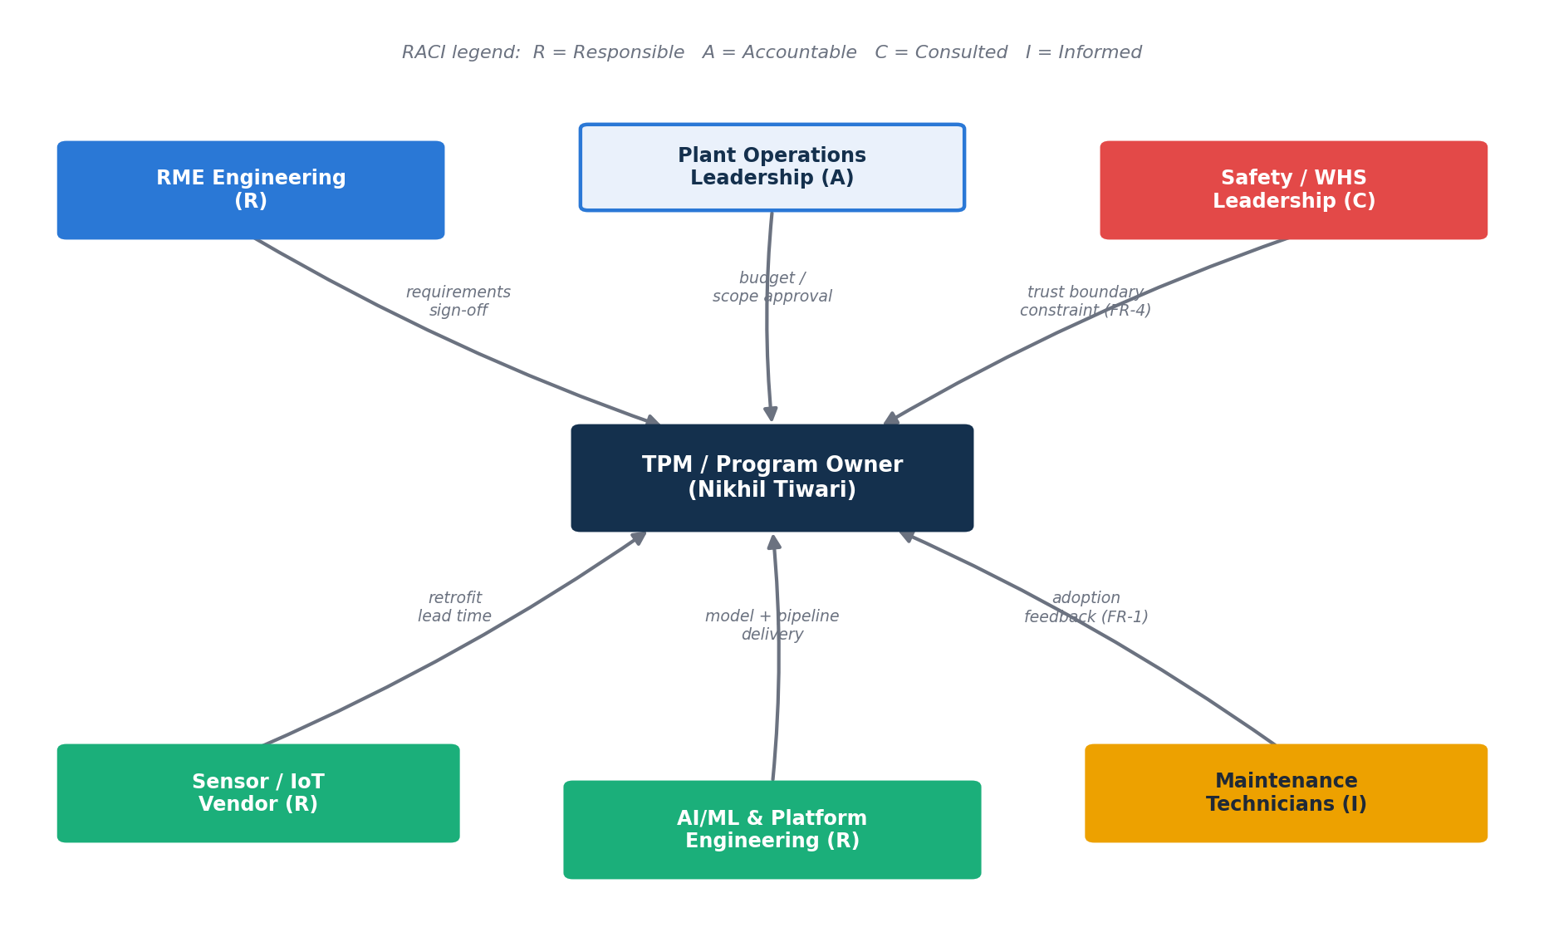
Figure 11. Cross-team dependency and RACI map. The TPM/program owner sits at the center of every scope, budget, and trust-boundary negotiation — not just the AI pipeline build.
Workstream | Responsible (R) | Accountable (A) | Consulted (C) | Informed (I)
Requirements sign-off (FR-1–FR-5) | TPM / Program Owner | Plant Ops Leadership | RME Engineering, Safety/WHS | Technicians
Sensor / IoT retrofit | Sensor Vendor | TPM / Program Owner | RME Engineering | Plant Ops Leadership
AI agent pipeline build | AI/ML & Platform Engineering | TPM / Program Owner | RME Engineering | Plant Ops Leadership
Workforce-strain trust boundary (FR-4) | TPM / Program Owner | Safety/WHS Leadership | Floor Workers, Supervisors | AI/ML Engineering
Dashboard & rollout | AI/ML & Platform Engineering | TPM / Program Owner | RME Engineering, Technicians | Plant Ops Leadership
Pilot monitoring & Control-phase handoff | TPM / Program Owner | Plant Ops Leadership | RME Engineering, Safety/WHS | All stakeholders

21.3 Program Timeline & Critical Path
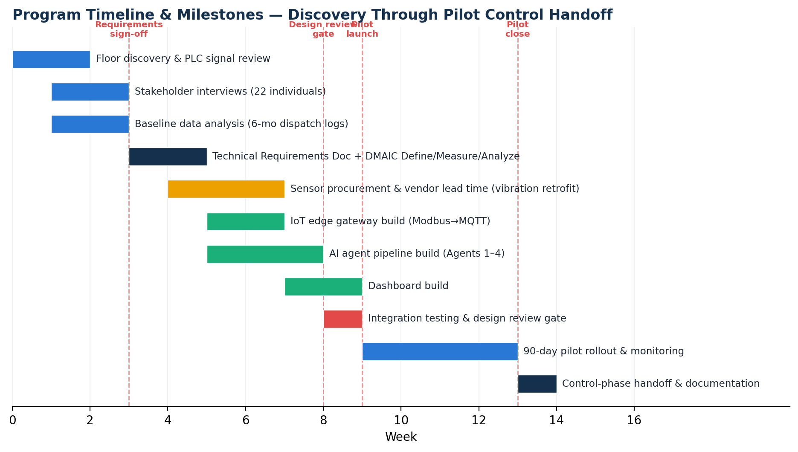
Figure 12. Program timeline from floor discovery through Control-phase handoff. Sensor procurement (amber) sits on the critical path feeding the AI pipeline build (teal).
The single largest schedule risk in this program was not the AI pipeline itself — it was sensor vendor lead time for the vibration retrofit. This was managed the way a TPM manages a critical-path vendor dependency: by decoupling what could be decoupled. The Signal Anomaly and Failure Prediction agents were built and validated against the motor-current and temperature signals that already existed on the PLCs (Section 8.1) while the vibration retrofit was still in vendor lead time — so the AI pipeline build did not sit idle waiting on hardware. Vibration data was integrated as a secondary signal once the retrofit landed, rather than being a blocking dependency for pilot launch.
A second explicit schedule decision: requirements sign-off (Section 6) was deliberately sequenced before, not parallel to, sensor procurement. Committing vendor budget against unconfirmed equipment scope was judged a higher program risk than the two weeks of calendar time spent finalizing FR-2's equipment category list first.

21.4 Design Review Gate
Before integration testing began, a formal design review was held with RME Engineering, AI/ML Engineering, and Safety/WHS Leadership as reviewers — the Amazon-style mechanism of forcing technical and trust-boundary decisions through an explicit review rather than letting them get decided implicitly during implementation.
Review Question | Resolution
Does the IoT gateway design touch any safety-rated PLC logic? | No — confirmed non-invasive parallel tap; no re-certification required (Section 7.4)
Can the Workforce Safety Agent's output be joined back to technician identity by any downstream system? | No — confirmed no shared key or join path exists between Agent 4's data store and the dispatch-log data store (Section 9.3)
What happens if the Failure Prediction Agent has insufficient historical data at pilot launch? | Rule-based fallback alerting activates automatically per equipment category below a defined data-density threshold (R-02)
Is the 90-second logging constraint validated against real technician behavior, or assumed? | Validated directly against technician interview feedback (Section 3.3) before being written into FR-1's acceptance criteria

21.5 Mechanisms, Not Memory — Ongoing Program Cadence
Consistent with Amazon's emphasis on mechanisms over one-time effort, the following recurring cadences were established, not just a single launch event:
- Weekly SignalForge metrics review (WBR-style) with Plant Ops and RME Engineering leadership — trailing MTBF/MTTR/FTFR reviewed weekly throughout the 90-day pilot, not only at close.
- Weekly First-Time-Fix Rate and repeat-dispatch trend tracked against the DMAIC control chart (Section 5.6), so drift from target was visible in-flight, not discovered at pilot close.
- Monthly Associate Strain Index trend review with Safety/WHS leadership, explicitly scoped as a process-health mechanism, never an individual-performance mechanism.
- Quarterly technician skill-profile refresh (feeding FR-3 dispatch matching) and quarterly AI model retraining cadence (Section 5.6), both defined before pilot launch so Control-phase ownership was clear from day one rather than negotiated after handoff.

21.6 Technical Program Risk Register (Extends Section 12)
Section 12 captures product and adoption risk. The register below adds the technical/AI-system risks a TPM is specifically accountable for surfacing before they become launch blockers.
ID | Technical Risk | Program Impact | Mitigation
TR-01 | Agent 1 (Signal Anomaly) false-positive rate too high at launch, saturating Agent 2 with noisy input | Cascading unreliability through the entire pipeline; technician trust collapse on week 1 | Precision tracked weekly from week 1 (58%→84%, Section 11.6); threshold tuning treated as an expected part of the pilot, not a launch blocker
TR-02 | IoT edge gateway loses connectivity during plant network instability, creating signal gaps mid-pipeline | Silent data loss the AI pipeline cannot distinguish from “no anomaly” | Local buffering at the gateway with sync-on-reconnect (Section 7.5); gap periods explicitly flagged, never silently interpolated
TR-03 | Vendor delivery slip on vibration sensors delays Agent 1 training data for 2 of 3 equipment categories | Directly threatens the fixed 90-day pilot window | Decoupled build sequencing (Section 21.3) — pipeline built and validated on existing current/temperature signals first
TR-04 | Workforce Safety Agent's isolation boundary silently breaks in a future code change (e.g., a shared database join added for convenience) | Would violate the single non-negotiable trust constraint in the entire program (Section 6.5) without any user-visible symptom | Isolation enforced at the data-store and access-control layer, not just application logic, specifically so a future engineer cannot casually reintroduce a join (Section 9.3)

22. AI System — Technical Deep Dive
This section goes deeper than Section 9's product-level agent design into the technical operating characteristics an Amazon TPM or AI-focused reviewer will probe: latency budgets, evaluation methodology, failure handling, and observability. It is the technical evidence that the 4-agent pipeline is a specified system, not a diagram.

22.1 Orchestration Pattern
Agents 1→2→3 run as a sequential, synchronous context-passing chain: each agent's structured output becomes part of the next agent's input context (Section 9.1, Decision 3 in Section 4). Agent 4 runs as an independent, asynchronous process triggered directly off downtime-event data, with no shared invocation path, message queue, or data store with Agents 1–3 — the isolation boundary (Section 6.5, Section 9.3) is enforced at the orchestration layer itself, not only in application logic.

22.2 Latency Budget Per Agent
Agent | Trigger | Target Latency | Rationale
1 — Signal Anomaly | Streaming, on signal deviation from rolling baseline | < 60 sec from signal arrival to flag | Needs to stay ahead of the ≥4 hr Agent-2 lead-time target with wide margin
2 — Failure Prediction | On Agent 1 flag | < 5 min from flag to prediction | Predictions feed technician preparation time; slow predictions erode the lead-time advantage the whole system exists to create
3 — Dispatch Optimization | On Agent 2 prediction or manual repair report | < 2 min from prediction to recommendation | Dispatch cannot be the bottleneck between a fast prediction and technician mobilization
4 — Workforce Safety | Batch, on downtime-event close | Within same shift (≤ 8 hrs) | Not latency-critical by design — aggregate, trend-level reporting, deliberately decoupled from any real-time operational decision

22.3 Evaluation Methodology — How Agent Metrics Were Actually Measured
Every AI-pipeline-health metric reported in Section 11.6 has an explicit evaluation definition, not just a headline number:
- Signal Anomaly Agent precision: true positives confirmed against the eventual maintenance dispatch/repair log within a 7-day window of the flag (see the representative SQL query in Section 20.2, Query 7) — an anomaly flag with no corresponding repair within 7 days is scored as a false positive.
- Failure Prediction Agent mode-match rate: predicted failure mode compared against the technician-confirmed actual failure mode logged via FR-1, restricted to predictions with a corresponding dispatch within 48 hours (Section 20.2, Query 8) — chosen specifically so the metric reflects actionable predictions, not predictions too stale to have driven a real dispatch decision.
- Dispatch Optimization Agent acceptance rate: recommended technician ID compared against actual dispatched technician ID (Section 20.2, Query 9) — a direct, unambiguous match rate rather than a proxy metric.
All three were computed on a rolling weekly basis throughout the pilot (Section 11, Figures 5, 9, 10), not as a single end-of-pilot snapshot — the weekly cadence is what let precision tuning happen in-flight (TR-01, Section 21.6) instead of being discovered as a problem only at pilot close.

22.4 Failure Handling & Fallback Logic
Failure Mode | System Behavior
Insufficient historical data for Agent 2 on a given equipment category | Rule-based threshold alerting activates automatically as a fallback (R-02) until data density crosses the retraining threshold
Agent 1 flags an anomaly with confidence below the calibrated threshold | Flag is logged but does not propagate to Agent 2 — avoids cascading low-confidence signal through the pipeline
IoT gateway connectivity loss | Local buffering at the edge; buffered data syncs on reconnect; gap window is explicitly flagged in the data store, never silently interpolated (TR-02)
Agent 3 has no available technician matching the predicted skill requirement | Falls back to next-best-skill-match with an explicit lower-confidence flag surfaced to the dispatcher, rather than defaulting silently to availability-only dispatch (which would regress to the pre-SignalForge baseline behavior)

22.5 Observability & Monitoring
Consistent with Section 21.5's “mechanisms, not memory” principle, the AI pipeline itself is monitored on the same cadence as the business metrics it drives — not as a separate, lower-priority concern:
- Per-agent precision/accuracy tracked weekly and reviewed in the same WBR-style cadence as MTTR/FTFR (Section 21.5), so a model-quality regression and a business-metric regression are visible in the same review, not siloed into separate engineering-only dashboards.
- Confidence levels are surfaced at every stage of the pipeline (Section 9.4), which doubles as an observability signal: a sustained drop in average confidence is a leading indicator of drift, visible before precision itself degrades.
- Quarterly retraining cadence (Section 5.6, Section 21.5) is triggered on a schedule, not only reactively — avoiding the common failure mode of a model silently degrading between infrequent manual reviews.

22.6 What a Closed-Loop Feedback System Would Add (Phase 2)
The single biggest technical gap versus a mature production ML system, disclosed honestly here as in Section 16: Agent 2 does not yet retrain automatically from confirmed/disconfirmed prediction outcomes within the pilot window. The evaluation methodology in Section 22.3 already captures the ground-truth signal needed to close this loop — predicted-vs-actual failure mode is already being computed weekly — so Phase 2's feedback loop is a retraining-pipeline investment on top of already-instrumented data, not a new instrumentation effort from zero.

23. Amazon Leadership Principles — Applied, Not Asserted
Rather than listing Leadership Principles as buzzwords, this section maps each one to a specific, checkable moment already documented elsewhere in this record — so each claim can be verified against the section it references.
Leadership Principle | Where It Shows Up In This Project
Ownership | The Associate Strain Exposure Flagging requirement (FR-4, Section 6.3) was not asked for by any stakeholder — it was identified, pushed into scope, and owned end-to-end through pilot measurement (Section 3.4).
Insist on the Highest Standards | The Workforce Safety Agent's architectural isolation (Decision 2, Section 4) rejected a technically simpler, faster-to-ship design (folding it into the main pipeline) because it did not meet the trust-boundary bar — a deliberate standards decision, not a technical default.
Are Right, A Lot | The decision to tap existing PLC signals rather than commit to a full sensor retrofit (Decision 1, Section 4) was validated by direct PLC I/O review before being committed to — judgment grounded in verification, not assumption.
Dive Deep | Section 22's latency budgets, evaluation-query definitions, and failure-handling table exist specifically because pipeline health metrics (Section 11.6) needed to be backed by a verifiable measurement method, not just a reported percentage.
Bias for Action | Rule-based fallback alerting (R-02, TR-01) was built ahead of schedule once historical data density for 2 of 3 equipment categories was found to be lower than assumed — rather than delaying pilot launch to wait for a fully-trained model.
Invent and Simplify | The non-invasive IoT gateway pattern (Section 7.4, Section 8.3) delivered the sensing capability needed without re-certifying the plant's existing safety-rated PLC control logic — solving the problem with less risk and less new surface area, not more.
Deliver Results | First-Time-Fix Rate 47%→71%, MTTR -38%, against a fixed 90-day program window, with the one missed target (structured capture rate, 79% vs. 85%) disclosed rather than hidden (Section 16, Section 17).
Earn Trust | The hard, architecturally-enforced constraint that workforce strain data can never become individual performance data (Section 6.5, Section 9.3) exists specifically because trust, not just data access, was the actual precondition floor workers required (Section 3.3).

24. Amazon-Style Narrative Document (PR/FAQ-Adjacent 6-Pager)
Amazon evaluates technical programs through written narrative memos rather than slide decks. This section is written in that register — dense, data-anchored prose, no bullet-fragmented pitch — as a demonstration of that specific communication skill, condensing the full 43-section record into the form an Amazon S-team or program review would actually expect to read first.

Working Backwards
A textile plant in Bhilwara ran maintenance the way most industrial sites without a reliability program do: reactively. A machine breaks, a technician is sent based on who is free, and 31% of the time that technician arrives without the tools or skill the job actually needed, walks back, and returns later. Meanwhile, when a conveyor went down, workers quietly picked up fifteen-to-twenty-five kilogram fabric rolls and carried them by hand — a workaround so normalized that six of seven line supervisors described it as simply what happens, and no system had ever measured it. Neither problem was visible in any report, because neither had ever been instrumented.
The program built to fix this, SignalForge, did not start from a sensor catalog or a model architecture. It started from a constraint: the plant's existing programmable logic controllers already generated most of the signal data a predictive system would need — motor current, partial temperature and pressure — and discarded it the instant each control loop finished using it. The technical program built around that constraint, not around a wish list, is what made a 90-day delivery window realistic instead of aspirational.

The Mechanism
Four AI agents were specified around four genuinely distinct reasoning tasks, not an arbitrary feature list: a Signal Anomaly Agent doing narrow statistical deviation detection; a Failure Prediction Agent forecasting failure mode and time-to-failure from that agent's already-confirmed output; a Dispatch Optimization Agent solving a constraint-matching problem between predicted failure mode and technician skill; and a Workforce Safety Agent, deliberately and permanently disconnected from the other three, correlating downtime with known manual-workaround patterns at the work-area and shift level only. That fourth agent's isolation was the single hardest program decision: a real, potentially valuable cross-signal correlation between strain patterns and failure patterns was knowingly forgone, because floor workers had made trust a precondition for any of this data existing at all, and trust that can be undone by a future database join is not actually trust — it is a policy statement waiting to be violated.
The technical program risk that most threatened the fixed 90-day window was not the AI pipeline; it was vendor lead time on the one sensor genuinely absent from the plant — vibration. That risk was managed by decoupling: the pipeline was built and validated against the current and temperature signals the PLCs already produced, so vibration retrofit lead time ran in parallel with pipeline development rather than blocking it. A formal design review gate, held before integration testing began, forced four specific technical and trust-boundary questions to an explicit resolution — among them, whether the Workforce Safety Agent's data could be joined back to technician identity by any downstream system — rather than letting those questions get implicitly decided during implementation.

The Result
Over the 90-day pilot, First-Time-Fix Rate moved from a 47% baseline to 71%, crossing the 70% target around week ten. Mean Time To Repair fell 38%, from 94 to 58 minutes. The Failure Prediction Agent's average lead time landed at 4.6 hours, ahead of the 4-hour target technicians needed to arrive prepared. Three hundred and twelve strain-flagged incidents were logged — the plant's first-ever baseline visibility into a cost that had existed the entire time and simply had no name. One target was missed and is disclosed as missed, not reframed: structured failure-mode capture landed at 79% against an 85% goal, because the 90-second logging constraint that made technician adoption realistic also left a compliance gap during the most chaotic breakdown moments — a tradeoff made deliberately, and revisited explicitly in the Control-phase plan rather than left as an open question.

FAQ

Why did this not become a full sensor retrofit from day one?
Because the PLC review showed most of the needed signal already existed and was being discarded. A retrofit-first plan would have traded a real, near-term pilot for a theoretical, fully-instrumented one — at meaningfully higher cost and schedule risk, for marginal signal-quality gain in Phase 1.

What would break this program's central trust guarantee, and how would anyone know?
A future engineer adding a shared database join between the Workforce Safety Agent's data store and the technician-identifying dispatch pipeline, for reasons of convenience rather than malice, would break it silently — which is exactly why the isolation is enforced at the data-store and access-control layer (Section 22.1), not only in application code that a well-intentioned future change could bypass without anyone noticing until it was already a problem.

Why report a missed target instead of a reframed one?
Because the 85% capture-rate target and the 79% actual result are both real numbers, and the gap between them — caused by a deliberate 90-second logging tradeoff — is more useful to the next person building on this program than a metric quietly redefined to look met. The Control-phase plan treats it as the next thing to fix, not the thing to hide.

