**Series ra pooka**

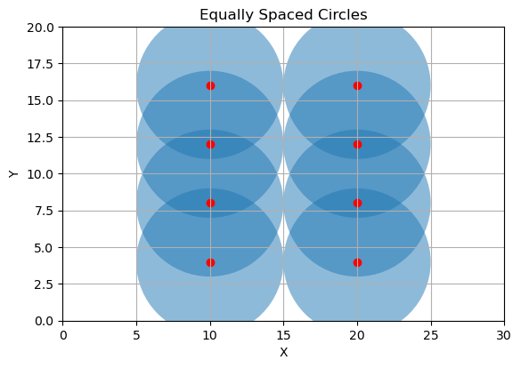

No.of Sensors:7

Coordinates of sensors:

Sensor 1: (10.0, 4.0)

Sensor 2: (10.0, 8.0)

Sensor 3: (10.0, 12.0)

Sensor 4: (10.0, 16.0)

Sensor 5: (20.0, 4.0)

Sensor 6: (20.0, 8.0)

Sensor 7: (20.0, 12.0)

Sensor 8: (20.0, 16.0)

Total area: 600

Total area covered by circles: 628.3185307179587

Total area uncovered by circles: -28.31853071795865

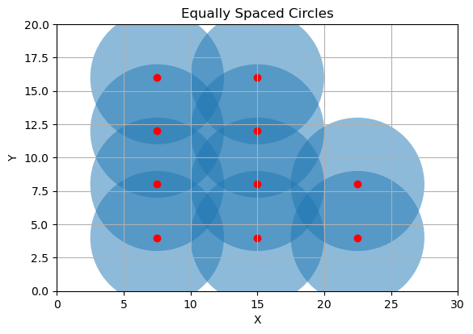

No.of Sensors:10

Coordinates of sensors:

Sensor 1: (7.5, 4.0)

Sensor 2: (7.5, 8.0)

Sensor 3: (7.5, 12.0)

Sensor 4: (7.5, 16.0)

Sensor 5: (15.0, 4.0)

Sensor 6: (15.0, 8.0)

Sensor 7: (15.0, 12.0)

Sensor 8: (15.0, 16.0)

Sensor 9: (22.5, 4.0)

Sensor 10: (22.5, 8.0)

Total area: 600

Total area covered by circles: 785.3981633974482

Total area uncovered by circles: -185.39816339744823

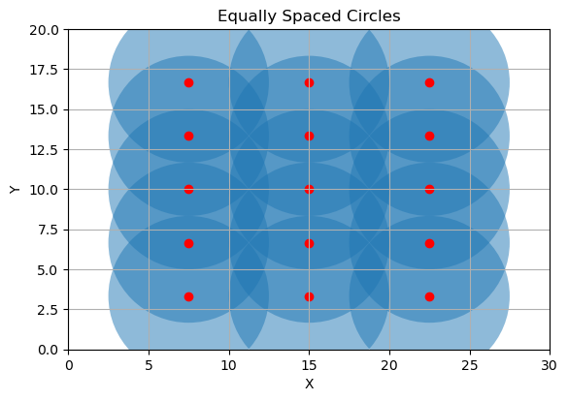

No.of Sensors:15

Coordinates of sensors:

Sensor 1: (7.5, 3.3333333333333335)

Sensor 2: (7.5, 6.666666666666667)

Sensor 3: (7.5, 10.0)

Sensor 4: (7.5, 13.333333333333334)

Sensor 5: (7.5, 16.666666666666668)

Sensor 6: (15.0, 3.3333333333333335)

Sensor 7: (15.0, 6.666666666666667)

Sensor 8: (15.0, 10.0)

Sensor 9: (15.0, 13.333333333333334)

Sensor 10: (15.0, 16.666666666666668)

Sensor 11: (22.5, 3.3333333333333335)

Sensor 12: (22.5, 6.666666666666667)

Sensor 13: (22.5, 10.0)

Sensor 14: (22.5, 13.333333333333334)

Sensor 15: (22.5, 16.666666666666668)

Total area: 600

Total area covered by circles: 1178.0972450961724

Total area uncovered by circles: -578.0972450961724

**Random ra Pooka**

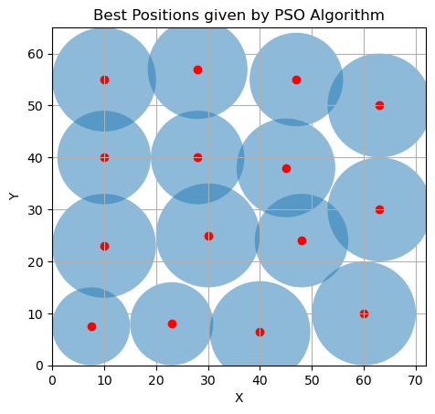

No.of Sensors:15

Coordinates of sensors:

Sensor 1: (7.5, 7.5)

Sensor 2: (23, 8)

Sensor 3: (40, 6.5)

Sensor 4: (30, 25)

Sensor 5: (10, 23)

Sensor 6: (28, 40)

Sensor 7: (10, 40)

Sensor 8: (10, 55)

Sensor 9: (47, 55)

Sensor 10: (48, 24)

Sensor 11: (60, 10)

Sensor 12: (45, 38)

Sensor 13: (63, 30)

Sensor 14: (63, 50)

Sensor 15: (28, 57)

Total area of the region: 4680

Total area covered by circles: 4149.258497228719

Total area uncovered by circles: 530.7415027712814

​

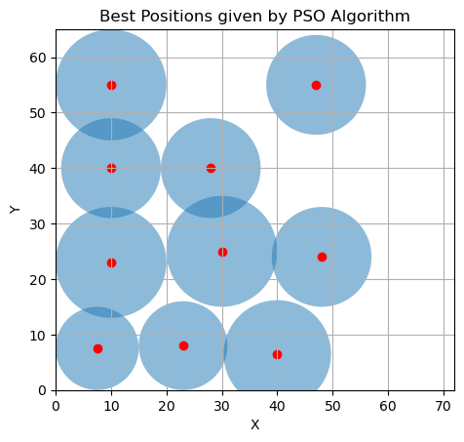

No.of sensors:10

Coordinates of sensors:

Sensor 1: (7.5, 7.5)

Sensor 2: (23, 8)

Sensor 3: (40, 6.5)

Sensor 4: (30, 25)

Sensor 5: (10, 23)

Sensor 6: (28, 40)

Sensor 7: (10, 40)

Sensor 8: (10, 55)

Sensor 9: (47, 55)

Sensor 10: (48, 24)

Total area of the region: 4680

Total area covered by circles: 2633.722785210467

Total area uncovered by circles: 2046.277214789533

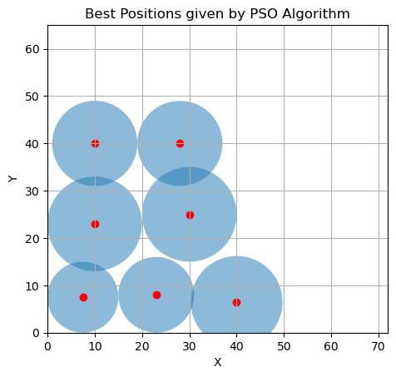

No.of Sensors:7

Coordinates of sensors:

Sensor 1: (7.5, 7.5)

Sensor 2: (23, 8)

Sensor 3: (40, 6.5)

Sensor 4: (30, 25)

Sensor 5: (10, 23)

Sensor 6: (28, 40)

Sensor 7: (10, 40)

Total area of the region: 2500

Total area covered by circles: 1810.6255099699413

Total area uncovered by circles: 689.3744900300587