Tech Stack :

* I’ve used Angular to create SPA
* SPA communicates to WebAPI to save and get story(documents) in to data store.
* I’ve used Mongo DB to save story(BSON) documents.
* We can use Azure Cosmos DB if client is after serverless approach.

This screen shows up if auth-cookie is missing.

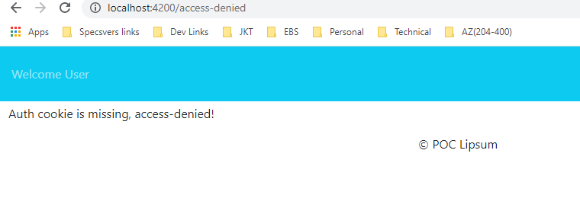

If auth-cookie is present, we redirect the user to enter the story.

