**Traffic Flow Prediction using Machine**

**Learning Techniques – A Systematic Literature Review**

# Abstract

**Purpose** : Traffic control in large cities is extremely tough. To alleviate costs associated with traffic congestion, some nations of the world have implemented

Intelligent Transportation systems (ITS). This paper reviews the application of Machine Learning (ML) and Artificial Neural Network (ANN) techniques and also their implementation issues in Traffic Flow Prediction. Techniques other than ML and ANN have also been discussed.

**Methodology** : The survey of literature on the Traffic Flow Prediction (TFP) and ITS was conducted using several secondary sources of information such as journals, conference proceedings, books, and research reports published in various publications, and then the literature that are reported promising have been included. The collected information is then reviewed to discover possible key areas of concern in the TFP and ITS.

**Findings/Results** : Traffic management in cities is important for smooth traffic flow. TFP and ITS are drawing much attention of the researchers these days. Application of ML, ANN and other techniques are being tried to alleviate the traffic flow problem in cities. TFP using ITS employing ML techniques to overcome the problem of traffic congestion looks promising.

**Originality** : This review of literature is conducted using secondary data gathered from various sources. The information acquired will be useful to expand on existing theories and frameworks or to develop a new technique or modify to improve the accuracy of TFP. Tables containing categories of prediction, ML pipelining , open source ML tools available, standard datasets available have been included.

**Paper Type** : Literature Review.

# Introduction

Traffic control in large cities is extremely tough. To alleviate costs associated with traffic congestion, some nations throughout the world have implemented Intelligent Transportation System (ITS). Models for predicting traffic flow are useful in the development of ITSs. ITS is a control and information system that makes use of integrated communications and data processing technology to improve human and commodities transportation, by enhancing safety, lowering road congestion, and effectively handling occurrence of congestion, to achieve transportation policy goals and objectives – such as demand management or priority measures for public transportation [1][2].

In city transportation and area management, traffic flow prediction has a wide range of applications. The traffic flow prediction issue is a time series problem that involves estimating the flow volume at a future time using data gathered from one or more observation points during prior periods. This research aims to train the system to forecast traffic using a traffic flow prediction algorithm. The system can make recommendations to the user based on their search. Traffic congestion is produced by the dynamic interactions of several causes. These aspects include variations in traffic volume over time, road architecture, weather conditions, accidents, road maintenance work, and so on. The public will profit from this system since users will be able to see current traffic flow and weather conditions on the roadways, minimizing the risk of road accidents and improving road safety [2].

This survey is about predicting the traffic flow in an urban city using Machine learning (ML) tools. Machine learning is a sort of artificial intelligence that involves the development of computer algorithms which improve accuracy as they analyze or learn from vast amounts of data. The capacity of ML to learn from prior data sets while being flexible lends itself to a wide range of applications. ML concepts and their applications can be used to predict traffic flow. Today’s methodologies cannot provide precise predictions, if there is a change in environmental variables (e.g., if there is construction or repair work, or changes in road structure or weather conditions) [3][4]. Therefore, it is important to develop a prediction system that utilizes more number of the variables that cause traffic congestion. This survey focuses on analyzing how to properly characterize traffic flow in urban road scenarios with an emphasis on long-term or short-term predictions. By training ML tools with some historical and time-series data, the machine automatically learns how to predict the traffic. Accurate prediction of traffic flow is important in modern transportation systems. It is a booster for many applications which need reliable future traffic information [5][6][7].

This communication has 12 sections. The following section includes the research objectives and goals. The third section includes the methodology performed. Section 4 gives an overview of traffic flow prediction using ML. Section 5 discusses the literature published so far. A discussion about future works is in Section 6 and the research gap in Traffic flow prediction is identified in Section 7 and is followed by the research agendas. Section 9 explains the analysis of the research agenda. Section 10 contains the final research proposal on the chosen topic. ABCD analysis is presented in Section 11 and conclusions on drawn in Section 12.

# Methodology

Various journal databases such as Elsevier, ScienceDirect, IEEE, Google scholar, and others have been used for this purpose and shortlisted articles that used ML, Deep Learning, and ANN techniques to predict the urban road traffic jam. All study materials were collected initially, and studied to find key threads across the articles.

**A. Autoencoder**

An autoencoder is an NN that attempts to reproduce its input, i.e., the target output is the input of the model. Fig. 1 gives an Illustration of an autoencoder, which has one input layer, one

hidden layer, and one output layer. Given a set of training samples {x(1), x(2), x(3),...}, where x(i)  Rd, an autoencoder

first encodes an input x(i) to a hidden representation y(x(i)

)

based on (1), and then it decodes representation y(x(i)

) back

into a reconstruction z(x(i) ) computed as in (2), as shown in y(x) = f(W1x + b) (1) z(x) = g (W2y(x) + c) (2)

where W1 is a weight matrix, b is an encoding bias vector, W2 is a decoding matrix, and c is a decoding bias vector; we consider logistic sigmoid function 1/(1 + exp(−x)) for f(x) and g(x) in this paper.

By minimizing reconstruction error L(X, Z), we can obtain the model parameters, which are here denoted as θ, as θ= arg min θ

L(X, Z)= arg min

One serious issue concerned with an autoencoder is that if the size of the hidden layer is the same as or larger than the input layer, this approach could potentially learn the identity function. However, current practice shows that if nonlinear autoencoders have more hidden units than the input or if other Fig. 2. Layerwise training of SAEs. restrictions such as sparsity constraints are imposed, this is not a problem [60]. When sparsity constraints are added to the

objective function, an autoencoder becomes a sparse autoencoder, which considers the sparse representation of the hidden

layer. To achieve the sparse representation, we will minimize the reconstruction error with a sparsity constraint as

SAO = L(X, Z) + γ

HD

j=1

KL(ρρˆj ) (4)

where γ is the weight of the sparsity term, HD is the number of hidden units, ρ is a sparsity parameter and is typically a small value close to zero, ρˆj = (1/N) N

i=1 yj (x(i)

) is the average

activation of hidden unit j over the training set, and

KL(ρρˆj )

is the Kullback–Leibler (KL) divergence, which is defined as

KL(ρρˆj ) = ρ log ρ ρˆj

+ (1 − ρ) log 1 − ρ

1 − ρˆj

.

The KL divergence has the property that KL(ρρˆj ) = 0 if ρ = ˆρj . It provides the sparsity constraint on the coding. The backpropagation (BP) algorithm can be used to solve this optimization problem.

**B. SAEs**

A SAE model is created by stacking autoencoders to form a deep network by taking the output of the autoencoder found on the layer below as the input of the current layer [59]. More clearly, considering SAEs with l layers, the first layer is trained as an autoencoder, with the training set as inputs. After obtaining the first hidden layer, the output of the kth hidden layer is used as the input of the (k + 1)th hidden layer. In this way, multiple autoencoders can be stacked hierarchically. This is illustrated in Fig. 2.

To use the SAE network for traffic flow prediction, we need to add a standard predictor on the top layer. In this paper, we put a logistic regression layer on top of the network for supervised traffic flow prediction. The SAEs plus the predictor comprise the whole deep architecture model for traffic flow prediction.

**C. Training Algorithm**

It is straightforward to train the deep network by applying the BP method with the gradient-based optimization technique. Unfortunately, it is known that deep networks trained in this way have bad performance. Recently, Hinton et al. have developed a greedy layerwise unsupervised learning algorithm that can train deep networks successfully. The key point to using the greedy layerwise unsupervised learning algorithm is to pretrain the deep network layer by layer in a bottom–up way. After the pretraining phase, fine-tuning using BP can be applied to tune the model’s parameters in a top–down direction to obtain better results at the same time. The training procedure is based on the works in [58] and [59], which can be stated as follows. 1) Train the first layer as an autoencoder by minimizing the objective function with the training sets as the input. 2) Train the second layer as an autoencoder taking the first layer’s output as the input. 3) Iterate as in 2) for the desired number of layers. 4) Use the output of the last layer as the input for the prediction layer, and initialize its parameters randomly or by supervised training. 5) Fine-tune the parameters of all layers with the BP method in a supervised way. This procedure is summarized in Algorithm 1.

# The role of Machine Learning in Traffic Flow Prediction

Traffic forecasting is the process of anticipating the volume and density of traffic flow to regulate vehicle movement, decrease congestion, and produce the ideal (lowest time- or energy-consuming) route [13]. Traffic forecasting is critical for two types of organizations:

1. **National/local authorities:**

Many cities have embraced ITS in the last ten to twenty years to aid in the planning and administration of urban transportation networks. These systems make use of real-time traffic data and forecasts to increase transportation efficiency and safety by notifying users about current road conditions and altering road infrastructure [14]. Using this method, the general public can be better informed about traffic flow and weather conditions on the roadways, minimizing the risk of accidents and increasing overall road safety [15].

1. **Logistics companies:**

The logistics business is another area of use. Several enterprises rely on accurate scheduling and effective route planning, including transportation, delivery, and field service . When it comes to travel, it's often not just about the present, but the future as well. For companies like these, accurate estimates of traffic and road conditions are critical to their planning and success.

Traffic jams are generated by several elements that interact in a complex way. Factors such as variations in traffic, weather conditions, accidents, and maintenance work all contribute to fluctuations in traffic volume. Even with today's methods, environmental variables can't be predicted with any precision (e.g., if there is construction or repair work, changes in road structure, or weather conditions) . To reduce traffic congestion, it is necessary to construct a more accurate prediction system. The primary goal of this study is to figure out how to accurately anticipate traffic flow in urban road scenarios all through machine learning techniques by using more of the underlying factors that contribute to traffic congestion as input into the forecasting process [20][21]. Figure 4 shows a Tree representation of ML algorithms used in Traffic flow prediction.

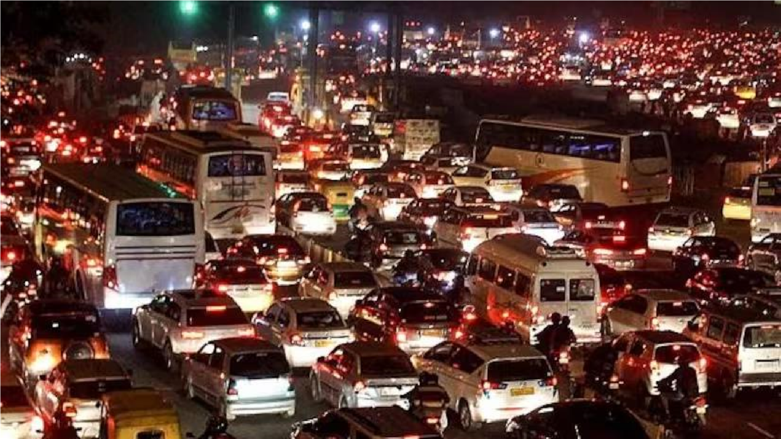

# Research Gap

It is concluded that the present approach, models, and publications appear to be falling short in addressing the benefits and issues associated with ITS from the literature review. There is a lack of research on the application of technology in the traffic flow prediction system. There is a need to simplify the approaches and also to improve their accuracy. As a result of recent improvements in ITS, researchers have been encouraged to implement traffic flow prediction with various ML approaches. Some of the algorithms in the ML techniques have a number of difficulties when it comes to implementing the complexity of traffic flow prediction systems. One way to ensure that Traffic flow prediction systems live up to their promise in practice is to improve the technology that addresses these problems. During the review, it was determined that various aspects of traffic flow prediction systems do not effectively leverage statistical methods. This survey identifies the following research gaps and makes recommendations for filling them.

* **Research Gap 1**: Which ML algorithm gives good accuracy in traffic flow prediction.
* **Research Gap 2**: Many categories and types of algorithms are available in Deep learning and ML. Different techniques and strategies are available in ML and deep learning for classifying and filtering the data. Identify the best among the available algorithms that will serve the purpose.
* **Research Gap 3**: User interface design is needed to display the studied results.
* **Research Gap 4**: Further explore the availability of dataset repositories.
* **Research Gap 5**: Possibility of designing new algorithms for traffic flow prediction.

# Conclusion

We propose a deep learning approach with a SAE model for traffic flow prediction. Unlike the previous methods that only consider the shallow structure of traffic data, the proposed method can successfully discover the latent traffic flow feature representation, such as the nonlinear spatial and temporal correlations from the traffic data. We applied the greedy layerwise unsupervised learning algorithm to pretrain the deep network, and then, we did the fine-tuning process to update the model’s parameters to improve the prediction performance. We evaluated the performance of the proposed method on a PeMS data set and compared it with the BP NN, the RW, the SVM, and the RBF NN model, and the results show that the proposed method is superior to the competing methods. For future work, it would be interesting to investigate other deep learning algorithms for traffic flow prediction and to apply these algorithms on different public open traffic data sets to examine their effectiveness. Furthermore, the prediction layer in our paper has been just a logistic regression. Extending it to more powerful predictors may make further performance improvement.

# References

1. Zhang, J., Wang, F. Y., Wang, K., Lin, W. H., Xu, X., & Chen, C. (2011). Datadriven intelligent transportation systems: A survey. IEEE Transactions on Intelligent Transportation Systems, 12(4), 1624-1639.

Google Scholar

1. Kim, Y. J., & Hong, J. S. (2015). Urban traffic flow prediction system using a multifactor pattern recognition model. IEEE Transactions on Intelligent Transportation Systems, 16(5), 2744-2755.

Google Scholar

1. Boukerche, A., & Wang, J. (2020). Machine Learning-based traffic prediction models for Intelligent Transportation Systems. Computer Networks, 181, 1-21.

Google Scholar

1. Qureshi, K. N., & Abdullah, A. H. (2013). A survey on intelligent transportation systems. Middle-East Journal of Scientific Research, 15(5), 629-642.

Google Scholar

1. Thomas, T., Weijermars, W., & Van Berkum, E. (2009). Predictions of urban volumes in single time series. IEEE Transactions on Intelligent Transportation Systems, 11(1), 71-80.

Google Scholar

1. Pan, T. L., Sumalee, A., Zhong, R. X., & Indra-Payoong, N. (2013). Short-term traffic state prediction based on temporal-spatial correlation. IEEE Transactions on Intelligent Transportation Systems, 14(3), 1242-1254.

Google Scholar

**Code link:-** https://colab.research.google.com/drive/1M0RF74JSbLY2isemtAr9f5aziInQhFCv?usp=sharing