**LEARNER’S ACADEMY**

**PROJECT DETAIL :-**

Project Name :- Learner’s Academy

Developer Name :- Nikhil Waware

**Github Link :-** https://github.com/nikhilwaware/Learners-Academy.git

**Project Details:** This project is for the design and developing a backend administrative portal for the Learner’s Academy using Java EE technologies

**Objective**: The Objective of this project is to apply servlet, jsp and JDBC concepts.

**Technologies and tools Used:**

* Servlet: to do the business logic and works a controller for the project.
* JSP: to handle the presentation view.
* SQL: to create and manage the database.
* JDBC: to make operations on the database for the project.
* Eclipse: to write and run the code.
* Tomcat: to run and deploy servlet application.

**Flow Chart:**

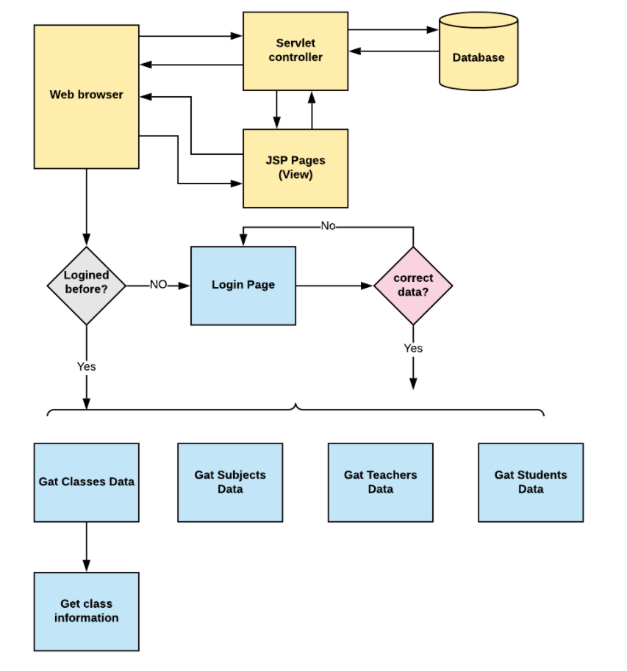

**Sprint Plan:**

**Sprint 1:**

1. Create database and tables.
2. Connect the database to the project.
3. Create models classes.
4. Create a database utility class to retrieve data.
5. Create login page.

**Sprint 2:**

1. Create JSP files for all pages of the project.
2. Create a servlet to get requests and send responses to the JSP files.
3. Debug and Test the project.

**Concept used in this programme:**

1. Object-Oriented: used to create and model objects for users and their credentials.
2. Databases: used to store and retrieve data.
3. Data Sources: used to define a set of properties required to identify and access the database.
4. Collections: used some collections such arraylist to store collection of data.
5. Exception Handling: used to catch problems that arises in the code especially in I/O blocks.

**How to run the program:**

1. clone project
2. Go to “\src\main\webapp\WEB-INF\web.xml” file and open it.
3. Edit the database’ properties such as username, password, driverClassName and url to be suit to your database administration tool.
4. Now run program on a server.
5. To login you must enter admin@learner.com for username and admin@123 for password.