**HBASE**

**What is HBase?**

HBase is a column-oriented non-relational database management system that runs on top

of Hadoop Distributed File System (HDFS). HBase provides a fault-tolerant way of storing

sparse data sets, which are common in many big data use cases. It is well suited for real

time data processing or random read/write access to large volumes of data.

Unlike relational database systems, HBase does not support a structured query language like

SQL; in fact, HBase isn’t a relational data store at all. HBase applications are written in JavaTM

much like a typical Apache MapReduce application. HBase does support writing applications

in Apache Avro, REST and Thrift.

**HBase Shell**

HBase contains a shell using which you can communicate with HBase. HBase uses the

Hadoop File System to store its data. It will have a master server and region servers. The

data storage will be in the form of regions (tables). These regions will be split up and stored

in region servers.

The master server manages these region servers and all these tasks take place on HDFS.

Given below are some of the commands supported by HBase Shell.

We can start the HBase interactive shell using “HBase shell” command as shown below.

**Practicals**

1. Start with HBase Shell.

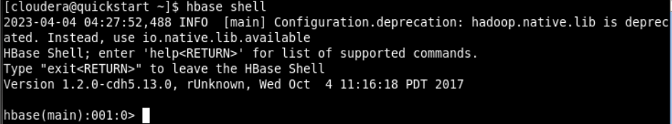

1. Check for HBase Prompt. If not, restart the services.

$ sudo su – This commands is to become super user

$ service hbase-master restart – This commands is to restart hbase-master services

$ service hbase-regionserver restart – This commands is to restart hbase-regionserver services.

1. Create a HBase table named ‘Student’ with column families StudID, StudName and StudAddress. Also cross check the creation and schema details of the table.

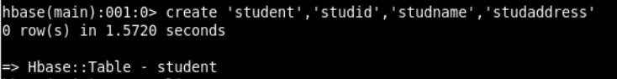

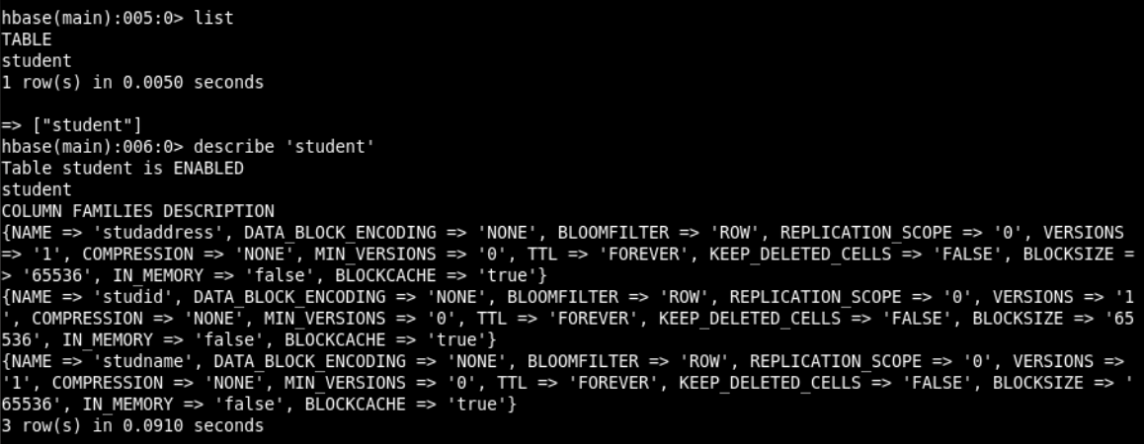

1. Insert following data into the student table.

(Syntax: put 'Student','S01','StudName:FName','Amit' )

S01,Amit Prakash Vaze, Mulund

S02,Sumit Neeraj Kulkarni, Devi Dayal Road, Mulund W

S03,Alka Deepak Yadav, PK Road, Thane, Maharashtra

S04,Amit Neeraj Yadav, Goshala Road, Mulund W, Maharashtra

S05,Veena Pushkar Mhatre, JN Road, Thane W, Maharashtra

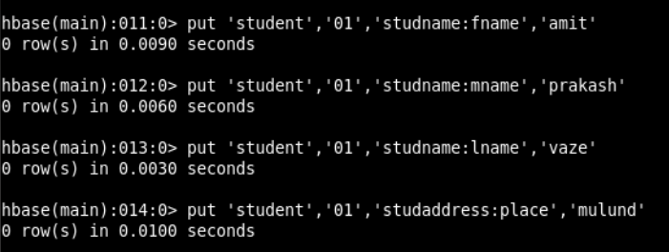

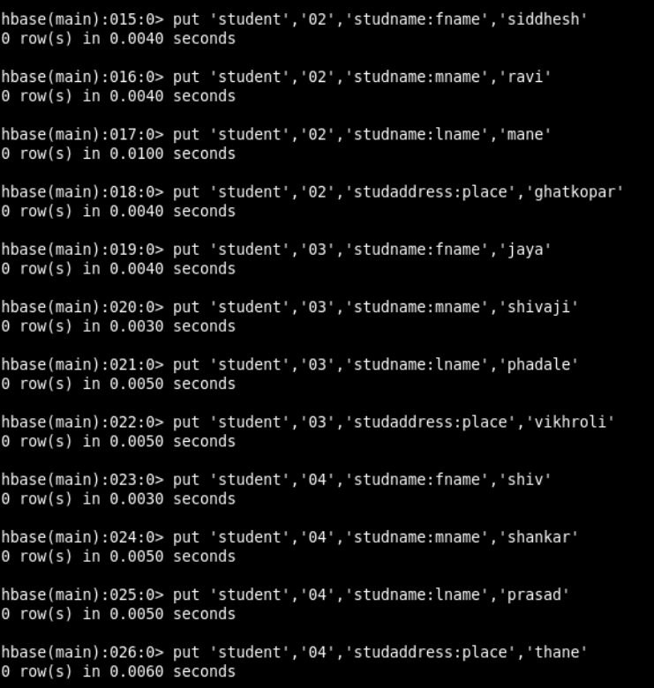

1. Display all rows from the Student table. (scan command)

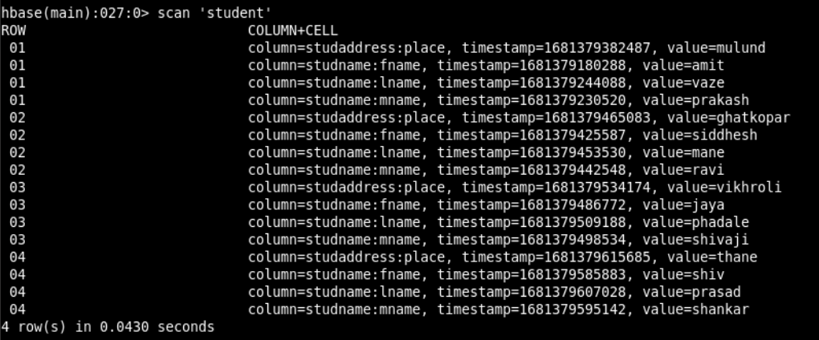

1. Display address list of all students. (get command)

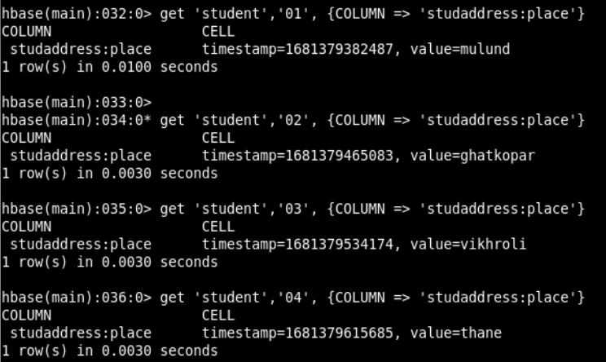

1. Display list of students.

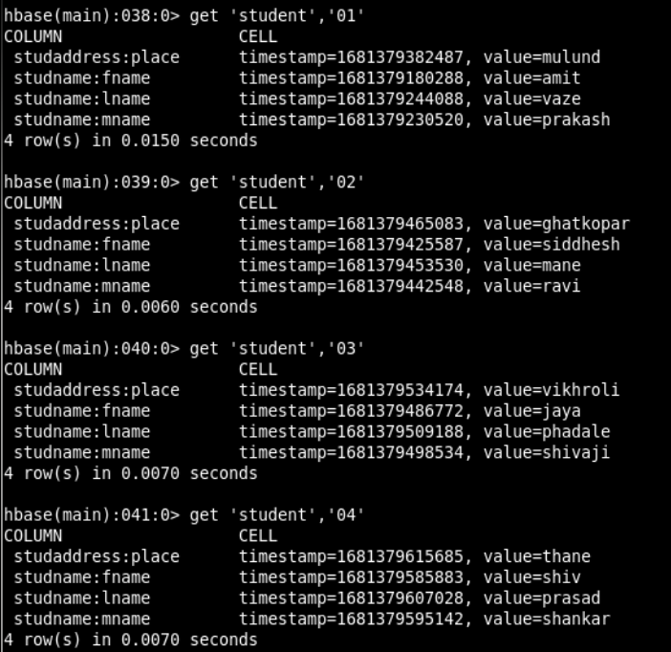

To get a particular list

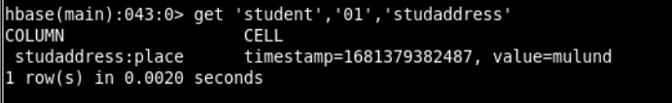

1. Display total number of students.

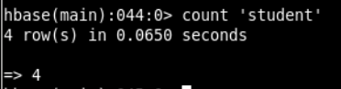

1. Disable Student table and display the table schema using describe command.

>disable ‘Student’



1. Check disabled status of the table using is-disabled command.

>is_disabled ‘Student’

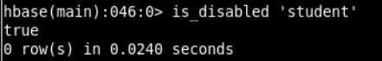

1. Enable Student table and display the table schema.

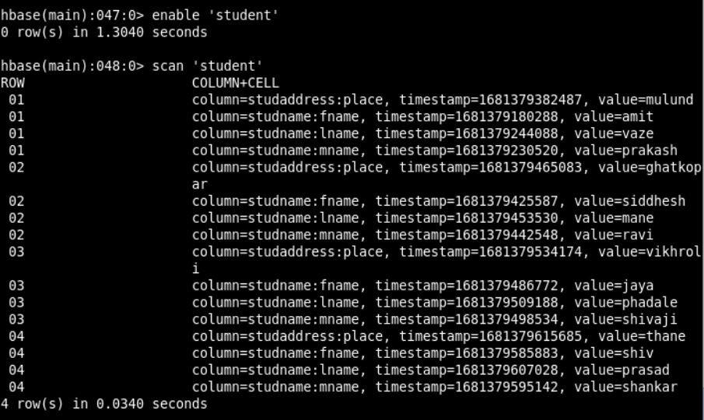

1. Demonstrate the deletion of column values and a row.

* Deleting a specific cell

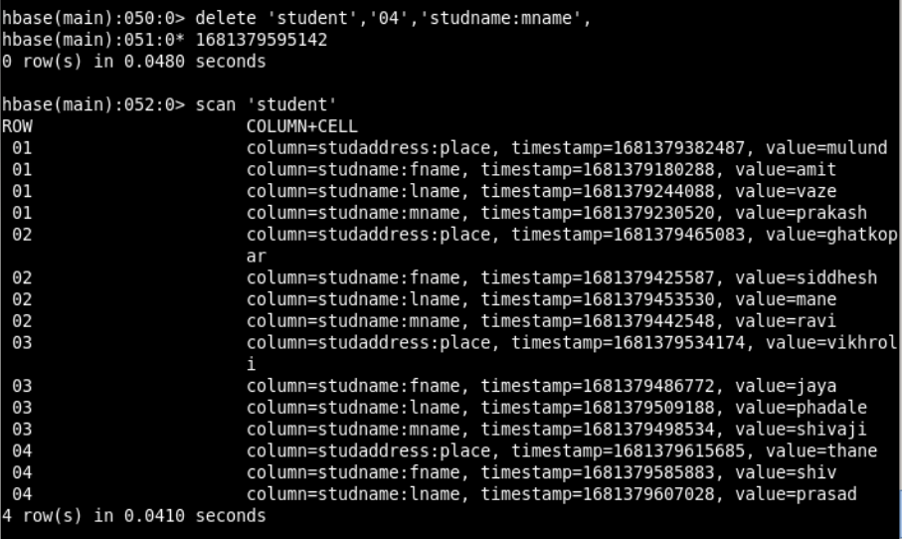

* Deleting all cells

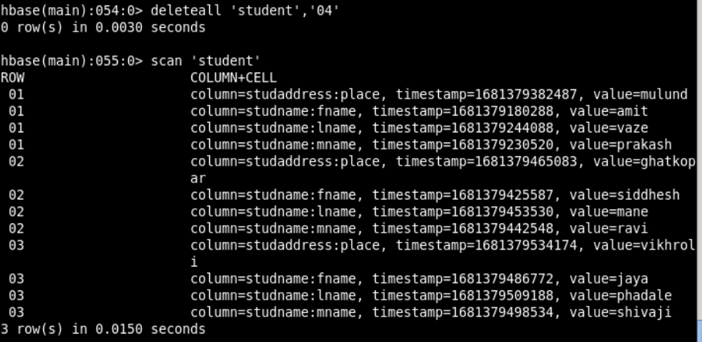

1. Set the maximum number of cell changes to 5.

>alter ‘Student’, Name=’NewColFamily’, VERSIONS=>5

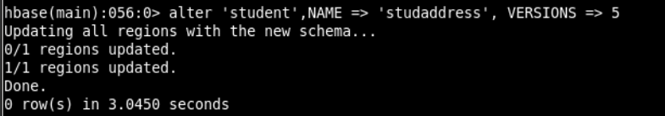

1. Delete column family ‘Address’ from Student table.

>alter ‘Student’,‘delete’ => ‘Address’

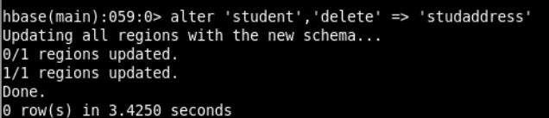

1. Check the existence of the Student table.

>exists ‘Student’

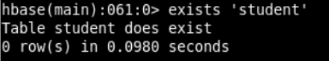

1. Drop Table ‘Student’

