***ComS 572: Term Project Proposal***

**3-2-5(Teen-Do-Paanch) Card Game**

*Preeti Bhardwaj*, *Amulya Gupta, Nikhita Sharma*

1. **Rationale for the project**:

Our project is directly inspired from the foundations of COMS 572. According to the nature of 3-2-5 card game, this project will incorporate designing an intelligent agent for which the environment is partially observable. Moreover, environment of the game is deterministic since the next state of game can be determined by current state and action executed by an agent. An agent will have a sequential experience as its future moves will depend on its and other agents’ previous moves. Additionally, in order to represent agent's’ memory we will implement concepts of knowledge representation and reasoning. Our project will take advantage of heuristic search algorithm(s) to choose which action will result in maximizing the performance measure of an agent. Specifically, our project will not implement any machine learning strategies.

1. **Specific goals of the project:** The project aims to achieve the following:
2. Design a rational agent which makes decisions at every state considering all the possible actions and chooses the best/better action to make one trick.
3. The agent should maximize its performance measure which is the number of tricks.
4. Agent should eventually win the game by making at least assigned number of tricks.
5. Create an intelligent 3-2-5 game playing agent.
6. **A detailed plan of activities to finish the project**: Creation of the following functions for the agent to play intelligently:
7. decide_dealer() : decide dealer (person who makes 2 tricks)
8. draw_cards() : distribute cards to each agent
9. play_priority() : returns which card to play based on the current set, set of available cards to the agent using a function call to priority()
10. priority() : a heuristic function that returns priority of a given card
11. decide_trump() : chooses which suit should be trump based on given set of cards
12. play_start_firstRound() : returns which card to start the game with (initial round)
13. play_start_nextRound() : returns which card to start the next round with (any round except initial round)
14. winner() : returns which agent won the trick based on the cards each agent played (for each round)
15. game_over() : display performance of each agent, along with the winner
16. **Description of the Game:**

The deck consists of 30-cards limited to 8s and higher for all suits, plus 7 of Hearts and the 7 of Spades. There are 3 individual players, and 3+2+5 = 10 possible tricks. On each trick, the highest of the led suit wins unless it is trumped.

The cards are ranked as follows: from high to low; Ace, King, Queen, Jack, 10, 9, 8 in the suits of Clubs and Diamonds. Similarly, for Spades and Hearts; Ace, King, Queen, Jack, 10, 9, 8, 7.

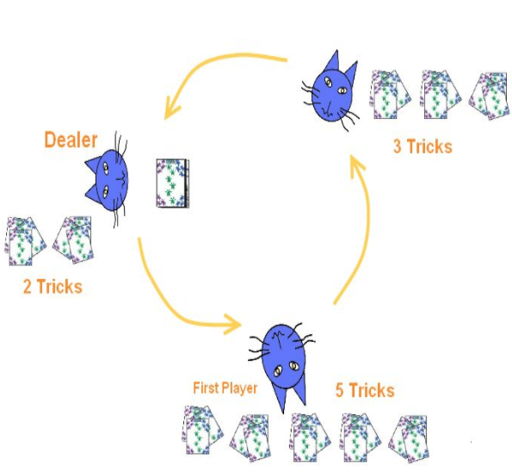

1. **Rules of the Game:**
2. Each agent becomes a dealer one by one.
3. The dealer make 2 tricks, the next agent (who chooses the [trump](https://en.wikipedia.org/wiki/Trump_(card_games))) makes 5 and last one makes 3.
4. **Dealing the Cards** - First distribute a set of 5 random cards to each agent. An agent who deals cards chooses the “trump” suit and then cards are dealt randomly in sets of 3 and 2.
5. **Playing Sequence -** The game will be played in an anticlockwise fashion. First lead is taken by the agent who sets the trump and subsequent ones are by the one who wins the trick. For instance, Agent 1 plays a card, then Agent 2 plays a card and then Agent 3 plays a card who finally wins. In the next round, Agent 3 will take the lead and will play a card which will lead to Agent 1 plays and finally Agent 2 will play.
6. **Sets of Rules -** There are sets of rules about the cards which can be played when a card has already been played. An agent will play by the same rules as a human plays using knowledge and reasoning. Specifically, the agent will use priorities and its memory to store the cards played in order to take a decision.
7. **Card Priorities** - An agent will determine the priority of each card it has in its hand. The agent will know definitely which cards are in its hand and which cards have been played. Priority of the card is dependent on three parameters:
   1. Selected trump.
   2. Ranking of the card.
   3. The cards that have already been played.
8. **References:**

* <https://en.wikipedia.org/wiki/3-2-5>
* http://www.catsatcards.com/Games/ThreeTwoFive.html