PACE CONNECT

Nikhita Patil, Sonal Sahu, Akshay Mehta, Shardul Virkar, Mable Macwan, Dhrashti Patel

*Seidenberg School of Computer Science and Information Systems*

*Pace University, New York, NY, USA*

***Abstract*—The students joining the university across the globe need a unified platform to connect with each other for gaining and sharing knowledge. The students need to connect with alumni students for enhancing their knowledge and opportunities regarding career, course works, curriculum, technological trends in the market. Although Blackboard and MyPace mobile application are present applications used by Pace students for coursework related information, they lack features needed by students to collaborate with each other. This paper proposes a forum – Pace Connect that provides a discussion platform for the students to connect with each other and resolve their queries. This**

**paper elaborates about the steps taken to achieve this goal**

**in detail.**

***Keywords***— **mobile application development, collaboration, queries solving, forum, alumni, firebase, android**

1. Introduction

The idea to develop Pace Connect came from the need of a forum where students can connect with each other to share or gain information. Every student joining Pace university faces similar problems. He has to contact his seniors for temporary accommodation to stay around the campus till he is familiar with the new surroundings and culture. The students would have to struggle finding connections with alumni/seniors from Pace who have accommodation available. Students from Pace have various coursework which requires books for studying. These books might be expensive to buy and once the course is over, the books would not be required. Students needed a platform where they could sell or buy books related to their course. Students can get career opportunities for full time or internship from alumni students of Pace. To connect with the alumni students, a forum is needed where the students can connect with alumni to reach out with their resumes or queries regarding career opportunities. There are events occurring in Pace for technical knowledge sharing, social connect, or cultural programs from different departments. Students do not receive notifications about such events regularly.

With the widespread of smartphones among university students, Pace Connect will be an application for the students, by the students. Students can access the app from their mobile phone and just post their queries. The queries can be related to any area related to Pace university. Seeing the queries, students having prior information to the queries can reply to these queries by just a single click. Students can gain information to all the questions they have in their mind by browsing through the discussion posted on the forum. Pace connect will be a one stop solution for all the students to quickly receive answers from other students.

1. Literature Review

MyPace mobile application and Blackboard are the current platforms where students can view their courses, grades, course schedule, find classes and connect with their professors.

Blackboard provides powerful and easy-to-use systems for educational instruction, communication, and assessment. Blackboard can be accessed from the internet at anytime and anywhere. Students can retrieve all of their course materials including assignments, lecture notes, slides, internet hyperlinks, and audio/visual aids. They can submit their assignments as soon as they are complete.

However, Blackboard, the software is harder to learn than expected, certain options may be restricted to specific operating systems, there are inefficiencies in bandwidth use when materials have to be downloaded every time access is sought, and cost. [6]

There are many gaps in MyPace mobile application such as :

* Tedious & sluggish UI - students do not find the interface friendly to use and that becomes tedious to use the Pace App
* Lack of relevance - social connectivity is not that good so that each pace student can reach out easily as needed to other students or alumni.
* No events alerts - there are no alerts pop-ups for the events schedule, a platform is needed to get notified about relative events.

Although MyPace mobile application and Blackboard are great for the students, they lack a major feature – collaboration of students with each other to post queries or solve queries of the students. These applications are not a discussion forum.

1. Current Solutions

The current solutions of Pace Connect are-

* Blackboard
* MyPace Portal

The growth and development of the internet has led to a dramatic increase in use of Blackboard and MyPace Portal that provide a great way to connect with Pace students and teachers without the restrictions of time and distance. They allow instructors to post announcements, assignments, grades and course material. It also allows students to view all of this information, submit assignments, and participate in discussion boards.

Table 1 provides an Overview of Current Solutions-

TABLE I

|  |  |  |
| --- | --- | --- |
|  | Blackboard | MyPace Portal |
| Year introduced | 1997 | 2000 |
| Open source | No | No |
| Free option available? | Yes, known as CourseSites | Yes? |
| Google Play app rating | 24,120 | 206 |
| iTunes app rating | 1,26,000 | 83 |

Blackboard is most used among students and teachers to share information, assignments, grade, announcements related to class and course material.

MyPace Portal is a one stop shop for students, staff, faculty, library, law school, and Reportal. It allows students to check class schedule, register, add or drop classes, locate classes important Pace contact numbers, and other related information.

While having many benefits, there are various gaps in the current applications that includes - tedious and sluggish UI that needs improvement to provide user friendly design, there is a lack of relevance that needs to be improved to connect socially with current students and pace alumni, there are no events alert that can help students to notify about relative events, there is no user forum that can provide communication platform to solve student’s queries.

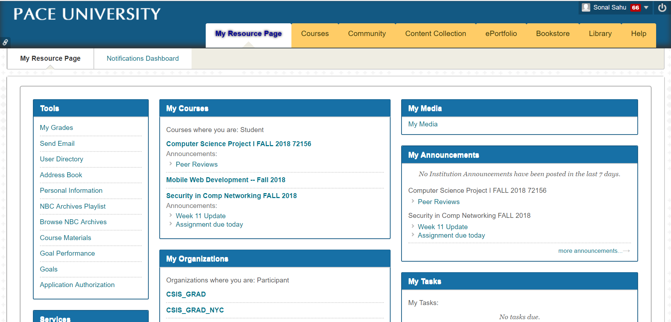

Fig. 1 Screenshot of Blackboard Application

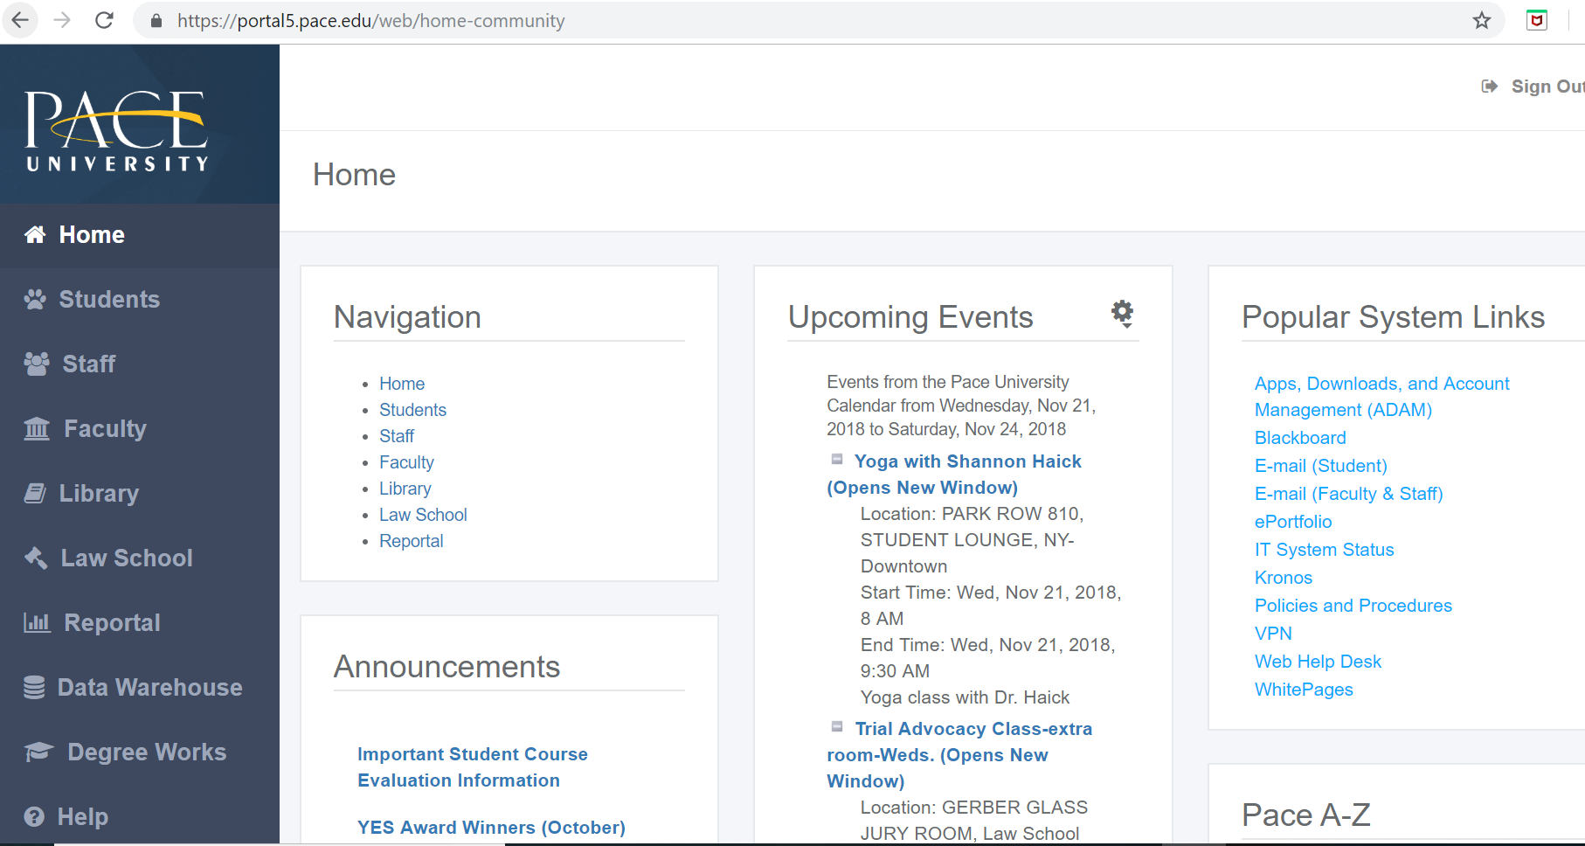

Fig. 2 Screenshot of Blackboard Application

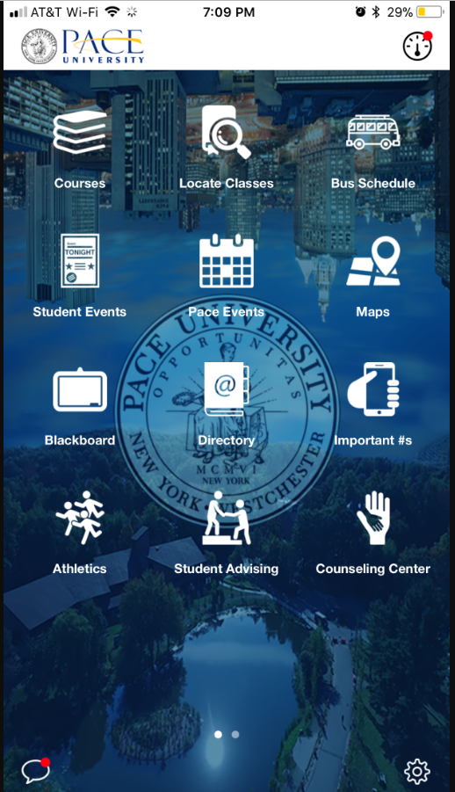

Fig. 3 Screenshot of MyPace Mobile App

1. Project Requirements

We aim at developing a mobile application for Pace University students to address the current gaps present in the MyPace Mobile application. The Pace Connect mobile app will provide a single platform for the current and alumni students to connect with each other and solve their queries.

Functional Requirements:

*Login**Module*

* Every new user of the application (current students or alumni students) has to create a profile on the Pace Connect app by signing up on the application and providing necessary biographic and academic details.
* On successful sign up, every user will be registered using a unique username and password for further login.
* The registered users once signed up, can log in to the application using their unique username and password.
* The registered user can also reset his password using Forgot password link.

*Forum Module*

* Once a registered user successfully logs in, he should see all the posts posted by students on the forum.
* He should be able to post a query on the forum.
* On posting a query on the forum, the user should be able to edit or modify the query posted by him.
* The registered user can also delete a query posted by him on the forum.
* The registered user should also be able to reply to queries posted by other users.

Technical Requirements: -

* This application will have support for cross browser platform (Android, Ios).
* This application will be responsive and can be accessed from website as well.
* Agile methodology will be followed to develop the application iteratively.
* Android, Java, XML and Google Firebase are the technologies used for development of the mobile application.

Usability Requirements: -

* Features of the mobile application will also work on all major browsers.
* The application will be responsive, easy to use, self-explanatory and user friendly.
* Validations will be performed on client and server side.
* Some students will beta test the application to gain feedback from students for further changes in the app.

V. METHODOLOGY

We have followed the Agile Software development with scrum as a methodology for development of the project.

Agile software development is an approach to [software development](https://en.wikipedia.org/wiki/Software_development) under which requirements and solutions evolve through the collaborative effort of [self-organizing](https://en.wikipedia.org/wiki/Self-organization#Human_society) and [cross-functional](https://en.wikipedia.org/wiki/Cross-functional_team) teams and their [customer(s)](https://en.wikipedia.org/wiki/Customer)/[end user(s)](https://en.wikipedia.org/wiki/End_user)[1]

*THE AGILE VALUES*

* Individuals and interactions over processes and tools
* Working software over comprehensive documentation
* Customer collaboration over contract negotiation
* Responding to change over following a plan

Scrum relies on a self-organizing, cross-functional team. The scrum team is self-organizing in that there is no overall team leader who decides which person will do which task or how a problem will be solved.

Within agile development, Scrum teams are supported by two specific roles. The first is a ScrumMaster, who can be thought of as a coach for the team, helping team members use the Scrum process to perform at the highest level.

The product owner (PO) is the other role, and in Scrum software development, represents the business, customers or users, and guides the team toward building the right product. The Scrum model suggests that projects progress via a series of sprints. During an agile Scrum sprint, the Scrum team takes a small set of features from idea to coded and tested functionality. At the end, these features are done, meaning coded, tested and integrated into the evolving product or system[2].

We followed the agile scrum methodology to develop our application. We added tasks in the JIRA to keep a track of our product and sprint backlog. Each sprint of 3 weeks was used to develop a module based on priority and weightage(story points) of the task.

1. Architecture

The implementation of Pace Connect mobile application follows a standard architecture. The technologies used for front end and backend are as follows:

1. *Frontend* – Android, Java, XML
2. *2. Backend* - Google firebase.
3. The motivation for this architecture is illustrated as follows:
4. *Android*

Android is an open and free operating system based on Linux, which is mainly used for mobile terminals, such as smart phones and panel computer. It is developed by Open Handset Alliance composed of more than 30 technology companies and mobile phone companies. Android tries to allow users experience the best service quality, and allow developers get a more open level for more convenient software developing. Thus, mobile applications with more convenient functions can be developed via Android.[3]

Android apps adapt to different devices. Android allows you to provide different resources for different devices. For example, you can create different layouts for different screen sizes. Then the system determines which layout to use based on the current device's screen size.

We chose Android over other platforms for the following reasons:

*Open Source*: Android platform is open source. The developers can use the SDK without any license issues.

*Customizable User Interface*: Android-based applications are highly customizable and easier to manage. Google is highly focused on making its user interface customizable to help developers create custom Android apps for business.

*Easy to Adopt*:  Android apps are scripted in Java programming language that leverages a rich set of libraries. Any developer familiar with Java can build Android applications easily.

*Low Investment*: Android has a relatively low barrier to entry. Its Software Development Kit (SDK) is available for free to developers which significantly reduces the development costs.

*User Base*: Android is ruling the mobile device market with more than 75% of market share.

When choosing the Android as front end for Pace Connect, following considerations were taken into account:

1. *Project scope –* Every student uses mobile application today, to keep a track of his classes, schedule, grades. The need for mobile application to connect with each other helped us choose Android as the frontend.
2. *Integration -* Android is a place that provides simple inter-app integration by offering multiple flexible tools. Integration of Android with Firebase as database is very simple.
3. *Adoption -* Android Applications are developed in Java language which is highly rich in libraries. It is quite easy and convenient for Java coders to build an Android App as compared to other language developers. It’s very beneficial for Java developers to transit the code script into a mobile application, and can also implement android application development services in the app. Since all the team members were proficient in Java language, Android was an obvious choice.
4. *Java*

Android application development is based on Java and uses Android Library packages.

[Java](https://www.androidauthority.com/java-tutorial-beginners-582147/) is a proven and powerful programming language, used on a wide range of devices and operating systems.

Java increases security because both the platform and the Java language were developed from the primary day with the issue of security at hand.

It makes development simple so that developers can compile the application once in Java platform and run it in any other platform that supports Java.

Java is vibrant and extensible platform. The codes are organized in units called classes which are stored in different files and packed to Java interpreter just when needed.

Since Android development is based on Java, we chose Java for developing android application.

1. *Google Firebase*

Firebase is a Backend-as-a-Service for mobile and web to build powerful apps. It was launched by Google to support web-based backends.[4]

Firebase aims at offering a real-time database as well as backend as a service. It stores JSON data in a real-time database. The Backend As a Service provides application developers an application programming interface (API), enabling app data to coordinate via clients stored on the Firebase cloud messaging server. If there's a change in the database, it is also synchronized across the clients and devices using the same database.

Firebase liberates developers to focus on making impressive client experiences. You do not have to manage servers or write APIs. Firebase is like your server, your API, and your data store, where everything that is written can be modified or changed as per your needs. Features of Firebase are as follows:

*Real-Time Database:* A real-time database has no Structured Query Language (SQL). Here, data is stored and synced as a JSON design in real time to every customer connected. All the customers using Android share a single database. Changes made in the client's application are synchronized with the real-time database automatically, which works in offline mode

*Analytics:* Firebase Google Analytics is a free and unlimited analytics solution. It offers you unlimited reporting for up to 500 different events that can be defined using the Firebase SDK.

*Notification:* Using Firebase cloud messaging (FCM), a client receives a notification on the app whenever new mail or any data is synced.

*Storage*: You can upload or download files such as video, photos, or pdf into Google cloud storage. Firebase offers a simple and quick framework for cloud storage.

Firebase satisfies all the requirements needed for our backend of android application. Hence, due to its varied advantages suiting the needs of our application, we chose Firebase as our backend.

When choosing the Firebase database for Pace Connect, following considerations were taken into account:

1. *Project scope –* Since the project was a small-scale application to be used by students, Firebase is good for prototyping an application. Firebase lets you bootstrap your initial prototype on Google-scale infrastructure. Firebase Database rules are pretty good for most of the needs when you are starting out. Backing up and restoring the database is also very simple.
2. *Adoption -*Since most of the team members were well versed with mobile development, working on Firebase was an easy choice since the learning curve was less.
3. *Maintenance -* Firebase architecture abstracts all of the functionalities. Your code is "serverless", meaning that you don't manage servers yourself. You write code and Firebase puts it on Google's servers and scales it up and down as needed.

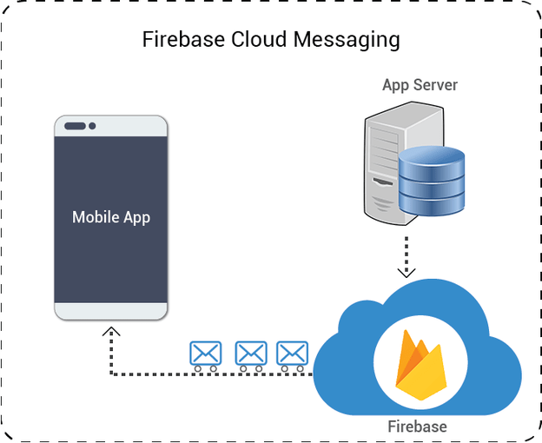

Fig. Architecture using Firebase

1. Design Wireframes

The sample designed pages of our application look as below.

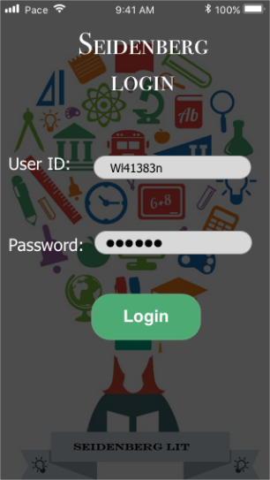 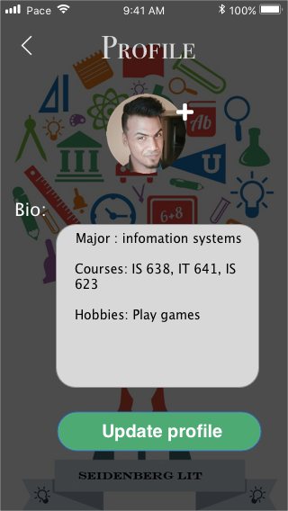

Fig. Design of Login Page

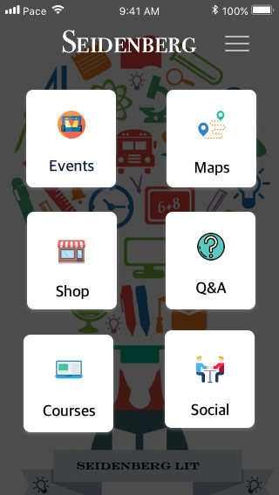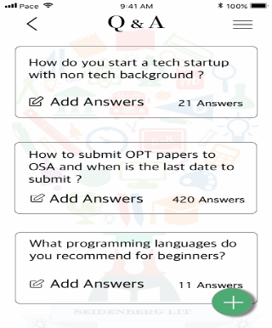

Fig. Design of Home Page

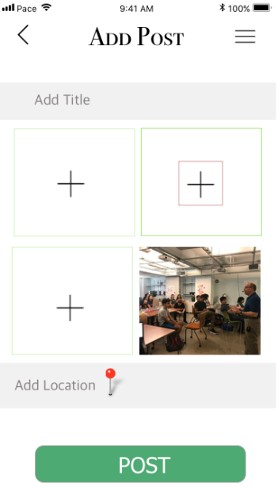

Fig. Design of Adding a post on forum and adding a reply to post

1. PRODUCT RESULT OF MVP

Following are the actual implementation of our application for the minimum viable product.

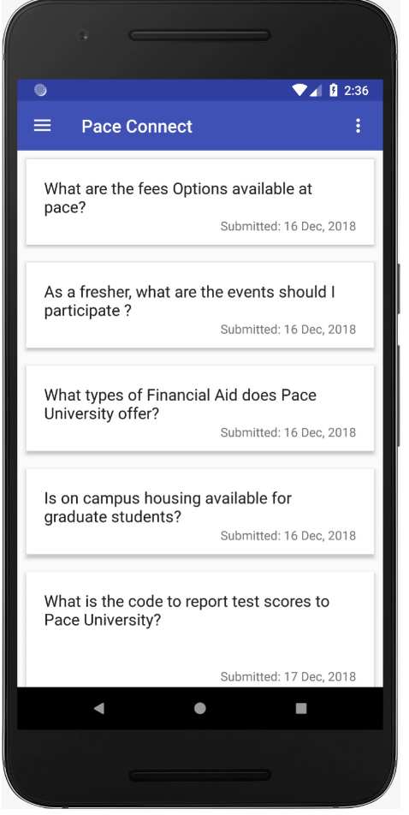

Fig. Implementation of All Queries Page

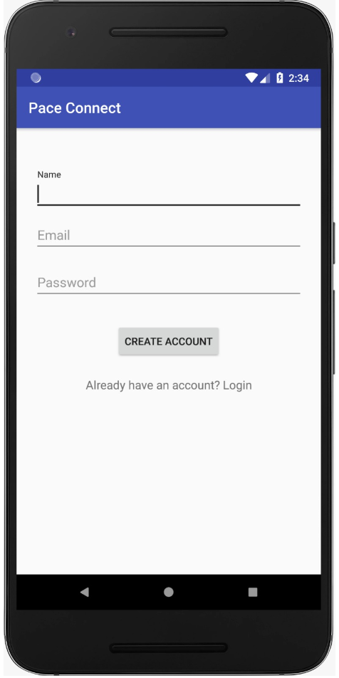 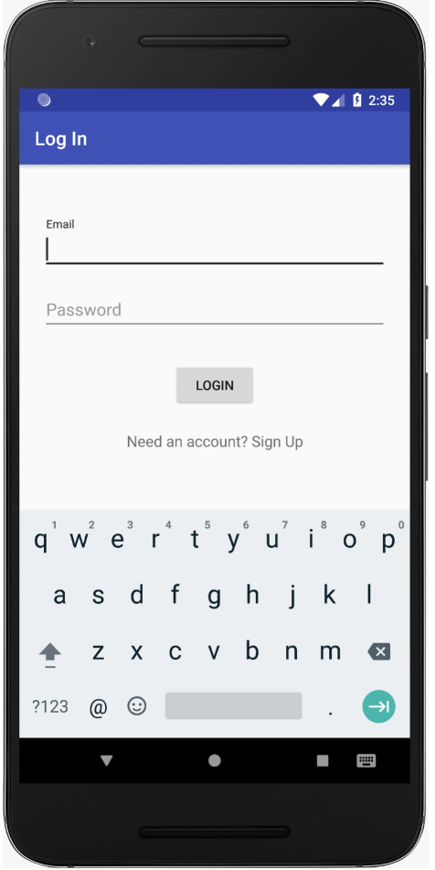

Fig. Implementation of Sign Up and Login

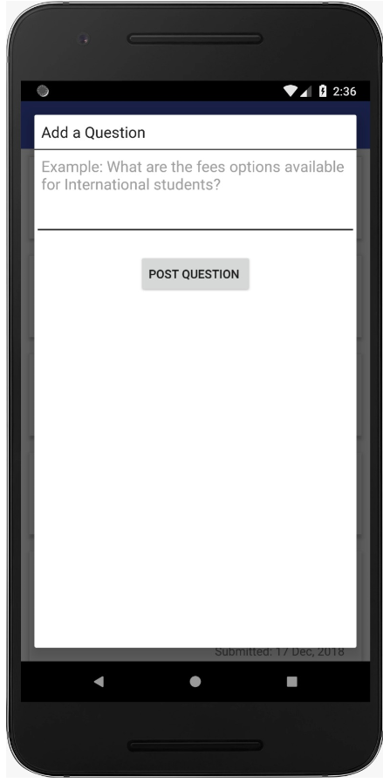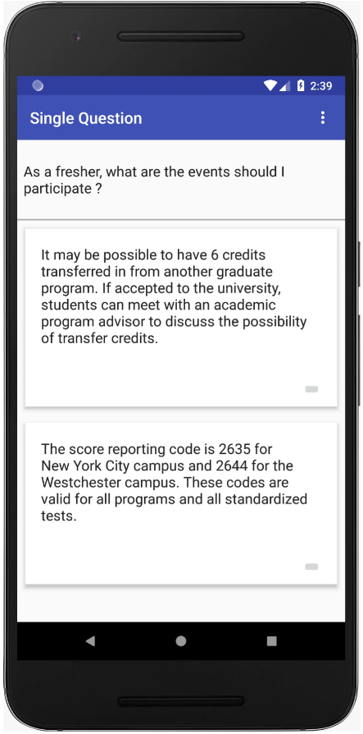

Fig. Implementation of Post Query Page

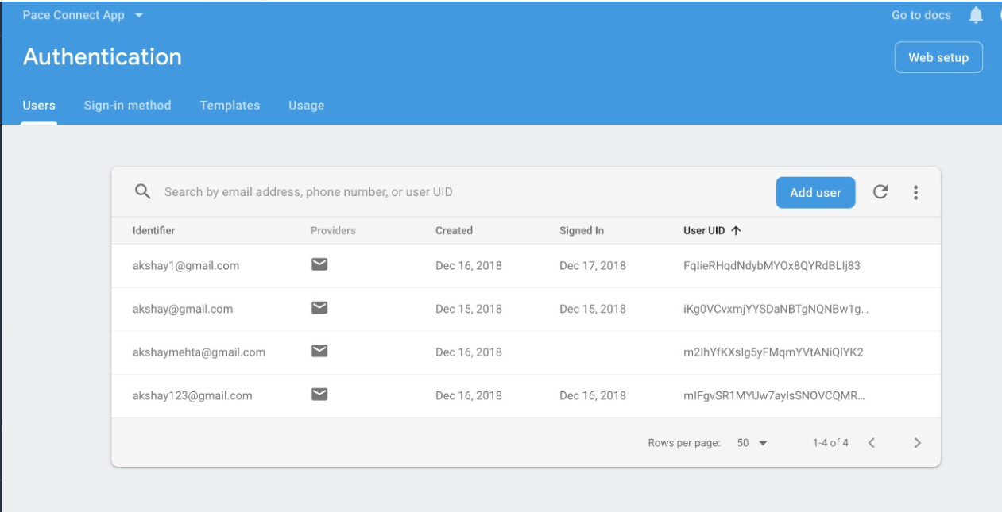

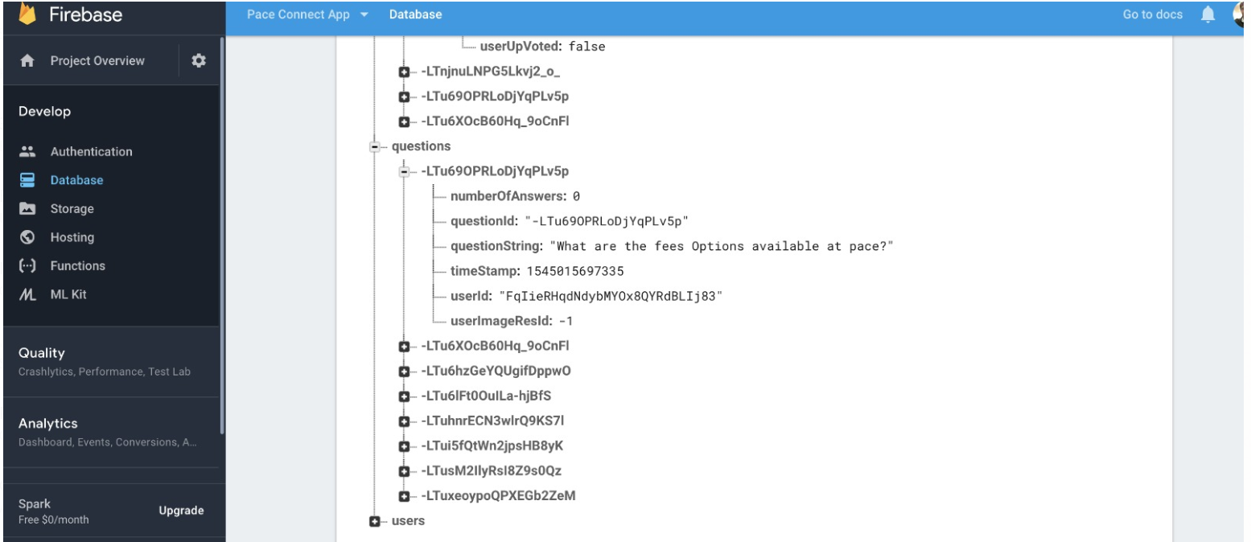

1. Conclusion

The authors have implemented an application for the students of Pace University to collaborate with each other for sharing and gaining of knowledge, buying or selling items, career opportunities, notification of events through a platform of a mobile application Pace Connect.

1. References
2. Agile Software Development https://en.wikipedia.org/wiki/Agile_software_development#Evolutions
3. Scrum https://www.mountaingoatsoftware.com/agile/scrum.
4. [Shao Guo-Hong](https://ieeexplore.ieee.org/search/searchresult.jsp?searchWithin=%22First%20Name%22:%22Shao%22&searchWithin=%22Last%20Name%22:%22Guo-Hong%22&newsearch=true&sortType=newest) (2014). Application Development Research Based on Android Platform.
5. A Quick Guide to Firebase: An Innovation in Mobile App Development
6. https://dzone.com/articles/a-quick-guide-to-firebase-an-innovation-in-mobile
7. Main advantages of developing Android apps

<http://androiddeveloper.galileo.edu/2017/09/04/main-advantages-developing-android-app>

[7] Bradford P (2006) The Blackboard Learning System. Conference on Instructional Technologies

Fig. Firebase Authentication Logs

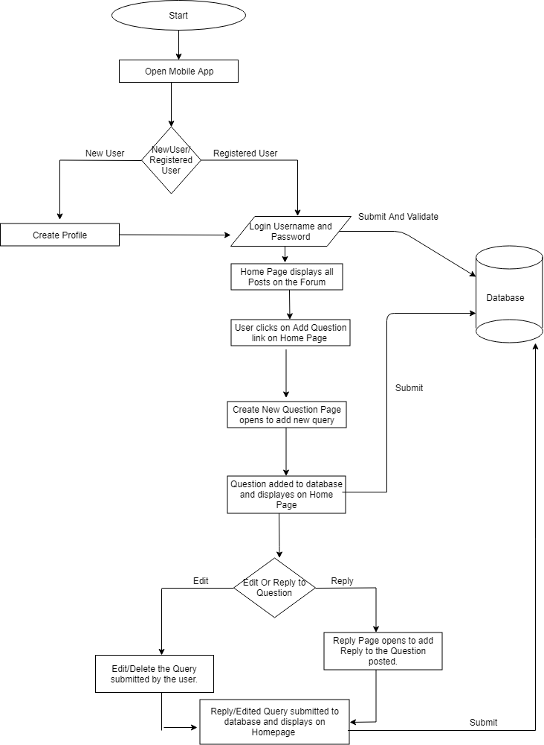

**FLOWCHART**