**Machine Learning**

**Project - 1**

**Name: Nikhita Rama Karkera**

**NetID: NXK180006**

**Network Description:**

The training data is preprocessed before the training.



My model has 4 layers and has a hyperbolic tangent activation function on each layer. The first layer has 10 nodes and the next 2 layers have 5 nodes. The last layer has k(Number of categories) nodes. The model also has a regularized layer which is regularized by l2(0.001). It also has a dropout of 0.2. The last layer has SoftMax activation function.

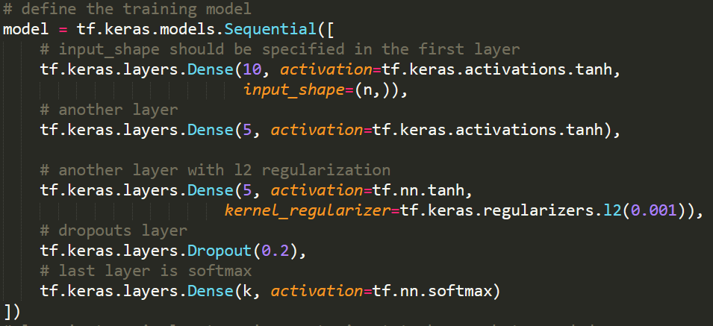

The model is optimized using Adam. The model is trained with epochs of 1000 and batch size of 32.

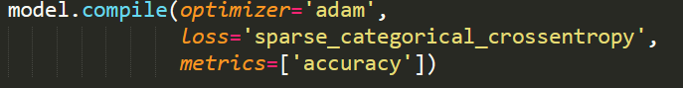

The testing data is trained after it has been preprocessed.

**Result of Experiment:**

I have checked the model for different training data and here is my result.

For dataset containing 10% of data (57 examples) and seed of 7 the result is:

