MINI PROJECT REPORT
MEDCARE HOSPITAL MANAGEMENT SYSTEM
1. Introduction
The MedCare Hospital Management System is a console-based real-world application developed using Java and MySQL. It manages patient registration, doctor management, appointments, billing, and hospital statistics.
The project applies Object-Oriented Programming concepts from Unit I and Unit II of Java Programming and is designed as a practical, database-connected application.
2. Objectives
- Develop a practical hospital management application using Java.
- Demonstrate fundamental and advanced OOP concepts.
- Store and retrieve hospital information using MySQL.
- Manage patients, doctors, appointments, and bills.
- Demonstrate encapsulation, inheritance, abstraction, polymorphism, interfaces, constructors, method overloading, and method overriding.
- Provide a simple console-based user interface.
3. Technologies Used
Technology | Purpose
Java | Application development
MySQL | Database management
JDBC | Java–MySQL connectivity
VS Code | Development environment
MySQL Connector/J | Database connectivity

4. Main Modules
Patient Management
- Register patient
- View patients
- Search patient
- Update patient
- Delete patient
Doctor Management
- Register doctor
- View doctors
- Search doctor
- Delete doctor
- Store consultation fee and salary

Appointment Management
- Book appointment
- View appointments
- Update appointment status
- Delete appointment

Billing
- Generate patient bills
- Calculate consultation and medicine charges
- Apply discount
- Display total amount

Hospital Statistics
- Total patients
- Total doctors
- Total appointments
- Total revenue
- Total doctor salary
- Estimated profit

5. OOP Features Used
Requirement | Implementation
Encapsulation | Patient, Doctor, Appointment, Bill
Varied data types & constants | HospitalConstants, model classes
Operator precedence | Bill.calculateBill(double)
Type casting | Main.java – double to int
Enum | Department.java
Control & jump statements | Main.java – if, switch, loops, break, continue, return
Array of objects | Patient[] in Main.java
Console I/O | Scanner in Main.java
Constructor overloading | Model classes
Method overloading | Bill.calculateBill() and calculateBill(double)
Static members | operationCount and static service objects
this keyword | Model class constructors/setters
String methods | trim() in Main.java
Inheritance | Person → Patient, Person → Doctor
super keyword | Patient.java, Doctor.java
Dynamic binding | Person person = doctor
Abstract class | Person.java
Interface | Billable.java implemented by Bill
toString() overriding | Person, Patient, Doctor, Appointment, Bill
Final class | HospitalConstants.java
Custom packages | hospital.model and hospital.service

6. Database Design
The system uses a MySQL database named hospital_management containing four main tables:
- patients
- doctors
- appointments
- bills
Java connects to MySQL using JDBC through the DatabaseConnection class.
7. Project Structure
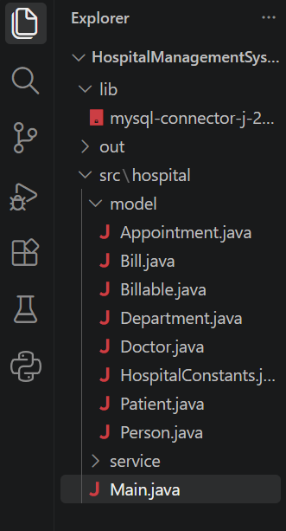

8. Sample Console Output
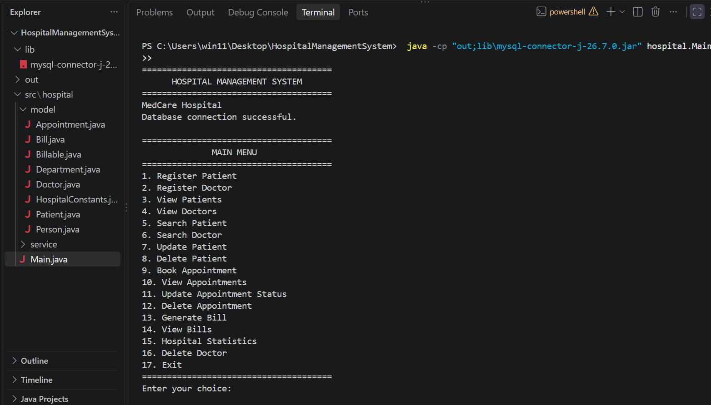
9. Conclusion
The MedCare Hospital Management System demonstrates how Java Object-Oriented Programming concepts can be applied to a practical real-world application. The system integrates Java with MySQL to provide persistent management of hospital records and implements the required Unit I and Unit II programming concepts.

