# 401KPlan_Recommendation

401K Plan Recommendation System

** Objective: **

A huge challenge in investing today is to manage risks while maximizing earnings and still have enough for a secure retirement. We proposed a 401K Plan Recommendation System, guiding the user about where and how much to invest. This decision is important to have a secure retirement plan and stable income post retirement.

** Application Solution Approach and Features: **

1. Interactive User Interface to present useful analytics and predictions of the user's 401K final balance when he retires.

2. customized view of his investment returns in a graphical representation form, for ease of understanding and comparison between different plans and to choose best out of them.

3. An ideal and customized recommendation of a 401K investment plan to the user based on his age, desired type of plan. These are calculated based on basic investment norms and other factors like inflation and varying rate of return on stocks or equities and bonds.

4. View of live information about rate of returns on bonds and stocks from Yahoo API, to help user understand how unpredictable rates of return are in various stocks and fixed income investments.

5.Help the user invest in safe options considering his age, considering a more practical rate of inflation and rate of returns from equities.

6. Graphical representation of the user selection and our recommended plans.

7. Graphs include annual analysis, analysis of 401K balance at the end of each year till his retirement, amount of investments made in various sectors, 401K balance with and without employee match.

8. We also give him our recommended plan which best suits for his age group, and is designed to get optimal results in all cases.

9. We took into account the live stock prices, which we gathered information from Yahoo API and calculated rate of returns as a mean average from all of those values. This is updated on a regular basis as stock prices change.

10. We also tried to make the inflation rate more than the average value, taking the worst case into consideration.

11. Our recommendations are best suited for anyone, even in the worst case of stock returns and inflation rate. The user can live up to his expenditure even after his retirement if he is investing as per our recommendations, based on his current expenditure and savings. We suggest him to play safe with his investments.

**Features:**

User Registration:

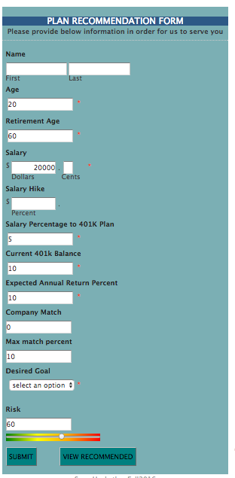

User Selection:

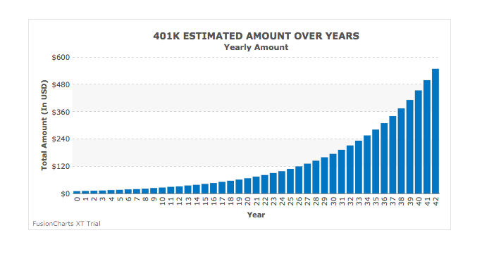

Types of his investment:

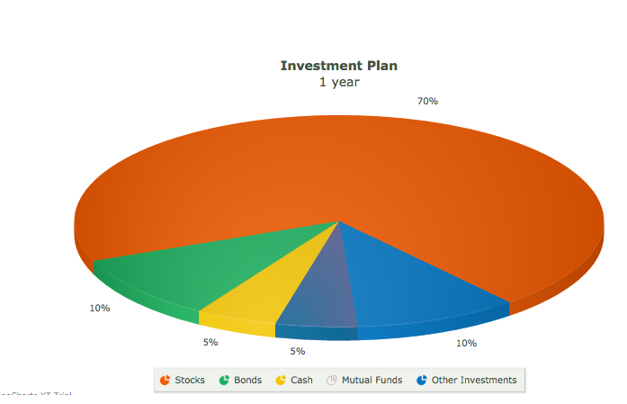

With and without employee match:

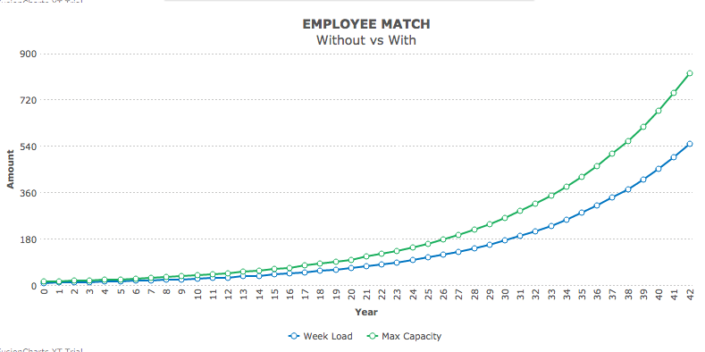

Our Recommendations:

Annual Analysis:

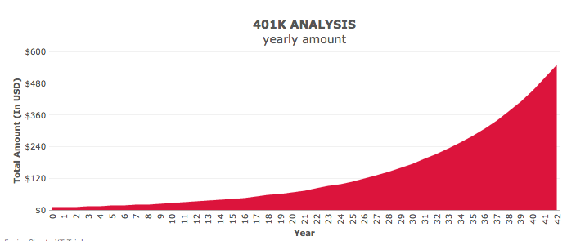

Live update from stocks and bonds:

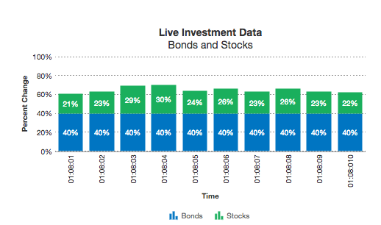

Types of investments at various Stages in his life:

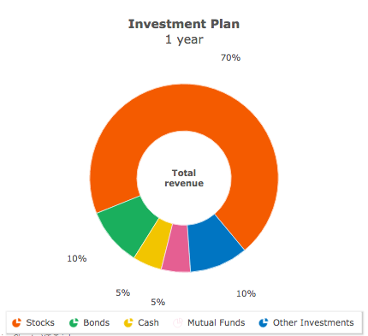

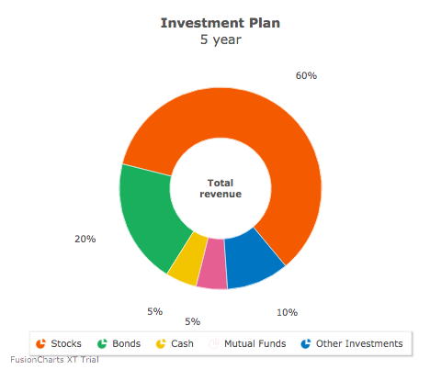

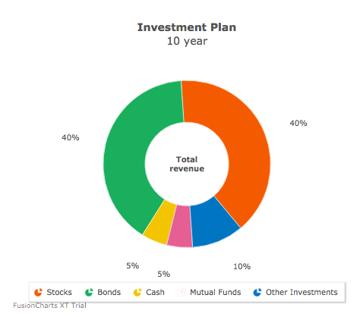

Conclusion:

We just don’t give him an investment plan based on his selection. We also recommend him our options, which will be more safe for him considering various factors in to account. We achieved in building an effective retirement portfolio for the user.