NTheddu_01225155_descriptive_Statistics.R

Nikhith

2019-12-28

library(tidyverse)

## -- Attaching packages ---------------------------------------------------------- tidyverse 1.2.1 --

## v ggplot2 3.2.1 v purrr 0.3.2  
## v tibble 2.1.3 v dplyr 0.8.3  
## v tidyr 1.0.0 v stringr 1.4.0  
## v readr 1.3.1 v forcats 0.4.0

## -- Conflicts ------------------------------------------------------------- tidyverse_conflicts() --  
## x dplyr::filter() masks stats::filter()  
## x dplyr::lag() masks stats::lag()

library(tidyr)  
library(dplyr)  
data<-read.csv('C:/Users/Owner/Downloads/reddit.csv')  
mean(data$Number.of.comments) # average number of comments

## [1] 19.77467

new_data<- data %>% separate(timestamp,c("Date","Time"),sep = " ") #separate data and time  
final_data<- new_data %>% separate(Date,c("Year","Month","Day"),sep = "-") #separate year, month,day  
ggplot(final_data,aes(Year))+geom_bar() #plot of year and count

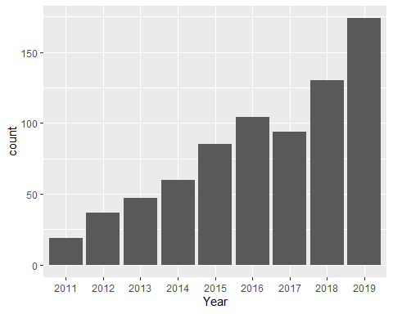

ggplot(final_data,aes(Month))+geom_bar() #plot of month and count

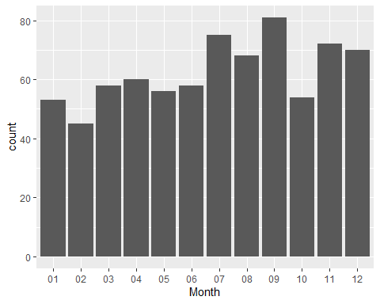

tail(names(sort(table(final_data$Author))),5) #prints top 5 users

## [1] "paolo001" "dmv12345" "Musichead2468" "dcretiree"   
## [5] ""

final_data[which.max(final_data$Number.of.comments),] #prints row containing max number of comments

## Author ID Number.of.comments  
## 5 Link2liberty 2w3mf8 642  
## Title  
## 5 Posted yesterday about stuck in DC  
## Actual.Posting.Content  
## 5 Hello again everybody, I posted just the other day about the Texas Young Americans for Liberty group stuck here. Turns out that the bus won't be able to pick us up today either. I just wanted to say thank y'all for connecting me with all the resources y'all did. Who knows how long we'll be here! (I personally don't mind it)   
## Points  
## 5 90  
## Image.URL  
## 5 https://www.reddit.com/r/washingtondc/comments/2w3mf8/posted_yesterday_about_stuck_in_dc/  
## Subreddit Created  
## 5 washingtondc 1424140173  
## Reddit.URL Year  
## 5 /r/washingtondc/comments/2w3mf8/posted_yesterday_about_stuck_in_dc/ 2015  
## Month Day Time  
## 5 02 16 21:29:33

final_data[which.max(final_data$Points),] #prints row containing max points

## Author ID Number.of.comments Title  
## 204 pamelagiahi dutf3j 503 Visiting for 2 weeks  
## Actual.Posting.Content  
## 204 This is my first time in D.C. was wondering if thereÃ¢\200\231s any cool / instagrammable (I know haha) places I should visit or eat at! Going to do all the touristy things but also want to see things tourists donÃ¢\200\231t usually see!  
## Points  
## 204 178  
## Image.URL  
## 204 https://www.reddit.com/r/washingtondc/comments/dutf3j/visiting_for_2_weeks/  
## Subreddit Created  
## 204 washingtondc 1573512759  
## Reddit.URL Year Month Day  
## 204 /r/washingtondc/comments/dutf3j/visiting_for_2_weeks/ 2019 11 11  
## Time  
## 204 17:52:39

summary(final_data) #summary of the whole data

## Author ID Number.of.comments  
## : 47 10m8l2 : 1 Min. : 0.00   
## dcretiree : 6 1134g9 : 1 1st Qu.: 5.00   
## dmv12345 : 5 11dv1i : 1 Median : 12.00   
## Musichead2468 : 5 11trjl : 1 Mean : 19.77   
## beefcake_123 : 4 12a5xt : 1 3rd Qu.: 22.00   
## dihydrogen_monoxide: 4 13ihbj : 1 Max. :642.00   
## (Other) :679 (Other):744   
## Title   
## "And this is why you never drink DC Tap Water." : 1   
## "Districtland," basically "Girls" set/filmed in DC : 1   
## "I'm moving to DC, please give me advice about X" posts. : 1   
## "I Drove My Aston Martin Through The Nightmare Traffic Of Washington D.C." : 1   
## "My white Neighbor's has been doing a lot of racial profiling and constantly calling the police": 1   
## #Blessed : 1   
## (Other) :744   
## Actual.Posting.Content  
## :356   
## \n\n[I'm fascinated by the responses I've gotten to my ranting from the young people of Reddit.Rather than subjecting everyone to my ranting, I thought it best to refer those interested to my blogspot listed below.](http://ronlehkersrants.blogspot.com/) \n[ ](http://ronlehkersrants.blogspot.com/)\n\n[http://ronlehkersrants.blogspot.com/](http://ronlehkersrants.blogspot.com/)\n\n[ ](http://ronlehkersrants.blogspot.com/)\n\n[ ](http://ronlehkersrants.blogspot.com/) : 1   
## I miss hearing The Hot Morning Mess with Mark Kaye, Kris Gamble producer Ron Ross, and my favorite Teapot Tim. I miss their stories and crazy antics. Kane was okay to listen to after they left. I officially stop listening to him when he cried on air, trying to make his wife at the time look bad. I know he was full of shit. : 1   
## \nI'm considering buying a Segway Mini pro, for my morning commute. I figure the Segway mini pro is much smaller than a normal sized Segway. I know at least for DC you have to have a helmet and can't use headphones but I'm debating if it is worth the trouble. It's small enough to bring on the metro and to my job\n\nI honestly want to use it on the sidewalk though.\n\nThoughts? : 1   
## "Love Thy Neighbor" is another dramatic story I wish EVERYONE could read. It's in today's Washington Post (7/2) and tells the story of a doctor coming to a small town in southwest Minnesota. He is warmly received and welcomed as a leader - until Trump is elected president. The only thing that hasn't changed is that he continues to worship Allah! Now his and his whole families' world changes.\nWhat a price our country is paying for electing Trump as our president. He has shown us how much PREJUDICED OUR CITIZENS ARE AGAINST THE PERCEIVED "OTHER."\nOf course minorities have known that for a long time.: 1   
## &#x200B;\n\nhttps://preview.redd.it/ob5hrp8v6ow31.jpg?width=3024&format=pjpg&auto=webp&s=4a39c5a5448f261c789e4bae0c3767227aa2687a : 1   
## (Other) :389   
## Points   
## Min. : 0.000   
## 1st Qu.: 0.000   
## Median : 0.000   
## Mean : 2.577   
## 3rd Qu.: 2.000   
## Max. :178.000   
##   
## Image.URL   
## http://act.credoaction.com/sign/rename_reagan_airport?sp_ref=146495001.4.15584.f.64466.3&referring_akid=.3052774.fqiIi0&source=fb_share_sp: 1   
## http://bandwidth.wamu.org/citing-israel-policy-d-c-jewish-community-center-pulls-the-plug-on-the-shondes/ : 1   
## http://claytonhanson.com/blog/2013/4/21/down-penn-ave-to-the-capital : 1   
## http://dailycaller.com/2015/03/25/discrimination-suit-takes-a-dramatic-twist-black-ex-posties-claim-wapo-purged-blacks/ : 1   
## http://dailycaller.com/2015/08/30/dc-govt-just-initiated-a-hostile-take-over-of-beloved-eastern-market/ : 1   
## http://dc.curbed.com/maps/crystal-city-art-walls : 1   
## (Other) :744   
## Subreddit Created   
## washingtondc:750 Min. :1.299e+09   
## 1st Qu.:1.430e+09   
## Median :1.489e+09   
## Mean :1.480e+09   
## 3rd Qu.:1.544e+09   
## Max. :1.577e+09   
##   
## Reddit.URL   
## /r/washingtondc/comments/10m8l2/i_just_need_to_rant_about_metro/ : 1   
## /r/washingtondc/comments/1134g9/pic_i_took_my_first_summer_here/ : 1   
## /r/washingtondc/comments/11dv1i/so_you_want_to_move_to_washington_dc/ : 1   
## /r/washingtondc/comments/11trjl/in_regards_to_my_twohour_drive_home_in_the/ : 1   
## /r/washingtondc/comments/12a5xt/respect_for_those_who_guard_the_unknown_fallen/: 1   
## /r/washingtondc/comments/13ihbj/week_off_down_to_party/ : 1   
## (Other) :744   
## Year Month Day   
## Length:750 Length:750 Length:750   
## Class :character Class :character Class :character   
## Mode :character Mode :character Mode :character   
##   
##   
##   
##   
## Time   
## Length:750   
## Class :character   
## Mode :character   
##   
##   
##   
##