
Department of CSE

B.Tech. CSE Trimester -5

2520030033
Nikhitha gondi

Cloud Infrastructure and Services
25CS2206E

LAB RECORD
2026

Experiment -2

AIM: To enable Multi-Factor Authentication (MFA) on the AWS root user account using a Virtual MFA device and verify the authentication process during AWS login. Also, to compare Virtual MFA devices, Hardware MFA devices and FIDO Security Keys.

Description:
Multi-Factor Authentication (MFA) is a security mechanism that provides an additional layer of protection to user accounts. It requires users to verify their identity using more than one authentication factor during login.
In this experiment, MFA is enabled on the AWS root user account using a Virtual MFA device through the Google Authenticator application. The application generates a six-digit Time-Based One-Time Password (TOTP), which is used during login verification.
After assigning the MFA device, the authentication process is tested by signing out and signing in again using the root user credentials and the generated MFA code.

Steps:
Part A: Enable MFA on AWS Root User
- Open the AWS Management Console at https://aws.amazon.com/console/.
- Sign in using the AWS root user email address and password.
- Complete the required verification steps.
- Click the account name in the top-right corner.
- Select Security Credentials.
- Locate the Multi-Factor Authentication (MFA) section.
- Click Assign MFA device.
- Enter a suitable device name, such as Root-Virtual-MFA.
- Select Authenticator app (Virtual MFA device).
- Click Next to display the QR code.
- Install and open Google Authenticator on the smartphone.
- Scan the QR code displayed on the AWS console.
- The application generates a six-digit authentication code.
- Enter the first code in the MFA code 1 field.
- Wait for the next code to generate and enter it in the MFA code 2 field.
- Click Add MFA to complete the registration.
- Verify that the Virtual MFA device is displayed in the AWS Security Credentials section.
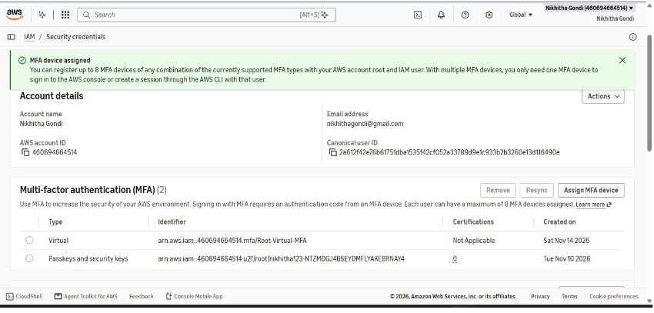
Part B: Verify MFA Authentication
- Sign out of the AWS Management Console.
- Open the AWS Management Console sign-in page.
- Select Root user.
- Enter the registered root user email address and password.
- Select the authenticator app verification method.
- Open Google Authenticator on the smartphone.
- Enter the currently displayed six-digit authentication code.
- Click Submit or the equivalent verification option.
- Verify that access to the AWS Management Console is successful.
Part C: Comparison of Different MFA Devices
- Study Virtual MFA devices such as Google Authenticator and Microsoft Authenticator.
- Study Hardware MFA devices that generate six-digit authentication codes.
- Study FIDO Security Keys such as YubiKey.
- Compare the devices based on their authentication method, security, convenience and usage.

Output:
Multi-Factor Authentication was successfully enabled on the AWS root user account using a Virtual MFA device through Google Authenticator.
The application generated six-digit authentication codes, which were used to complete MFA verification during login. After signing out and signing in again, the AWS account was successfully accessed using the authenticator app verification method.
The Virtual MFA device was successfully displayed in the AWS Security Credentials section. The existing passkey/security key MFA method was also retained.
Thus, MFA assignment and authentication verification were successfully completed.


