
Department of CSE

B.Tech. CSE Trimester -5

Roll Number: 2520030033
Name: Nikhitha Gondi

Cloud Infrastructure and Services
25CS2206E

LAB RECORD
2026

Experiment -1(b): Enabling Multi-Factor Authentication (MFA)

AIM: To create an IAM user in AWS and enable Multi-Factor Authentication (MFA) to provide an additional layer of security for AWS account access.

Description:
AWS Identity and Access Management (IAM) is used to manage users and control access to AWS resources. An IAM user can be created with the required permissions so that daily access does not depend on using the root account. Multi-Factor Authentication (MFA) adds another verification step during sign-in. In this experiment, an IAM user named Student1 was created successfully. The AWS security credentials page also confirmed that a passkey MFA device had been assigned to the root user.

Steps:
1. Open the AWS Management Console and sign in using the root account.
2. Search for IAM and open the Identity and Access Management (IAM) service.
3. Select Users from the left navigation pane and click Create user.
4. Enter the username Student1 and proceed through the user-creation steps.
5. Configure the required sign-in access and permissions, review the details, and click Create user.
6. Return to the IAM users page and verify that Student1 appears in the users list.
7. Open the AWS account security credentials page and locate the Multi-Factor Authentication section.
8. Select Assign MFA device and choose Passkey or Security key.
9. Follow the browser prompts to register and verify the passkey.
10. Confirm that the console displays the successful MFA device assignment.

Output:
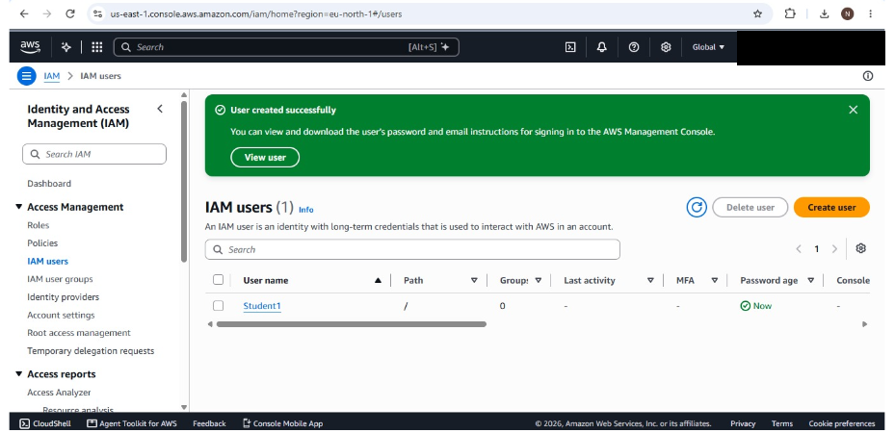
Figure 1: AWS IAM users page showing the successfully created Student1 user.
The AWS security credentials page displayed the confirmation “Passkey MFA device assigned,” showing that MFA was successfully configured for the root user.
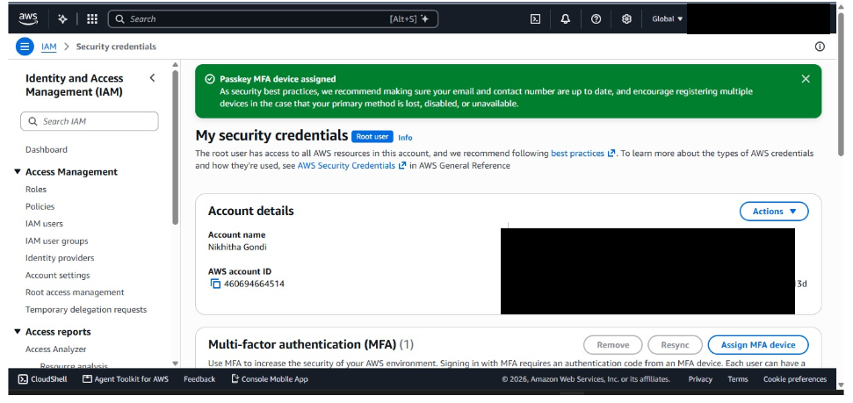
Figure 2: AWS security credentials page showing successful passkey MFA assignment.

Result:
The IAM user Student1 was created successfully in AWS. The AWS console also confirmed successful passkey MFA assignment for the root user. Thus, the user-creation and MFA security configuration activities demonstrated in the screenshots were completed.

