
Department of CSE

B.Tech. CSE Trimester -5

2520030033
Nikhitha Gondi

Cloud Infrastructure and Services
25CS2206E

LAB RECORD
2026

Experiment -1

AIM: To create an AWS free tier account to provision the resources.

Description:
Amazon Web Services (AWS) is a cloud computing platform that provides services such as computing, storage, databases and monitoring over the internet. Instead of maintaining physical servers, users can access and manage cloud resources through the AWS Management Console.
The objective of this experiment was to access the AWS platform by creating or using an AWS account and opening the AWS Management Console. The console provides a central interface for selecting a region and accessing services such as Amazon EC2, Amazon S3 and Amazon CloudWatch.
The submitted output shows the AWS Console Home page after sign-in. The selected region is Europe (Stockholm). A notification also indicates that the Asia Pacific (Hyderabad) opt-in region is being configured. The recently visited services visible in the console include EC2, S3 and CloudWatch.

Steps:
1. Open a web browser and visit https://aws.amazon.com/.
2. Choose the option to create an AWS account. Enter the required account and contact details and complete the verification steps requested by AWS.
3. Sign in to the AWS Management Console using the created account credentials.
4. After signing in, open Console Home. This is the central dashboard used to access AWS services.
5. Check the Region selector in the top navigation bar and select the required AWS Region. In the submitted output, Europe (Stockholm) is selected.
6. Open the service menu or use the search bar to locate services such as Amazon EC2, Amazon S3 and Amazon CloudWatch.
7. Verify that the console is accessible. If an opt-in Region is still being configured, wait for the process to finish and refresh the page before selecting that Region.
The AWS Management Console was accessed successfully. The screenshot below is the submitted output showing Console Home, the selected Europe (Stockholm) Region, and the EC2, S3 and CloudWatch services in Recently visited.
Output:

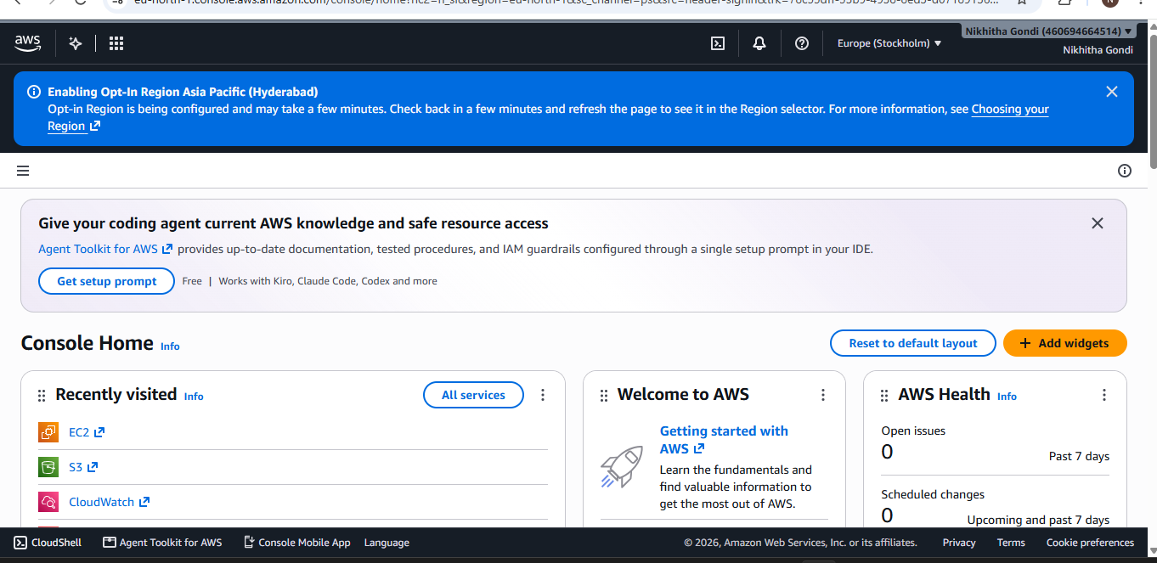
Figure 1: AWS Management Console Home

