Detection of DDOS Attack using Entropy Approach
In computer world two systems can interact with each other using network connection and sometime some malicious users can intercept those connections signals and then alter request values to perform malicious activities on receiver system. To detect and avoid such malicious attacks we are employing CUSUM entropy based DDOS (distributed denial of service) attacks detection technique.
The cumulative sum of entropy (CUSUM) can be used to track the randomness of the data over time. For example, if the cumulative sum of entropy is increasing, then the data is becoming more random. If the cumulative sum of entropy is decreasing, then the data is becoming less random.
As per CUSUM technique if there is sudden change in value then it will consider as attack. While normal communication all system network signature CUSUM value will be less than 0 and if malicious alteration occur then CUSUM value will get high and based on this approach we can say weather network communication is normal or attack.
To train CUSUM algorithm we are employing DDOS dataset and below screen showing dataset details
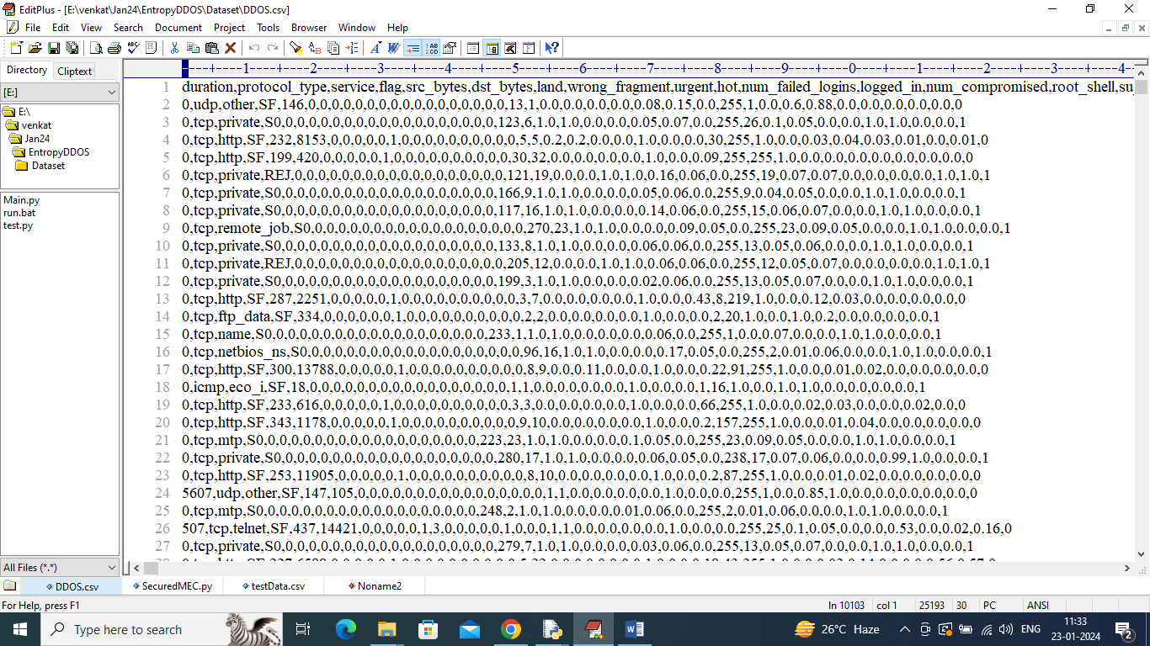
In above dataset screen first row represents dataset column names of network connection and remaining rows represents values and in last column we have class label as 0 or 1 where 0 means normal and 1 means attack. We will use this label to compare CUSUM prediction is correct or not and based on this we will evaluate its performance using Accuracy, Precision, Recall and FSCORE.
In below screen showing code for CUSUM computation
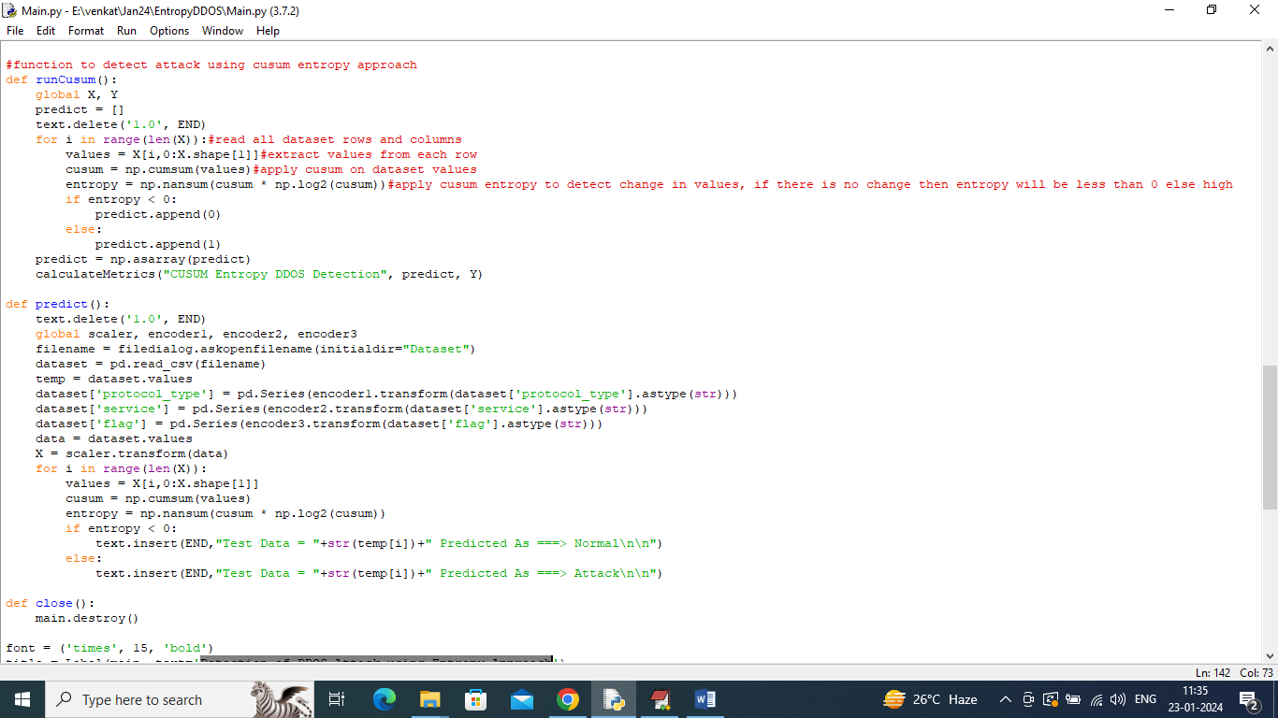
In above screen read red colour comments to know about entropy based attack detection.
To implement this project we have designed following modules
- Upload DDOS Dataset: using this module we will upload dataset to application and then plot graph of number of normal and attacks records
- Pre-process Dataset: dataset contains both numeric and non-numeric values but CUSUM will accept only numeric values so will process dataset to convert non-numeric values to numeric values and then shuffle and replace missing values with 0
- Normalize Training Features: using this module we will normalize all processed dataset values
- Train CUSUM Entropy Model: using this module will compute CUSUM entropy technique to detect attacks packets and then compare predicted labels with actual labels to calculate accuracy
- Predict Attack from Test Data: using this module we will upload test data and then apply CUSUM entropy model to predict weather test data is normal or attack.
SCREEN SHOTS
To run project double click on ‘run.bat’ file to get below screen
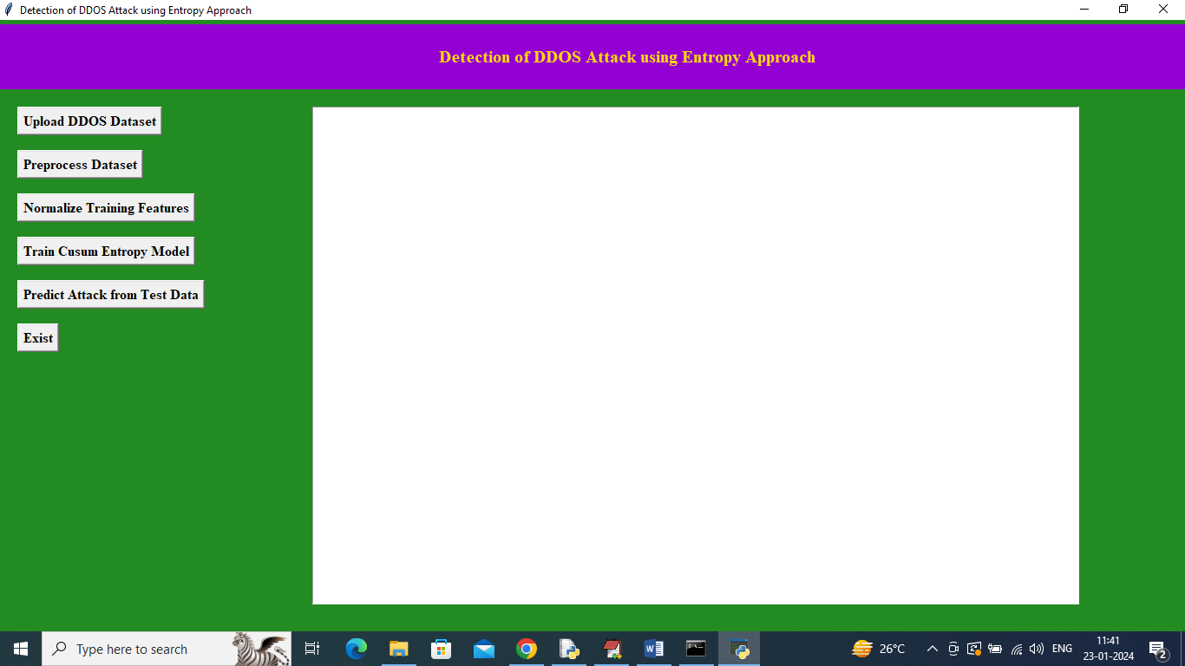
In above screen click on ‘Upload DDOS Dataset’ button to upload dataset and then will get below output
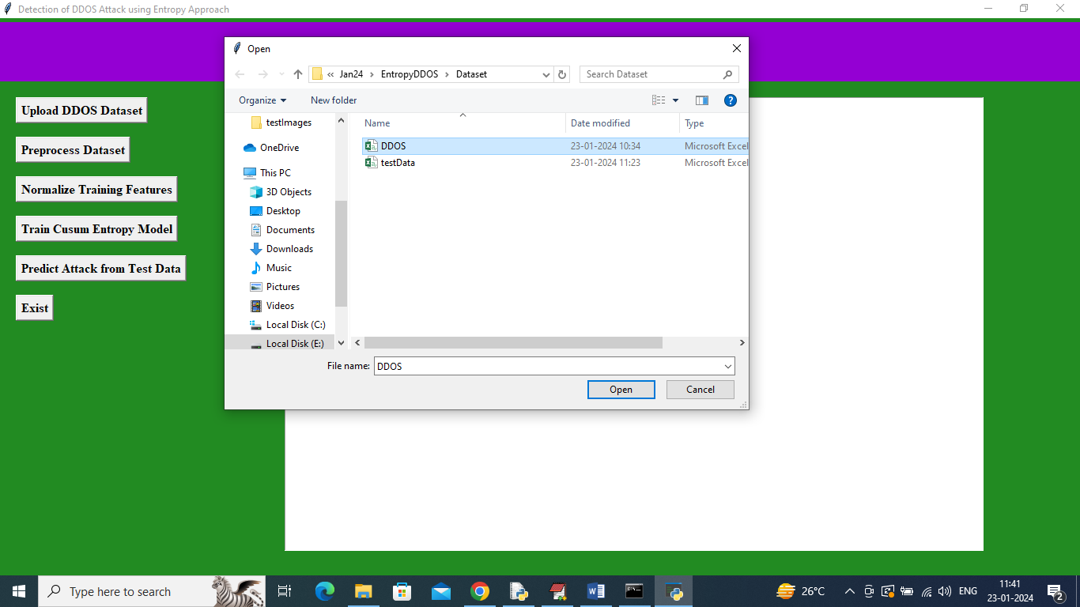
In above screen selecting and uploading ‘DDOS’ dataset file and then click on ‘Open’ button to load dataset and then will get below output
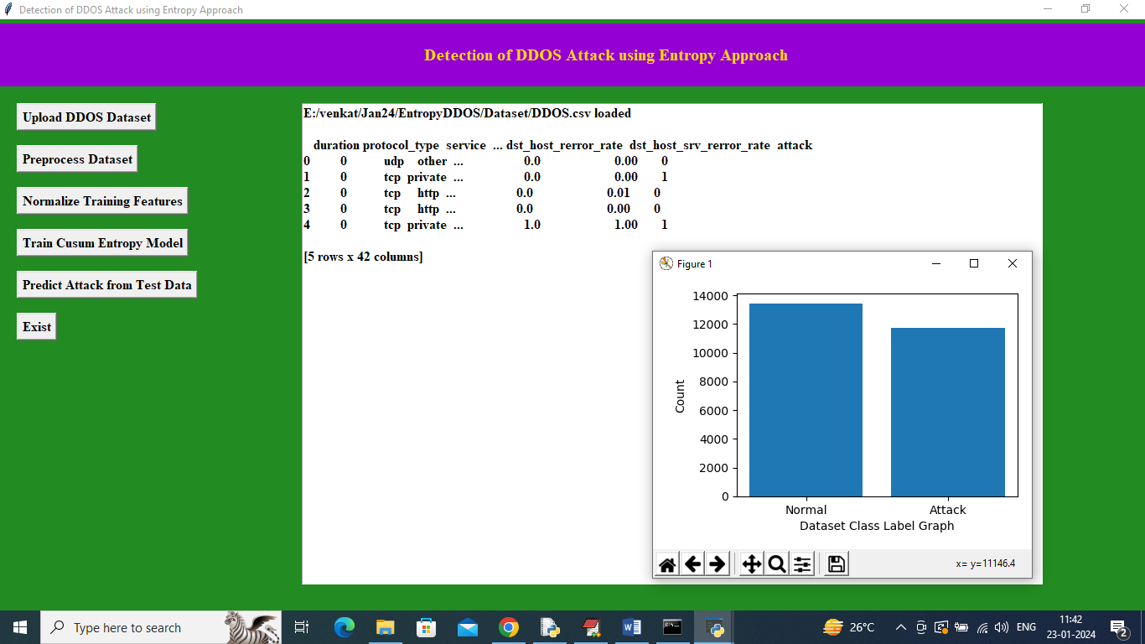
In above screen dataset loaded and displaying few records from dataset and can see dataset contains both numeric and non-numeric values and by processing dataset will convert non-numeric to numeric values. In above graph x-axis represents class labels and y-axis represents number of records in that class label. Now close above graph and then click on ‘Pre-process Dataset’ button to process dataset and then will get below output
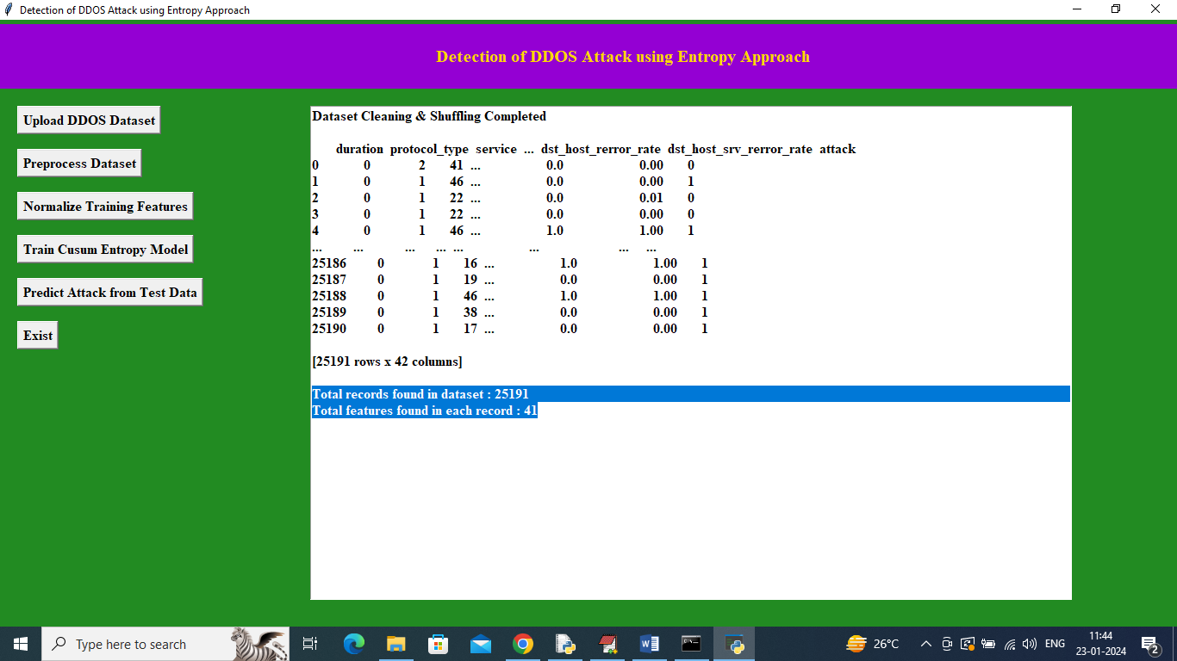
In above screen can see all dataset values converted to numeric and can see total records and number of features available in each record and now click on ‘Normalize Training Features’ button to get below output
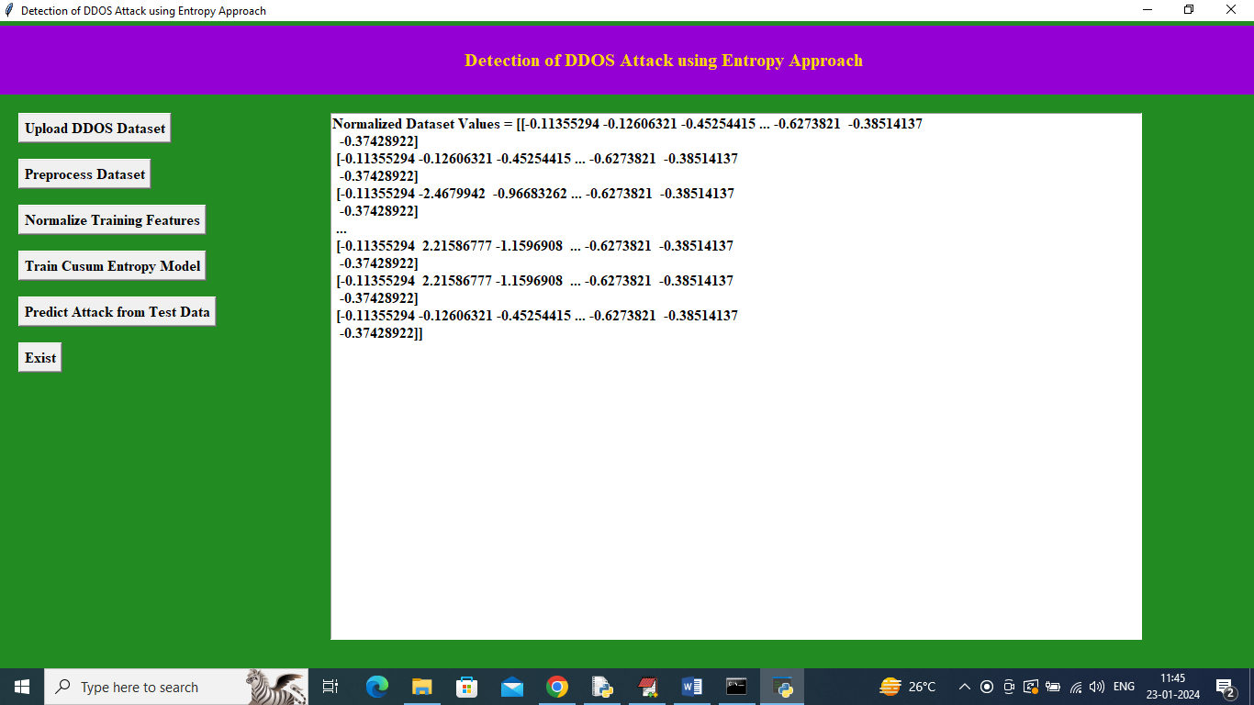
In above screen all dataset values normalized and now click on ‘Train CUSUM Entropy Model’ button to train entropy and get below output
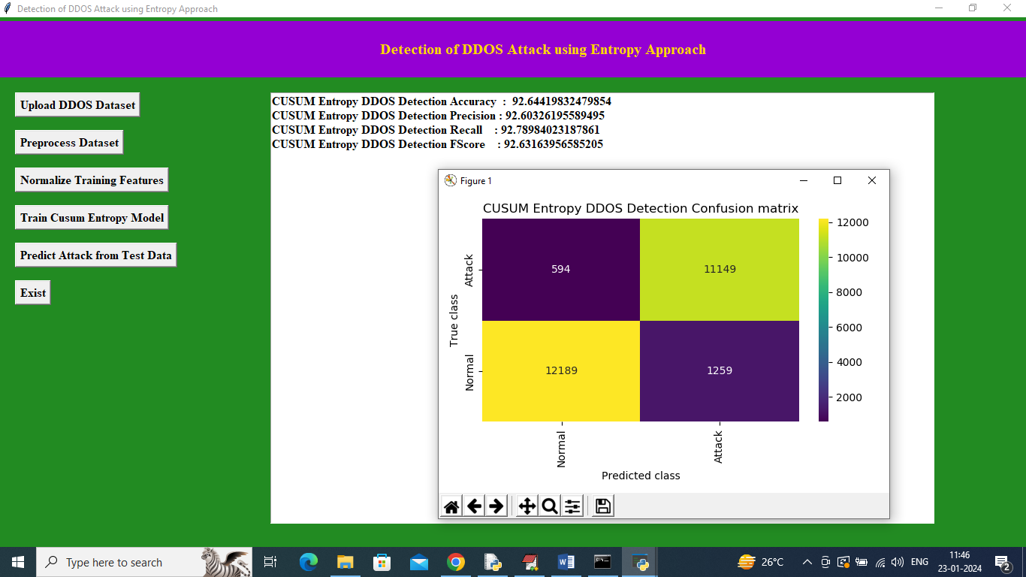
In above screen entropy DDOS attack detection got 92% accuracy and can see other metrics also and in confusion matrix graph x-axis represents Predicted Labels and y-axis represents True Labels and all yellow and light green boxes contains correct prediction count and all blue boxes contains incorrect prediction count which are very few. Now close above graph and then click on ‘Predict Attack from Test Data’ button to upload test data and then will get below output
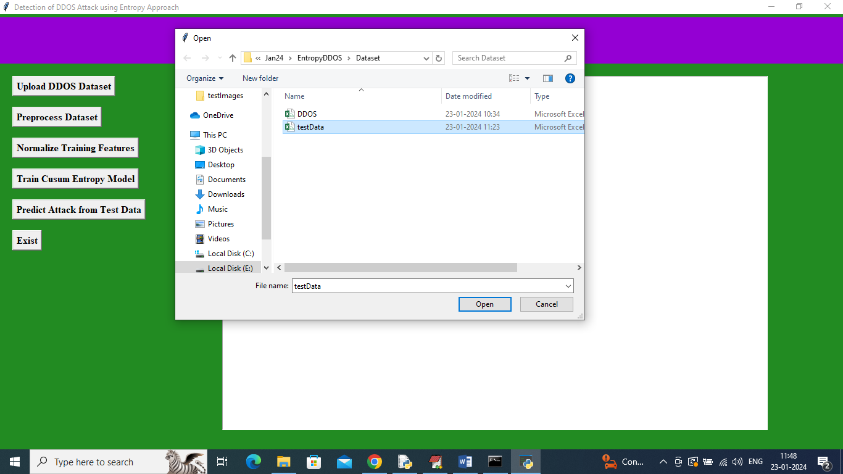
In above screen selecting and uploading ‘test data’ file and then click on ‘Open’ button to get below output
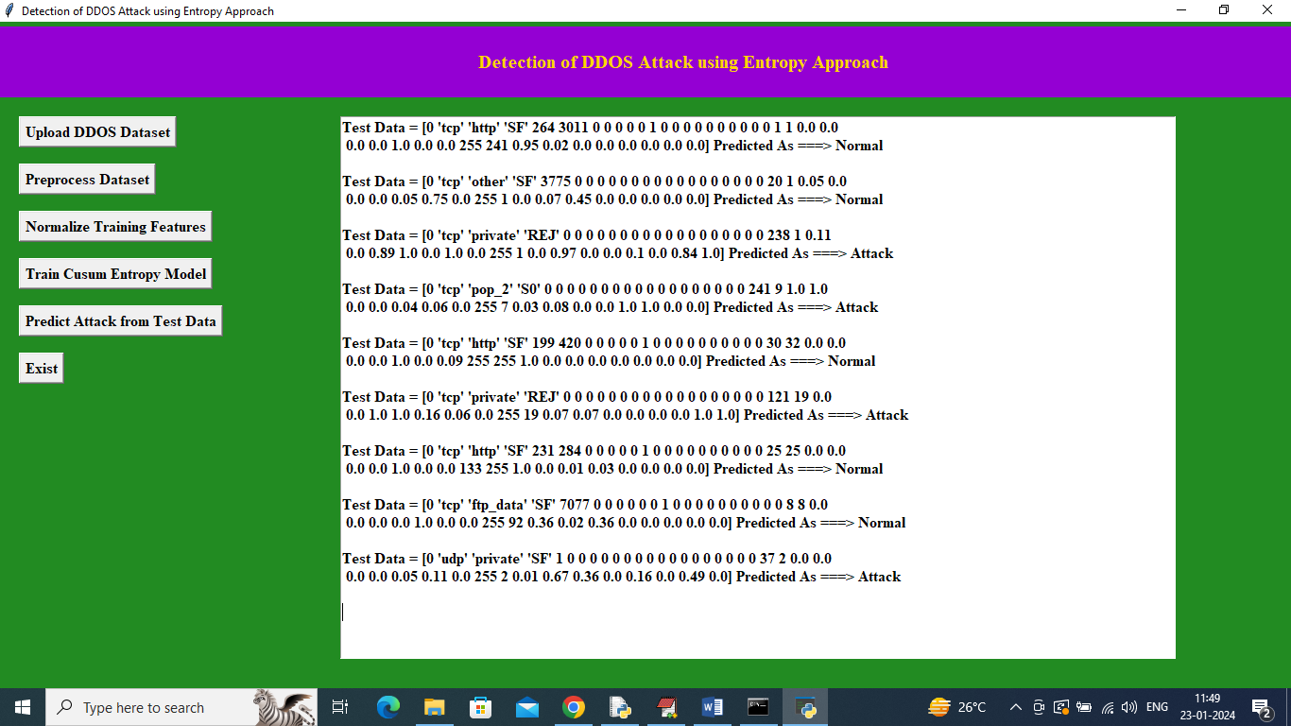
In above screen in square bracket can see TEST DATA values and after = arrow symbol can see CUSUM predicted values as ‘Normal or Attack’

