**Molecular Property Prediction Challenge**

**Model Architecture**

SchNet is a variant of deep tensor neural networks (DTNNs) that inherently respects the fundamental symmetries of atomistic systems, such as rotational and translational invariance, as well as invariance to the ordering of atom indices. Its architecture utilizes continuous-filter convolutional layers to effectively capture both spatial and chemical interactions. The model represents each atom as a feature vector x(l)i ∈ RD, where D denotes the feature space dimension and l represents the layer in the network. Atomic interactions are iteratively updated T times through pairwise interactions between feature vectors of atoms within a defined cutoff distance, incorporating information about the chemical environment and complex many-body interactions. The continuous-filter convolution layers, facilitated by filter-generating networks, refine these feature representations. Finally, the model pools atomwise updates to predict global molecular properties, ensuring an accurate and efficient mapping of structure-property relationships.

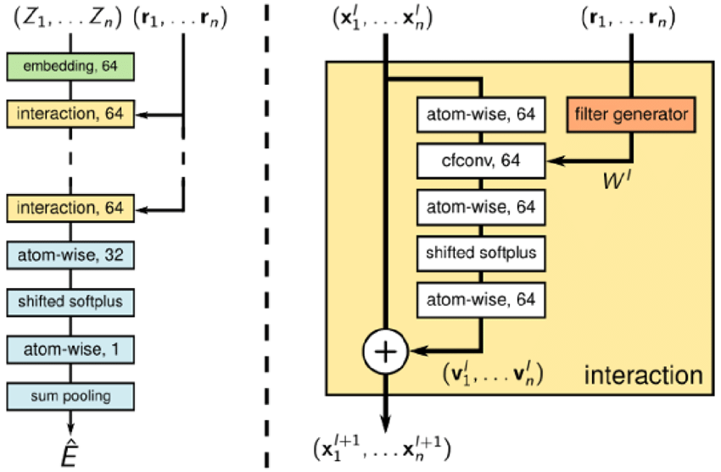

**Why choose PaiNN over SchNet?**

We employed a polarizable atom interaction neural network (PaiNN) to predict accurate dipole moments. PaiNN is particularly effective for predicting dipole moments because it learns from both geometric and directional information in molecular structures. It processes not only the positions of atoms but also how their spatial interactions influence directional properties like dipole vectors. By preserving rotation equivariance, PaiNN ensures that if a molecule is rotated, the predicted dipole moment rotates accordingly therefore aligning with physical reality. Its message-passing layers incorporate 3D structural and angular information, enabling accurate modeling of charge separation and molecular polarization, which are critical for calculating dipole moments.

While SchNet is better than grid-based architectures which can cause changes in atomic properties based on position of the atom in the grid, SchNet uses continuous convolutional layer to be translation and rotation invariant. This architecture works well for scalar properties. But for vector properties such as dipole moments, the model needs to be equivariant which means it should depend upon rotation etc. PaiNN incorporates not only interatomic distances but also atomic charges and directional (vector) embeddings, which is advantageous for the prediction of dipole moments.

**Hyperparameter Optimization**

Optimization of hyperparameters in SchNet is a tedious process as numerous layers and corresponding variables are involved. To facilitate this process, we used Optuna to optimize relevant hyperparameters to minimize the loss function.

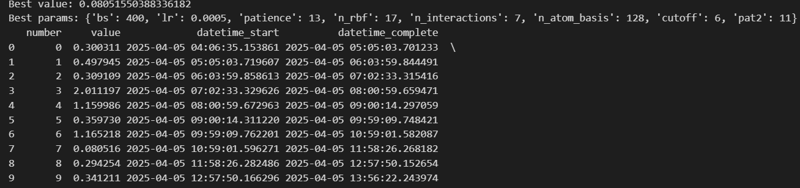

**Model Training and Prediction**

Using the hyperparameters obtained from Optuna, we trained the model with a walltime of approximately 2 hours on a single Nvidia RTX A6000 GPU. To enhance generalizability and prevent overfitting, we employed an EarlyStopping callback based on the validation loss. The model was evaluated using Mean Absolute Error (MAE) and Root Mean Squared Error (RMSE) as performance metrics. Training progress was monitored and logged using TensorBoard.

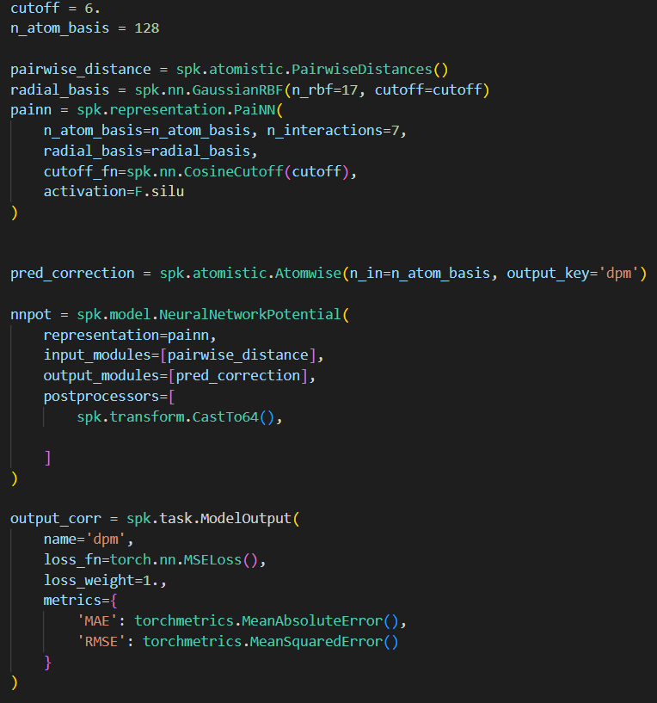

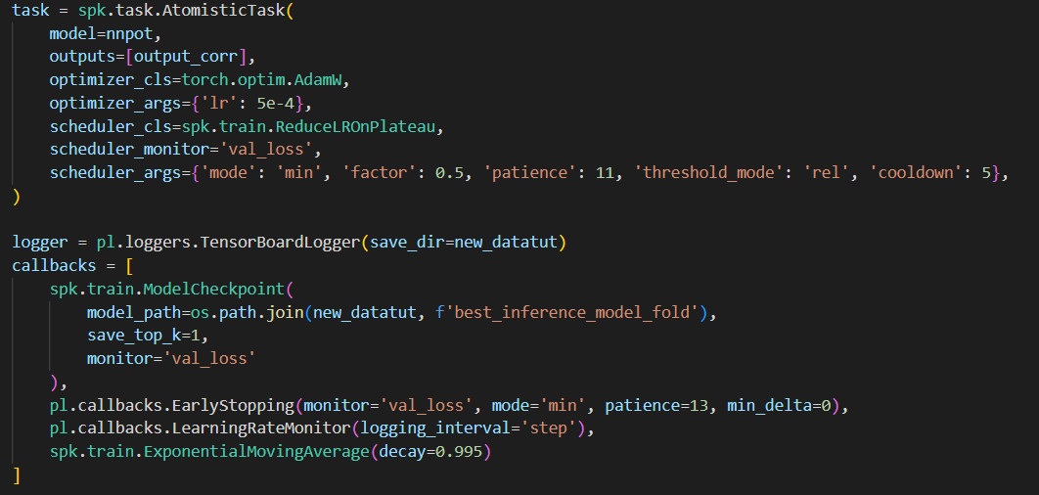

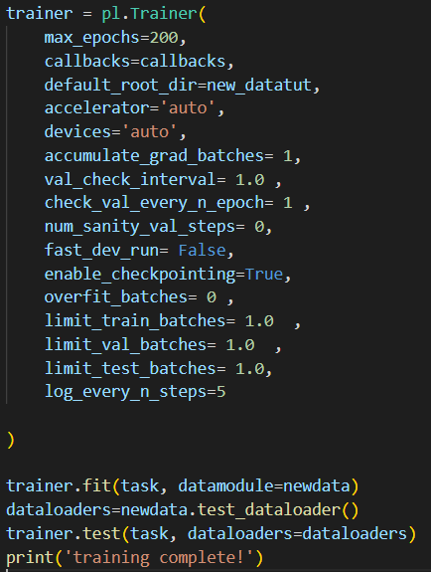

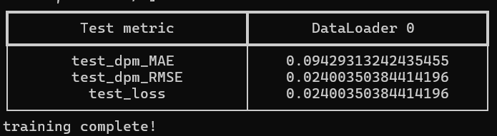 **Mean Squared Error obtained : 0.019 D**

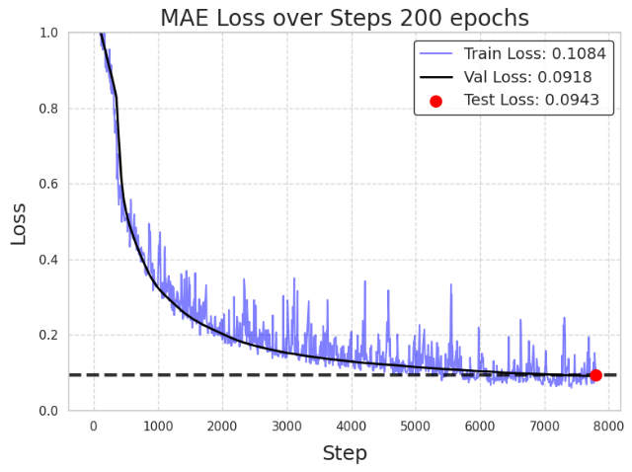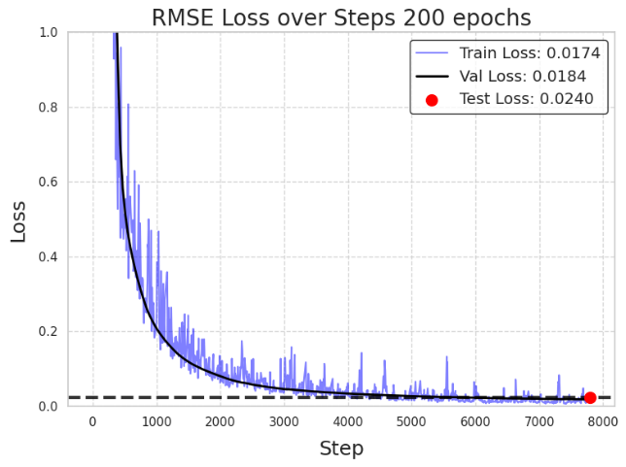

The model showed consistent performance on the training, validation, and test sets, indicating strong generalization without overfitting. By combining SchNet’s ability to model molecular environments using continuous filters instead of fixed grids, with PaiNN’s sensitivity to 3D geometry and directional interactions, our approach is well-suited for predicting complex properties like dipole moments.

**Descriptor Calculation Pathway Tryout**

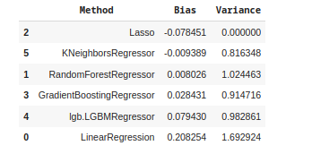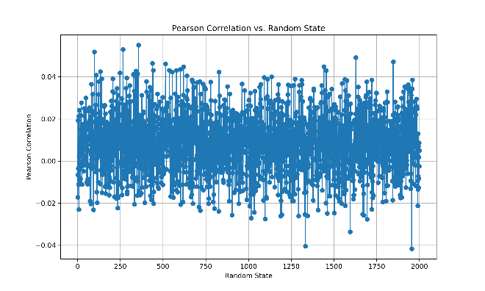

In our initial approach, we explored a wide range of 2D and 3D molecular descriptors that we believed might correlate with dipole moment. We systematically evaluated various combinations and mathematical transformations of these descriptors, building multiple models in the process. However, as illustrated by the random state versus Pearson correlation plots and the overall model performance table, these descriptors exhibited poor correlation with dipole moment, ultimately proving ineffective for accurate prediction.

Recognizing the limitations of descriptor-based models, we pivoted to a DTNN architecture (PaiNN), which inherently captures the critical physical interactions underlying dipole moment. These models effectively learn atom pair distances (as scalar features) and electronic distributions (as vector features like partial charges), both of which are fundamental to dipole moment calculation.

We further optimized the model using automated hyperparameter tuning via Optuna, and incorporated early stopping to prevent overfitting. As a result, our model achieved significantly minimized training and test losses, and reached a mean absolute error (MAE) that closely aligns with values reported in the literature.

It’s worth noting that while literature values are based on the full QM9 dataset, our challenge was limited to a 20k subset. Therefore, the performance achieved here is not only competitive but also highly realistic and robust given the data constraints.