PROJECT REPORT
LIBRARY MANAGEMENT SYSTEM
A MySQL-Based Relational Database Project

Independently Developed Project
Technology: MySQL | SQL | MySQL Workbench
2026

ABSTRACT
The Library Management System is an independently developed MySQL-based project designed to organize and manage essential library information. The system maintains records of books, authors, categories, members, librarians, borrowing transactions and fines using a relational database structure.
The project demonstrates practical SQL and database concepts including DDL, DML, filtering, aggregate functions, GROUP BY, HAVING, joins, single-row functions, subqueries, views, triggers and stored procedures. Primary and foreign keys are used to establish relationships and maintain data integrity. Triggers support automatic updates to available book copies, while stored procedures provide reusable database operations.

TABLE OF CONTENTS
1. Introduction
2. Problem Statement
3. Objectives
4. Scope of the Project
5. Technologies Used
6. System Requirements
7. System Design
8. Database Design
9. Entity Relationship Diagram
10. Database Tables
11. SQL Concepts Implemented
12. Views
13. Triggers
14. Stored Procedures
15. Testing
16. Advantages
17. Limitations
18. Future Enhancements
19. Conclusion
20. References

1. INTRODUCTION
A library handles a large amount of information related to books, authors, categories, members, librarians and borrowing transactions. A relational database provides a structured method for storing these records and retrieving them efficiently using SQL.
This project implements a Library Management System using MySQL. It represents major library entities through seven related tables: Authors, Categories, Books, Members, Librarians, Borrowings and Fines. The system is designed as a practical demonstration of relational database design and SQL operations.

2. PROBLEM STATEMENT
Managing library information without a structured database can make it difficult to maintain book records, monitor available copies, track borrowing and returns, and maintain fine information. This project addresses these requirements by organizing the information into related tables and providing SQL-based operations for data retrieval and management.

3. OBJECTIVES
- Design a relational database for library operations.
- Maintain book, author and category information.
- Maintain member and librarian records.
- Track book borrowing, due dates and returns.
- Track total and available book copies.
- Maintain fine amounts and payment status.
- Demonstrate practical SQL querying and database operations.
- Implement views, triggers and stored procedures.
- Maintain relationships using primary and foreign keys.

4. SCOPE OF THE PROJECT
The project covers the database management requirements of a library. It includes catalog management, member and librarian records, borrowing and return tracking, book availability and fine records. It also demonstrates SQL querying and MySQL database programming features.

5. TECHNOLOGIES USED
Technology / Tool | Purpose
MySQL 8.0+ | Relational database management
SQL | Database definition, manipulation and querying
MySQL Workbench | Database design, SQL execution and testing
MySQL Command Line Client | Command-line SQL execution and verification

6. SYSTEM REQUIREMENTS

6.1 Hardware Requirements
- Computer or laptop
- At least 4 GB RAM recommended
- Sufficient storage for MySQL and project files
- Keyboard and mouse

6.2 Software Requirements
- Windows, Linux or macOS
- MySQL Server 8.0 or later
- MySQL Workbench
- MySQL Command Line Client

7. SYSTEM DESIGN
The system follows a relational database design in which each major entity is represented by a table. Primary keys uniquely identify records and foreign keys connect related records. Books are associated with authors and categories. Borrowings connect books, members and librarians, while fines are associated with borrowing records.

7.1 Main Modules
- Book Management
- Author Management
- Category Management
- Member Management
- Librarian Management
- Borrowing and Return Management
- Fine Management
- SQL Query and Reporting Operations

8. DATABASE DESIGN
The database is named librarymanagementsystem and contains seven relational tables.
Table | Columns
Authors | author_id (PK), author_name, country
Categories | category_id (PK), category_name
Books | book_id (PK), title, author_id (FK), category_id (FK), publication_year, total_copies, available_copies
Members | member_id (PK), member_name, email, phone, membership_date
Librarians | librarian_id (PK), librarian_name, email
Borrowings | borrowing_id (PK), book_id (FK), member_id (FK), librarian_id (FK), borrow_date, due_date, return_date
Fines | fine_id (PK), borrowing_id (FK), fine_amount, paid_status

9. ENTITY RELATIONSHIP DIAGRAM
The ER diagram represents the entities and relationships in the database. Authors and Categories have one-to-many relationships with Books. Members, Librarians and Books have one-to-many relationships with Borrowings. A Borrowing can have zero or one associated Fine.

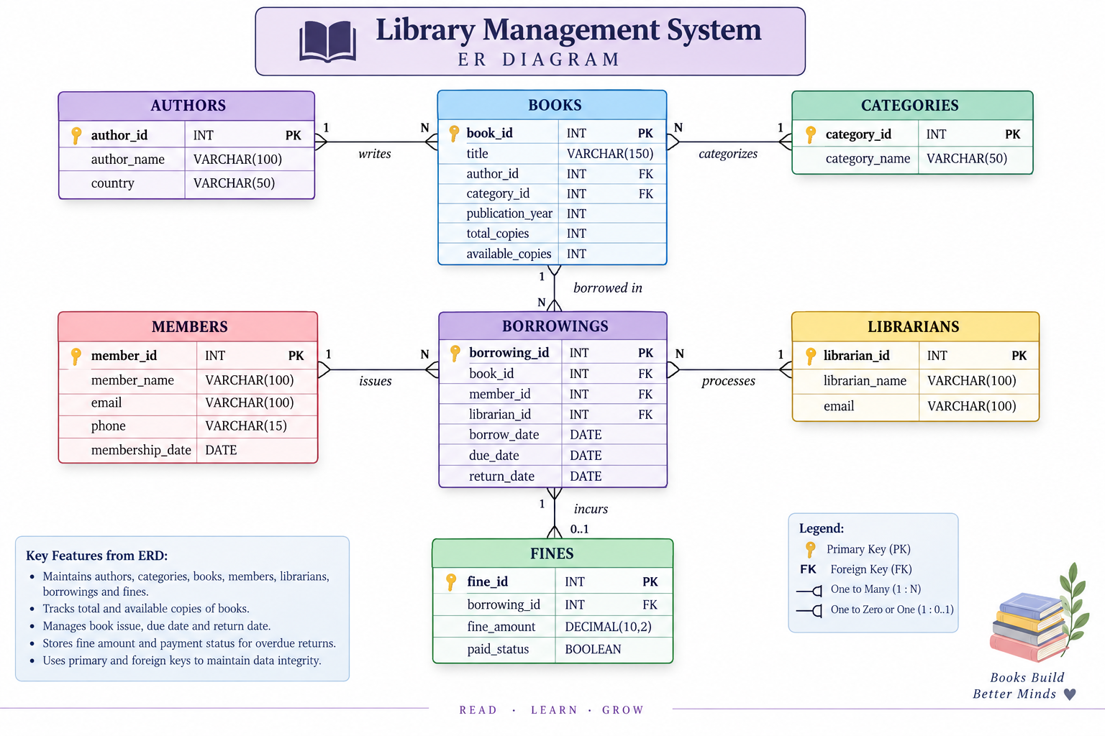

Figure 1: Entity Relationship Diagram

10. DATABASE TABLES

Authors
Stores author names and country information. author_id is the primary key.

Categories
Stores unique categories used to classify books.

Books
Stores book titles, authors, categories, publication years and copy quantities.

Members
Stores member names, email addresses, phone numbers and membership dates.

Librarians
Stores librarian names and email addresses.

Borrowings
Stores issue, due and return information and links books with members and librarians.

Fines
Stores fine amounts and whether a fine has been paid.

11. SQL CONCEPTS IMPLEMENTED
Concept | Application
DDL | Creating the database and tables.
DML | Inserting and managing records.
WHERE | Filtering records using conditions.
Aggregate Functions | COUNT, SUM, AVG, MIN and MAX for summaries.
GROUP BY & HAVING | Grouping records and filtering grouped results.
Joins | INNER JOIN, LEFT JOIN, RIGHT JOIN and CROSS JOIN.
Single-Row Functions | LOWER, UPPER, CONCAT, SUBSTR, LENGTH, REPLACE, TRIM, ROUND, YEAR and DATEDIFF.
Subqueries | Single-row, multi-row and EXISTS-based nested queries.
Views | Reusable virtual tables for common queries.
Triggers | Automatic actions for selected database events.
Stored Procedures | Reusable routines for common database operations.

12. VIEWS
Views are virtual tables based on SQL queries. They simplify repeated data retrieval and provide convenient access to commonly required information.
- all_books
- book_info
- all_members
- indian_authors
- available_books
- recent_books
- borrowed_books
- returned_books
- books_with_more_copies
- unpaid_fines

13. TRIGGERS
Triggers are database programs that execute automatically when specified events occur. The project uses triggers to support book-copy availability management. For example, a BEFORE INSERT trigger can initialize available_copies from total_copies when a new book is created, and an AFTER UPDATE trigger can increase available_copies when a borrowed book is returned.
In MySQL triggers, NEW refers to the new row values and OLD refers to the previous row values. INSERT uses NEW, UPDATE can use OLD and NEW, and DELETE uses OLD.

14. STORED PROCEDURES
Stored procedures are reusable SQL routines stored in the database. The project includes procedures for displaying books and members, finding records by ID, retrieving available or borrowed books, filtering books by category and filtering books between publication years.
- show_books()
- show_members()
- books_by_category(IN cat_id INT)
- find_book(IN b_id INT)
- find_member(IN m_id INT)
- available_books()
- borrowed_books()
- books_between_years(IN start_year INT, IN end_year INT)

15. TESTING
Testing is performed by executing SQL statements against the database and verifying the returned results. The following operations can be used to validate the implementation.
Test | Purpose
Table verification | Verify records stored in all seven tables.
Join testing | Verify relationships between books, authors, categories, members and librarians.
View testing | Verify results returned by created views.
Stored procedure testing | Call procedures with different parameters and verify output.
Trigger testing | Verify available_copies changes after relevant borrowing or return operations.
Fine testing | Verify fine amounts and paid-status records.

16. ADVANTAGES
- Organized storage of library information.
- Clear relationships between related entities.
- Primary and foreign keys support data integrity.
- SQL enables flexible searching and reporting.
- Views simplify repeated queries.
- Triggers automate selected database operations.
- Stored procedures provide reusable database routines.
- Book availability can be tracked using copy quantities.

17. LIMITATIONS
- The current project focuses mainly on the database layer.
- It does not include a complete graphical end-user application.
- Automated online fine payment is outside the current scope.
- Real-time notifications and external integrations are not included.

18. FUTURE ENHANCEMENTS
- Develop a web or desktop interface.
- Add secure authentication and role-based access.
- Add automated overdue-fine calculation.
- Add search and dashboard-based reporting.
- Add email or notification support for due dates.
- Add analytics for borrowing trends and book usage.
- Add backup and recovery functionality.

19. CONCLUSION
The Library Management System demonstrates the practical use of MySQL and SQL to build a structured relational database for library operations. The seven-table design connects catalog information with members, librarians, borrowing transactions and fines.
The project also demonstrates important SQL concepts such as filtering, aggregation, grouping, joins, functions and subqueries, along with views, triggers and stored procedures. It provides a practical foundation that can be extended into a complete library application with a user interface, authentication, reporting and notification features.

20. REFERENCES
- MySQL Documentation – SQL statements, database objects, triggers, views and stored procedures.
- MySQL Workbench Documentation – Database design and SQL development environment.
- GeeksforGeeks – SQL and database learning resources.

