

Name : Nikhitha V
Reg No :192512490
Course name : Advanced Wireless Commincation
Course code : ECA5610

MATLAB Analysis of Spectrum Bands, Propagation Loss and Cellular Interference

Aim:

To compare a simplified free-space path-loss estimate across representative sub-1 GHz, mid-band and mmWave frequencies, and examine how distance and frequency reuse affect received signal and a simple interference measure

Objectives:
1. Calculate or simulate path loss at representative sub-1 GHz, mid-band and mmWave frequencies.
2. Compare estimated received signal strength as frequency and distance change.
3. Examine how cell separation or frequency reuse changes a simplified interference ratio.
4. Relate the results to coverage and spectrum-use considerations across mobile generations, while stating model limitations.

Requirements:
  - Computer with MATLAB

Program :
clear; clc; close all;
% Representative bands and link-budget assumptions
freqGHz = [0.7 3.5 28];
freqMHz = freqGHz * 1000;
bandName = ["Sub-1 GHz"; "Mid-band"; "mmWave"];
txPowerdBm = 30;
gtDbi = 0; grDbi = 0;
distanceKm = logspace(log10(0.1),log10(2),200);
distanceAtPointKm = 0.5;

% Free-space path loss (d in km, f in MHz)
fspl = @(fMHz,dKm) 32.44 + 20*log10(fMHz) + 20*log10(dKm);
lossAtPoint = fspl(freqMHz,distanceAtPointKm);
rxAtPoint = txPowerdBm + gtDbi + grDbi - lossAtPoint;
linkTable = table(bandName,freqGHz(:),lossAtPoint(:),rxAtPoint(:), ...
'VariableNames',{'Band','Frequency_GHz','FSPL_dB','EstimatedRx_dBm'});
disp(linkTable);

% Path loss and received power over distance
figure; tiledlayout(1,2);
nexttile; hold on; grid on;
for k=1:numel(freqMHz)
plot(distanceKm,fspl(freqMHz(k),distanceKm),'LineWidth',1.5);
end
set(gca,'XScale','log'); xlabel('Distance (km)'); ylabel('Path loss (dB)');
legend(bandName,'Location','northwest'); title('Free-Space Path Loss');
nexttile; hold on; grid on;
for k=1:numel(freqMHz)
rx = txPowerdBm + gtDbi + grDbi - fspl(freqMHz(k),distanceKm);
plot(distanceKm,rx,'LineWidth',1.5);
end
set(gca,'XScale','log'); xlabel('Distance (km)'); ylabel('Estimated received power (dBm)');
legend(bandName,'Location','southwest'); title('Illustrative Received Power');

% Simple first-tier co-channel reuse estimate
cellRadiusKm = 0.5;
reuseN = [1 3 7 12];
pathLossExponent = 3.5;
reuseDistance = sqrt(3*reuseN) * cellRadiusKm;
sirLinear = (reuseDistance/cellRadiusKm).^pathLossExponent / 6;
sirDb = 10*log10(sirLinear);
reuseTable = table(reuseN(:),reuseDistance(:),sirDb(:), ...
'VariableNames',{'ReuseClusterN','ApproxInterfererDistance_km','ApproxSIR_dB'});
disp(reuseTable);
figure; plot(reuseN,sirDb,'o-','LineWidth',1.5); grid on;
xlabel('Reuse cluster size N'); ylabel('Approximate SIR (dB)');
title('Simplified Co-Channel SIR versus Reuse Cluster Size');

fprintf('At %.2f km, estimated received powers are:\n',distanceAtPointKm);
disp(table(bandName,rxAtPoint(:),'VariableNames',{'Band','Rx_dBm'}));

Output:

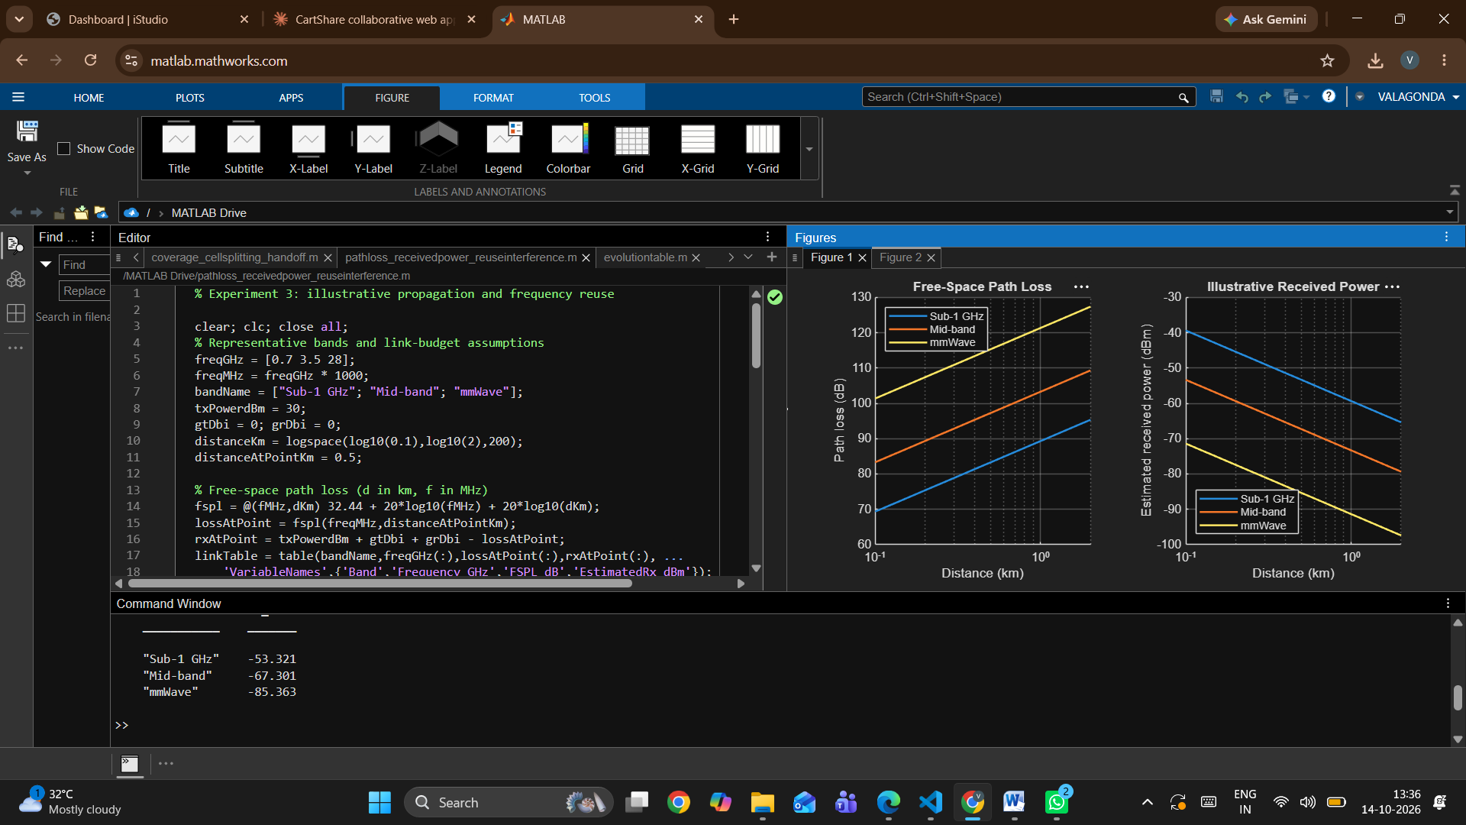
+
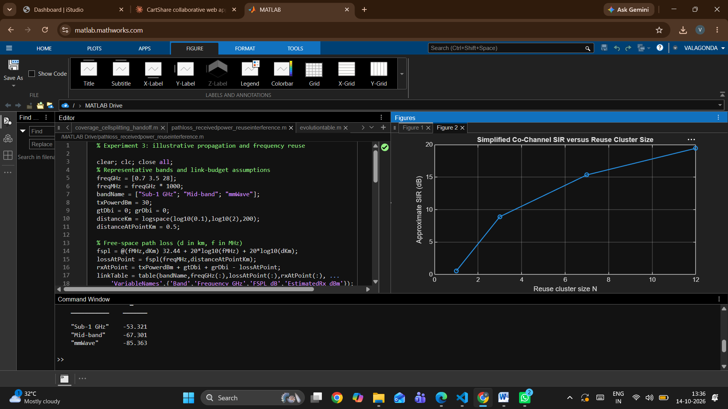

Conclusion

Summarize the frequency and distance trends from the simulation and the effect of reuse separation on the illustrative SIR. Identify the free-space assumption, fixed transmit power and idealized six-interferer geometry as limitations. Note that practical coverage depends on antenna characteristics, environment, bandwidth, receiver sensitivity, interference, regulatory constraints and the chosen propagation model.

