Name : V. Nikhitha
Reg No 192512490
Code : ECA-5610
Course : ADVANCED WIRELESS COMMUNICATION SYSTEM
Exp No 02

MATLAB Simulation of Cellular Coverage, Cell Splitting and Handoff in a Multi-Cell Network

Aim:
To model a simplified hexagonal cellular network and study how cell radius affects coverage,estimated user capacity and handoff as a mobile crosses a cell boundary.

Program code:(OBJECTIVE 1,2,3&4):

% Experiment 2: simplified hexagonal coverage and handoff
clear; clc; close all;
% Baseline assumptions
serviceAreaKm2 = 5;
radiiKm = [1.0 0.5];
usersPerCell = 30;
hexArea = @(R) (3*sqrt(3)/2) .* R.^2;
cellAreaKm2 = hexArea(radiiKm);
cellCount = ceil(serviceAreaKm2 ./ cellAreaKm2);
estimatedUsers = cellCount .* usersPerCell;
capacityTable = table(radiiKm(:), cellAreaKm2(:), cellCount(:), ...
repmat(usersPerCell,numel(radiiKm),1), estimatedUsers(:), ...
'VariableNames', {'Radius_km','CellArea_km2','EstimatedCells', ...
'UsersPerCell','IllustrativeUsers'});
disp(capacityTable);
% Plot a 7-cell cluster: central cell plus six neighbors
R = radiiKm(1);
centers = [0 0; 1.5*R sqrt(3)*R/2; 1.5*R -sqrt(3)*R/2; ...
0 sqrt(3)*R; 0 -sqrt(3)*R; -1.5*R sqrt(3)*R/2; ...
-1.5*R -sqrt(3)*R/2];
theta = (0:6)*pi/3; % flat-top hexagon vertices
figure; hold on; axis equal; grid on;
for k = 1:size(centers,1)
plot(centers(k,1)+R*cos(theta), centers(k,2)+R*sin(theta), 'k-');
text(centers(k,1),centers(k,2),sprintf('Cell %d',k), ...
'HorizontalAlignment','center');
end
xlabel('x (km)'); ylabel('y (km)');
title('Idealized Seven-Cell Hexagonal Cluster');
hold off;
% Mobile moves across the boundary between centers at x=0 and x=1.5R
mobileX = linspace(-0.2*R,1.7*R,300);
mobileY = zeros(size(mobileX));
d1 = hypot(mobileX, mobileY);
d2 = hypot(mobileX-1.5*R, mobileY);
servingCell = ones(size(mobileX));
servingCell(d2 < d1) = 2;
handoffIndex = find(diff(servingCell) ~= 0,1,'first') + 1;
figure; hold on; grid on;
plot(mobileX,d1,'LineWidth',1.5);
plot(mobileX,d2,'LineWidth',1.5);
if ~isempty(handoffIndex)
xline(mobileX(handoffIndex),'--r','Handoff decision');
end
xlabel('Mobile x-position (km)'); ylabel('Distance to cell center (km)');
legend('Cell 1','Cell 2','Location','best');
title('Nearest-Center Handoff Approximation');
hold off;
figure; stairs(mobileX,servingCell,'LineWidth',1.5); grid on;
xlabel('Mobile x-position (km)'); ylabel('Serving-cell ID');
title('Serving Cell Along the Mobile Path');
if ~isempty(handoffIndex)
fprintf('Geometric handoff at x = %.3f km\n',mobileX(handoffIndex));
end

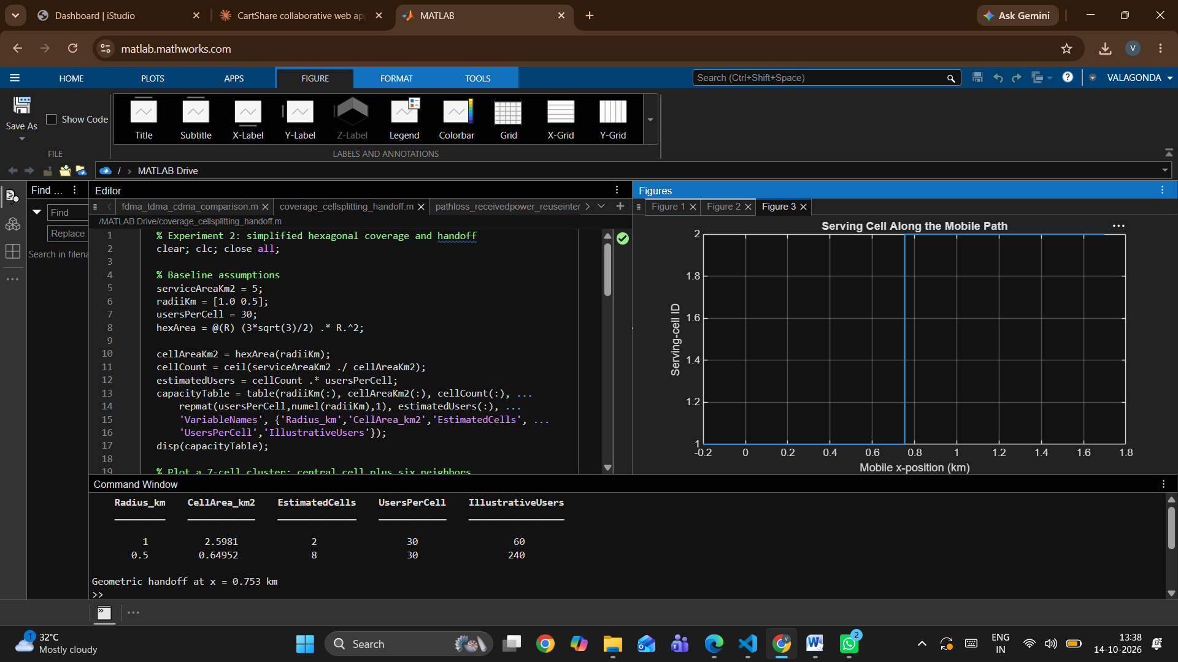

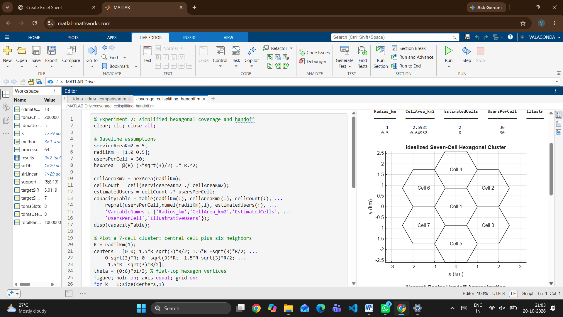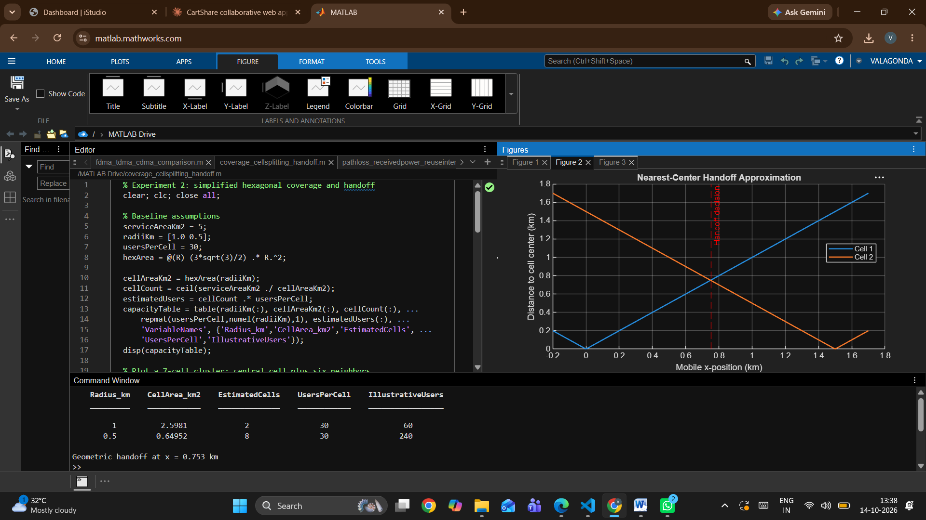

Result:
FDMA, TDMA and CDMA were simulated in MATLAB with the stated illustrative parameters. FDMA supported 5 users (1 MHz / 200 kHz), TDMA supported 8 users (one per slot) and CDMA supported 13 users at a 7 dB target SIR. The CDMA SIR fell as simultaneous users increased, confirming that CDMA capacity is interference-limited. The evolution table linked FDMA, TDMA, CDMA, WCDMA and OFDMA-based access to 1G through 5G.

