ECA5701-NANOELECTRONICS  C01-3  EXPERIMENT 3 | V.NIKHITHA  192512490
Simulation of Energy States of Quantum Dot using NanoHub
Aim: To obtain the energy states of Quantum dots.
Case Study 1: Simulate the energy states of cylindrical quantum dots of X=15 nm, Y = 10.5nm and Z = 8 nm.
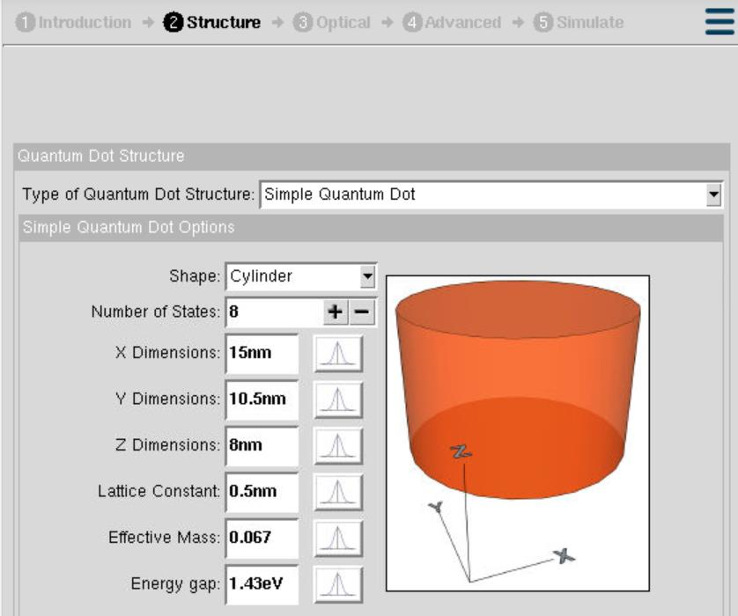 | 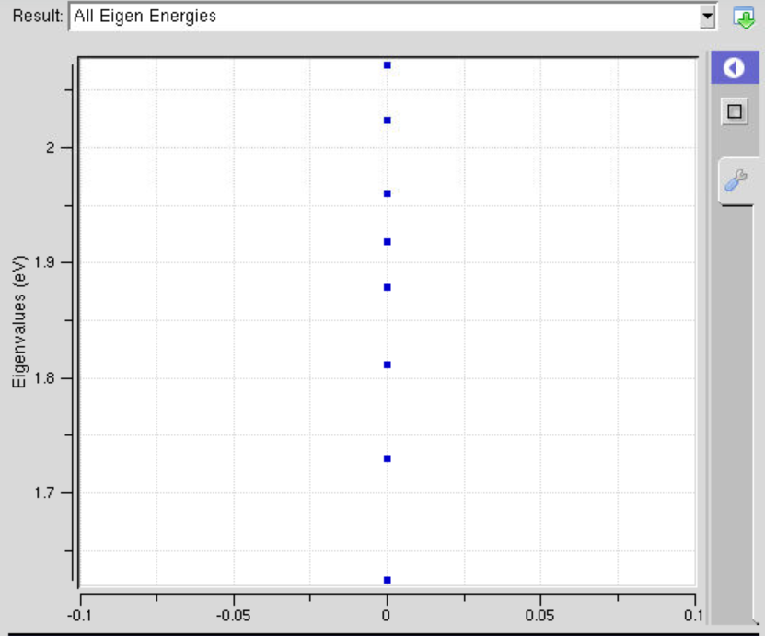

Case Study 2: Simulate the energy states of two-layer cuboid quantum dots
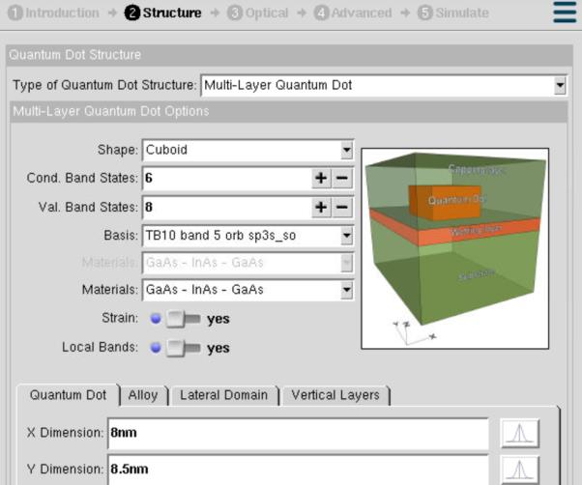 | 