ECA5701-NANOELECTRONICS  C01-4  EXPERIMENT 4 | V.NIKHITHA  192512490
Kronig Penney Model
Aim: To simulate Energy functional vs Energy graph using Kronig Penney model
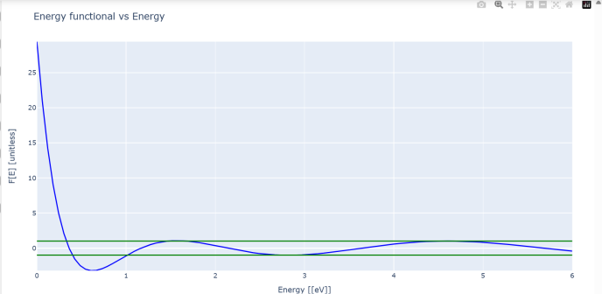
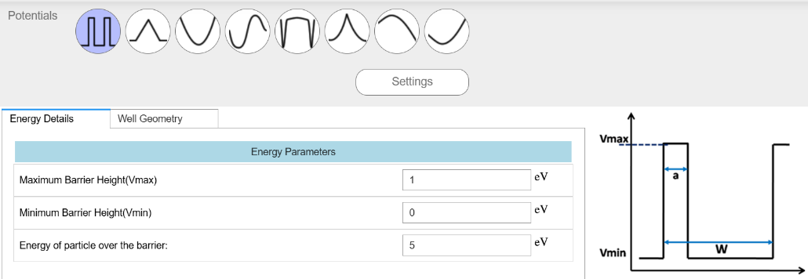
Case Study 1: Simulate the output for Triangular well
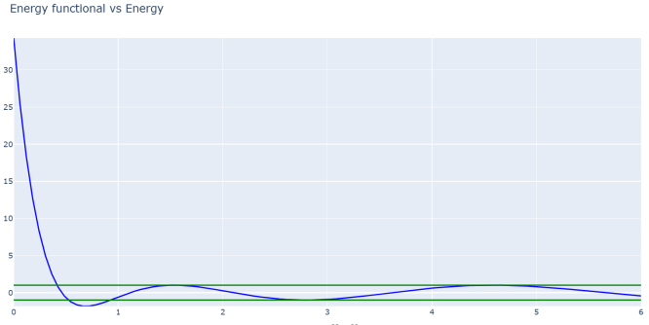

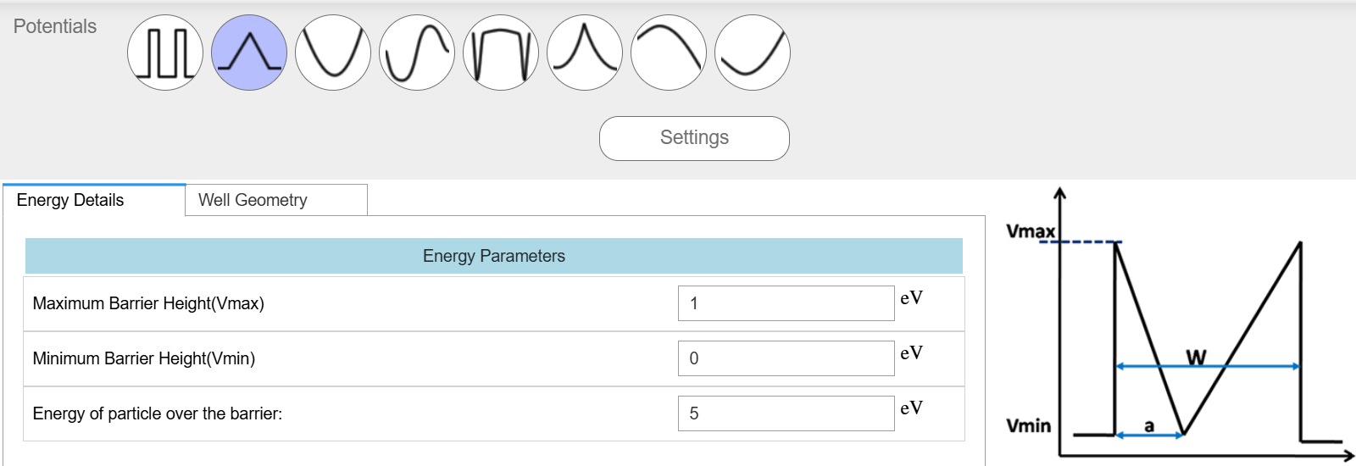
Case Study 2: Simulate the output for Sinusoidal Potential
